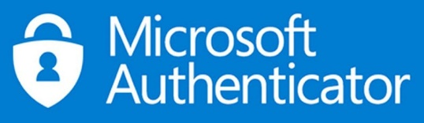
Setting Up The

Microsoft Authenticator App

If you have already installed Microsoft Authenticator, delete the app and reinstall it.
- Log in to a PC, Laptop or use your mobile phone to login to office.com

- Enter office.com in the address bar and press Enter.

- Click on the Sign In button to log in to your college Microsoft Account.

- Click on your initials or avatar in the top-right corner of the page.
- Click on View Account.
- One the Security Info tile, click on UPDATE INFO.
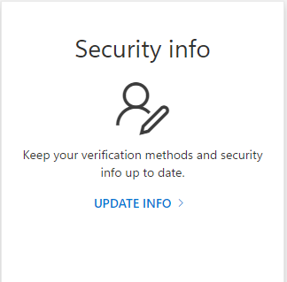

NB – If Office.com asks for Authenticator at this point, your account needs resetting. To reset Email ITCallLogging@derby-college.ac.uk and request to reset your MFA account, include your student ID, Example 12345678@student.derby-college.ac.uk. Any changes will take up to 24 hours to take effect.

- Click on Add sign-in method.

- From the drop-down box, select Authenticator app.
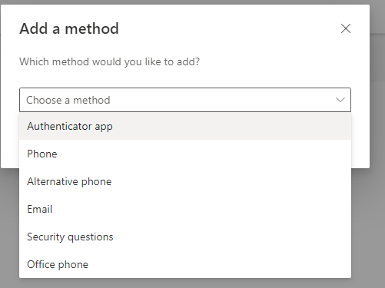

- Click on the Add button.

- Click on Next in the pop-up window.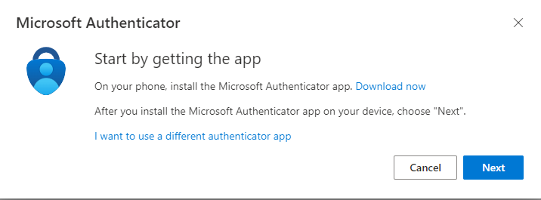

- Open Authenticator App on your phone, select Add an account, and select "Work or school".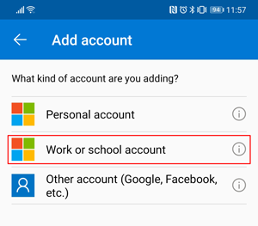

- Click on Next in the pop-up window on your PC or laptop.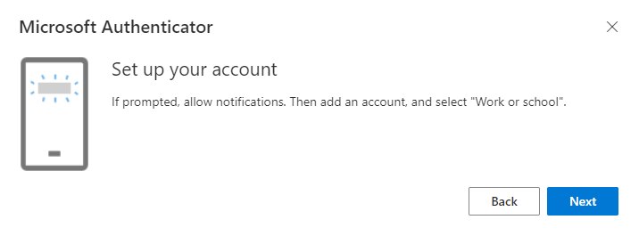
- On your phone, click on the Scan a QR code option.

- Scan the QR code from the PC / laptop that has popped up.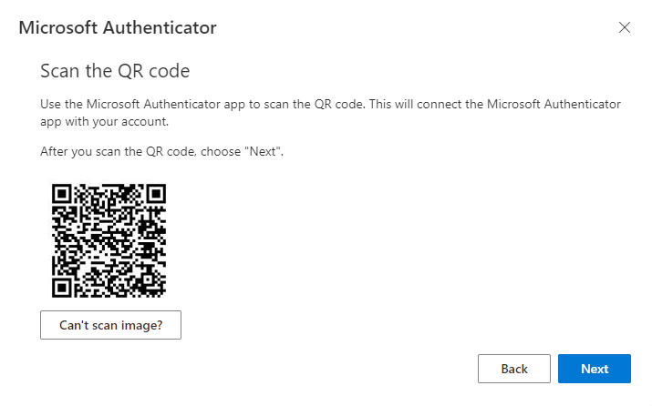

- Click on Next on the Let’s try it out screen.
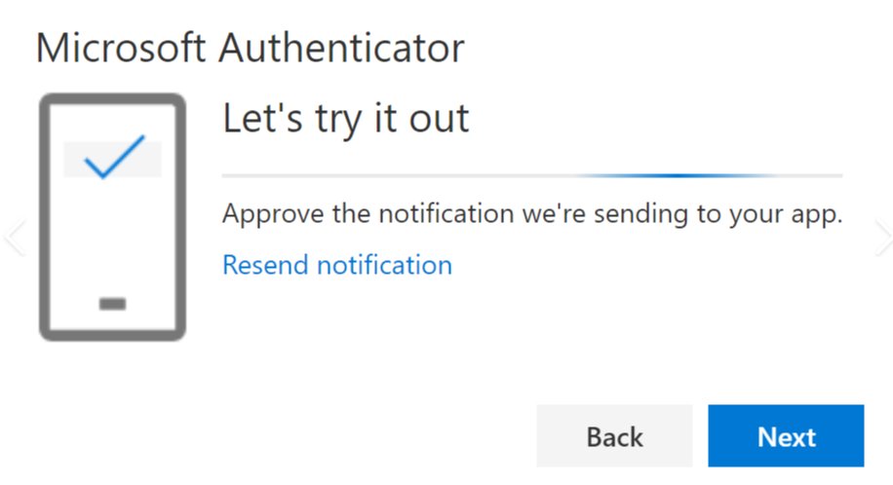

- Your phone will get a notification asking you to approve sign-in by entering the number displayed on screen. You will also be prompted to enter your phone’s pin or biometric sign-in.
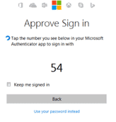
- Click next on the information pop-ups to finish.
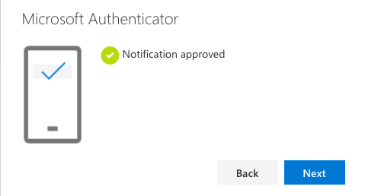

- You now need to set Authenticator App as your default authentication method. Click on the link underneath Security info.
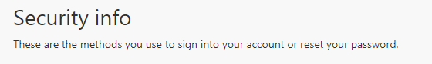

- On the "Change default method" screen, select the option for Microsoft Authenticator to be set as your default from the drop-down list. Then click "Confirm."
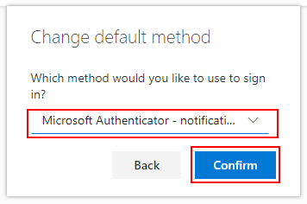

- Microsoft Authenticator set-up is now complete. You can now log out.

