Derby College Winter Dressage Series
Come and have a go at the new tests in a fun and relaxed environment
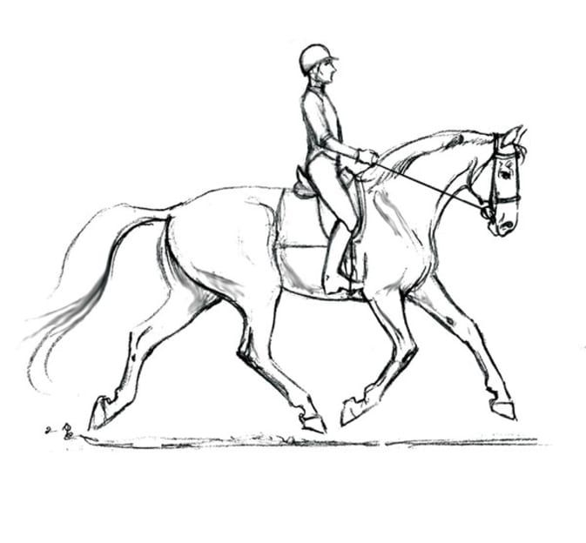

SCHEDULE:
Date | Class 1 | Class 2 | Class 3 | Class 4
12th September | Intro 1 2024 | Prelim 1 2024 | Prelim 2 2024 | Novice 1 2024
11th October | Intro 2 2024 | Prelim 2 2024 | Prelim 3 2024 | Novice 2 2024
7th November | Intro 3 2024 | Prelim 3 2024 | Prelim 1 2024 | Novice 3 2024
7th March | Intro 1 2024 | Prelim 1 2024 | Prelim 2 2024 | Novice 1 2024
18th April | Intro 2 2024 | Prelim 2 2024 | Prelim 3 2024 | Novice 2 2024


To enter, please email your entry to equineentries@derby-college.ac.uk by 7pm on the Wednesday prior to the show. Entries cost £15 per class which must be paid in cash or card on the day of the event.

