Winter Dressage Series
Come and have a go at the new tests in a fun and relaxed environment
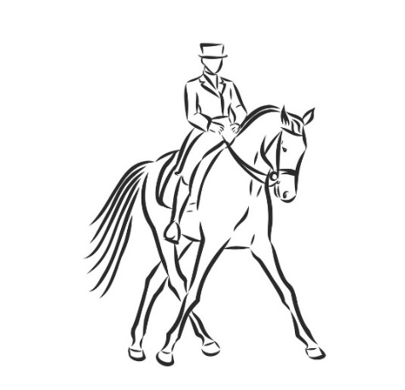
12th October, 9th November, 1st February, 8th March, 18th April

Date | Class 1 | Class 2 | Class 3 | Class 4
12th Oct | Intro 1 2024 | Prelim 1 2024 | Prelim 3 2024 | Novice 1 2024
9th Nov | Intro 2 2024 | Prelim 2 2024 | Prelim 1 2024 | Novice 2 2024
1st Feb | Intro 3 2024 | Prelim 3 2024 | Prelim 2 2024 | Novice 3 2024
8th March | Intro 2 2024 | Prelim 2 2024 | Prelim 3 2024 | Novice 2 2024
18th April | Intro 1 2024 | Prelim 1 2024 | Prelim 2 2024 | Novice 1 2024

Points League 2025/26
This year we will be hosting a points league, and the winner of the league will be presented with a sash and a prize. Points will be collated at the end of the final show.

1st - 6 points | 2nd - 5 points | 3rd - 4 points | 4th - 3 points | 5th - 2 points | 6th - 1 point

To enter, please email your entry to equineentries@derby-college.ac.uk by 7pm on the Wednesday prior to the show.
Entries WILL close early if full. If this is the case, it will be notified on the Derby College Equestrian Centre Facebook Page. Late entries may be accepted if there is room at the organiser’s discretion. Your times will be put up on the Derby College Equestrian Centre Facebook page by the end of the day on the Wednesday prior to the event.
Entries cost £15 per class which must be paid in cash or card on the day of the event

Terms & Conditions of Entry
- Entries cost £15 per class which must be paid in cash or card on the day of the event. ANYONE WHO ENTERS AND DOES NOT PAY FOR ANY REASON WILL HAVE FUTURE ENTRIES REFUSED.
- There will be a caterer & photographer at all our events.
- All competitors must sign a perpetual disclaimer which will be valid for every riding session at Derby College.
- Withdrawals must be received by the Wednesday before competition, otherwise entry fees MUST still be paid
- In case of the event having to be cancelled due to bad weather an announcement will be put on the Derby College Facebook page, or phone 07980 891295 on the show day if you are unsure.
- The Winter Dressage Series is a relaxed, fun event. Competitors and their supporters are expected to enter into the spirit of the event and be friendly and supportive of fellow competitors.
- Novice horses and riders are welcome and will be given chance to end on a good note within their time slot.
- The event organisers reserve the right to refuse or revoke any entry without explanation.
- The event organisers accept no responsibility for accidents, injury or loss to competitors, spectators, animals or equipment. Admission is granted and entries accepted on these conditions.
- All horses and riders must have adequate 3rd party insurance. We also recommend accident insurance for all competitors.
- The Judge’s or Event Organiser’s decision is final in all respects. Stewards’ instructions must be adhered to.
- Riders must be an appropriate size/weight for their horses/ponies.
- British Dressage rules will be followed, except where expressly stated.
- Helmet cameras may not be worn.
- The Event Organisers reserve the right to cancel or split any class or substitute judges without explanation.
- Dogs are not permitted on college grounds.
- Only competitors may ride their horses at the competition and this must be in the warm up ring only. No lunging is permitted. For safety reasons, only 8 people permitted in the warm up at any one time. Preference is given to the next 8 competitors.
- There will be no first aid cover at events.
Entries are accepted on the understanding that competitors agree to abide by these rules.

