Religion, Philosophy, and Ethics 2025/2026
Academic Studies



Start Date | September 2025
End Date | 4th July 2026 (End of Year 1)  July 2027 (End of Year 2)
Level of course | Level 3
Awarding Body | Eduqas
Specification | A-Level Religious Studies – Specification

CONTENTS

YOUR SUBJECT TEACHER 3
INTRODUCTION & AIMS OF THE COURSE 3
COURSE STRUCTURE 4
KEY COURSE INFORMATION 5
YEAR PLAN OF STUDY 6
SUCCESSFUL LEARNER HABITS 7
SUBJECT RESOURCES 7
TERMINOLOGY GLOSSARY 8

YOUR SUBJECT TEACHER

Welcome to Religion, Philosophy, and Ethics

Adam Naylor MA, BA, PGDipEd (QTS), NPQLT
Adam.Naylor@derby-college.ac.uk

INTRODUCTION & AIMS OF THE COURSE

A-Level Religion, Philosophy, and Ethics is an ideal choice for those who are interested in engaging in the great questions of our existence, religious experience, the role of language in presenting valid arguments, the problem of evil, the existence / non-existence of God, whether ethical terms such as ‘good’ and ‘bad’ have actual meaning and gaining an understand of the development and role of Christianity OR Islam in a global context; both historic and contemporary.

Religion, Philosophy, and Ethics works well with many other subjects including:
- English Language
- English Literature
- Psychology
- Geography
- Sociology
- Politics
- History
- Law

Other students who study Religion, Philosophy, and Ethics have gone on to study / have careers in:
- Barrister
- Civil Service fast streamer
- Diplomacy
- Health service manager
- Journalism
- Local government officer
- Marketing executive
- Newspaper journalist
- Psychotherapist
- Recruitment consultant
- Solicitor
- Stockbroker
- Teaching

COURSE STRUCTURE

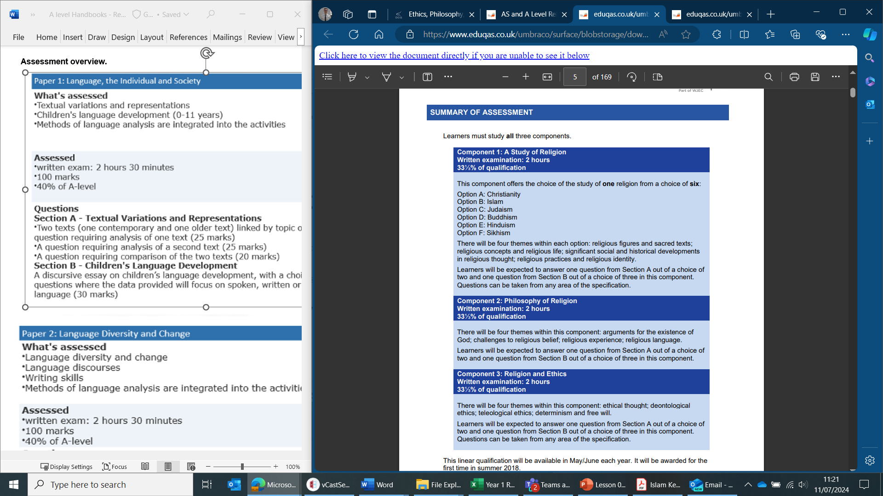
Assessment overview.

KEY COURSE INFORMATION

Length of Study | 3 x 1 hour and 40-minute lessons a week (5 hours a week)  - Lesson 1: Religion: Christianity OR Islam.  - Lesson 2: Philosophy.  - Lesson 3: Ethics.
Your classrooms | S1, S2 and S4.
Key skills you will be developing during the course to be successful | The ability explain / examine elements of religion as well as key theories in western philosophy and ethics. This will then provide you with the skills to apply ethical theories to moral dilemmas, which include: abortion, animal testing for medication research, homosexuality, the nuclear deterrent, capital punishment and immigration.
What will lessons look like? | You will engage in group work, class discussion, interactive activities, independent research and a variety of written tasks.
Informal Assessment Methods | Exam style essay questions will feature frequently throughout the year. We will also do quizzes to ensure you remember key terminology and theory.
Essential Equipment/ Resources | Paper, pens, highlighters.

YEAR PLAN OF STUDY

Year 1 Contents:

Component 1: Christianity

- T1(ABC): Religious Figures and Sacred Text.
- T2(ABC): Religious Concepts.
- T2(DEF): Religious Life.
- T4(ABC): Religious Practices that Shape Religious Identity.

Component 2: Philosophy

- T1(ABC): Arguments for the Existence of G-d (Inductive).
- T1(DEF): Arguments for the Existence of G-d (Deductive).
- T2(ABC): Problem of Evil and Suffering (Part 1).
- T3(ABC): Religious Experience (Part 1).

Component 3: Ethics
- T1(ABC): Ethical Thought (Divine Command Theory, Virtue Theory, and Ethical Egoism).
- T2(ABC): Natural Law Theory.
- T3(ABC): Situation Ethics.
- T3(DEF): Utilitarianism.

Year 2 Contents:

Component 1: Christianity

- T1(DEF): Religious Figures and Sacred Life.
- T3(ABC): Significant Social and Historical Developments in Religious Thought (Part 1).
- T3(DEF): Significant Social and Historical Developments in Religious Thought (Part 2).
- T4(DEF): Religious Practices that Shape Religious Identity.

Component 2: Philosophy

- T2(DEF): Problem of Evil and Suffering (Part 2).
- T3(DEF): Religious Experience (Part 2).
- T4(ABC): Religious Language – Non-Cognitive and Cognitive Language.
- T4(DEF): Religious Language – Symbolic, Mythic, and Language Games.

Component 2: Ethics
- T1(DEF): Meta-Ethics (Naturalism, Intuitionism, and Emotivism).
- T2(DEF): Natural Law Theory (Modern Updates).
- T4(ABC): Predestination / Determinism.
- T4(DEF): Free Will / Libertarianism.

SUCCESSFUL LEARNER HABITS

Regular revision: The best way to stay on top of all of your subjects is to allocate time to review and revise the content you have studied in call. There are many methods you can utilise to achieve this aim, however some that have worked well in Religion, Philosophy, and Ethics are mind maps, flashcards, planning responses to essays and Quizlet.
Good attendance: All topics build onto each other, therefore missing lessons means that you risk putting yourself at a disadvantage. A good attendance will allow you to learn the content over the two-year course, ask questions, practice key skills, and develop confidence in the many theories and ideas we study.
Exam practice: As the year progresses you will need to engage with a variety of exam-style questions and practice.
Engage with WAGOLLS (What A Good One Looks Like): Exemplars are provided regularly

SUBJECT RESOURCES

Resources to further support your studies in Religion, Philosophy, and Ethics can be found at:
pod.derby-college.ac.uk/mod/glossary/showentry.php?eid=105
You will also receive summary notes and knowledge organisers for each topic.

TERMINOLOGY GLOSSARY

Explain | Write a systematic and comprehensive account of a topic, exploring underlying reasons, focusing upon the aspect  highlighted in the question (such as definition, nature, purpose, features), e.g.  - Explain how...  - Explain why...  - Explain the importance/significance of…  - Explain is focused on reasons in relation to a straightforward topic.
Examine | Portray and account for different facets of, or angles on, a complex practice, concept or belief, e.g.  - Examine the characteristics of...  - Examine different ways in which...  - Examine is focused on the varied aspects of a many-sided topic
Apply | Show how a principle, theory or teaching might be used in relation to an issue or situation, e.g. how an ethical theory might be employed to solve an ethical problem.
Evaluate | Using evaluative skills to make a reasoned judgement (including an appropriate conclusion), whilst having critically considered  a variety of arguments/ideas
AO | We will regularly refer to Assessment Objectives (AO). In Religion, Philosophy, and Ethics there are two Aos; AO1 is linked to ‘knowledge and understanding’ and AO2 is linked to ‘analysis and evaluation’.
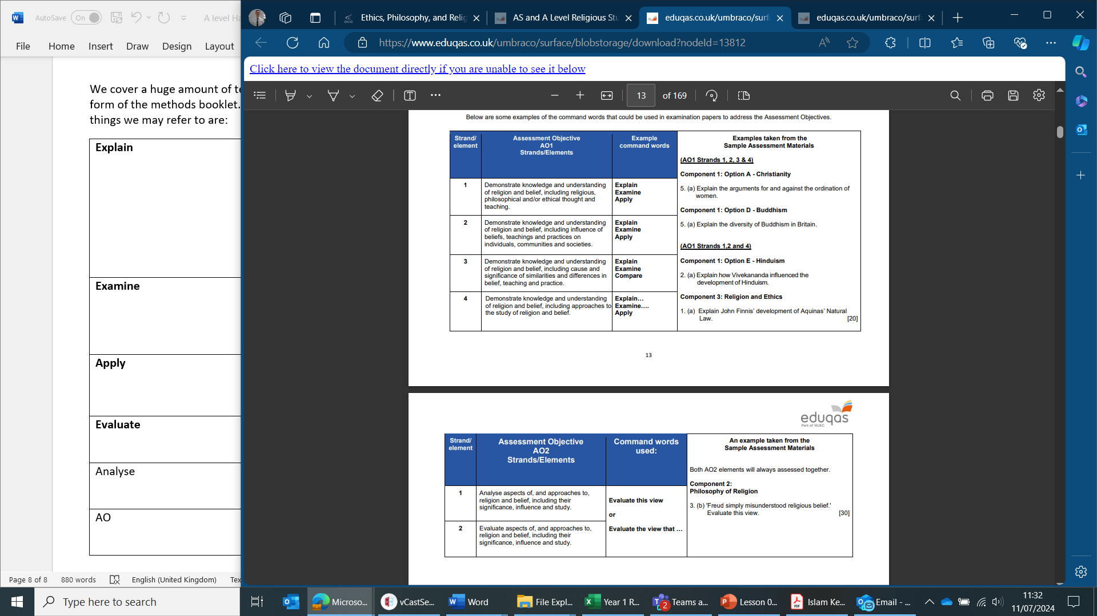
We cover a huge amount of terminology across both years; therefore, this will be provided in class in the form of the methods booklet. You will also receive a theory bank at the end of each year. But some key things we may refer to are:

