MATHEMATICS A1 2026-7
Academic Studies



Start Date | 7th SEPTEMBER 2026
End Date | 2nd JULY 2027
Level of course | 3
Awarding Body | AQA

CONTENTS

YOUR SUBJECT TEACHERS 3
INTRODUCTION & AIMS OF THE COURSE 4
COURSE STRUCTURE 5
KEY COURSE INFORMATION 6
YEAR PLAN OF STUDY 7
ENRICHMENT AND VISITS 8
SUCCESSFUL LEARNER HABITS 9
SUBJECT RESOURCES FOR STUDENTS 10
TERMINOLOGY GLOSSARY 11

YOUR SUBJECT TEACHERS

ROBIN LONGFIELD – robin.longfield@derby-college.ac.uk
Teacher of A1 & A2 Mathematics & Core Maths & Further Mathematics
Subject Leader – Mathematics Level 3

ANDY MCELHONE andy.mcelhone@derby-college.ac.uk
Teacher of A1 & A2 Mathematics & Further Mathematics

RACHEL UFF rachel.uff@derby-college.ac.uk
Teacher of A1 & A2 Mathematics & Core Maths & Further Mathematics

INTRODUCTION & AIMS OF THE COURSE

Introduction
Welcome to studying Mathematics at the Joseph Wright Centre. This handbook contains details of your first year Mathematics A-level Programme and other important information.
We will be following the AQA Specification for our course. This specification can be found here.
A-level maths is a demanding course and you need to be determined, develop good study skills and be hardworking to succeed. You may not have a full timetable, like in school, but you are still doing a full-time course and you should expect the workload to be like a full-time job, with Directed Independent Learning Tasks set every class to consolidate learning from your classes.

A-level Mathematics

- There is no coursework in A-level maths.
- This is the first year of a two-year course.
- You will study Pure Maths, Statistics and Mechanics. Statistics and Mechanics together count for one third of the marks. There are no optional modules in this course.
- Your examinations will be in summer 2028.
- In June 2027 we will ask you to complete a Progression Examination. This is important as it helps us to determine predicted grades that will be required for references. If you do not do very well in this exam, your progression to A2 may be in doubt. You will be offered the opportunity to show improvement in effort and your potential to achieve a higher grade.
- You will complete homework assessments and tests regularly as the course progresses.
- A pass at A-level includes grades A* to E. You will be given a target grade to work towards.
- We will expect you to bring your own stationary. Some A-level questions are very long and for this reason we want you to work on A4 paper. You will need at least one file to keep your completed work organised when it is returned to you. We do not use exercise books.
- We may ask you to upload images of your work to a digital folder and ask you to complete assessments or undertake research on-line.

- For A-level Maths one of the following calculators is mandatory

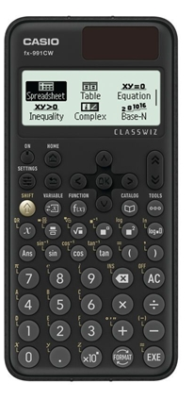
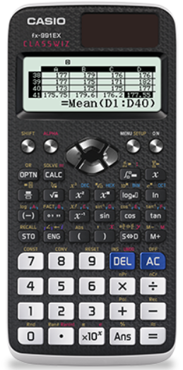
Casio FX 991EX Classwiz Casio FX 991CW Classwiz

These calculators have functions and data required for A-level which your GCSE calculator will not have.
Graphical Calculators are not essential but do provide additional functionality that can assist you in lessons and exams.

Expectations

Team Effort
Your success will be the result of a team effort. It is important that you learn to work independently and that you can identify problem areas with your work and how to overcome them. It would be easy to ignore these, but you must use the resources available to help you. These can include the obvious ones, like textbooks etc., but it also includes your classmates, parents and carers, and your teacher.

ORACY
You are expected to contribute to lessons and offer your ideas. This will be done in a variety of ways – pair work, group work, offering answers to questions to the whole group and in presentations about Mathematics. We will help you develop these skills through structured activities as we are aware this can sometimes be difficult for some students.

Liaise with Staff
College is different to school. Some of you will experience finding Maths “hard” for the first time in A-Levels. Your professional relationships with Robin, Andy and Rachel are key. If you are having trouble with the work use the systems to contact them to discuss this. It is through discussion we get better.

COURSE STRUCTURE

Assessment of your work
If we ask you to do some independent work, we may not always take it in for marking. This does not mean it is not important. Remember that you are not doing homework for us, you are doing it for you. We would expect you to check your own answers when you have these, and physically mark your work. Try to identify errors if you can and correct these but ask about things you do not understand. When your work has been graded, how does the grade compare with your target grade and your stretch and challenge grade? Try to identify what you should do if you are not achieving your target grades.
Sometimes we will ask you to assess your own work with a mark scheme or assess someone else’s work. It is important for you to know how marks are gained and what examiners are looking for. It is also important for you to discover how easy it is to follow your own work.
We may ask you to upload your work or set a task to provide evidence that you completed a task. Sometimes we will ask you to do an online assessment.

A-level Maths Y1 Key Assessment Weeks (Provisional)

Assessment | Week commencing | Content from | Topics
Diagnostic | 21/9/26 | First few weeks | See Year Plan of Study below
FA1 | 2/11/26 | Pure Assessment | Term 1 Pure content
FA2 | 4/1/27 | Pure Assessment | Term 1 & 2 Pure content
FA3 | 22/2/27 | Pure & Statistics Assessment | All Pure & Statistics content
FA4 | 12/4/27 | Pure & Mechanics Assessment | All Pure & Mechanics content

Provisional Progression Exam Dates: During W/c 7th June 2027: Covers all content.

Your potential progression to A2 will be assessed after the above process and we will also take into account all the relevant factors which have contributed to your level of progress, including your attendance level, punctuality record, engagement in class & with subject support, homework completion rate etc.

KEY COURSE INFORMATION

Length of Study | First year of a two year course, 3 lessons per week of 1h40m, and additional support sessions where needed
Your classrooms | F14
Key skills you will be developing during the course to be successful | Problem solving & logical thinking;  Critical thinking.
What will lessons look like? | Traditional delivery with student activities to enhance learning, consolidation & practice.
Informal Assessment Methods | Formal Assessments each half-term
Essential Equipment/ Resources | A4 Subject folder with A4 lined & graph paper  Casio FX-991 EX or CW Classwiz Calculator is mandatory (see above)  A1 Textbook – obtain from Library
Health and Safety | No specific requirements

OUTLINE PLAN OF STUDY

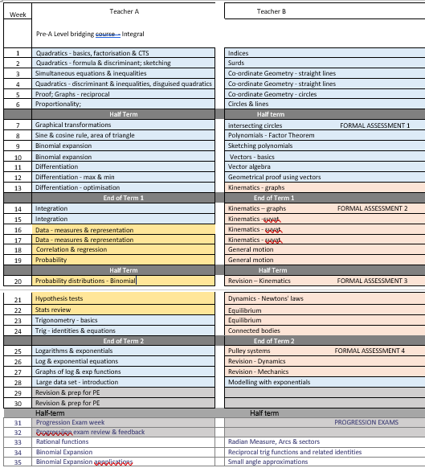

ENRICHMENT AND VISITS

MATHS CLUB – ALL YEAR
UKMT SENIOR CHALLENGE & WOMEN’S CHALLENGE– NOV 2026
RITEANGLE CHALLENGE – DEC 2026
PROJECT WEEK – JUNE 2027

SUCCESSFUL LEARNER HABITS

Become an Expert Learner
To become an expert learner, you should:
- Remember your reasons for choosing A-level Maths;
- Engage fully with the course - in lessons and with your independent study;
- Take responsibility for your progress – you will not become an expert if all you do is attend classes;
- Reflect on what works well and review your strengths and weaknesses;
- Plan your learning for improvement;
- Ask questions – if in doubt, ASK!
- Regard mistakes as an opportunity to learn - identify errors and correct your work;
- Develop effective study habits;
- Regard independent study as an opportunity to learn, not a chore;
- Use feedback to improve;
- Attend lessons punctually & be ready to learn;
- Value the opinions & support of others;
- Be prepared to share your ideas and opinions and support others in your group;
- Organise your work – the more accessible it is, the easier it will be for you to apply your skills and knowledge to problems and transfer those skills and apply them to new areas of Maths;
- Explore your resources and use them;
- Try a different approach to solving a problem if the one you are trying does not seem to be leading anywhere - perseverance and determination pay;
- Have a growth mindset;
- Accept that some topics take longer to learn than you might expect, but practice is always beneficial;
- Sometimes you might need to leave a problem and come back to it another time;
- Look at your options for overcoming problems.


Ostriches are not expert learners
If you are experiencing any problems, please let us know. We will always try to help if there is a problem but will be unable to help if we do not know that the problem exists. Do not be an ostrich.

Be independent!
The study you undertake independently is at least as important as what you do in class!

We will often ask you to complete some learning tasks as part of your preparation for a lesson. Some examples of this could be:
- Revise differentiation from first principles before we continue with this in trigonometry in year 2;
- Watch some video-clips to introduce some terminology or new ideas, and then tackle basic questions;
- Read through some notes and examples;
- Attempt some straightforward examples;
- Revise thoroughly for assessments;
- Produce a resource to be used in a lesson;
In the lesson itself we will then be able to move onto more challenging content or develop the initial ideas further.
- After each lesson you should spend some time practising the skills you have been using in class. make sure you complete the Directed Independent Learning Tasks that are set after every lesson;
The following study skills are useful in maths:
- Mark your own work using a different coloured pen to the one you used to complete the work - where possible, identify errors, and then correct them;
- Use an A4 file & A4 paper - some of the questions that you will do are quite long and you will avoid having to keep turning back to copy previous work;
- Use resources or solutions to check your work and work through presentations again if necessary;
- If you are stuck with a topic, go back a stage and practise questions from this earlier stage, and work through to more difficult problems;
- Practise a lot! - this will build your confidence and help you join the dots in your learning and see shortcuts;
- Try to link different topics together – as you tackle new topics, think about what skills and knowledge you have used from previous topics - a web diagram can be used to show links between topics - this might help you when you come to revise;
- File your work in a sensible order;
- Create a key points or summary page for a topic as you finish it in class so that you can use it as a quick reference guide when you begin to revise;
- Keep a learning journal and go through the cycle - Plan, Do, Reflect, Review - set yourself targets and record this progress on ProPortal;
- Do not just file your marked work – ask ‘What does it tell you? What should you do more of? How will you do this?’
- Keep up to date - with around 10 hours of study every week, you can quickly fall behind.
If the only work you are doing is in lessons, you will not have a successful outcome.
On-line accounts
We will provide you with accounts for www.mymaths.co.uk and https://integralmaths.org/ as soon as possible. You can use these to learn, develop, revise and assess your work. We will give you guidance on these later. Please record your account details for these carefully.
Microsoft Teams
You will be part of a Team for maths and we will ask you to upload images of your work to a digital notebook or assessment. Information will be posted within your Team, but it is also important that you check your college email account regularly. You will be given further guidance about using Teams. For guidance on using Teams please click here.

SUBJECT RESOURCES FOR STUDENTS

Get the help you need! Come into the Library or use the resources online and ask any one of the friendly team members for help. All the Libraries for Learning Team are skilled researchers willing to help you find the information you need and guide you to resources you might not have considered to help you finish those assignments. On the rare occasions that the library does not have exactly what you want, they will do their best to borrow it through another library. They can also give you advice on study skills and digital skills via the Skills Hubs too (see Study Skills and Digital Skills on the Libraries for Learning Pod Page).
A1 Textbook – obtain from the Library before your first lesson:

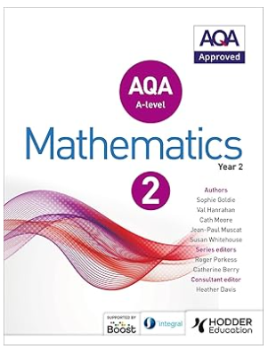
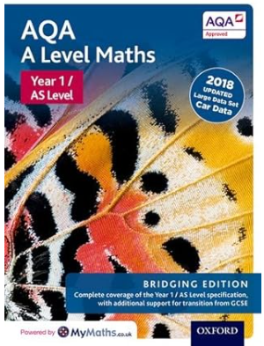

ISBN: 978-0-19-843642-3 ISBN: 9781471852893

Search for more resources using the library catalogue: Library Catalogue



GLOSSARY OF TERMS

A Glossary of Terms for Advanced Level Mathematics is available on INTEGRAL Maths which all students will be given access to during their first weeks in college. Please use it to learn & understand the key technical terms used in Mathematics and then use the correct technical terms when answering questions.

The following tasks for teacher A and B should be completed each week in addition to the set work by the teacher. This will be checked regularly for completion.
INDEPENDENT LEARNING

TEACHER A
Week | Syllabus Reference |  | Task 1 | Task 2
1 | B3,5 | Quadratics 1 | AQA AS Pure: Test Q1 | Integral
2 | B3 | Quadratics 2 | AQA AS Pure: Test Q2 | Integral
3 | B4,5 | Simultaneuous Equns and Inequalities | AQA AS Pure: Test E1 | Integral
4 | B3 | Quadratics 3 | AQA AS Pure: Test E2 | Integral
5 | A1 | Proof | AQA AS Pure: Test PS2 | Integral
6 | B7 | Proportional Reasoning
7 | B9 | Transformations | AQA AS Pure: Test G1 | Integral | AQA AS Pure: Test G2 | Integral
8 | E1 | FA1 and Sine and Cosine Rules | AQA AS Pure: Test T3 | Integral
9 | E1 | DIRT and Sine and Cosine Rules
10 | G1,3 | Differentiation 1 | AQA AS Pure: Test D1 | Integral
11 | G2 | Differentiation 2 | AQA AS Pure: Test D2 | Integral
12 | G1 | Differentiation: 1st Principles | AQA AS Pure: Test D3 | Integral | AQA AS Pure: Test D4 | Integral
13 | H1,2 | Integration 1 | AQA AS Pure: Test I1 | Integral
14 | FA Prep
15 | H3 | FA2 & Integration 2 | AQA AS Pure: Test I2 | Integral
16 | H3 | Integration 3 | AQA AS Pure: Test I3 | Integral
17 | K1, L1,3 | Single Variable Data | AQA AS Stats: Test D2 | Integral
18 | L2 | Data Presentation
19 | L2,4 | Bi-variate Data | AQA AS Stats: Test D3 | Integral
20 | M1 | Probability | AQA AS Stats: Test P1 | Integral | AQA AS Stats: Test P2 | Integral
21 | N1 | FA3 & Binomial Distribution | AQA AS Stats: Test B1 | Integral
22 | O1 | Hypothesis Testing | AQA AS Stats: Test H1 | Integral
23 | O2 | Hypothesis Testing 2 | AQA AS Stats: Test H2 | Integral
24 | E1,3 | Trigonometry 1 | AQA AS Pure: Test T1 | Integral
25 | E5,7 | Trigonometry 2 | AQA AS Pure: Test T2 | Integral
26 | F1,4 | Logarithms 1 | AQA AS Pure: Test L1 | Integral
27 | F5 | FA3 &Logs and Exponential Equations | AQA AS Pure: Test L2 | Integral
28 | F1,2,3 | Graphs of Exponentials | AQA AS Pure: Test L3 | Integral
29 |  | Large Data Set
30 |  | Progression Exam Preparation
31 |  | Progression Exam Preparation
32 |  | Progression Exams – no lessons
33 | E4 | Reciprocal Trigonometric Functions | AQA Maths Pure: Test TF1 | Integral
34 | G4 | Product and Quotient Rule | AQA Maths Pure: Test D3 | Integral
35 | B10 | Partial Fractions | AQA Maths Pure: Test A3 | Integral

TEACHER B
Week | Syllabus Reference | Topic | Task 1 | Task 2
1 | B1,2 | Indices & Surds | AQA AS Pure: Test S1 | Integral | AQA AS Pure: Test S2 | Integral
2 | C1 | Coordinate Geometry: Lines | AQA AS Pure: Test C1 | Integral
3 | C2 | Coordinate Geometry: Circles | AQA AS Pure: Test C2 | Integral
4 | C2 | Coordinate Geometry: Circles and Lines
5 | C2 | Coordinate Geometry: Problem Solving
6 | D1 | Binomial Expansions | AQA AS Pure: Test B1 | Integral
7 | D1 | Binomial Expansions 2
8 | B6 | Polynomials | AQA AS Pure: Test P1 | Integral
9 | B6 | Polynomials: Factor Theorem leading to Algebraic Division | AQA AS Pure: Test P2 | Integral
10 | B6 | Polynomials Algebraic Division 2
11 | Q1,2 | Kinematics – Travel graphs: | AQA AS Mech: Test K1 | Integral
12 | Q2 | Kinematics – travel graphs: | AQA AS Mech: Test K2 | Integral
13 | Q3 | Kinematic: Constant acceleration formulae | AQA AS Mech: Test K3 | Integral
14 | Q3 | Kinematics: Constant acceleration formulae 2
15 | Q3 | Kinematics: Multi-stage problems
16 | Q4 | Kinematics: Using calculus
17 | J1,2 | Vectors | AQA AS Pure: Test V1 | Integral
18 | J3,4 | Vectors 2
19 | J3 | Vectors: Geometrical problems
20 | J5 | Kinematics: Practice/past questions
21 | R1,3 | Forces and Newton’s Laws 1 | AQA AS Mech: Test F1 | Integral
22 | R2,3 | Forces and Newton’s Laws 2 | AQA AS Mech: Test F2 | Integral
23 | R4 | Forces and Newton’s Laws 3 | AQA AS Mech: Test F3 | Integral
24 | R4
25 | R1-4 | Forces: Writing ”Fully Justified” Solutions
26 | R4 | Forces and Newton’s Laws: Resolving forces | AQA AS Mech: Test V1 | Integral
27 | R4 | Forces and Newton’s Laws: Resolving forces 2
28 |  | FA 4 MECHANICS
29 |  | FA4 DIRT FEEDBACK
30 |  | Progression Exam Revision/Prep
31 |  | Progression Exam Revision/Prep
32 |  | Progression Exams – no lessons
33 | G2,4 | Chain Rule and Differentiation of non-polynomials: | AQA Maths Pure: Test D2 | Integral
34 | E1 | Radians and Arc-length/Sector Area | AQA Maths Pure: Test T1 | Integral
35 | E2 | Small Angle Approximations and Differentiation of sin/cos from 1st principles.: | AQA Maths Pure: Test T2 | Integral

