|  |
| --- |
|  |
| **English Literature A Level** |
| **Course Handbook 2024-25** |

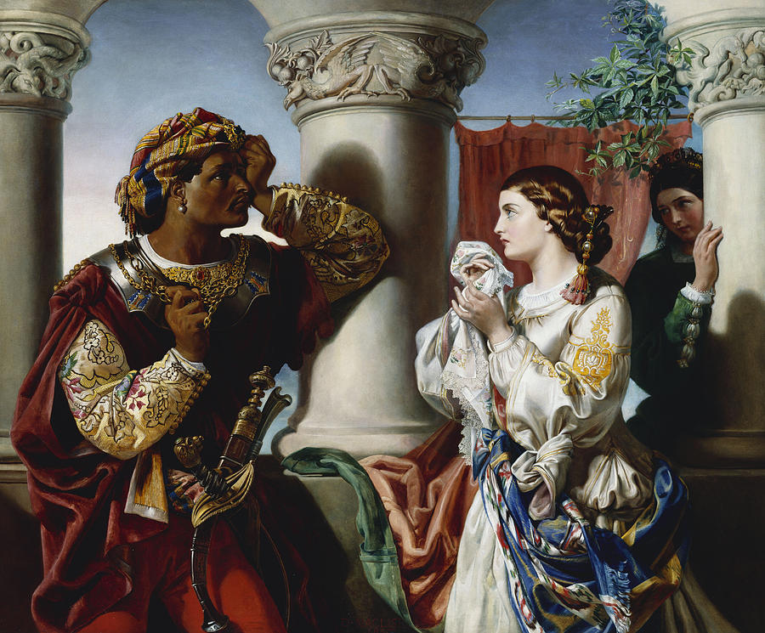

AQA – Specification B - 7717

*Aspects of Tragedy* and *Elements of Crime Writing*

[AQA | AS and A-level | English Literature B | Specification at a glance](https://www.aqa.org.uk/subjects/english/as-and-a-level/english-literature-b-7716-7717/specification-at-a-glance)

|  |
| --- |
| CONTENTS |

YOUR SUBJECT TEACHERS 3

INTRODUCTION & AIMS OF THE COURSE 4

COURSE STRUCTURE 5

YEAR PLAN OF STUDY – subject to change if necessary 11

KEY COURSE INFORMATION 24

ASSESSMENT AND FEEDBACK 25

KEY EXPECTATIONS 27

LIBRARIES FOR LEARNING 28

SUPPORT FOR YOUR STUDY SKILLS AT DCG 29

SUPPORT FOR YOUR DIGITAL SKILLS AT DCG 30

STUDENT VOICE 31

GLOSSARY OF TECHNICAL TERMS 32

ENRICHMENT AND VISITS 33

GOOD STUDY HABITS AND HOMEWORK 34

SUBJECT RESOURCES FOR STUDENTS 35

TERMINOLOGY GLOSSARY (feel free to save your own version and add to this)! 36

HOW TO WRITE THE PERFECT PARAGRAPH 41

ASSESSMENT OBJECTIVES 42

|  |
| --- |
| YOUR SUBJECT TEACHERS |

A very warm welcome from the A Level English Literature Team at Joseph Wright. This handbook is designed to give you an overview of the course and what is expected of you as a learner. It will also help you to plan your workload and knowledge of when topics alter and the texts that will be studying throughout the year.

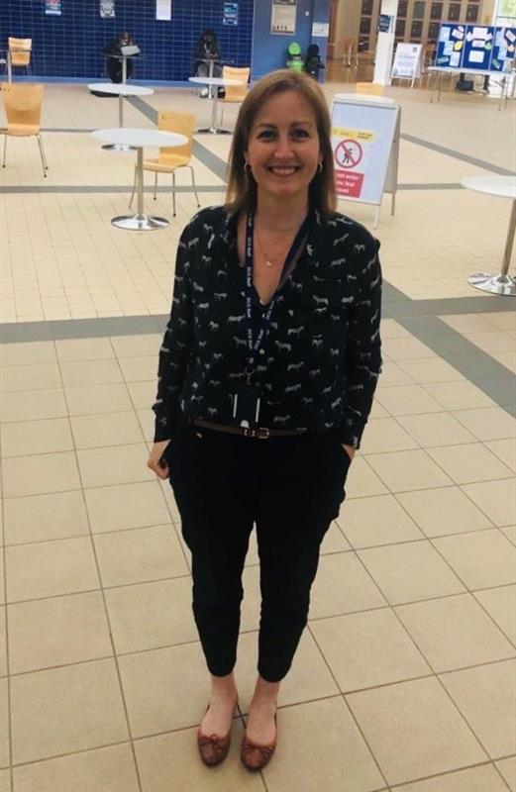

Emma Goodwin

Coordinator / teacher

Sally Archer

Curriculum Manager



Jonny Lee

Coordinator / teacher

**We are based in the Joseph Wright building. You will find us in F26 during non-teaching hours. English Literature lessons are typically in S28.**

Our contact details are:

[sally.archer@derby-college.ac.uk](mailto:sally.archer@derby-college.ac.uk)

[emma.goodwin@derby-college.ac.uk](mailto:emma.goodwin@derby-college.ac.uk)

[jonny.lee@derby-college.ac.uk](mailto:jonny.lee@derby-college.ac.uk)

You will also be able to contact us on Microsoft Teams.

You can also contact us on Teams.

|  |
| --- |
| INTRODUCTION & AIMS OF THE COURSE |

English Literature is an ideal course for anyone with a thirst for knowledge and a passion for learning. It is an academically challenging but very highly-regarded discipline for both employers and universities. A Level English Literature is delivered by a highly qualified subject specialist team with an extensive range of subject qualifications in literature.

Having an A Level in English Literature is particularly attractive for students hoping to go to Russell Group institutions and on to graduate careers across the professional spectrum. This course will require you to analyse, interpret, compare and understand a wide range of literary texts from two specific literary genres throughout time (tragedy and crime writing).

It fits particularly well with students who wish to pursue criminology, humanities, law and classics as we cover ideas from all of these areas in our curriculum. We offer a number of supra-curricular enrichment opportunities such as theatre visits, university trips and hosting guest speakers. If you have a curiosity and a flair for analysis, and are prepared to work hard, you are our ideal learner!

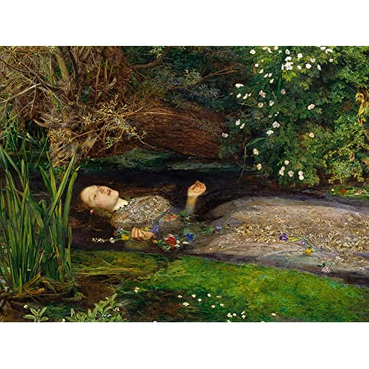

|  |
| --- |
| COURSE STRUCTURE |

We study the **AQA English Literature (specification B) A Level**. Over the two-year course, you will work towards two exam papers. You will also complete two essays for the NEA (non-exam assessment) component of the course.

**Paper 1: Literary genres**

Choice of two options – we study option 1A: Aspects of tragedy

Study of three texts: ‘Othello’; ‘Death of A Salesman’ and a selection of poetry by John Keats

**written exam: 2 hours 30 minutes**

**closed book**

75 marks

40% of A-level

Questions

* Section A: one passage-based question on set Shakespeare text (25 marks)
* Section B: one essay question on set Shakespeare text (25 marks)
* Section C: one essay question linking two texts (25 marks)

**Paper 2: Texts and genres**

Choice of two options – we study option 2A: Elements of crime writing

Study of three texts: ‘Atonement’ by Ian McEwan; ‘Brighton Rock’ by Graham Greene and a selection of poetry by Robert Browning, Oscar Wilde and George Crabbe

Examination will include an unseen passage.

**written exam: 3 hours**

**open book**

75 marks

40% of A-level

Questions

* Section A: one compulsory question on an unseen passage (25 marks)
* Section B: one essay question on set text (25 marks)
* Section C: one essay question which connects two texts (25 marks)

**Non-exam assessment: Theory and independence**

Study of two texts: one prose text of your choice and a collection of poetry (‘Amores’ by DH Lawrence) informed by study of the AQA Critical Anthology

Two essays of 1250–1500 words, each responding to a different text and linking to a different aspect of the Critical Anthology

The first essay is re-creative (you will choose a novel and write an extract that would fit in to the original text). The re-creative piece will be accompanied by a commentary.

50 marks

20% of A-level

assessed by teachers

moderated by AQA

**A (very) broad outline of the first year…**

|  |  |  |
| --- | --- | --- |
| Year 1 | **Teacher 1 (2 lessons per week)** | **Teacher 2 (1 lesson per week)** |
| Half-term 1 | **What is ‘Tragedy?**   * Introduction to features of tragedy from Aristotle onwards – tragic hero/character types/ narrative arcs etc. * The context of Othello and Shakespearean Tragedy * Introduction to advanced literary terminology * Beginning our study of “Othello”- focusing on extract response for Paper 1: Section A   Exam skills – using formal, academic and critical expression and responding to an extract | **The poetry of John Keats**  Here will explore the narrative poetry of John Keats as well as exploring the Romantic movement of the 19th Century.  This is for Paper 1: Section C (two-text question on an aspect of tragedy). The poems we will cover in depth are:   * **“La Belle Dame Sans Merci”** * **“Isabella: the pot of basil”** * **“Eve of St Agnes”** * **“Lamia” (after Christmas)**   Exam skills – using formal, academic and critical expression as well as evaluating a dramatic text through close analysis of poetic methods. |
| Half-term 2 | **‘Othello’**   * Concluding our study and understanding of the text * Writing about the wider text in essay style (Paper 1: Section B) * Exploring critical perspectives of the play for AO5 * Dramatic Methods   **Exam skills – using formal, academic and critical expression** |
| Half-term 3 | **Modern Tragic Drama – ‘Death of a Salesman’**  In this unit we will be exploring “Millerean” Tragedy and modern drama.   * Context – post-WW2 America/ Marxism and Capitalism * Tragedy and the Common Man * Links to classic/Shakesperean tragic conventions * Dramatic Methods   Exam skills – using formal, academic and critical expression as well as evaluating a dramatic text | **Continue the poetry of John Keats**   * Study ‘Lamia’ * Consolidate key themes and ideology present within Keats’ poetry * Exam skills – offer insight in relation to the tragic genre and begin to compare to ‘Death of a Salesman’   **Introduction to NEA 1 (First coursework assignment)**  **Critical Perspectives– 10% of whole course**  In this unit, we will look at a range of different critical perspectives including: Marxism, Narrative Theory, Post-colonialism and Eco-criticism. You will produce your own 750 word piece of creative writing based on an existing prose text of your choice, for example: a letter or diary entry from a character of your choice. Your choice of text cannot be one currently studied on any of the exams for Spec B. |
| Half-term 4 | **Continue ‘Death of a Salesman’**   * Consolidate knowledge of context – in particular Miller’s critique of capitalism and the American Dream * Consider characterisation and character arcs – in particular what are the journeys of Willy, Linda, Biff and Happy? What might Miller want them to represent? * Reconsider the structure of a tragic play. How can we see elements of this structure in ‘Death of a Salesman’? | **Continue NEA 1 (First coursework assignment)**  You will produce a 750-word commentary evaluating your choices, comparing their own work to the base text and evaluating both texts as deeply as possible. This is a further 750 words and should incorporate all the terminology and critical ideas that we have covered. You will be supported through this process by your teacher. |
| Half-term 5 | **Complete ‘Death of a Salesman’.**   * Consider the tragedy inherent in the climax and denouement of the play. * Revise plot – what happens when. Why?   **Revise ‘Othello’ for progression exams**   * Revise narrative and authorial intent * Consider character arcs and how characters relate to tragic ‘stock’ characters * Reconsider the plot in light of Freytag’s triangle. * Understand what exam style questions look like and how to plan and write up answers. * Revise key quotations. | **Revise ‘Death of a Salesman’ and poetry for progression exams.**   * Revise narratives and authorial intent * Make assured comparisons that link to the tragic genre. * Understand what exam style questions look like and how to plan and write up answers. * Revise key quotations. |
| Half-term 6 | **Introduction to NEA2 – feminist critical theory**   * Consider traditional representations of female writers and female characters * Consider critiques of these representations. How is a modern attitude different to that exhibited in classic texts? * Read a selection of DH Lawrence poems from ‘Amores’. * Choose three poems to concentrate on and consider how they portray femininity and the female experience. | **Introduction to unseen crime**   * Identify, understand and analyse generic conventions * Begin to consider sub genres – how to different eras and styles of crime writing differ? How might authorial intent change? * Work on annotating an unseen extract independently. Be able to pick out and analyse writers’ use of language and links to generic conventions. * Apply your knowledge of exam style analysis and writing exam style paragraphs to new texts. |

**A (very) broad outline of the second year – elements of crime writing**

**Year 2 – Elements of Crime Writing**

|  |  |  |
| --- | --- | --- |
| Year 2 | **Two lessons in the week** | **The other lesson in the week** |
| Half-term 1 | **‘Atonement’ Ian McEwan**   * Beginning our study and understanding of the text (after you have read it in the summer). * Exploring historical context (the 1930s onwards). * Exploring generic conventions – especially of plot and character. * Exam skills – using formal, academic and critical expression as well as evaluating a prose text. * Writing about the text in essay style (Paper 2: Section B) or as a two-text response (Section C). * Exploring critical perspectives of the novel for Assessment Objective 5 | **Unseen crime writing**   * Introduction to features of crime writing throughout history of literature * Exploring a range of texts from throughout the history of literature in readiness for the unseen component of Paper 2. * Be able to annotate an unseen extract independently. Be able to pick out and analyse writers’ use of language and links to generic conventions. * Exam skills – using formal, academic and critical expression when responding to crime extracts. * Apply your knowledge of exam style analysis and writing exam style paragraphs to new texts.   **NEA2**  We will also revisit NEA2:   * You will receive general feedback about your first draft. Remember that we cannot give you specific feedback. * We will revisit the texts, feminist criticism and essay skills. |
| Half-term 2 | **‘Brighton Rock’ by Graham Greene**   * Beginning our study and understanding of the text (you need to have read it before we start teaching). * Exploring historical context (the 1930s o). * Exploring generic conventions – especially of plot and character. * Exam skills – using formal, academic and critical expression as well as evaluating a prose text. * Writing about the text in essay style (Paper 2: Section B) or as a two-text response (Section C). * Exploring critical perspectives of the novel for Assessment Objective 5 * Continuation of advanced literary terminology * Begin to make links to ‘Atonement’ and the poetry. | **Victorian crime poetry – ‘My Last Duchess’ / ‘Porphyria’s Lover’ / The Laboratory (Browning)**   * Here you will explore the poems above in the context of crime. * Recap knowledge of poetic form from the study of Keats and apply to new texts. * Exam skills – using formal, academic and critical expression as well as evaluating poetic texts. Analysing texts in context. * Begin to make links between Browning’s poetry and the two novels that you have studied.   **Concluding NEA2 - final submission before Christmas Break.** |
| Half-term 3 | **The crime anthology of Victorian poems –‘The Ballad of Reading Gaol’ (Wilde) and ‘Peter Grimes’ (Crabbe)**   * Here you will explore the poems above in the context of crime. * Recap knowledge of poetic form from the study of Keats and – especially - Browning and apply to new texts. * Exam skills – using formal, academic and critical expression as well as evaluating poetic texts. Analysing texts in context. * Make thorough links between the poetry anthology and the two novels that you have studied. | **Unseen crime/exam prep**   * Exploring a range of texts from throughout the history of literature in readiness for the unseen component of Paper 2. * Be able to annotate an unseen extract independently. Be able to identify and analyse writers’ use of language and links to generic conventions. * Exam skills – using formal, academic and critical expression when responding to crime extracts. * Apply your knowledge of exam style analysis and writing exam style paragraphs to new texts. |
| Half-term 4 | **Revision of Paper 1 – Tragedy – ‘Othello’**   * Understand and be able to analyse generic conventions. Link to texts. * Re-evaluate the plot and characterisation of ‘Othello’ in light of your knowledge of generic conventions. * Revisit the context of Aristotelian and Shakespearean tragedy. * Consolidate your own interpretation of ‘Othello’. Link to critical perspectives. * Practise key exam skills such as annotation and planning answers. * Practise writing GELATIC paragraphs under time pressure. | **Revision paper 2 crime**   * Understand and be able to analyse generic conventions. Link to texts. * Re-evaluate the plot and characterisation of the set texts in light of your knowledge of generic conventions. * Consistently make links between the set texts. * Revisit contexts – making sure to link them to crime and authorial intent. * Consolidate your own interpretation of the set texts. Link to critical perspectives. * Practise key exam skills such as annotation and planning answers. * Practise writing GELATIC paragraphs under time pressure. |
| Half-term 5 | **Revision of Paper 1 – Tragedy – ‘Death of a Salesman’ and poetry anthology**   * Understand and be able to analyse generic conventions. Link to texts. * Re-evaluate narratives, themes and characterisation in the poems in light of your knowledge of generic conventions. * Revisit poetic form and structure and how they can be used to elevate tragedy. * Consolidate your own interpretation of the texts. Link to critical perspectives. * Practise key exam skills such as annotation and planning answers. * Practise writing GELATIC paragraphs under time pressure.   Exam dates:  Paper 1 Wednesday the 14th of May 2025 Paper 2 Thursday the 22nd of May 2025 | **Revision paper 2 crime – unseen crime**   * Explore a range of texts independently. * Be able to annotate an unseen extract quickly. Be able to identify linguistic techniques and analyse writers’ use of language. Consistently make links to generic conventions. * Exam skills – using formal, academic and critical expression when responding to crime extracts. * Apply your knowledge of exam style analysis and writing exam style (GELATIC) paragraphs to new texts.   Exam dates:  Paper 1 Wednesday the 14th of May 2025 Paper 2 Thursday the 22nd of May 2025 |

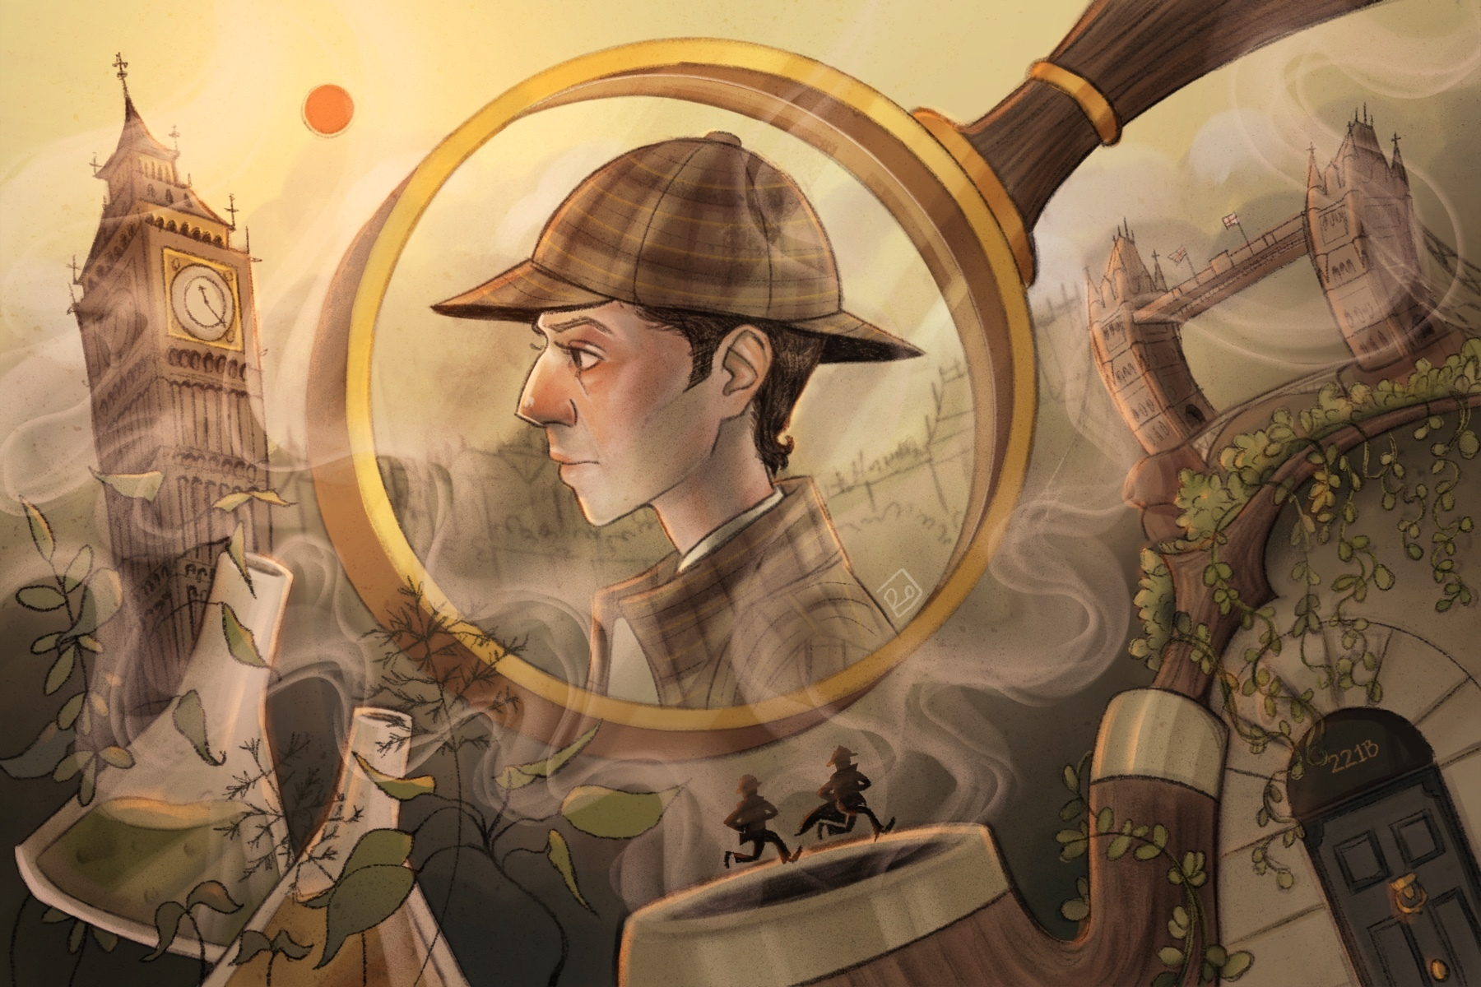

|  |
| --- |
| YEAR PLAN OF STUDY – subject to change if necessary |

|  |  |  |
| --- | --- | --- |
| Week Beginning | Teacher 1 Topic  Year 1 in black  Year 2 in blue | Teacher 2 Topic  Year 1 in black  Year 2 in blue |
| 1  09/09/24 | * Induction - bridging work on tragedy. ‘Othello’ text to be purchased if not already. * What is a genre? Discuss and exemplify. * Aspects of Tragedy: theory and terminology.        * Atonement – introduction to novel study, Check understanding and go through context. * Familiarity with crime fiction: * Gain a broad understanding of the genre of crime fiction. Explore the characteristics, conventions presented within the novel. | * Introduction to Keats and romantic poetry. * Consider context of enlightenment/romantic era ideologies. Understand poetic forms – epistles, odes, sonnets, ballads, negative capability * Begin to read ‘La Belle Dame Sans Merci’ and consider the character of the knight. How is he presented as a tragic figure? * Recap what is a genre? Can you distinguish between different genres? Which writers (especially those studied on our course) can we attach to tragedy/crime? * What are genre conventions of crime? * Implementation of key terminology – crime conventions – AQA subject specification * Begin introduction to crime booklet     NEA2 hand in |
| 2  16/09/24 | * *Introduction to Othello* * Class reading of Othello/group discussion/work and individual written tasks on Act 1 (read the first half).. * Discussion of tragic terms. * Note-taking on tragic theory.   Year 1 Initial assessment task.       * Consolidate understanding of context – in particular interwar Britain and shifting social dynamics. * Go through part 1 of *Atonement*. Discuss characterisation and generic concepts. | * Finish reading ‘La Belle Dame Sans Merci’ Class reading/discussion. * Begin Isabella. Consider the presentation of Lorenzo. * Continue to develop knowledge of romantic tropes.        * Work through introduction to crime booklet * Consider sub genres and generic conventions (in particular characterisation) * Recap and write GELATIC paragraph |
| 3  23/09/24 | * Class reading of ‘Othello’ * Explore tragic terminology and conventions – tie in to what we have read so far. * Compare classical tragedy to Shakespearean tragedy * Understand components within a GELATIC paragraph.        * Finish/recap part 1 of *Atonement*. Discuss characterisation and generic conventions. * Watch the opening of the film. * Study exposition –  and central characters. Consider symbolism. Link back to context. | * Continue to read through ‘Isabella’ and explore the plot * Consider tragic elements within the poem.              * Feedback on first draft of NEA2. |
| 4  30/09/24 | * Class reading of ‘Othello’ * Recap knowledge of tragic conventions * Consider significance of the setting of Venice * Explore renaissance theory and historical context.        * Analyse the novel’s complex narrative structure * Focus on childhood and innocence and juxtaposition with crime conventions. * Begin film adaptation | * Continue to read ‘Isabella’ * Consider social, historical and political influence of the regency era * Link to how language impacts meaning      * Introduction to extract analysis. * Discuss importance of annotation and practise. * Pick out techniques used by writer and analyse |
| 5  07/10/24 | * Class reading of Othello * Discuss and practise how to approach an extract question * Write GELATIC paragraphs * Reconsider social and historical context in part 1 of ‘Atonement.’ Link to genre and specific extracts. | * Explore alternative interpretations of Isabella * How does Keats’ poetry consider and frame tragic conventions?      Year 2 FA1- unseen crime extract |
| 6  14/10/24 | * Class reading of Othello * Recap literary terms * Identify and analyse Shakespeare’s use of dramatic methods.      * Reconsider setting * Emily Tallis/Robbie Turner See booklet as provided for detailed activities. * Homework – read Stretch and Challenge article in booklet on the Tallis House * Continue to watch adaptation, comparing with the novel. | * Finish ‘Isabella’; recap plot and characterisation * GELATIC paragraph/s on key aspects of the poem      * Consider the importance of setting in crime fiction. * Dissect the setting in an extract. Link to generic conventions. |
| 7  21/10/24 | * Class reading of Othello * Teacher to model essay skills in preparation for formal assessment (to be completed during the next working week)      * Continue to discuss crime conventions in ‘Atonement * Consider the impact of war on civilians – a crime against humanity. Discuss consequences of war on narrative and elements of crime found within the novel | * Discussion/Q+A * Short extracts for written analysis Modelled annotation      * Feedback and follow up tasks based on FA1 – unseen crime extract.       . |

|  |  |  |
| --- | --- | --- |
| OCTOBER HALF TERM | | |
| 8  04/11/24 | * Continue reading – we will be up to Act 3. * Class reading of Othello/group discussion/work and individual written tasks on Act 3. * Year 1 Assessment 1 – whole text question (section B on exam paper 1) * Analyse the novel’s complex narrative structure which includes multiple perspectives and time shifts * Explore this structure and unreliable narration in relation to impact on the reader * Create posters on key themes   Deception/Appearance    Guilt/Innocence    Justice and the Law    Remorse/Shame    Confession/Punishment     Revenge/Anger    Responsibilty/Evasion   * Finish off novel | * TEOSA (‘The Eve of St Agnes’)– * Research tasks- opportunity to make a wide range of links between context and texts studied so far. Link back to the Gothic genre. * Coursework lesson – NEA2 |
| 9  11/11/24 | * Consolidate knowledge of Act 3 * Compare story of ‘Othello’ with original story. Evaluate tragic elements. Continue to analyse tragic concepts and terminology.     Recap genre conventions.  Go through the plot of ‘Brighton Rock’  Make links between ‘Atonement’ and ‘Brighton Rock.’ Analysing use of:   * Narrative structure * Narrative theory * Literary devices * Language forms   Begin to explore characterisation | * Start reading TEOSA * Discussion/Q+A * Section B style question – approaches, structure, overview of characters and key themes     In preparation for crime poetry, explore the social, cultural and historical aspects of the Victorian era. Including crime, societal norms, gender roles and the influence of the Industrial revolution. |
| 10  18/11/24 | * Class reading of Othello * Feedback and reflection on your assessment. Consider your approach to the different assessment objectives. * Discuss thesis statements and how to use effectively when writing essays. * Explore the context of ‘Brighton Rock’ * Consider social class, the concept of a criminal underworld and Britain in the 1930s * Discuss the opening of the novel. How and why does Greene create an immediate sense of tension/suspense? | * Continue TEOSA * Discussion/Q+A * Section B style question – approaches, structure, overview of characters and key themes.   My Last Duchess. Read, annotate and link to crime writing conventions     * Setting * Gender * Class * Antagonist * Paranoia |
| 11  25/11/24 | * Class reading of Othello * How to critical approaches help us to inform alternative ideas about the texts? * Construct GELATIC paragraph/s     Year 2 Assessment 2 – ‘Atonement’ essay   * ‘Brighton Rock’ – discuss the importance of setting. * Consider the corruption that runs throughout the novel and how this is linked to places/locations. * Link to conventions of the crime genre. | * Continue TEOSA * Discussion/Q+A * Continue to discuss/analyse tragic conventions   Read Porphyria’s Lover, setting, mood, key themes, criminal psyche with activities on PPT and in handbook |
| 12  02/12/24 | * Class reading of Othello – Act 5 * Consider authorial intent – what is Shakespeare trying to achieve? Why? * Recall and apply knowledge of literary devices. * Complete character profiles * Consider how characters correspond with key roles within crime fiction | * Complete TEOSA * Recap plot and characterisation * What are the key tragic elements?     Coursework lesson – NEA2 |
| 13  09/12/24 | * Class reading of Othello * Develop awareness of alternative interpretations * Keep linking back to tragic conventions   Year 2 Assessment reflection. Engage with feedback and improve aspects of your essay.   * Brighton Rock – Consider and evaluate crimes committed within the novel * Reconsider the structure of the novel. How is it typical of crime fiction. What is unusual? Why? | * Recap of three poems studied so far. * Develop points of comparison and link to the tragic genre.      Read and annotate ‘The Laboratory’ – power of the rich to evade justice, corruption, booklet pages completed for all of Browning, context recapped including his own life/concerns. |
| 14  16/12/24 | * Class reading of Othello/group discussion/work and individual written tasks on Act 5. * Consolidate knowledge of ‘Othello’ and the tragic genre * Recap and evaluate links to crime within ‘Brighton Rock.’ Make revision posters. * Go through possible exam questions. Recap and write GELATIC paragraphs – consider targets from FA2. | * Prepare for assessment on the first week back. * Recap, analyse and write GELATIC paragraphs * Comparison of all three Browning poems using CRIMES mnemonic * Recap any aspects of the poems that are unclear |
| CHRISTMAS HOLIDAYS | | |
| 15  06/01/25 | * Review ‘Othello’ as a whole: tragic trajectory, conventions, plotting character development. * TBORG pre-reading activities, Victorian penal system, Wilde’s trial and sentence – dehumanisation, cruelty, society’s flaws, indecency laws etc. * Read part 1 and 2 with guided annotations, questions in handbook to support * Go through revision for mock exam (week commencing 29th of January) | Year 1 Assessment 2 - Keats   * Return to unseen crime. Use booklets for extracts/knowledge/skills * Consider the timeline of crime sub genres * In groups, annotate and evaluate short extracts – consider which features of sub genres are present |
| 16  13/01/25 | * Introduction to Arthur Miller and the Tragic Genre * Begin with an overview of Arthur Miller's life and his influence on American drama. Discuss his motivations for writing ‘Death of a Salesman’ * Begin to read the play. Explore the concept of the tragic hero and its characteristics. Introduce the central character, Willy Loman, and analyse his traits in relation to the tragic hero archetype. * TBORG – continuation -religious imagery, danse macabre, horror. * Read part 3- end  with guided annotations, questions in handbook to support – students to answer big question: “How does Wilde create sympathy for criminals in this poem, and why?” | * Begin ‘Lamia’ * What are your first impressions of Lamia? Table of ideas. How does * Keats present Lamia’s transformation? * Unseen Crime– In Cold Blood, guided reading, group response * Marking of exemplar essay in book on Ziggy cam – conventions of literary non fiction (extracts available in booklet) |
| 17  20/01/25 | * Examine the historical and social context of the play, particularly the American Dream. Discuss how the American Dream relates to the tragic themes in the play. * Continue reading through the play. Begin watching a performance. * Discuss first impressions of the play. Make links with other tragic texts in order to develop understanding of the tragic genre. * Pre-reading activities for ‘Peter Grimes’ - regency era, pastoralism, antipastoralism, Augustan era poetry, operatic tragedies * Begin to read ‘Peter Grimes’ and link to crime conventions. | Year 1 assessment 2 feedback – reflect, evaluate and rewrite.   * Unseen Crime – Agatha Christie and Whodunnits – the Golden Age, group responses to Christie extract – The Mousetrap – dramatic methods. * Use exemplar to discuss method of response / structure |
| 18  27/01/25 | * Dive deep into the characterisation of Willy Loman. Analyse his dreams, flaws, and the conflicts he faces. Discuss how his character aligns with the tragic downfall pattern. Consider his hamartia and fatal flaw. * Introduce Linda Loman and her role in the tragedy. Explore her loyalty to Willy and the sacrifices she makes. * Year 2 mock exam paper 2 (plus revision) | * Lamia’ – key themes and symbols so far. * Emerging tragic aspects in Part 1. Individual analysis tasks. * Poirot extract  – Agatha Christie and the mysterious affair at Styles, (in handbook) each group focuses on a different aspect of crime writing, writes a perfect GELATIC paragraph   . |
| 19  03/02/25 | * Shift focus to Biff and Happy Loman. Analyse their characters, their dreams, and their roles in the overall tragedy. Discuss their impact on Willy's journey. * Recap links with poetry. Explore how to write exam paragraphs for two texts questions * Continued close reading and analysis of Peter Grimes. Finish reading text. Focus on sympathy for victims, class, suffering, morality. * Link back to context. Consider the significance of setting and characterisation. | * Finish reading and annotation ‘Lamia’ * Consider the structure of the poem and make links to tragic conventions. * Origins of the detective -read academic article in handbook on “The Moonstone”, typical and atypical detectives throughout crime lesson -  flipped learning, students select one detective  text from list and produce presentations for whole class (homework) * Stretch – Todorov’s article in handbook, read and pick out key ideas. |
| 20  10/02/25 | * Explore the dramatic structure of the play. Discuss Miller's use of flashbacks and the non-linear narrative. Analyse how this structure contributes to the tragic impact. * Discuss the symbolism in the play, such as the seeds and the flute. Examine how these symbols enhance the tragic elements and themes. * Summarise and compare all of the poetry anthology. Concentrate on elements of crime. * Link to past questions, including mock exam and assemble revision plans/guides. | * Consider tragic elements in all 4 Keats poems – make lists/mind maps. Consider characterisation, setting and themes.      * Noir and neo-noir. Students learn about post WW2 hardboiled fiction with key examples, read the Carver/Galbraith extract in handbook and annotate for key features. * Consider the development from noir to neo-noir. Typical features of modern crime – homework, respond to “Force of Nature” exam question in handbook, peer assess following lesson after 1.2 term |
| FEBRUARY HALF TERM | | |
| 21  24/02/25 | Year 1 Assessment 3 - ‘Death of a Salesman’ and Keats   * Analyse the conflicts within the Loman family and their contribution to the tragic outcome. Discuss the tension between personal desires and societal expectations. Use this to revise context * Return to exam style (GELATIC) paragraphs and develop analytical skills. * Year 2 feedback on mock exam, reflection evaluation and rewriting * Go through revision for upcoming poetry assessment | * Begin booklet on narrative theory. Consider the elements inherent in a novel * Explore different story types * Explore favourite texts and choose a novel to use for NEA1      * Revise crime poetry. Discuss what all of the poems have in common and also what is unique about the poems * Use exam questions to consider which poems/aspects of poems to focus on for each topic. * Add to quotation banks |
| 22  03/03/25 | * Explore the theme of the American Dream in-depth. Discuss its various interpretations and how it leads to Willy's downfall. * Analyse the motif of abandonment in the play, focusing on Willy's feelings of abandonment by his sons and his own actions that contribute to this theme. * Paper 1 Revision, DOAS whole text summary and focus on Acts 1 and 2. * Filling gaps in Y1 handbook where needed. | * Use the NEA1 booklet to go through structure, beginnings, endings and time * Continue to link back to your own experiences of novels/films * Revise crime poetry. * Practise essay skills. Critique model paragraphs/answers * Quickfire planning. This will inform revision * Retrieval practice for key quotations. |
| 23  10/03/25 | Year 1 assessment feedback   * Examine the motif of disillusionment and the characters' gradual realization of their own limitations. Discuss how this motif is central to the tragic narrative. * Make links to Keats in preparation for assessment first lesson back. * Paper 1 Revision, DOAS Requiem * Also Key themes and ideas/major and minor characters. * Filling gaps in Y1 handbook where needed. | * Use the NEA1 booklet to go through setting, narrators and characterisation * Continue to link back to your own experiences of novels/films   Year 2 assessment – crime poetry question |
| 24  17/03/25 | * Finish reading the play * Introduce critical perspectives on the play, including feminist and Marxist interpretations. Engage in critical discussions. * Discuss the play's impact on American theatre and its enduring relevance in contemporary society. * Revise Keats poetry – key themes, quotations and links to tragic conventions * Fill in gaps in the handbook where necessary | * Use the NEA1 booklet to go through character types and narrative gaps * Continue to link back to your own experiences of novels/films * Look at examples of other NEA1s and critique * Student led lesson on key aspects of unseen crime to study/revise. * By the end of the lesson, students should feel confident about annotating and structuring essays. Peer and teacher support will enable this. |
| 25  24/03/25 | * Create revision resources about characterisation, plot and tragic elements. * Review key concepts, characters, and themes from the play. Present your own interpretation of these. Link back to the tragic genre. * Revisit resources on comparing DOAS and Keats. Concentrate on tragic elements * Revise essay planning – especially thesis statements and GELATIC paragraphs. * Take away a question to plan and write up over Easter. | * Begin writing NEA1 narrative gap. Your teacher will discuss deadlines and further support later in the year.   Year 2 assessment feedback, evaluation, rewriting.  Plan revision for Easter. Complete a self-audit of knowledge for paper 2 (crime) |
| 26  31/03/25 | Preparation for assessment – recap annotation, GELATIC paragraphs and tragic conventions.  Year 1 Assessment 4 – ‘Othello’ extract question     * Paper 1 Revision, Othello, key themes and context * Filling gaps in Y1 handbook where needed.  Recap of main characters, plot, theme etc as well as Shakespearean tragic conventions | * Recap LBDSM and Isabella. Consider narrative, key quotations and tragic elements * Crime revision. Student choice for focus of lesson. * Crime conventions explored. Consider writers’ foregrounding of particular elements. * Essay plans and constructing GELATIC paragraphs vital.   Set yourself independent tasks to complete at home. |
| EASTER HOLIDAY | | |
| 27  21/04/25 | * Finish/recap DOAS if necessary. * Return to Act 1 of ‘Othello’ – recap plot and analyse beginning of tragic trajectory      * Paper 1 Revision, Othello, key themes and context- -Act 1 * Filling gaps in Y1 handbook where needed.  Recap of Act 1, Venice – skill, unseen approach (use 2022 paper) | * Recap TEOSA and Lamia. Consider narrative, key quotations and tragic elements      * Crime revision. Student choice for focus of lesson. * Crime conventions explored. Consider writers’ foregrounding of particular elements. * Essay plans and constructing GELATIC paragraphs vital. * Set yourself independent tasks to complete at home. |
| 28  28/04/25 | Year 1 assessment 4 - feedback, evaluation, rewriting   * Return to Act 2 of ‘Othello’ – recap plot and analyse tragic trajectory * Annotate another extract. Write intro, GELATIC paragraph and conclusion. Evaluate. * Paper 1 Revision, Othello, key themes and context- -Act 2 * Filling gaps in Y1 handbook where needed – skill, Section A unseen approach (use Iago soliloquy paper) | * DOAS - Tragic themes in DOS-small groups create A3 poster-carousel activity. * Crime revision. Student choice for focus of lesson. * Crime conventions explored. Consider writers’ foregrounding of particular elements. * Essay plans and constructing GELATIC paragraphs vital. * Set yourself independent tasks to complete at home. |
| 29  05/05/25 | * Return to Act 3 of ‘Othello’ – recap plot and analyse tragic trajectory * Return to whole text question. Consider past questions and thesis statements * Paper 1 Revision, Othello, key themes and context- -Act 3 and 4 * Filling gaps in Y1 handbook where needed – skill, Section B essay approach using theme map and past questions | * With teacher guidance, make links to Keats poetry. Use past exam questions to decide on key topics to compare. * Crime revision. Student choice for focus of lesson. * Crime conventions explored. Consider writers’ foregrounding of particular elements. * Essay plans and constructing GELATIC paragraphs vital. * Set yourself independent tasks to complete at home. |
| 30  12/05/25 | * Return to Act 4 of ‘Othello’ – recap plot and analyse tragic trajectory * Return to whole text question. Construct an essay plan and chose paragraphs to write up. Peer evaluate.    Exam paper 1 – Wednesday 14th May | * Paper 1 Section C. Preparation for progression exams. Decoding the question. * Write up question for homework             Exam paper 1 – Wednesday 14th May |
| 31  19/05/25 | * Return to Act 5 of ‘Othello’ – recap plot and analyse tragic trajectory * Othello revision – Paper 1 Section A and B * Set revision schedule for half term holiday.      Exam paper 2 – Thursday 22nd May | * Paper 1 Section C. Preparation for progression exams. Decoding the question. * Peer mark questions completed for homework. * Set revision schedule for half term holiday.      Exam paper 2 – Thursday 22nd May |
| MAY HALF TERM | | |
| 32  02/06/25 | Year 1 progression exams    Exam paper 2 – Wednesday 5th June. No more Year 2 lessons after this date. | Year 1 progression exams  Exam paper 2 – Wednesday 5th June. No more Year 2 lessons after this date. |
| 33  09/06/25 | * Introduce feminist criticism. Explore historical context and prominent figures/ideas. * Explore a feminist critique of traditional literature – link to your own engagement with literature/films | * Preparation for Yr 2 – looking at the genre of Crime. Use introduction to crime booklets * Discuss your experiences of crime fiction/films * Assessmble list of generic conventions – use ‘The Hound of the Baskervilles’ extract to help. |
| 34  16/06/25 | Progression  exams – reflection, evaluation and rewriting paragraphs   * Introduce poetry. Explore and analyse content, themes and authorial intention. | * Explore characterisation within crime. Use famous examples to help. * Consider gender roles within crime fiction and how these have changed over time. * Use extracts to inform analysis. Revisit key annotation strategies. |
| 35  23/06/25 | * Continue exploration of poetry. Begin to link to feminist theory * Decide on a title for NEA 2. Make notes linking relevant texts to feminist theory. | * Look at narrative structure in crime fiction (link back to narrative theory in NEA1) * Consider alternative narrative structures using the booklet * Using a film clip, test your ability to spot crime conventions |
| 36  30/06/25 | * Finish off reading of poetry and recap themes/authorial intent as necessary. * Create a plan for NEA2 essay. | * Revisit expectations for summer study and year 2 * Creative writing (crime) and analysis. |
|  |  |  |

|  |
| --- |
| KEY COURSE INFORMATION |

|  |  |
| --- | --- |
| **Start Date** | 11th September |
| **End Date** | 4th July 2025 (End of Year 1)  22nd May 2025 (End of Year 2 – exam for paper 2) |
| **Level of course** | Level 3 |
| **Awarding Body** | AQA |
| **Specification** | [AQA | AS and A-level | English Literature B | Specification at a glance](https://www.aqa.org.uk/subjects/english/as-and-a-level/english-literature-b-7716-7717/specification-at-a-glance) |
| **Length of Study** | 5 hours per week in Year 1  5 hours per week in Year 2 |
| **Your classrooms** | S27 |
| **Key skills you will be developing during the course to be successful** | Analysis, evaluation, comparison, world issues, inclusivity, morals and ethics, contextualisation and many more. |
| **What will lessons look like?** | A range of discussion  Annotations of text  Regular group and paired work  Modelled answers and improvement |
| **Informal Assessment Methods** | Regular written and verbal feedback  Use of technology for feedback |
| **Essential Equipment/ Resources** | Subject folder  Set texts (students need to buy their own copies)  Optional textbooks  Pens and paper |
| **Health and Safety** | Responsible classroom conduct |

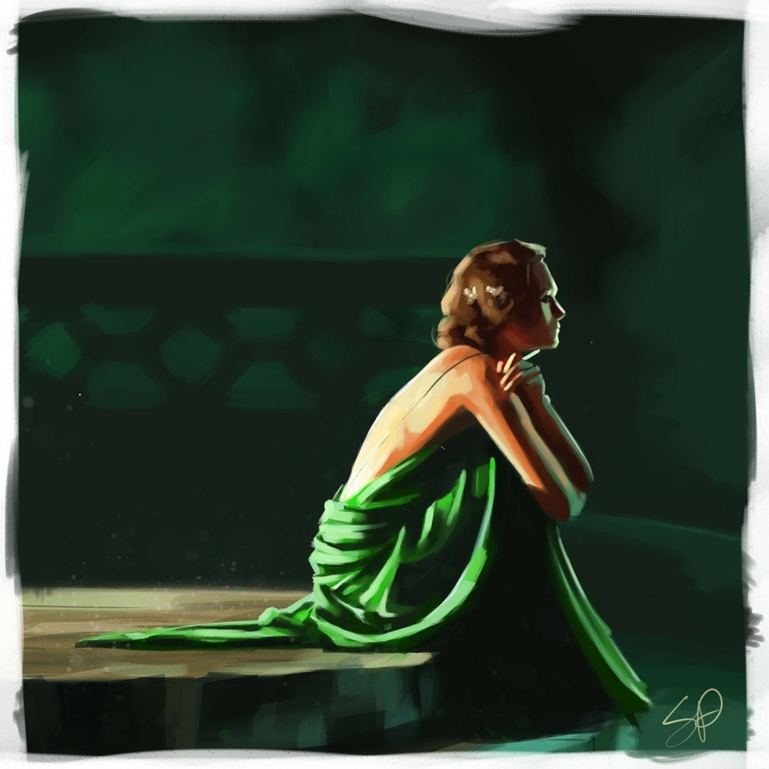

|  |
| --- |
| ASSESSMENT AND FEEDBACK |

**Dates of assessments:**

|  |  |  |  |
| --- | --- | --- | --- |
| **Teaching Week** | **W/C** | **Year 1** | **Year 2** |
| 3 | 23/09/2024 | Diagnostic task |  |
| 5 | 07/10/2024 |  | **Assess 1** |
| 8 | 04/11/2024 | **Assess 1** |  |
| 11 | 25/11/2024 |  | **Assess 2** |
| 15 | 06/01/2025 | **Assess 2** |  |
| 18 | 27/01/2025 |  | **Assess 3 (MOCK EXAM WEEK)** |
| 21 | 24/02/2025 | **Assess 3** |  |
| 23 | 10/03/2025 |  | **Assess 4** |
| 27 | 21/04/2025 | **Assess 4** |  |
| 30 | 12/05/2025 |  | Final paper 1 |
| 31 | 19/05/2025 |  | Final paper 2 |
| 32 | 02/06/2025 | **Progression Exams** |  |

**Assessment and Feedback**

* Your work will be returned within 15 working days. You will then complete a DIRT (dedicated improvement and reflection time) task in which you take the time to work through your feedback and improve the quality of your assessment.
* After every assessment, you will set developmental, actionable target goals on ProMonitor. It is vital that you come back to these targets throughout the year.
* As you probably know, A Level work is ultimately graded using grades A* to E.

**Academic Malpractice**

DCG is keen to support students and avoid any cases of Academic malpractice. Awarding Organisations take matters of academic malpractice very seriously and require all schools and colleges to have specific policies and procedures in place to both educate staff and students about malpractice, thus deterring them from committing it, whether intentional or not, and report and investigate any suspected malpractice where it may occur.

While we don’t want to see anyone jeopardise their grades or marks, we must ensure the validity of all qualifications and we must investigate any suspected breaches fully. It is your responsibility to ensure you understand the rules and boundaries:

* You must not copy from someone else or give opportunities to another student to copy from you.
* Any wording taken from a published source must be correctly referenced for example:

(Morrison, 2000, p29).

* Where computer-generated content has been used (AI tools such as ChatGPT) you must reference these correctly for example: ChatGPT 3.0 (https://openai.com/blog/chatgpt/), 25/01/2024.
* You may also be required to include a bibliography to support referencing.
* You must also avoid working collaboratively with other students beyond what is permitted as this may be deemed to be collusion.

Other examples include:

* Falsification or fabrication of results,
* Deliberate destruction of other student’s work
* Any other act that will give you an unfair advantage. This also relates to not following clear guidance in examinations or assessments where examination conditions exist.

You will be required to complete an Authentication Form on submission of any and all assignments/NEA projects. This will confirm that the work is your own, and that it is referenced appropriately, including the use of AI. Where academic malpractice is suspected, this will be reported to your Team Manager who will conduct an investigation and, where relevant, the Awarding Organisation may also be informed and investigate further. Where malpractice is discovered to have occurred, sanctions may be imposed which could include:

* Zero marks for the work or exam.
* Disqualification from the qualification.
* Disqualification from taking any qualification with that Awarding Organisation often over a set period of time.
* Warnings which can last several years.

For further details and to fully familiarise yourself with JCQ guidance please see the Joint Councils for Qualifications (JCQ) website:

[Information for candidates documents - JCQ Joint Council for Qualifications](https://www.jcq.org.uk/exams-office/information-for-candidates-documents)

Further information can be found on the DCG website:

[Examination Information - DCG (derby-college.ac.uk)](https://www.derby-college.ac.uk/student-support/examination-information/)

**Appeals Procedures**

Each Awarding Organisation will have slightly different processes for appealing decisions. Appeals can be made where:

* You believe that the awarding body policies and procedures have not been followed correctly in respect of external quality assurance/standards verification (policies and procedures can be found on the relevant awarding body website).
* You believe that the awarding body policies and procedures have not been followed correctly in respect of qualification decisions (policies and procedures can be found on the relevant awarding body website).
* You disagree with the outcome of your internal appeals procedure (for example, a decision in relation to reasonable adjustments or assessment outcomes).

However, should you, as a student wish to appeal, firstly:

* Contact your lecturer/trainer/assessor and discuss your concerns.

If you are still not satisfied with the outcome, the College would usually make an appeals application on your behalf. This would require your consent. It is possible to apply directly to the Awarding Organisation but only once the College’s internal processes have been followed. At this point you would be informed of the next stages and Awarding Organisation communication link. This is time bound and this will also be communicated to you once the internal appeals process has taken place.

Note: you must be aware that through this process the initial grade can go up, stay the same, or go down.

|  |
| --- |
| KEY EXPECTATIONS |

The 5Ps and College code of conduct.

To be successful at Derby College you will be expected to be:

* Positive
* Polite
* Punctual
* Prepared, and
* Professional in your approach.

Please pay attention to the code of conduct, you will be asked to sign a copy to promise you will abide by the College guidelines: [Code of Conduct (sharepoint.com)](https://studentderbycollegeac.sharepoint.com/sites/StudentHandbook/SitePages/Code-of-Conduct.aspx)

**Derby College has a zero tolerance approach to all forms of bullying, harassment and abuse both online and face-to-face.** [Statement on Sexual Harassment, Bullying and Online Abuse (sharepoint.com)](https://studentderbycollegeac.sharepoint.com/sites/StudentHandbook/SitePages/Statement-on-Bullying.aspx)

If you or anyone else is being bullied, harassed or abused – or if you become aware of discriminatory behaviour or actions taking place – you are encouraged to report this by contacting either your course tutor or <https://studentderbycollegeac.sharepoint.com/sites/Welfare/SitePages/Chat-to-a-Welfare-Officer.aspx> or call our confidential **BULLYING HELPLINE** on **01332 387499.**

What all students can expect from Derby College Group:

* We will listen to you and take your concern seriously and deal with it in a sensitive manner.
* We will give you support and involve you in any decision that affects you.
* We will take disciplinary action against any student who has harmed you and/or breached the college Code of Conduct.

|  |
| --- |
| LIBRARIES FOR LEARNING |

**Make your life easier!**

To make a real success at Derby College visit the library. Bring your existing skills and the Libraries for Learning team will help you do the rest.  Use the private study space to work on your assignments whilst making use of the extensive resources. There is IT help available to improve your skills to present your work with a professional finish and IT kit (laptops and PCs) for you to use on-site and then, print your work in the Library at no cost to you using your student print allowance.

**Get the help you need!**

Come into the Library or use the resources online and ask any one of our friendly team members for help.  All the Libraries for Learning Team are skilled researchers willing to help you find the information you need and guide you to resources you might not have considered to help you finish those assignments.  On the rare occasions that the library does not have exactly what you want, they will do their best to borrow it through another library.  They can also give you advice on study skills and digital skills via the Skills Hubs too (see Study Skills and Digital Skills sections below).

**Improve your grades!**

Research has established that the students who achieved the highest grades on their chosen course of study were those who took full advantage of all that the library offers by borrowing books and accessing electronic resources most frequently. In contrast, the students with the lowest marks were those who made the fewest visits to the library.  What are you waiting for?

**Boost your Personal Development!**

Embark on an exciting journey of discovery and growth by joining the Libraries for Learning Reading Challenge! This is more than just a chance to read – it's an opportunity to explore new worlds, ignite your imagination, and sharpen your mind. By diving into a variety of genres and authors, you'll enhance your critical thinking, expand your vocabulary, and gain a deeper understanding of different perspectives. Plus, completing the challenge can bolster your applications and CVs, showing your commitment to personal development and intellectual curiosity. So why not take on the challenge? It's your ticket to adventure, knowledge, and a brighter future!

Everything about the Libraries for Learning Service can be found on the [Libraries for Learning Moodle Page](https://pod.derby-college.ac.uk/course/view.php?id=36) including the [Library Catalogue](https://broomx.cirqahosting.com/cirqa-web-app/), and all the [contact details](https://pod.derby-college.ac.uk/course/view.php?id=36).

PLEASE COMPLETE AS MUCH EXTRA READING AS YOU CAN! ASK EMMA OR JONNY FOR ADVICE.

|  |
| --- |
| SUPPORT FOR YOUR STUDY SKILLS AT DCG |

The [Study Skills Hub](https://pod.derby-college.ac.uk/course/view.php?id=266) course includes a wide-ranging selection of information and resources to support the continuing development of your study skills, (the stuff you can easily do to improve your college life and continued learning).  You can work through these short modules (see below for a detailed list) in any order and obtain a virtual badge in recognition of your participation.

On completion of any 6 modules, you will also be awarded a Bronze level certificate.  If you go on to complete a further 6 (12 in total) you will be awarded a Silver level certificate and a Gold certificate on completion of all modules.

Links to the complete course and individual modules are listed below:

|  |  |  |
| --- | --- | --- |
|  | [**Study Skills Hub (complete course)**](https://pod.derby-college.ac.uk/course/view.php?id=266) | |
| [Better Learning](https://pod.derby-college.ac.uk/mod/hvp/view.php?id=22332) | [Note Taking](https://pod.derby-college.ac.uk/mod/hvp/view.php?id=22334) | [Managing your Time](https://pod.derby-college.ac.uk/mod/hvp/view.php?id=22336) |
| [Independent Learning](https://pod.derby-college.ac.uk/mod/hvp/view.php?id=22338) | [Better Thinking](https://pod.derby-college.ac.uk/mod/hvp/view.php?id=22340) | [Preparing for Assessments or Exams](https://pod.derby-college.ac.uk/mod/hvp/view.php?id=22342) |
| [Internet Search Strategies and using Google](https://pod.derby-college.ac.uk/mod/hvp/view.php?id=22344) | [Using Chatbots to Search the Internet](https://pod.derby-college.ac.uk/mod/hvp/view.php?id=22346) | [Starting Research](https://pod.derby-college.ac.uk/mod/hvp/view.php?id=22349) |
| [Referencing and Plagiarism](https://pod.derby-college.ac.uk/mod/hvp/view.php?id=22352) | [Using Artificial Intelligence (AI) as a Study Aid](https://pod.derby-college.ac.uk/mod/hvp/view.php?id=22354) | [Trusted Sources](https://pod.derby-college.ac.uk/mod/hvp/view.php?id=22356) |
| [Presentation Skills](https://pod.derby-college.ac.uk/mod/hvp/view.php?id=22358) | [Critical Thinking](https://pod.derby-college.ac.uk/mod/hvp/view.php?id=22360) | [Continuing Research](https://pod.derby-college.ac.uk/mod/hvp/view.php?id=22362) |
| [Primary and Secondary Sources](https://pod.derby-college.ac.uk/mod/hvp/view.php?id=22366) | [Copyright and Intellectual Property](https://pod.derby-college.ac.uk/mod/hvp/view.php?id=22370) | [Learning from Feedback and Reflective Practice](https://pod.derby-college.ac.uk/mod/hvp/view.php?id=22373) |

All modules are supported by the Libraries for Learning Team so please contact them at [learningresources@derby-college.ac.uk](mailto:learningresources@derby-college.ac.uk) if you would like any additional support or information – they are here to help!

|  |
| --- |
| SUPPORT FOR YOUR DIGITAL SKILLS AT DCG |

Each of the three Digital Skills Hub courses includes a wide-ranging selection of information and resources to support the continuing development of your Digital Skills from the time you start with us at DCG to the time you move on.  You can work through the modules and obtain a virtual badge in recognition of your participation.  On completion of the first 6 modules, you will also be awarded a Bronze level certificate.  If you go on to complete a further 6 (12 in total) you will be awarded a Silver level certificate and a Gold certificate on completion of all modules. The course and the modules for each one are listed below.

|  |  |  |
| --- | --- | --- |
|  |  |  |
| [**Digital Skills Hub: Getting Started**](https://pod.derby-college.ac.uk/course/view.php?id=286) | [**Digital Skills Hub: Progressing**](https://pod.derby-college.ac.uk/course/view.php?id=260) | [**Digital Skills Hub: Moving on**](https://pod.derby-college.ac.uk/course/view.php?id=261) |
| [Acceptable Use Policy (AUP)](https://pod.derby-college.ac.uk/mod/hvp/view.php?id=23627) | [Plagiarism and Copyright](https://pod.derby-college.ac.uk/mod/hvp/view.php?id=21524) | [GDPR and Data Protection](https://pod.derby-college.ac.uk/mod/hvp/view.php?id=22237) |
| [Online Safety](https://pod.derby-college.ac.uk/mod/hvp/view.php?id=23631&forceview=1) | [Privacy and Cookies](https://pod.derby-college.ac.uk/mod/hvp/view.php?id=21611) | [Phishing and Scams](https://pod.derby-college.ac.uk/mod/hvp/view.php?id=21581) |
| [An Introduction to Mobile Devices](https://pod.derby-college.ac.uk/mod/hvp/view.php?id=23618) | [Essential Tech Skills](https://pod.derby-college.ac.uk/mod/hvp/view.php?id=21516) | [Setting up a Desktop PC](https://pod.derby-college.ac.uk/mod/hvp/view.php?id=21622) |
| [Introduction to MyDCG and your College Individual Learning Plan (MyILP)](https://pod.derby-college.ac.uk/mod/hvp/view.php?id=23651&forceview=1) | [Your Digital Footprint](https://pod.derby-college.ac.uk/mod/hvp/view.php?id=21614) | [LinkedIn and Professional Networks](https://pod.derby-college.ac.uk/mod/hvp/view.php?id=21557) |
| [College IT Troubleshooting](https://pod.derby-college.ac.uk/mod/hvp/view.php?id=23653&forceview=1) | [Maintaining a Device (Basic Troubleshooting)](https://pod.derby-college.ac.uk/mod/hvp/view.php?id=21616) | [Troubleshooting your Device](https://pod.derby-college.ac.uk/mod/hvp/view.php?id=21559) |
| [Logging In](https://pod.derby-college.ac.uk/mod/hvp/view.php?id=23674&forceview=1) | [Microsoft 365 Applications](https://pod.derby-college.ac.uk/mod/hvp/view.php?id=21618) | [Microsoft 365 Tips and Tricks](https://pod.derby-college.ac.uk/mod/hvp/view.php?id=21569) |
| [Microsoft OneDrive](https://pod.derby-college.ac.uk/mod/hvp/view.php?id=23675&forceview=1) | [Sharing on Microsoft OneDrive and Microsoft Teams](https://pod.derby-college.ac.uk/mod/hvp/view.php?id=21514) | [Collaborative Working](https://pod.derby-college.ac.uk/mod/hvp/view.php?id=22299) |
| [Emailing and Using Microsoft Outlook](https://pod.derby-college.ac.uk/mod/hvp/view.php?id=23678&forceview=1) | [Organising your Inbox](https://pod.derby-college.ac.uk/mod/hvp/view.php?id=21530) | [Creating a Personal Email (Gmail) Account](https://pod.derby-college.ac.uk/mod/hvp/view.php?id=21555) |
| [Microsoft Teams](https://pod.derby-college.ac.uk/mod/hvp/view.php?id=23682&forceview=1) | [Microsoft Teams for Remote Learning](https://pod.derby-college.ac.uk/mod/hvp/view.php?id=21518) | [Google Meet and Zoom](https://pod.derby-college.ac.uk/mod/hvp/view.php?id=21571) |
| [Microsoft Word](https://pod.derby-college.ac.uk/mod/hvp/view.php?id=23683&forceview=1) | [Progressing with Microsoft Word](https://pod.derby-college.ac.uk/mod/hvp/view.php?id=21534) | [Document Basics (Google Docs and Pages)](https://pod.derby-college.ac.uk/mod/hvp/view.php?id=21561) |
| [Using Library e-Resources](https://pod.derby-college.ac.uk/mod/hvp/view.php?id=23684&forceview=1) | [Creating a Digital Portfolio and Submitting Assignments](https://pod.derby-college.ac.uk/mod/hvp/view.php?id=21520) | [Creating and Presenting an Academic Poster](https://pod.derby-college.ac.uk/mod/hvp/view.php?id=21624) |
| [Using the Internet](https://pod.derby-college.ac.uk/mod/hvp/view.php?id=23690&forceview=1) | [Searching the Internet and Using Chatbots](https://pod.derby-college.ac.uk/mod/hvp/view.php?id=21526) | [Internet Search Techniques](https://pod.derby-college.ac.uk/mod/hvp/view.php?id=21579) |
| [Microsoft PowerPoint](https://pod.derby-college.ac.uk/mod/hvp/view.php?id=23691&forceview=1) | [Video Creation in Microsoft PowerPoint](https://pod.derby-college.ac.uk/mod/hvp/view.php?id=21536) | [Presentation Basics (Google Slides, Keynote and Prezzi)](https://pod.derby-college.ac.uk/mod/hvp/view.php?id=21563) |
| [Microsoft Excel](https://pod.derby-college.ac.uk/mod/hvp/view.php?id=23692&forceview=1) | [Progressing with Microsoft Excel](https://pod.derby-college.ac.uk/mod/hvp/view.php?id=21538) | [Spreadsheet Basics (Google Sheets and Numbers)](https://pod.derby-college.ac.uk/mod/hvp/view.php?id=21565) |
| [Microsoft OneNote](https://pod.derby-college.ac.uk/mod/hvp/view.php?id=23693&forceview=1) | [Accessibility Tools](https://pod.derby-college.ac.uk/mod/hvp/view.php?id=21620) | [Using External Applications and Websites](https://pod.derby-college.ac.uk/mod/hvp/view.php?id=21626) |
| [An Introduction to AI](https://pod.derby-college.ac.uk/mod/hvp/view.php?id=24006) | [Using Artificial Intelligence](https://pod.derby-college.ac.uk/mod/hvp/view.php?id=21528) | [Using AI to Prepare for Interviews](https://pod.derby-college.ac.uk/mod/hvp/view.php?id=21575) |
| [CVs, Application Forms and UCAS](https://pod.derby-college.ac.uk/mod/hvp/view.php?id=24007) | [Preparing for Interviews](https://pod.derby-college.ac.uk/mod/hvp/view.php?id=21544) | [Professional Image](https://pod.derby-college.ac.uk/mod/hvp/view.php?id=21567) |
| [Managing Your Money Online](https://pod.derby-college.ac.uk/mod/hvp/view.php?id=24008) | [Digital Tools for Everyday Living](https://pod.derby-college.ac.uk/mod/hvp/view.php?id=21532) | [Social Intelligence and Communication Skills](https://pod.derby-college.ac.uk/mod/hvp/view.php?id=21577) |

All modules are supported by the Libraries for Learning Team, so please contact them at [learningresources@derby-college.ac.uk](mailto:learningresources@derby-college.ac.uk) if you would like any additional support or information – they are here to help!

|  |
| --- |
| STUDENT VOICE |

There is no bigger group of people than students in the classroom! Therefore, listening to students is essential.

Student Voice refers to listening to what YOU think and feel during your time in education at DCG. This is not just about the College listening, but also about acting upon, your feedback.

We want to know:

* Positives – what you enjoy and want to do again,
* Improvements – what and how we can change to improve,
* New Ideas – we are always looking for student-led initiatives.

We listen to students through...

* Cross College Surveys
* Focus Groups
* Student Voice Meetings
* And The Student Representative System.

**What is a Student Representative?**

Student Representatives or Student Reps are volunteers representing the opinions and suggestions of the students in their class. Student Reps gather the feedback from their class and pass that information to their Academy Representatives and leaders within the college. This is an outstanding experience to add to your CV, job application, or UCAS form.

**What are Academy Reps?**

This is a senior volunteer role and represents the views of students in the whole Academy, rather than just the class.  Academy reps present feedback from Student Reps in their Academy to the senior leadership team (the people who lead the whole college).

Want to learn more about Student Voice?

* The Student Voice Coordinator will be visiting YOU in tutorial sessions this October.
* Contact Pippa Lucas (She/Her), Student Voice Coordinator, with any questions you may have via the email below.

Email - [studentvoice@derby-college.ac.uk](mailto:studentvoice@derby-college.ac.uk)

|  |
| --- |
| GLOSSARY OF TECHNICAL TERMS |

The following list is a brief glossary of terms you will learn or be exposed to during your learning.

|  |  |
| --- | --- |
| **Term** | **Definition** |
| **DIRT** | **Dedicated improvement and reflection time.** This is time to reflect on assessments and demonstrate improvements in the quality of your work. |
| **FA** | **Formal Assessments** You will have one assessment every half term. These will be graded. They help you and your teacher to understand your progress. |
| **GELATIC** | This is the paragraph structure that we encourage you to use. The letters represent:  Genre  Evidence  Literary device/language focus  Alternative Reading  Terminology  Intent (of writer)  Context  You do **not** have to include these elements in any particular order.  See the end of this handbook for a more detailed explanation. |
| **Genre** | This is a noun that you will be hearing a lot! The simplest definition is that genre is a category or type (of literature). For paper 1 (studied in year 1) we look at the tragic genre. For paper 2 (studied in year 2) we look at the crime genre. It is vital that you understand the **conventions** of these genres – the things that we often see in these texts. |
| **Interim assessment** | You will complete an interim assessment in the week or two before your formal assessment to give you the best possible chance. |
| **Literature** | Any collection of [written](https://en.wikipedia.org/wiki/Writing) work – usually used (including by us) more narrowly for texts specifically considered to be an [art](https://en.wikipedia.org/wiki/Art) form, especially [novels](https://en.wikipedia.org/wiki/Novel), [plays](https://en.wikipedia.org/wiki/Drama), and [poems](https://en.wikipedia.org/wiki/Poetry). |
| **NEA** | **Non-exam assessment.** This used to be known as coursework. You will complete two extended pieces of work in class and at home. They are worth 20% of your final grade. Your teachers will give you lots of support! |
| **Significance** | • ‘Significance’ is a key word in several of our questions. It’s the invitation to **explore meanings**. • ‘Significance’ can also be addressed in terms of the narrative of the text, or in terms of its dramatic direction and the text's construction. • ‘Significance’ isn’t the same as importance – it's about what's signified, what meanings arise in terms of **values** and ideas and **how these meanings are produced by what writers do and the methods they use.** • ‘Significance’ invites students to think about what messages are given out by the text. Are particular characters and ideas given preferential treatment? Are other characters and ideas neglected or sidelined? |

|  |
| --- |
| ENRICHMENT AND VISITS |

Past visits have included: Derby Gaol Museum, The Globe Theatre, Paris Trip, Theatre Productions and in-house and outbound university lectures. We are forging links with Derby University and Derby Book festival and hope to run events for both first years and second years in the Autumn term.

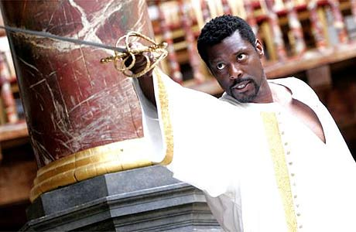

|  |
| --- |
| GOOD STUDY HABITS AND HOMEWORK |

You should aim to complete 3-5 hours per subject, per week. You Will be given a separate booklet to record what you have done and how it has helped you.

|  |
| --- |
| SUBJECT RESOURCES FOR STUDENTS |

Specific resources and recommended reading lists to support your learning can be found below:

The primary and secondary texts for the course are available on our college Moodle page

[English A Level: English Literature books (derby-college.ac.uk)](https://moodle.derby-college.ac.uk/mod/book/view.php?id=267426&chapterid=4867)

We also recommend these additional textbooks, some of which are available in the library. It is not mandatory to purchase these and they will only be used to enhance the programme rather than as set work:

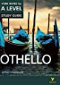

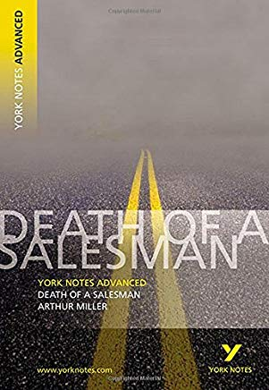**Textbooks/Revision Guides**

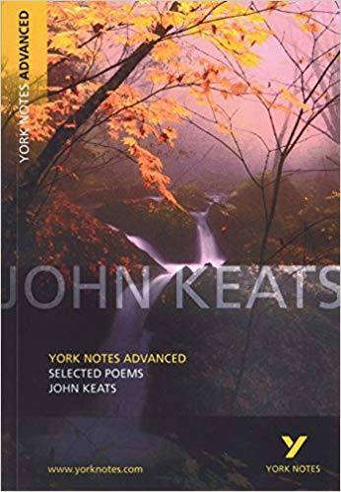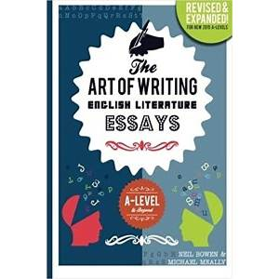

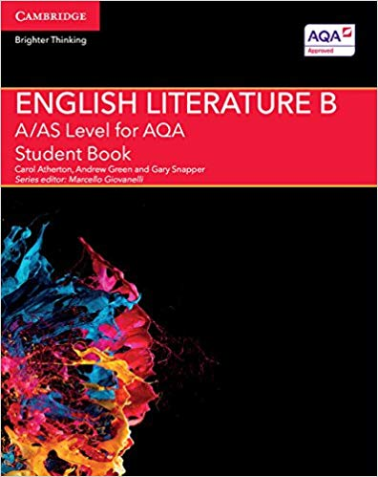

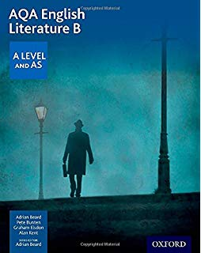

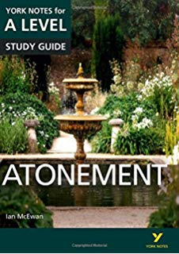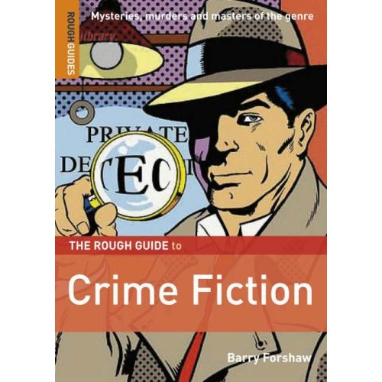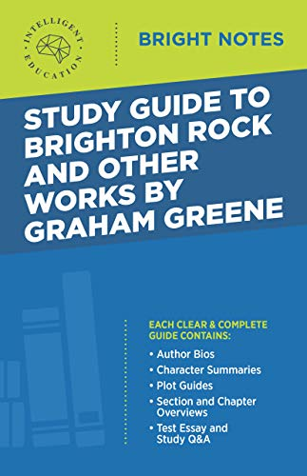

|  |
| --- |
| TERMINOLOGY GLOSSARY (feel free to save your own version and add to this)! |

**Terms Glossary (AO1/AO2)**

**Alexandrine**: a line of six iambic feet, often used to mark a conclusion in a work which is in [heroic couplets](https://www.english.cam.ac.uk/classroom/terms.htm#couplet): Alexander Pope in his Essay on Criticism (1709) satirised this technique (which he was not above using himself): ' Then, at the last and only couplet fraught | With some unmeaning thing they call a thought, | A needless Alexandrine ends the song, | That like a wounded snake, drags its slow length along.' The final line of that extract is of course itself an alexandrine. Spenser used an alexandrine to end his modified form of [ottava rima](https://www.english.cam.ac.uk/classroom/terms.htm#ottava). The same word is used to describe a line of twelve syllables which is the dominant form of French verse. See [syllabic verse](https://www.english.cam.ac.uk/classroom/terms.htm#syllabic).

**Allegory:** using a section of, or a whole, narrative to represent ideas or messages. Sometimes this [trope](https://www.english.cam.ac.uk/classroom/terms.htm#trope) works by an extended metaphor ('the ship of state foundered on the rocks of inflation, only to be salvaged by the tugs of monetarist policy'). More usually it is used of a story or fable that has a clear secondary meaning beneath its literal sense. Orwell's *Animal Farm*, for example, is assumed to have an allegorical sense, as does Dickens’ *A Christmas Carol*.

**Alliteration:** The repetition of the same consonants (usually the initial sounds of words or of stressed syllables) at the start of several words or syllables in sequence or in close proximity to each other.. More recently it is used for expressive or occasionally onomatopoeic effect. There are sub-forms of alliteration such as: sibilance, plosive alliteration, fricative alliteration etc.

**Anaphora:** Repetition of the same word or words at the beginning of consecutive syntactic units.

**Assonance:** The word is usually used to describe the repetition of vowel sounds in neighbouring syllables (compare [Alliteration](https://www.english.cam.ac.uk/classroom/terms.htm#alliteration). The consonants can differ: so 'deep sea' is an example of assonance, whereas 'The queen will sweep past the deep crowds' is an example of internal [rhyme](https://www.english.cam.ac.uk/classroom/terms.htm#rhyme). More technically it is used to describe the 'rhyming of one word with another in the accented vowel and those which follow, but not in the consonants, as used in the versification of Old French, Spanish, Celtic, and other languages' (OED).

**Asyndeton:** The omission of a conjunction from a list ('chips, beans, peas, vinegar, salt, pepper'). Compare [polysyndeton](https://www.english.cam.ac.uk/classroom/terms.htm#polysyndeton).

**Blank verse:** is the metre most frequently used by Shakespeare. It consists of an unrhymed [iambic pentameter](https://www.english.cam.ac.uk/classroom/terms.htm#pentameter). It was first used in Henry Howard, Earl of Surrey's, translation of Books 2 and 4 of Virgil's Aeneid, composed some time in the 1530s or 40s. It was adopted as the chief verse form in Elizabethan verse drama, and was subsequently used by Milton in *Paradise Lost* and in a wide range of subsequent narrative poems and dramatic texts.

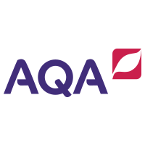**Caesura:** A pause or breathing-place about the middle of a metrical line, generally indicated by a pause in the sense. The word derives from a Latin word meaning 'cut or slice', so the effect can be quite violent. However in many lines of [blank verse](https://www.english.cam.ac.uk/classroom/terms.htm#blank_verse) the caesura may be almost inaudible. A medial caesura is the norm: this occurs in the middle of a line. An initial caesura occurs near the start of a line; a terminal caesura near its end. A 'masculine caesura' occurs after a stressed syllable, and a 'feminine caesura' occurs after an unstressed syllable. The plural is caesurae.

**Couplet:** a rhymed pair of lines, which are usually of the same length. If these are [iambic pentameters](https://www.english.cam.ac.uk/classroom/terms.htm#pentameter) it is termed a heroic couplet. This form was made popular by Chaucer's ‘Canterbury Tales’ and became the dominant poetic form in the latter part of the seventeenth century.

**Elision:** The omission of one or more letters or syllables from a word. This is usually marked by an apostrophe: as in 'he's going to the shops'. In early printed texts the elided syllable is sometimes printed as well as the mark of elision, as in Donne's 'She 'is all States, all Princes I'.

**Enjambment:** The effect achieved when the syntax of a line of verse transgresses (runs over) the limits set by the metre at the end of the verse. Thus 'Black drizzling crags that spake by the way-side/ As if a voice were in them, the sick sight/ And giddy prospect of the raving stream...' [End-stopping](https://www.english.cam.ac.uk/classroom/terms.htm#endstopping) is the alternative to enjambment.

**End-stopping:** The effect achieved when the syntax of a line coincides with the metrical boundary at the end of a line. The contrary of [enjambment](https://www.english.cam.ac.uk/classroom/terms.htm#enjambement).

**Foot:** the basic unit for describing metre, usually consisting of a certain number and combination of stressed and unstressed syllables. Stressed and unstressed syllables form one or other of the recognised metrical forms: an iamb is 'di dúm'; a trochee is 'dúm di', a spondee is 'dúm dúm' (as in 'home-made'), an [anapaest](https://www.english.cam.ac.uk/classroom/terms.htm#anapaest) is 'di di dúm', and a [dactyl](https://www.english.cam.ac.uk/classroom/terms.htm#dactyl) is 'dúm di di'.

**Feminine Rhyme:** a rhyme of two syllables in which the final syllable is unstressed ('mother | brother'). If an iambic pentameter ends in a feminine rhyme the last, unstressed, syllable is usually not counted as one of the ten syllables in the line ('To be or not to be, that is the question' - the 'ion' is unstressed and takes the line into an eleventh syllable).

**Form:** The term is usually used in the analysis of poetry to refer to the structure of stanzas (such as [ottava rima](https://www.english.cam.ac.uk/classroom/terms.htm#ottava)). It can also be used less technically of the general structural principles by which a work is organised, and is distinguished from its content.

**Free Verse:** verse in which the metre and line length vary, and in which there is no discernible pattern in the use of rhyme.

**Genre** (from Latin genus, type, kind): works of literature tend to conform to certain types, or kinds. Thus we will describe a work as belonging to, for example, one of the following genres: epic, pastoral, satire, elegy etc. All the resources of linguistic patterning, both stylistic and structural, contribute to a sense of a work's genre. Generic boundaries are often fluid; literary meaning will often be produced by transgressing the normal expectations of genre.

**Homophones:** Words which sound exactly the same but which have different meanings ('maid' and 'made').

**Hypermetrical:** having an extra syllable over and above the expected normal length of a line of verse. See also [feminine rhyme](https://www.english.cam.ac.uk/classroom/terms.htm#feminine).

**Iambic pentameter:** an unrhymed line of five [feet](https://www.english.cam.ac.uk/classroom/terms.htm#foot) in which the dominant accent usually falls on the second syllable of each foot (di dúm), a pattern known as an iamb. The form is very flexible: it is possible to have one or more feet in which the expected order of accent is reversed (dúm di). These are called [trochees](https://www.english.cam.ac.uk/classroom/terms.htm#trochee).

**Irony:** strictly a sub-set of [allegory](https://www.english.cam.ac.uk/classroom/terms.htm#allegory): irony not only says one thing and means another, but says one thing and means its opposite. The word is used often of consciously inappropriate or understated utterances (so two walkers in the pouring rain greet each other with 'lovely day!', 'yes, isn't it'). Irony depends upon the audience's being able to recognise that a comment is deliberately at odds with its occasion. Dramatic irony occurs when an audience of a play know some crucial piece of information that the characters onstage do not know (such as the fact that Oedipus has unwittingly killed his father).

**Metaphor:** the transfer of a quality or attribute from one thing or idea to another in such a way as to imply some resemblance between the two things or ideas: 'his eyes blazed' implies that his eyes become like a fire. Many metaphors have been absorbed into the structure of ordinary language to such an extent that they are all but invisible, and it is sometimes hard to be sure what is or is not dead metaphor: 'the fat book' may imply a metaphor, as when we talk of a note of music as 'high' or 'low'. These often result from the tendency of metaphors to become received idioms in which the original force of the implied comparison is lost. See also [Simile](https://www.english.cam.ac.uk/classroom/terms.htm#simile).

**Metonymy:** A figure of speech in which the name of one object is replaced by another which is closely associated with it. So 'the turf' is a metonym for horse-racing, 'Westminster' is a metonym for the Houses of Parliament, 'Downing Street' is a metonym for the Prime-Minister or his office. 'Sceptre and crown came tumbling down' is a metonymic way of saying 'the king fell from power'. See [synecdoche](https://www.english.cam.ac.uk/classroom/terms.htm#synecdoche).

**Metre:** A regular patterned recurrence of light and heavy stresses in a line of verse. These patterns are given names. Almost all poems deliberately depart from the template established by a metrical pattern for specific effect. Assessing a poem's metre requires more than just spotting an [iambic pentameter](https://www.english.cam.ac.uk/classroom/terms.htm#pentameter) or other metrical pattern: it requires you to think about the ways in which a poem departs from its underlying pattern and why. Emotion might force a reverse foot or [trochee](https://www.english.cam.ac.uk/classroom/terms.htm#trochee), or the normal patterns of speech might occasionally cut across an underlying rhythm. See [Iambic Pentameter](https://www.english.cam.ac.uk/classroom/terms.htm#pentameter).

**Monorhyme**: A rhyme scheme in which all lines rhyme (aaaa etc.)

**Onomatopoeia:** The use of words or sounds which appear to resemble the sounds which they describe. Some words are themselves onomatopoeic, such as 'snap, crackle, pop.'

**Ottava Rima:** an eight line verse [stanza](https://www.english.cam.ac.uk/classroom/terms.htm#stanza) [rhyming](https://www.english.cam.ac.uk/classroom/terms.htm#rhyme) abababcc. In English it is usually in [iambic pentameter](https://www.english.cam.ac.uk/classroom/terms.htm#pentameter). It was introduced into English by Sir Thomas Wyatt in the 1530s, and was widely used for long verse narratives. Sir John Harington translated Ariosto's Orlando furioso into ottava rima in 1591; Byron used the form in Don Juan (1819-24). Edmund Spenser produced a nine line modification of the form which ends with an [alexandrine](https://www.english.cam.ac.uk/classroom/terms.htm#alexandrine) and rhymes ababbcbcc. for his Faerie Queene (1590-6). This is known as the Spenserian stanza, and was quite widely used by Wordsworth, Byron and Keats.

**Personification:** the attribution to a non-animate thing of human attributes. The thing personified is often an abstract concept (e.g. 'Lust'). Personification is related to allegory, insofar as personification says one thing ('Lust possessed him') and really means another.

**Plosive:** A consonantal sound in the formation of which the passage of air is completely blocked, such as 'p', 'b' or ‘d’.

**Polysyndeton:** The use of multiple conjunctions, usually where they are not strictly necessary ('chips and beans and fish and egg and peas and vinegar and tomato sauce'). Compare [asyndeton](https://www.english.cam.ac.uk/classroom/terms.htm#asyndeton).

**Quatrain:** a verse stanza of four lines, often rhyming abab. Tennyson's In Memoriam rhymes abba, however.

**Refrain:** A repeated line, phrase or group of lines, which recurs at regular intervals through a poem or song, usually at the end of a [stanza](https://www.english.cam.ac.uk/classroom/terms.htm#stanza). The less technical term is 'chorus'.

**Register:** a term designating the appropriateness of a given style to a given situation. Speakers and writers in specific situations deploy, for example, a technical vocabulary (e.g. scientific, commercial, medical, legal, theological, psychological), as well as other aspects of style customarily used in that situation. Literary effect is often created by switching register.

**Rhyme:** When two or more words or phrases contain an identical or similar vowel-sound, and the consonant-sounds that follow are identical or similar (red and dead). Feminine rhyme occurs when two syllables are rhymed ('mother | brother'). Half-rhyme occurs when the final consonants are the same but the preceding vowels are not. ('love | have'). The ‘rhyme scheme’, or regularly recurring patterns of rhyme within a poem or stanza, is recorded by using a letter of the alphabet to denote each rhyme, and noting the order in which the rhymes recur (aabbcc... is the most simple rhyme scheme of all, that of the couplet).

**Rhythm:** a term designating the pattern of stressed and unstressed syllables in verse or prose. Different lines of verse can have the same [metre](https://www.english.cam.ac.uk/classroom/terms.htm#metre) but a different rhythm. Thus two lines of alliterative verse in Middle English poetry might have the same metrical pattern of four stressed syllables, but their rhythm might differ by having a greater or lesser number of unstressed syllables intervening between the stressed syllables.

**Rhyme Royal:** A form of verse which consists of [stanzas](https://www.english.cam.ac.uk/classroom/terms.htm#stanza) of seven ten-syllable lines, riming a b a b b c c. It was first used by Chaucer, and was also the form chosen by Shakespeare for the tragic gravity of his narrative poem Lucrece (1594).

**Simile:** a comparison between two objects or ideas which is introduced by 'like' or 'as'. The literal object which evokes the comparison is called the tenor and the object which describes it is called the vehicle. So in the simile 'the car wheezed like an asthmatic donkey' the car is the tenor and the 'asthmatic donkey' is the vehicle. Negative similes are also possible (as in Shakespeare's Sonnet 'My mistress' eyes are nothing like the sun'). Epic similes are more extended similes, which might involve multiple points of correspondence between tenor and vehicle. The frequently occur in long heroic narrative poems in the classical tradition, such as Milton's Paradise Lost (1667), as when Milton describes the combat of Satan and Death:

*'Incenst with indignation Satan stood  
Unterrifi'd, and like a Comet burn'd,   
That fires the length of Ophiucus huge   
In th' Artick Sky, and from his horrid hair   
Shakes Pestilence and War...'*

This double simile (first Satan is compared to a comet, then to a cloud) reflects back on the literal action: the violent energy of the comet is damped down by the immobile clouds. This change of vehicle reflects back on the fight which is the simile's tenor: it suggests that Satan starts off blazing with eagerness to fight Death, and then pauses, perhaps nervously.

**Sonnet:** In its earliest usages this can mean just 'a short poem, often on the subject of love.' Now it is almost always used to denote a fourteen line poem in [iambic pentameter](https://www.english.cam.ac.uk/classroom/terms.htm#pentameter). There are two main forms of Sonnet: the 'Shakespearean Sonnet' rhymes abab cdcd efef gg. It was the form favoured by Shakespeare, in his Sonnets (1609), although it is first found in the work of Henry Howard, Earl of Surrey. The three quatrains can be linked together in argument in a variety of ways, but often there is a 'volta' or turn in the course of the argument after the second quatrain. The final [couplet](https://www.english.cam.ac.uk/classroom/terms.htm#couplet) often provides an opportunity to sum up the argument of the poem with an epigram. Edmund Spenser's Amoretti (1595) introduced a variant form in which the quatrains are connected by rhyme: abab bcbc cdcd ee. The 'Petrarchan Sonnet', which is the earliest appearance of the form, falls into an octet, or eight line unit, and a sestet, or six line unit. The Petrarchan sonnet form rhymes abbaabba cdecde (although the sestet can follow other rhyme-schemes, such as cdcdcd).

**Stanza:** 'A group of lines of verse (usually not less than four), arranged according to a definite scheme which regulates the number of lines, the metre, and (in rhymed poetry) the sequence of rhymes; normally forming a division of a song or poem consisting of a series of such groups constructed according to the same scheme' (OED). See also [ottava rima](https://www.english.cam.ac.uk/classroom/terms.htm#ottava), [quatrain](https://www.english.cam.ac.uk/classroom/terms.htm#quatrain). This term is preferable to the less technical 'verse', since that word can also refer to a single line of a poem. In printed poems divisions between stanzas are frequently indicated by an area of blank space.

**Stichomythia**: a technique in verse drama in which sequences of single alternating lines, or half-lines (hemistichomythia) or two-line speeches (distichomythia) are given to alternating characters.

**Stress**: Emphasis given to a syllable in pitch, volume or duration (or several of these). In normal spoken English some syllables are given greater stress than others. In [metrical](https://www.english.cam.ac.uk/classroom/terms.htm#metre) writing these natural variations in stress are formed into recurrent patterns, such as [iambs](https://www.english.cam.ac.uk/classroom/terms.htm#pentameter), [anapaests](https://www.english.cam.ac.uk/classroom/terms.htm#anapaest) or [trochees](https://www.english.cam.ac.uk/classroom/terms.htm#trochee).

**Syllable:** The smallest unit of speech that normally occurs in isolation, or a distinct sound element within a word. This can consist of a vowel alone ('O') or a combination of a vowel and one or more consonants ('no', 'not'). Monosyllables contain only one syllable ('dog', 'big', 'shoe'); polysyllables contain more than one syllable. The word 'syllable' contains three syllables.

**Synecdoche**: the rhetorical figure whereby a part is substituted for a whole ('a suit entered the room'), or, less usually, in which a whole is substituted for a part (as when a policeman is called 'the law' or a manager is called 'the management'). See [metonymy](https://www.english.cam.ac.uk/classroom/terms.htm#metonymy).

**Trope:** a general term for any figure of speech which alters the literal sense of a word or phrase: so [metaphor](https://www.english.cam.ac.uk/classroom/terms.htm#metaphor), [simile](https://www.english.cam.ac.uk/classroom/terms.htm#simile) and [allegory](https://www.english.cam.ac.uk/classroom/terms.htm#allegory) are all tropes, since they affect the meaning of words. In the rhetorical tradition tropes are contrasted with figures, which are rhetorical devices which affect the order or placing of words (so the repetition of a particular word at the start of each line is a figure).

|  |
| --- |
| HOW TO WRITE THE PERFECT PARAGRAPH |

**We recommend using GELATIC paragraphs when you write essays. This will help you to meet the assessment objectives (on the next page). You do not have to include the GELATIC elements in any particular order.**

G – Genre Convention(s) – link to the text-type (tragedy/play/poetry) e.g. one of the most important scenes/in one of the final stanzas/a key feature of tragic drama is…

E – Evidence (using a section of text to illustrate your point.

L- Literary Device / Language Focus

A- Alternative Reading? Can you look at this in another way? Could you apply existing literary criticism?

T- Terminology – using subject specific language

I – Intention of Writer?

C – Context: considering social/historical or cultural implications from the time of production/reception.

|  |
| --- |
| ASSESSMENT OBJECTIVES |

• AO1: Articulate informed, personal and creative responses to literary texts, using associated

concepts and terminology, and coherent, accurate written expression.

• AO2: Analyse ways in which meanings are shaped in literary texts.

• AO3: Demonstrate understanding of the significance and influence of the contexts in which

literary texts are written and received.

• AO4: Explore connections across literary texts.

• AO5: Explore literary texts informed by different interpretations.