Sociology 2026/2027
Academic Education



Start Date | 7 September 2026
End Date | July 2028
Level of course | A level
Awarding Body | OCR
Specification | OCR A Level in Sociology Specification v1.1

CONTENTS

YOUR SUBJECT TEACHERS 2
INTRODUCTION & AIMS OF THE COURSE 3
COURSE STRUCTURE 4
KEY COURSE INFORMATION 6
YEAR PLAN OF STUDY 7
ASSESSMENT AND FEEDBACK 7
ENRICHMENT AND VISITS 9
SUCCESSFUL LEARNER HABITS 11
SUBJECT RESOURCES FOR STUDENTS 12
GLOSSARY OF TERMS 12

YOUR SUBJECT TEACHERS

The Sociology Team:

Silke Krieger-Ford - Teacher and Co-ordinator  Silke.Krieger-Ford@Derby-College.ac.uk   | Nina Henry - Teacher  Nina.Henry@Derby-College.ac.uk  
Judith Copeland – Teacher
Judith.Copeland@Derby-College.ac.uk



Alisha Stone
Alisha.Stone@Derby-College.ac.uk



INTRODUCTION & AIMS OF THE COURSE

What is sociology?

Sociology is the study of society. It looks at human social relationships and institutions, within and across different societies. Sociology’s subject matter is diverse, ranging from the family to crime and globalisation. It explores divisions of gender, ethnicity, age and social class etc. as well as shared beliefs within a shared culture.

Sociology also tries to understand cooperation within society and causes of significant social change and conflict. The purpose is to understand how human action and consciousness both shape and are shaped by our surrounding cultural and social structures (government, schools, family etc.).

This course aims to develop a sociological imagination. This doesn’t just mean knowing things, though this is important, it also important to be able to develop your interpretive, analytical and evaluative skills. These will help you to critically review the theories and ideas put forward in sociology and any other subject for that matter. These skills are highly prized in the workplace too.

This course, therefore, prepares students for progression into higher education, apprenticeships, further study, the workplace and to be an informed, openminded members of their local communities. Sociology enables students to gain a holistic understanding of the nature of British society, the changes and challenges individual’s face within this, and how social cohesion can promote progress.



Specification

The content of the curriculum follows the OCR course specification. It is designed to challenge students’ own perspectives to allow then to think outside the box and develop a sociological imagination.

Key academic skills will be developed starting with recall of knowledge and culminating in evaluation of sociological theory and explanation.

We start with culture and identity which provides a firm base for exploring society. This will develop the tools needed to delve deeper into topics within society such as crime, the family and global media.

Research methods are also an important topic that will be studied. This helps with the evaluation of sociological theories and helps students be more critically aware.

During your course we provide opportunity for regular exam practice, which assists students to reach their potential. Both verbal and written feedback is provided to ensure students are aware of both what they have done well, but also where improvements are needed.

Sociology is an enriching subject; beyond the OCR specification it covers a wide variety of topics which means it harmonises well with many other A- Level subjects. An A-level in sociology leads onto higher level apprenticeships and undergraduate degrees. Careers associated with Sociology often link to jobs within the public centre, or jobs where you need an understanding of people and societal structures.

 | Progression  Intended destinations are diverse for those who study a social science, many make the natural progression route of working in the public sector, often in roles that help and support people. From nursing to probation services, the deep understanding that sociology cultivates makes working for public organisations an attractive choice. There are also several government careers in the civil service and local government roles in councils, often these are not people facing but have social policy in mind.

COURSE STRUCTURE

Assessment overview

Exam | Unit title | Outline | Assessment
1 | Culture socialisation and identity | This unit involves examining culture and socialisation. Types of identity. Family. | 1h 30 mins 30%
2 | Social inequality and research methods | This unit involves examining issues of inequality and difference in relation to issues such as class, gender, ethnicity and age. Research methods. | 2 hr 15 mins 35%
3 | Debates in contemporary society: global and digital social world. Crime and deviance. | This unit involves examining global digital media and crime and deviance. | 2 hr 15 mins 35%

Year 1 Unit Content

Paper 1 Section A Socialisation, Culture and Identity

Key Question | Content | Skills
- That is Culture? | Culture, norms and values  Types of culture:  • subculture  • high culture  • popular culture  • global culture  • consumer culture  Cultural diversity  Cultural hybridity | be able to understand the relative nature of culture, norms and values.  Use cross cultural material as evidence.
- What is Socialisation | Primary and Secondary  Agencies of socialisation:  • family  • peer group  • media  • religion  • education  • workplace  Nature/nurture debate  Formal agencies of social  control:  • police  • law/legal system courts  • government  • military  Informal agencies of social  control:  • family  • peer group/subcultures  • media  • religion  • education  • workplace | Be able to link definitions of primary socialisation and secondary socialisation  to relevant agencies of socialisation, understanding that socialisation is a  lifelong process.  Consider the implications of the nature/ nurture debate for an understanding of socialisation.  Explore the overlap between formal and informal social control for work, education and religion.
- What is Identity? | The concept of identity  Aspects of identity and  the associated cultural  characteristics:  • ethnicity  • nationality  • gender  • social class  • sexuality  • age  • disability  Hybrid identities | Understand how identities are created including the influence of agencies of socialisation.  Understand the different aspects of an individual’s identity, their relative  importance to individuals and ways in which they may intersect.  Consider changing identities.
Paper 1 Section B Option 1: Families and relationships

Key Question | Content | Skill
- How diverse are modern families? | The diversity of family and  household types in the  contemporary UK:  • nuclear families  • extended families  • lone parent families  • reconstituted families  • same-sex families  • non-family households  Aspects of and reasons for  family and household diversity  in the contemporary UK,  including:  • trends in marriage, divorce  and cohabitation  • demographic changes:  - birth-rate  - family size  - age at marriage  - age of childbearing  - ageing population  • family diversity in terms of:  - social class  - ethnicity  - sexuality  The ideology of the nuclear  family and the theoretical  debates about the role and  desirability of the nuclear family  in contemporary society:  • functionalism  • New Right  • Marxism  • feminism  • postmodernism  Debates about the extent  of family diversity in the  contemporary UK | Also consider newer/emerging types of families and households  Have an overview of trends over the last 30 years and consider the key reasons  for these changes. Detailed knowledge of statistics on marriage, divorce and  demographic changes are not required.  Consider issues of consensus versus conflict, social order and control in relation to theoretical views of the role  of the family in contemporary society.  A theoretical approach to considering the extent of family diversity should be taken.
- To what extent are roles and relationships within families and households changing? | Roles and relationships  between partners and how  they are changing, including  issues of power  Roles and relationships  between parents and children  and how they are changing,  including issues of power | Consider a range of issues including the domestic division of labour and the ‘dark  side’ of the family.  A theoretical approach  should be taken, applying functionalist, Marxist and feminist approaches.  Consider issues such as the growth of the child-centred family and the extension of  childhood.  Consider the impact of the ageing population on the relationship between  grandparents, parents and children.  A theoretical approach should be taken, applying feminist approaches.
Paper 2: Research Methods: Only part of paper 2 is covered in year 1

Key Question | Content | Skill
1.What is the relationship  between theory and method? | Positivism:  • patterns  • trends  • objectivity  • value freedom  • quantitative data  Interpretivism:  • meanings and experiences  • verstehen and empathy  • rapport  • subjectivity  • researcher imposition  • reflexivity  • qualitative data  Key research concepts:  • validity  • reliability  • representativeness  • generalisability | Understand how social research is guided by theory.  Use these concepts in an evaluative way when considering the research process and methodological theories
2. What are the main stages of the research process? | Key concepts in the research  process:  • factors influencing the  choice of research topic  • aims/hypothesis/research  questions  • primary data  • secondary data  • operationalisation  • pilot studies  • data collection  • respondent validation  • longitudinal studies  • interpretation of data  • the relationship between  sociology and social policy  Sampling process  Sampling techniques  • random  • systematic  • stratified  • snowball  • volunteer  • opportunity  • purposive  • Access and gatekeeping  Ethics | consider how sociological research contributes to social policy  Understand the practical, ethical and theoretical factors influencing choice of sampling process.  Understand the advantages and disadvantages of random and non-random sampling techniques.  Understand how samples are accessed and the issues with access.  Understand ethical considerations such as those used by the British Sociological  Association and why ethical principles should be followed.
- Which methods are used in sociological research | Research methods:  • questionnaires  • structured interviews  • statistical data (official and  non-official)  • content analysis  • observations (participant,  non-participant, covert,  overt)  • unstructured interviews  • semi structured interviews  • ethnography  Quantitative and qualitative  Data  - Mixed methods  - triangulation  - methodological pluralism | Consider the uses of research methods in the context of social inequalities.
Paper 3 – Only part of paper 3 is covered in year 1 Section A: Globalisation and the digital social world
Key Question | Content | Skill
- What is the relationship  between globalisation  and digital forms of  communication? | Definitions of globalisation  Developments in digital forms  of communication in a global  society:  • digital revolution  • global village  • networked global society  • media convergence  • social media  • virtual communities  • digital social networks  Applying sociological theories to digital forms of communication:  • Marxism  • feminism  • postmodernism | Consider how developments in digital communication are related to social capital.  Have an overview of how developments in digital forms of communication have been  theoretically interpreted
- What is the impact of digital | The impact of digital forms of  communication on:  • people’s identity  • social inequalities  • relationships  The impact of digital forms of  communication on culture:  • conflict and change  • cultural homogenisation  • cultural defence/  ‘glocalisation’ | consider people’s identity and social  inequalities in relation to:  • social class  • gender  • age  consider both the positive and negative  impacts of digital forms of communication.

In your second year you will study:

Social in equalities (Paper 2)
- The nature of stratification and measuring social class | •Systems of stratification  •Measuring social class  •Objective measurements  •Subjective measurements  •Class in the UK
- Theory of social class inequality | •The Functionalist perspective  •The Marxist perspective  •The Neo Marxist perspective  •The Weberian perspective  •The New Right Perspective  •The Feminist perspective  •Postmodern perspectives
- Life chances and social class | •Income  •Wealth  •Health  •Education  •Employment
- Life chances and gender inequality | •Income  •Wealth  •Health  •Education  •Employment
- Life chances and ethnic inequality | •Income  •Wealth  •Health  •Education  •Employment
- Chances and age inequality | •Income  •Wealth  •Health  •Education  •Employment
- Poverty | •Types of poverty  •Cycle of deprivation  •Those in poverty  •The existence of poverty

Crime and Deviance (paper 3)
1. The definition and measurement of crime and deviance | • crime;  • deviance;  • relativity;  • social construction.  Assess the implications of the above on the definition of crime and deviance.
2. Methods for measuring crime | • official statistics;  • victim surveys;  • self-report studies.  Give an overview of the different methods, and  examples of each, including advantages and  disadvantages.  Link the methods to theories.
3. Trends, patterns and explanations of crime and deviance | Trends and patterns related to crime by:  • gender;  • ethnicity;  • social class;  • Victimisation  • age.  Consider evidence of trends and patterns. You may want to look at trends over the last 25–30 years.
4. Theoretical explanations: | • functionalism  • subculturalism  • Marxism  • new criminology  • interactionism  • realism (left and right)  • New Right  • feminism  Consider the contribution each theory has made to an explanation of crime. This should include relevant conceptual and empirical evidence and an evaluation of each.
5. Types of crime | - White collar, including, occupational and corporate crime.  - Green crime, including primary and secondary  - Global crime including state crime  Consider how crime is changing and the implications this might have.
5. Solutions to the problem of crime | Solutions to crime, including;  • left realism and right realism  • Right wing and left wing crime prevention  • feminism.  Consider different solutions and an evaluation of each; link them to relevant theories; and exemplify each with a Government policy.

Exam structure

Paper 1
Section A: Socialisation, Culture and Identity: 1 hour and 30 mins

Section A | Total Marks | AO1 | AO2 | AO3 | Content
Qu. 1 | 6 marks | 4 marks | 2 marks | N/A | A definition style question. You need to express the meaning of a sociological term/concept and develop it. Then apply two examples, which are also developed.
Qu. 2 | 12 marks | 4 marks | 8 marks | N/A | This question will present two source materials. 4 marks are awarded for each source material (total 8 marks) and a further 4 marks for wider knowledge.
Qu. 3 | 20 marks | 8 marks | 8 marks | 4 marks | This is an essay-based question that will always ask you to ‘Outline and briefly evaluate…’ a sociological issue.



Section B: Families and relationships

Section B | Total Marks | AO1 | AO2 | AO3 | Content
Qu. 4 | 12 marks | 8 marks | 4 marks | N/A | This question will ask you to outline two contrasting points, which are then supported with evidence apply two examples, which are also developed.
Qu. 5 | 16 marks | 8 marks | 4 marks | 4 marks | This question will always begin with ‘Explain and briefly evaluate…’
Qu. 6 | 24 marks | 8 marks | 8 marks | 8 marks | This is an essay-based question that will ask you to ‘Assess…’

Paper 2

Section A: Researching and understanding social inequalities Section A: Research methods and researching social inequalities A mix of short and medium length questions, based on two source materials provided.

Section A | Total Marks | AO1 | AO2 | AO3 | Content
Qu. 1 | 4 marks | N/A | 4 marks | N/A | This question requires you to identify two conclusions from research findings from source A
Qu. 2 | 6 marks | 2 marks | 4 marks | N/A | A source question: this question requires you to identify two points supported by evidence, from source B. describing specific sociological research.
Qu. 3 | 10 marks | N/A | 4 marks | 6 marks | Using source, A explain two advantages and or disadvantages of the method used.
Qu. 4 | 25 marks | 5 marks | 5 marks | 15 marks | Use source B and wider sociological knowledge, explain and evaluate a methodological issue.

Section B: This section focuses on evidence and explanations for social inequality.

Section A | Total Marks | AO1 | AO2 | AO3 | Content
Qu. 1 | 20 marks | 12 marks | 8 marks | N/A | Outline ways (four) in which the social group a person belongs to (age, ethnicity, social class, or gender) can affect life chances.
Qu. 2 | 40 marks | 2 marks | 4 marks | marks | Assess a sociological view regarding the existence and effect of social inequality. This is an essay questions requiring four points, which are all evaluated.

Paper 3

Section A: Globalisation and the digital social world. The first two questions are based on two sources of information provided in the exam.

Section B | Total Marks | AO1 | AO2 | AO3 | Content
Qu. 1 | 9 marks | 5 marks | 4 marks | N/A | This question requires the use of one source and additional sociological knowledge to explain a sociological issue or phenomenon. It will begin ‘With reference to the source/s …’ or ‘Explain…’ You will be required to make 2 points.
Qu. 5 | 10 marks | 4 marks | 2 marks | 4 marks | This question requires the use of one source and additional sociological knowledge, which is evaluated. It will always begin ‘With reference to source…’ You are expected to make two points and fully evaluate each.
Qu. 6 | 16 marks | 4 marks | 4 marks | 8 marks | This is an essay-based question that will ask you to ‘Assess, Evaluate, Discuss the view…’ You are expected to make two supporting points and three evaluative points.

Section B: Crime and Deviance

Section A | Total Marks | AO1 | AO2 | AO3 | Content
Qu. 1 | 10 marks | 6 marks | 4 marks | N/A | This question will require evidence to support a specific point.
Qu.2 | 20 Marks | 8 marks | 4 marks | 8 marks | This question is an essay based question. It will ask the extent to which a specific argument can be supported.
Qu. 2 | 40 marks | 16 marks | 8 marks | 16  marks | This question is an essay based question, that will ask you to outline and evaluate a theoretical view of crime and deviance.

Assessment Objectives
In each unit you are required to meet some or all of these assessment objectives:

Assessment Objectives | Requirement
AO1 | Gather knowledge and understanding set out in the specification.
AO2 | Be able to accurately apply that knowledge using valid evidence from contemporary society and sociological theory and research.
AO3 | Be able to interpret, analyse and evaluate this knowledge and evidence.

KEY COURSE INFORMATION

Length of Study | 3 x 1hour 40 mins classes per week for 36 weeks in the first year.  3 x 1hour 40 mins classes per week for 32 weeks, plus revision sessions in the final half-term, in the second year.
Your classrooms | S16 and S17
Key skills you will be developing during the course to be successful | Study skills including notetaking, listening skills, comprehension, essay writing, academic writing, reading academic text, working with source material, revising, time management, research, debating, critical analysis and evaluation.
What will lessons look like? | Lesson will consist of a range of individual and group activities along with teacher delivery.
Informal Assessment Methods | The A level is awarded from the performance in your three external exams (see above), at the end of the second year.  We require you to complete internal formal assessments (mock exams) in both your first and second year.  NB: Progression from year 1 to year 2 is not automatic but based on your performance in these formal assessments and commitment to your studies.
Essential Equipment/ Resources | There are a range of textbooks available for this course. We will give you the chance to review which one suits your needs best. Secondhand textbooks are often available from online shops.  The library also stocks copies of key textbooks and some are available digitally. You will be shown how to access them when you start your course.  You will need to provide your own stationery including pens, ring binder folders, lined paper – all A4 size.
Health and Safety | There are no additional subject specific H&S requirements. You will be expected to follow the college general requirements, including the fire regulations, which will be delivered at the start of the academic year. There are regular fire drills to test everyone’s understanding and compliance.

YEAR PLAN OF STUDY

Independent Study



Independent study is an essential part of your A level course and a skill requirement for access to higher education. All sociology students will be expected to complete an on-line, independent study log. This is available in your sociology Teams folder. Completion of a range of activities will go towards a gold, silver or bronze award. This can be used within your university or job applications to evidence a range of independent learning skills and motivation.

Year Planning
Year 1
Autumn 1 | Autumn 2 | Spring 1 | Spring 2 | Summer 1 | Summer 2
Understand what sociological theory is  Learn a basic overview of  - Functionalist theory  - New Right theory  - Consensus/right wing  What is culture?  Understand the exam structure and mark scheme for short answer questions.  Explore contemporary examples related to the topic. | What is Socialisation?  Explore the nature V nurture debate  Define primary socialisation and explore the impact of the different agencies – Family –  Define formal and informal social control -  Formal Informal agencies of social control explain impact and studies. | What is identity?  socialisation impacts upon identities.  Changing identities  Gender identities  Sexuality and identity  Age identities  National identities  Explore the extent of hybrid identities. | What is identity?  Socialisation and impacts on identities  Changing identities  Ethnic identities  Disability and identities  Social Class identities  H hybrid identities. | Introduction to Sociological research in the context of preparing for the summer project  aims/hypothesis/research questions  • primary data • secondary data operationalisation  • pilot studies  • data collection  • respondent validation  • longitudinal studies  • interpretation of data  • sociology and social policy  Learn the key theories and analyse research from the two views:  - Positivism:  - Interpretivism:  Ethics | Introduction to Sampling process in the context of preparing for the summer project  Learn about and analyse the usefulness of different sampling techniques  Explore issues related to access and gatekeeping  Quantitative and qualitative data Research methods:  Mixed methods  • triangulation  • methodological pluralism
Explore the sociological imagination and sociological perspectives  - Marxist theory  - Feminist theory  - Postmodernist theory  - Conflict perspectives  How diverse are modern families?  Patterns and trends in family structures and demographic changes  Extent of diversity in relation to social class, sexuality, ethnicity | The ideology of the nuclear family  Ideology of the nuclear family and theoretical debates about the role of the nuclear family and family diversity within the UK.  Functionalism  New Right  Marxism  Feminism  Postmodernism | Changing roles and relationships.  Roles and relationships between partners and are changing, including issues of power.  dark side of the family.  Roles and relationships between parents and children are changing, including issues of power.  Child centredness. | Globalisation  Learn a key definition of globalisation and think about problems with defining the term.  Explore developments in digital forms of communication and how they are related to social capital.  – virtual realities  - global village  - media convergence | Digital forms of communication  Sociological theories to digital forms of communication  Theoretical application:  Marxism  Feminism  Postmodernism | Digital forms of communication  Social identity  Relationships  Social Inequalities  Consider both positive and negative impacts.  Impact of globalisation and digital communication on culture:  Cultural homogenisation  Cultural defence/glocalisation  Conflict and change

Year 2
Autumn 1 | Autumn 2 | Spring 1 | Spring 2 | Summer 1 | Summer 2
Key definitions within crime and deviance:  • crime and deviance  • social order  • social control  • the relativity of crime and deviance  • the social construction of crime and deviance  Update glossary with key concepts  Deviance  Official statistics  Validity  Anomie  Life chances  Subcultures  Measuring crime and  • official crime statistics  • victim surveys  • self-report studies  Recap key concepts of  Validity  Representativeness  Reliability  View of offending:  Functionalism | Sociological theories and their view of offending:  New Right  Marxism  Neo-Marxism/radical criminology  Interactionism  Update glossary with key concepts  Hegemony  Criminogenic  Social problems  Labelling theory  Media representations | Sociological theories and their view of offending:  Realism (left and right)  Analyse social policy in relation to crime:  • Left wing:  o social and community crime prevention and punishment  o restorative justice  o structural changes in society  Explore patterns of crime in a global context:  • global organised crime  • green crime  Update glossary with key concepts  Broken windows theory  Relative deprivation  Glocalisation  Zemiology | Analyse social policy in relation to crime:  • Right wing:  o situational crime prevention  o environmental crime prevention  o retributive justice  o punitive punishment and control  Left wing:  o social and community crime prevention and punishment  o restorative justice  o structural changes in society  Update glossary with key concepts  Retributive justice  Restorative justice  Sociological theories and their view of offending:  Feminism  Explore the social distribution of offending and victimisation in terms of:  • gender  • social class  • age  • ethnicity | Revision  Paper one  Culture and Identity  Family  Paper 3  Globalisation and digital world  Crime and Deviance  Past paper practice and exam technique mastery | Exam Preparation  Past paper practice and exam technique mastery
Consolidation of Sociological research with exam questions  Consolidate key concepts in the research process and explore factors influencing the choice of research topic  • aims/hypothesis/research questions  • primary data • secondary data  • operationalisation • pilot studies  • data collection  • respondent validation  • longitudinal studies  • interpretation of data  • social policy  Key theories:  Positivism:  Interpretivism  Research ethics  Sampling techniques  Access and gatekeeping  Quantitative and qualitative data and methods.  SOLE lessons | Life chances  Explore social inequality and difference in relation to:  • social class  • gender  • ethnicity  • age  patterns and trends in relation to work and employment. Evidence of social inequalities from a range of areas of social life and life chances.  SOLE lessons | Sociological theories and their view of stratification  Recap all the theories – what can the students remember from their previous learning.  Analyse the main sociological explanations of social inequality and difference:  • Functionalism  • New Right | Sociological theories and their view of stratification  Analyse the main sociological explanations of social inequality and difference:  • Marxism  • Weberian | Sociological theories and their view of stratification  Analyse the main sociological explanations of social inequality and difference:  Feminism  (plus Postmodernism for evaluation) | Exam Preparation

ASSESSMENT AND FEEDBACK

Referrals Procedures and Resubmissions Procedures

You will have a clear plan of what to expect, what assessments will take place during the year and when you can expect these assessments to happen. You can expect your work to be marked and quality assured where appropriate and returned within 15 working days of submission.

Once you have submitted your work, it will be marked and potentially be quality assured by the Internal Quality Assurance team. This is particularly key where the learning outcomes have not been met and a resubmission opportunity has been given.

Where a referral has been given, by the teacher or assessor will provide you with an opportunity to resubmit. However, you must read the feedback carefully to ensure you are clear of what you need to do and where a graded qualification and assessment is in place what you can attempt. This will be time bound and you will be given a re-submission date by your trainer/assessor/lecturer, and you must meet this deadline.

Academic Malpractice

DCG is keen to support students and avoid any cases of Academic malpractice. Awarding Organisations take matters of academic malpractice very seriously and require all schools and colleges to have specific policies and procedures in place to both educate staff and students about malpractice, thus deterring them from committing it, whether intentional or not, and report and investigate any suspected malpractice where it may occur.

While we don’t want to see anyone jeopardise their grades or marks, we must ensure the validity of all qualifications and we must investigate any suspected breaches fully. It is your responsibility to ensure you understand the rules and boundaries:

- You must not copy from someone else or give opportunities to another student to copy from you.
- Any wording taken from a published source must be correctly referenced for example:
(Morrison, 2000, p29).
- Where computer-generated content has been used (AI tools such as ChatGPT) you must reference these correctly for example: ChatGPT 3.0 (https://openai.com/blog/chatgpt/), 25/01/2024.
- You may also be required to include a bibliography to support referencing.
- You must also avoid working collaboratively with other students beyond what is permitted as this may be deemed to be collusion.
Academic Malpractice continued:

Other examples include:
- Falsification or fabrication of results,
- Deliberate destruction of other student’s work
- Any other act that will give you an unfair advantage. This also relates to not following clear guidance in examinations or assessments where examination conditions exist.

You will be required to complete an Authentication Form on submission of any and all assignments/NEA projects. This will confirm that the work is your own, and that it is referenced appropriately, including the use of AI. Where academic malpractice is suspected, this will be reported to your Team Manager who will conduct an investigation and, where relevant, the Awarding Organisation may also be informed and investigate further. Where malpractice is discovered to have occurred, sanctions may be imposed which could include:

- Zero marks for the work or exam.
- Disqualification from the qualification.
- Disqualification from taking any qualification with that Awarding Organisation often over a set period of time.
- Warnings which can last several years.

For further details and to fully familiarise yourself with JCQ guidance please see the Joint Councils for Qualifications (JCQ) website:
Information for candidates documents - JCQ Joint Council for Qualifications

Further information can be found on the DCG website:
Examination Information - DCG (derby-college.ac.uk)

Appeals Procedures

Each Awarding Organisation will have slightly different processes for appealing decisions. Appeals can be made where:
- You believe that the awarding body policies and procedures have not been followed correctly in respect of external quality assurance/standards verification (policies and procedures can be found on the relevant awarding body website).
- You believe that the awarding body policies and procedures have not been followed correctly in respect of qualification decisions (policies and procedures can be found on the relevant awarding body website).
- You disagree with the outcome of your internal appeals procedure (for example, a decision in relation to reasonable adjustments or assessment outcomes).

However, should you, as a student wish to appeal, firstly:

- Contact your teacher and discuss your concerns.

If you are still not satisfied with the outcome, the College would usually make an appeals application on your behalf. This would require your consent. It is possible to apply directly to the Awarding Organisation but only once the College’s internal processes have been followed. At this point you would be informed of the next stages and Awarding Organisation communication link. This is time bound and this will also be communicated to you once the internal appeals process has taken place.
Note: you must be aware that through this process the initial grade can go up, stay the same, or go down.

ENRICHMENT AND VISITS

Students will be encouraged to participate in activities that go beyond the curriculum and support them in developing a broader knowledge of the subject matter, develop character education and support progression to positive destinations.

- Events (britsoc.co.uk)
- BSA Young Sociologist of the Year Competition (britsoc.co.uk)
- Discover Sociology - Home
- bsa-young-sociologist-of-the-year-competition (discoversociology.co.uk)

- Sociology Buddy system and Sociology Ambassador

- Media Literacy Ambassadors programme

- Participation in the AdAstra programme activities.

- London visit
- Criminology Conference
- Residential trip to Auschwitz Memorial Museum

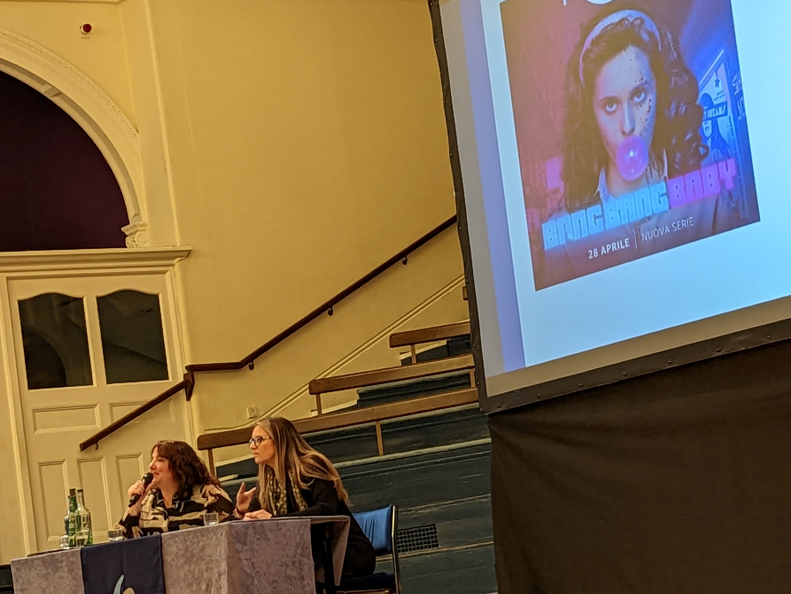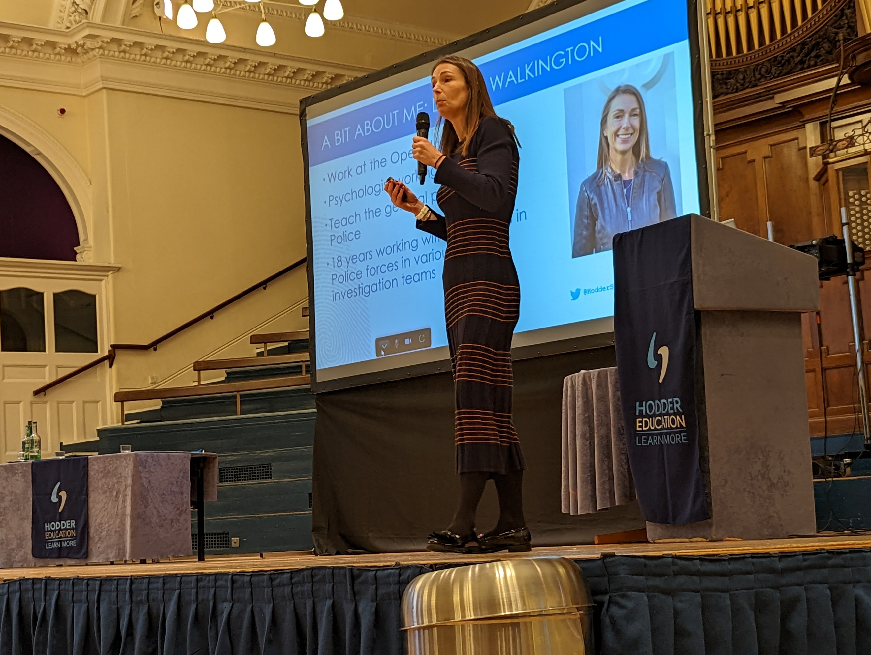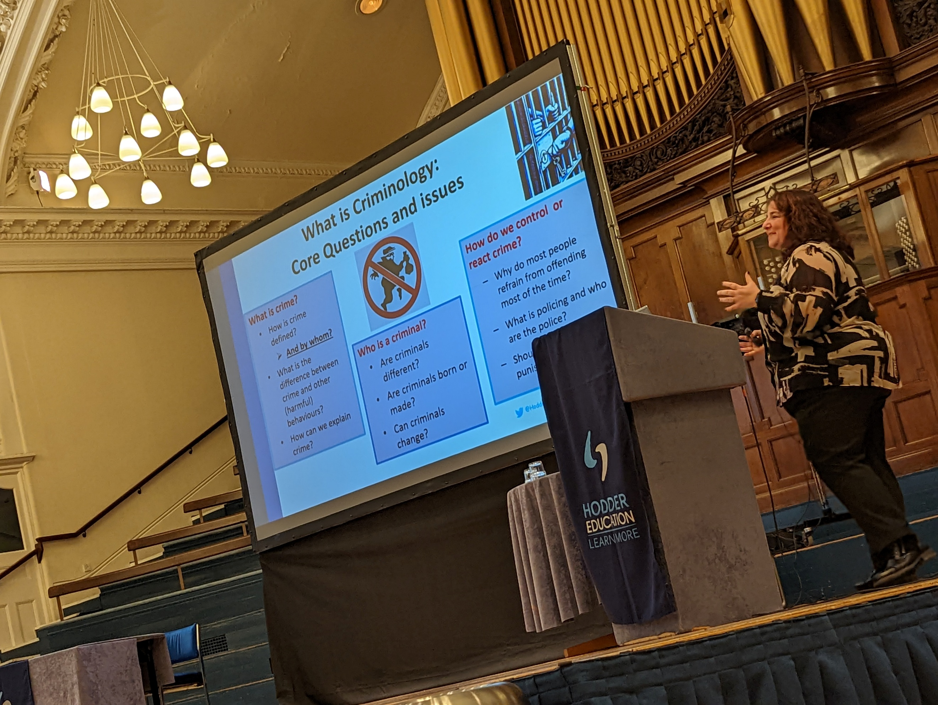

SUCCESSFUL LEARNER HABITS

How to make notes.
.
How to prepare for assessments.
Subject specific guidance
During your sociology classes you will be give guidance on exactly what is needed for each question in the exams you will be sitting. It is important that you take note of :
- Marks available
- The structure and length of response that is required
- What assessment objective are being tested and how many marks there are for each.
Further information about the course, including past papers and examiners reports can be found at AS and A Level - Sociology - H180, H580 (ocr.org.uk)

Making Notes
Use a well tested note-taking strategy such as Cornell notes Cornell Notes - Find out how they work - YouTube

How to study independently
- Allocate specific times in the week.

- If you keep to a routine it is easier to maintain. Try organising a study group to motivate each other.
- Set specific goals for your study times. Even if you have completed all official work, consider using the time to review and revise, or research contemporary issues. This will reduce your workload at exam periods and help you to build knowledge and skills.
- Goals will help you stay focused and monitor your progress. Simply sitting down to study has little value. You must be very clear about what you want to accomplish during your study times.
- Breakdown the goals into tasks.
- Start studying when you plan to, don’t procrastinate and end up rushing or not finishing.
- Start with the most difficult assignments first, after a short warm-up. You be more effective because you have more mental energy.
- Tell friends not to call or put your phone on do not disturb; it is too easy to get distracted.
- Get in-touch with another student or your tutor for help, if you are stuck and finding something difficult. This avoids wasting time and or sapping your confidence.
- Take regular breaks, you can give yourself a treat, or time out to check on phone messages. Make sure you set a strict time limit.

YOUR NEXT STEPS OPPORTUNITIES

Sociology: Employability Skills
This is not an exhaustive list of skills. It is designed to show you the importance of sociological skills to successful career progression.
 | Sociological Skills | Employability Skills | Careers Routes
Analytical skills | Especially problem-solving ability and sharp, critical thinking. | These skills are a plus for all kinds of duties and projects. Essential leadership and development. | Roles which require problem solving and sensitivity such as police and emergency services, social work, social policy, local and national government, disaster management.
Statistics and research design | Interpreting patterns and trends.  Identifying strengths and weakness of research methods | Organisations value an employee who can work with others to define a problem or research question, design and carry out a study to find answers. Understand principles of appropriate and effective research methods. | Helps prepare you for working in areas such as:  Government and social research departments, public opinion polling agencies, marketing firms and other research or program development settings..
Cultural understanding | Including norms and values, in inter and intra cultural groups. | Employers need workers who can understand and operate within the context of cultural and other diversities. Corporations are increasingly seeking employees with a global perspective and a high degree of intercultural awareness, more sensitivity to diversity and able to challenge stereotyped assumptions.  Knowledge of legal requirements. | Essential in many roles including:  Transnational corporations and international government departments, marketing, recruitment. Tourism, emergency services, social work, teaching, NGO charities, overseas employment, human resources and recruitment.
Changing social structures | Historical and contemporary patterns in the way society/ies are organised and the experiences of the individual in society. | Building skills to understand cause and effect help to promote knowledge and understanding that will promote the skills and career opportunities above. It will promote critical thinking - analytical and evaluative skills. This in turn promotes cultural understanding including cross generational. | Historical, cultural and structural context need to be understood in all the roles mentioned above.

SUBJECT RESOURCES FOR STUDENTS

Reading List
- 1.OCR A level Sociology (2022): Katherine Roberts, Paul Taylor, Sue Brisbane, Nayda Ali, Steve Chapman, Jannine Jacob-Roth.

- 2. OCR Sociology for A Level Book 1 (28 Aug. 2015): Sue Brisbane, Katherine Roberts, Paul Taylor, Steve Chapman, Jannine Jacobs-Roth, Nayda Ali. – digital copy available via the library.

- 3.My Revision Notes: OCR A Level Sociology Paperback (24 Nov. 2017): Steve Chapman

- 4.OCR A Level Sociology Student Guide 1: Socialisation, Culture and Identity with Family (29 Jan. 2016): Steve Chapman

- 5.Sociology OCR A level. Debates in contemporary society: globalisation and the digital social world with crime and deviance (2020): Katherine Roberts and Steve Chapman

- Sociology OCR A-Level. Researching and understanding social inequalities (2020): Katherine Roberts and Steve Chapman

- Sociology Review – copies in the library or online : https://my.dynamic-learning.co.uk/?csid=9781471862410&uid=aa93fa1a-8bb0-4870-b478-56ebf9942676&cid=93144&to=201905&gd=2017-05-19T17:02:09&ke=5AC8AB20A0A2AAABC46FC9118C3C7DB0&sa=MOLgo2fznxyqRiRZMPELjTGdCnoPJp&mp=6

Contemporary Issues

We also advise students to keep up to date with contemporary issues, especially those related to the topics studied over the two year course. Access to on-line news outlets such as:

BBC News
The Guardian
The Times
The Telegraph
Independent
Al Jazeera

Be aware that there will always be an element of bias in these resources, so reading a range of outlets will provide a better idea of the debates and improve your critical skills.

Be aware of Fake News

The term Fake News generally refers to news stories that have been completely or partially made up. Sometimes, though, it is used to discredit stories that opponents disagree with. It is essential for everyone, especially sociologists, to develop skills to spot and avoid giving credit to fake news.

Fake news is made up and designed to deceive readers to maximise traffic and profit or to manipulate political and social debates. They can also be generated by individuals on their social media accounts like Facebook and Instagram,

To avoid fake news use sites that are known to be legitimate and read or watch a variety of outlets.

Use fact checker sites such as:

- www.snopes.com

- fullfact.org

Never relie on information gained from returns from general search engines such as google search, or social media platforms.

Library Help and Resources

Get the help you need! Come into the Library or use the resources online and ask any one of the friendly team members for help. All the Libraries for Learning Team are skilled researchers willing to help you find the information you need and guide you to resources you might not have considered to help you finish those assignments. On the rare occasions that the library does not have exactly what you want, they will do their best to borrow it through another library. They can also give you advice on study skills and digital skills via the Skills Hubs too (see Study Skills and Digital Skills on the Libraries for Learning Pod Page).
Specific resources and recommended reading lists to support your learning can be found below:

The library Subject Reading List can, with links to resources, can be accessed here: Sociology (A Level) - Level 3

Search for more resources using the library catalogue: Library Catalogue


- Take full advantage of more resources available under the Electronic Resources tile resources, these include:

- Philip Allan Reviews - an archive of A-level magazine reviews, which include, biological sciences, business, chemistry, economics, geography, international baccalaureate, modern history, PE, physics, politics, psychology, religious studies, and sociology.
- Primal Pictures - Primal Pictures is a highly accurate and detailed 3D atlas of the human anatomy. It enables you to virtually explore parts of the body such as the nervous system, the skeleton and the cardiovascular system.
- Gale – an extensive collection of newspaper and journal articles. The collection includes full-text articles from a selection of UK and international newspapers.
- Britannica Academic - Britannica Academic provides thousands of academic, credible and citable resources to use in essays.

GLOSSARY OF TERMS

The following list is a brief glossary of terms you will learn or be exposed to during your learning. These are general terms that explain key concepts related to the subject and assessment methods. This does not include topic specific terminology, this will be provided with your independent study log.

Term | Definition
Analysis | A close examination of a situation
Assess | measure and judge the extent or quality of something
Assessment Objectives | The key skills assessed in each part of the exam.
Compare and Contrast | understanding similarities and differences between two things
Critique | Assess and review strengths and weaknesses
Culture | Relating to a specific group and its beliefs / ideas.
Determinism | The idea that your actions are dictated by situations so you're not free to choose what you'd like to do.
Discrimination | Behave in an unfair way with a certain person or group.
Discuss | Consider a statement or to offer a considered review of or balanced argument about a particular topic.
Dominant, | Something which is more influential or noticeable.
Economy | The social system which manages money and resources.
Evaluate | weigh the nature of the evidence available and discuss the convincing aspects of an argument as well as its implications and limitations, and the less convincing elements within an argument.
Empirical | An argument which uses practical evidence rather than theoretical ideas.
Ethnicity | To be part of a specific cultural group often sharing the same heritage.
Feminist | The belief that women should have the same opportunities and influence as men.
Functionalism | A consensus theory focusing on the inter-relationship and functions of societal structures.
Gender roles | Expected social position based on your sex or chosen identity.
Interactionism | A theory that sees society as a social construct.
Marxism | A conflict theory created by Karl Marx, explaining inequality between social classes.
Norm | Expected behaviour in a group or society
Patriarchy | A male-dominated society.
Peer group | People of a similar age or social position.
Perspective | A high-level theory that attempts to explain the whole workings of society
Positivism | A theory that argues sociology is a science
Postmodernism | A theory that argues that society has moved beyond the era of modernism to one focused on individuals and hyper-reality.
Research Methods | A variety of ways in which a sociologist can research a social phenomenon.
Socialisation | Process of learning norms and values
Status | Social worth of different social groups and individuals
Social Class | People with the same social and economic situation
Stratification | Dividing groups into different levels
Urbanisation | The growth of cities
Values | Ethical principles of a society or group

NOTES

