Politics A Level

Course Handbook

Start Date | 8th September 2025
End Date | July 2027
Level of course | 3
Year of course | 1
Awarding Body | AQA
Specification | https://www.aqa.org.uk/subjects/politics/a-level/politics-7152/specification-at-a-glance

CONTENTS

WELCOME TO DCG 3
YOUR TEACHERS AND THE TEAM AROUND YOU 4
INTRODUCTION AND COURSE CONTENT 5
OVERVIEW OF UNITS/MODULES/TOPICS 6
YEAR PLAN OF STUDY 7
KEY INFORMATION ABOUT YOUR COURSE 8
ASSESSMENT AND FEEDBACK 9
KEY EXPECTATIONS 11
TUTORIALS 12
WORK EXPERIENCE 13
LIBRARIES FOR LEARNING 14
SUPPORT FOR YOUR STUDY SKILLS AT DCG 15
SUPPORT FOR YOUR DIGITAL SKILLS AT DCG 16
STUDENT VOICE 17
GLOSSARY OF TECHNICAL TERMS 18
YOUR NEXT STEPS OPPORTUNITIES 19
COURSE SPECIFIC CONTENT 20

YOUR TEACHERS AND THE TEAM AROUND YOU

Politics teaching staff | Which days are we  in college? | Email contact:
Adam Naylor | Monday-Friday | Adam.Naylor@derby-college.ac.uk
Ross Holmes (Curriculum Manager)   | Monday to Friday | Ross.holmes@derby-college.ac.uk
Helen Johnson (Course Co-ordinator)  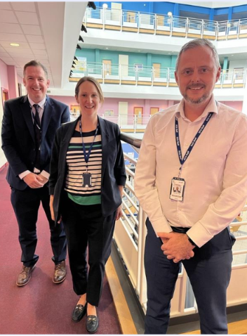 | Tuesdays, Wednesdays and Thursdays | Helen.johnson@derby-college.ac.uk

INTRODUCTION AND COURSE CONTENT

Introduction:

Lively, relevant, controversial… there are many ways to describe A-level Politics. There’s no denying that it’s one of the most interesting and engaging qualifications you can choose.
Covering news and current affairs from the UK and US, it helps you understand how the UK country is run and develops research, written communication and debate skills. It also helps grow your confidence.
It’s ideal if you’re considering studying politics, sociology, ethics, advertising or journalism at university and is highly regarded by employers in industries including politics, international organisations, the media, government and the civil service.

Politics A-level will broaden your awareness and knowledge of on goings in the world. Further, through debates and your assessments you will improve your vocal competence and confidence whilst adhering to an academic writing style. These skills will transfer to any essay-based topics and will be vital for anyone studying in higher education.

Scheme of assessment
Find past papers and mark schemes, and sample papers at aqa.org.uk/pastpapers
Our A-level exams in Politics include questions that allow students to demonstrate their ability to:
- recall information
- draw together information from different areas of the specification
- apply their knowledge and understanding in practical and theoretical contexts.

A-level exams in politics include three broad question types.
9 mark questions require students to explain and analyse different political institutions, processes, concepts, theories and issues prescribed in the specification. Students are required to develop and substantiate at least three points in a structured, analytical answer, making use of appropriate political vocabulary and examples to substantiate their answer.
25 mark extract based questions require students to comprehend and interpret the argument(s) contained in political information, using their knowledge and understanding of the issue to analyse and evaluate the argument(s) put forward. The answer should be balanced, maintain a sustained line of reasoning and lead to a reasoned conclusion, communicated with relevance, clarity and coherence. The political information used in exams may take the form of political publications, government publications, newspaper extracts, manifestos, visual material and data.
25 mark essay questions require students to analyse and evaluate a given statement using their knowledge and understanding of the issue under discussion. The question may draw from different sections of the specification, requiring students to identify and substantiate parallels, connections, similarities and differences between aspects of politics studied. The answer should take the form of a structured and balanced argument, maintaining a sustained line of reasoning, communicated with relevance, clarity and coherence and leading to a reasoned conclusion. The 25 mark essay questions for comparative politics (component 2, section C), will require students to make explicit comparisons between UK and US government and politics.

Aims
Courses based on this specification must encourage students to:
- develop knowledge and an informed understanding of contemporary political structures and issues in their historical context, both within the UK and globally
- develop a critical awareness of the changing nature of politics and the relationships between political ideas, institutions and processes
- develop knowledge and an informed understanding of the influences and interests which have an impact on decisions in government and politics
- develop knowledge and an informed understanding of the rights and responsibilities of individuals and groups
- develop the ability to critically analyse, interpret and evaluate political information to form arguments and make judgements
- develop an interest in, and engagement with, contemporary politics.
Assessment objectives
Assessment objectives (AOs) are set by Ofqual and are the same across all A-level Politics specifications and all exam boards.
The exams will measure how students have achieved the following assessment objectives.
- AO1: Demonstrate knowledge and understanding of political institutions, processes, concepts, theories and issues.
- AO2: Analyse aspects of politics and political information, including in relation to parallels, connections, similarities and differences.
- AO3: Evaluate aspects of politics and political information, including to construct arguments, make substantiated judgements and draw conclusions.

Assessment objective weightings for A-level Politics
Assessment objectives (AOs) | Component weightings (approx %) |  |  | Overall weighting (approx %)
Assessment objectives (AOs) | Paper 1 | Paper 2 | Paper 3 | Overall weighting (approx %)
AO1 | 30-40 | 30-40 | 30-40 | 30-40
AO2 | 35-45 | 35-45 | 35-45 | 35-45
AO3 | 25-35 | 25-35 | 25-35 | 25-35
Overall weighting of components | 33⅓ | 33⅓ | 33⅓ | 100

Assessment weightings
The marks awarded on the papers will be scaled to meet the weighting of the components. Students’ final marks will be calculated by adding together the scaled marks for each component. Grade boundaries will be set using this total scaled mark. The scaling and total scaled marks are shown in the table below.

OVERVIEW OF UNITS/MODULES/TOPICS

Assessment overview
Assessment overview.

Assessment overview and exam information.
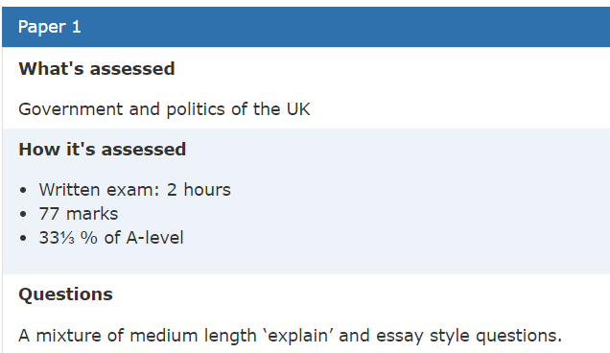
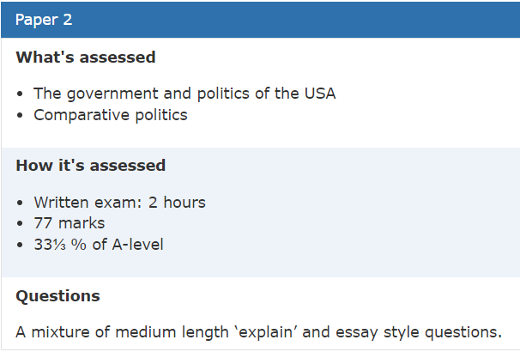
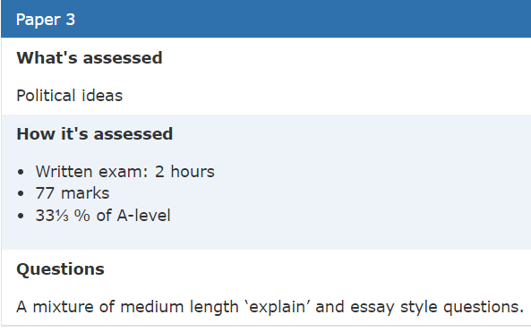

YEAR PLAN OF STUDY

Teacher 1 – Blue
Teacher 2 – Red

Year 1

Autumn 1 | The nature and sources of the British ConstitutionThe structure and role of Parliament  Liberalism
Autumn 2 | The Prime Minister and cabinet  Conservatism
Spring 1 | The judiciary  Democracy and participation  Socialism
Spring 2 | Elections and referendums  Pressure groups  Feminism
Summer 1 | Political parties  The European Union  Feminism
Summer 2 | Devolution  Feminism

Year 2

Autumn 1 | The constitutional framework of US government  The executive branch of government: President
Autumn 2 | The legislative branch of government: Congress  The electoral process and direct democracy
Spring 1 | The judicial branch of government  Political parties  Pressure groups
Spring 2 | Civil rights  Comparative politics (both teachers)
Summer 1 | Revision

KEY INFORMATION ABOUT YOUR COURSE

Length of Study | 5 hours, 37 weeks at college, 2 years.
Your classrooms
Key skills you will be developing during the course to be successful | Subject specific.  - The kind of skills you will have developed include:  - gathering information, assessing and interpreting it  - leading and participating in discussions and groups  - organising workloads and working to deadlines  - developing opinions and ideas  - essay writing, presentation and analytical skills  - reading pages of text and picking out the essential points  - stating a case  - solving problems  - assimilating facts  - expressing yourself clearly (certainly in writing, and probably in person too)
What will lessons look like? | A mixture of engaging in key contemporary political on goings, dissecting fundamental ideas and building our own ideas from this in an essay style format. Debating key ideas and seeing if our arguments can withstand scrutiny.
Informal Assessment Methods | A mixture of questioning, low stakes testing and engagement with exam questions
Essential Equipment/ Resources | AQA Politics  Politics Review - Hodder Education Magazines    Keep up with the news!

ASSESSMENT AND FEEDBACK

Assessment and Feedback
Key Dates – A Level Year 1

Event | Date
Swap, Don’t Drop Deadline | 3rd October 2025
Progression Fair | TBC
Personal Statement Draft Deadline | 22nd May 2026
EPQ (Extended Project Qualification) Start | 9th January 2026
Progression Exam Week | Week Commencing 1st June 2026
Progression Day | 2nd July 2026
Futures Week | Week Commencing 6th July 2026

Formal Assessment Dates

Assessment | Date
Formal Assessment 1 | Week Commencing 3rd November 2025
Formal Assessment 2 | Week Commencing 5th January 2026
Formal Assessment 3 | Week Commencing 23rd February 2026
Formal Assessment 4 | Week Commencing 20th April 2026
Progression Exam (FA5) | Week Commencing 1st June 2026

Referrals Procedures and Resubmissions Procedures

You will have a clear plan of what to expect, what assessments will take place during the year and when you can expect these assessments to happen. You can expect your work to be marked and quality assured where appropriate and returned within 15 working days of submission.

Once you have submitted your work, it will be marked and potentially be quality assured by the Internal Quality Assurance team. This is particularly key where the learning outcomes have not been met and a resubmission opportunity has been given.

Where a referral has been given, by the teacher or assessor will provide you with an opportunity to resubmit. However, you must read the feedback carefully to ensure you are clear of what you need to do and where a graded qualification and assessment is in place what you can attempt. This will be time bound and you will be given a re-submission date by your trainer/assessor/lecturer, and you must meet this deadline.

Academic Malpractice

DCG is keen to support students and avoid any cases of Academic malpractice. Awarding Organisations take matters of academic malpractice very seriously and require all schools and colleges to have specific policies and procedures in place to both educate staff and students about malpractice, thus deterring them from committing it, whether intentional or not, and report and investigate any suspected malpractice where it may occur.

While we don’t want to see anyone jeopardise their grades or marks, we must ensure the validity of all qualifications and we must investigate any suspected breaches fully. It is your responsibility to ensure you understand the rules and boundaries:

- You must not copy from someone else or give opportunities to another student to copy from you.
- Any wording taken from a published source must be correctly referenced for example:
(Morrison, 2000, p29).
- Where computer-generated content has been used (AI tools such as ChatGPT) you must reference these correctly for example: ChatGPT 3.0 (https://openai.com/blog/chatgpt/), 25/01/2024.
- You may also be required to include a bibliography to support referencing.
- You must also avoid working collaboratively with other students beyond what is permitted as this may be deemed to be collusion.

Other examples include:

- Falsification or fabrication of results,
- Deliberate destruction of other student’s work
- Any other act that will give you an unfair advantage. This also relates to not following clear guidance in examinations or assessments where examination conditions exist.

You will be required to complete an Authentication Form on submission of any and all assignments/NEA projects. This will confirm that the work is your own, and that it is referenced appropriately, including the use of AI. Where academic malpractice is suspected, this will be reported to your Team Manager who will conduct an investigation and, where relevant, the Awarding Organisation may also be informed and investigate further. Where malpractice is discovered to have occurred, sanctions may be imposed which could include:

- Zero marks for the work or exam.
- Disqualification from the qualification.
- Disqualification from taking any qualification with that Awarding Organisation often over a set period of time.
- Warnings which can last several years.

For further details and to fully familiarise yourself with JCQ guidance please see the Joint Councils for Qualifications (JCQ) website:
Information for candidates documents - JCQ Joint Council for Qualifications

Further information can be found on the DCG website:
Examination Information - DCG (derby-college.ac.uk)

Appeals Procedures

Each Awarding Organisation will have slightly different processes for appealing decisions. Appeals can be made where:
- You believe that the awarding body policies and procedures have not been followed correctly in respect of external quality assurance/standards verification (policies and procedures can be found on the relevant awarding body website).
- You believe that the awarding body policies and procedures have not been followed correctly in respect of qualification decisions (policies and procedures can be found on the relevant awarding body website).
- You disagree with the outcome of your internal appeals procedure (for example, a decision in relation to reasonable adjustments or assessment outcomes).

However, should you, as a student wish to appeal, firstly:

- Contact your lecturer/trainer/assessor and discuss your concerns.

If you are still not satisfied with the outcome, the College would usually make an appeals application on your behalf. This would require your consent. It is possible to apply directly to the Awarding Organisation but only once the College’s internal processes have been followed. At this point you would be informed of the next stages and Awarding Organisation communication link. This is time bound and this will also be communicated to you once the internal appeals process has taken place.

Note: you must be aware that through this process the initial grade can go up, stay the same, or go down.

KEY EXPECTATIONS

The 5Ps and College code of conduct.

To be successful at Derby College you will be expected to be:
- Positive
- Polite
- Punctual
- Prepared, and
- Professional in your approach.

Please pay attention to the code of conduct, you will be asked to sign a copy to promise you will abide by the College guidelines: Code of Conduct (sharepoint.com)

Derby College has a zero tolerance approach to all forms of bullying, harassment and abuse both online and face-to-face. Statement on Sexual Harassment, Bullying and Online Abuse (sharepoint.com)
If you or anyone else is being bullied, harassed or abused – or if you become aware of discriminatory behaviour or actions taking place – you are encouraged to report this by contacting either your course tutor or https://studentderbycollegeac.sharepoint.com/sites/Welfare/SitePages/Chat-to-a-Welfare-Officer.aspx or call our confidential BULLYING HELPLINE on 01332 387499.

What all students can expect from Derby College Group:

- We will listen to you and take your concern seriously and deal with it in a sensitive manner.
- We will give you support and involve you in any decision that affects you.
- We will take disciplinary action against any student who has harmed you and/or breached the college Code of Conduct.

Key Expectations Politics

What You Can Expect from Us
As your Politics teachers, we are committed to making sure you get the most out of this course. You can expect:
- Lessons that are both engaging and challenging, helping you make sense of real-world political ideas and issues.
- Clear support and guidance throughout the course — including regular feedback on your work and help with how to improve.
- Frequent progress checks, so you always know where you are, what’s going well, and what you can do next to move forward.
- Opportunities to apply what you’ve learned through group tasks, real-life case studies, discussions, and activities that link theory to the politics in the real world.

What We Expect from You
To succeed in A Level Politics, we need you to take an active role in your learning. That means:
- Excellent attendance and punctuality — being in every lesson and arriving on time really matters and makes a big difference to your progress.
- Being prepared for every lesson — this includes bringing your folder, notes, and being ready to take part in class discussions.
- Keeping up with homework and wider reading,— meeting deadlines and showing pride in your work shows maturity and responsibility.
- Staying curious and involved — ask questions, contribute to conversations, and take an interest in the news so you can link lessons to the real world. This means thinking about where your information is coming from such as signing up for updates and access to social media/newspaper pages.

TUTORIALS

Tutorials
- What are these?
- Expectations in group tutorials on this course?
- Expectations in a one to one on this course?

Tutorial Programme

The tutorial programme will pro-actively encourage and nurture students to develop effective behaviours and attitudes, fostering understanding and preparing them as professionals at work and as social contributors in life.

A weekly session which will seek to raise awareness and develop your knowledge of key topics. Students will also be challenged to demonstrate key transferrable skills and exam/assessment ready techniques.

These compulsory sessions are also opportunities for you to get an update on the opportunities arising at college.

Within the tutorial programme, your personal tutor will also meet with you at least every 6 weeks to help offer individualised support and set and review targets.

WORK EXPERIENCE

Work Experience/Placement
Work experience is a key part of your A Level journey. It gives you the chance to see how real politicians or political organisations work, and build valuable skills like communication, teamwork, and problem-solving. It also helps strengthen your CV and UCAS or apprenticeship applications by showing initiative and a genuine interest in the world of work.
You’re expected to complete a meaningful placement or summer school that will enhance your future plans.

🔹 When and Where?
Work Experience Week: Week Commencing 6th July 2026
You’ll organise your placement with a local business or organisation. This could be:
- A local company
- A school office or admin team
- Placements with MPs, councillors, charities, or think tanks.
- A local political organisation
- A summer school eg. Our Programmes - The Sutton Trust
University events (Summer Schools/Residentials)

Enrichment & Super-Curricular Opportunities
Students can strengthen their UCAS applications and future prospects through:
- Essay Competitions – e.g. John Locke Institute, RA Butler Prize (Cambridge), Northeastern University London Essay Competition.
- Debating & Model UN – develops confidence, research, and persuasive argumentation.
- Lectures & Masterclasses – universities often host taster sessions, public lectures, and online seminars.
- Internships & Work Experience –
- Trips & Visits – Parliament, Supreme Court, party conferences, or political museums.
Placements should be confirmed in advance and approved by college.

🔹 Support for Gaining a Placement
If you need help finding or organising a placement, Sophie Ballard is available to support you!
You can contact her:
- On Microsoft Teams
- Or find her in Room F27
She can help with ideas, contacting employers, and getting everything in place.

🔹 Preparation, Recording and Reflection
Before your placement, you’ll complete preparation activities in tutorial – such as writing a professional email, setting goals, and learning about expectations in the workplace.
During your placement, you’ll be expected to:
- Keep a log of your hours
- Reflect on what you’ve learned each day
- Record the skills you’ve developed (e.g. communication, time management)
Afterwards, you’ll complete a short reflection on what you learned and how it connects to your A Level Business studies.

More information can be found on the
Work Experience and Progression Hub (sharepoint.com)

Guest Speakers - We have talks from politicians and academics to discuss their role and the route they took to that position.

A trip to Parliament and the Supreme Court/The Old Bailey which are amongst the options for the London visit that is for the whole year group.

Debate Club - There is a weekly debate club, where you can come and take part (or observe if you are shy - until you feel confident to share your points). The topics are chosen by students and have covered a very wide range of issues – abortion, are ghosts real? should we limit the right to protest?

Engagement with these opportunities is beneficial for you and also reflective of your commitment to your studies. It is also encouraging for the people who are organising it. If there is something that you would like to see happen – then let us know and we can look at how it may be achieved – or support you with setting something up.

There is also an expectation of 5 hours independent study (outside of your lessons for each subject). There is a list of activities that you can do, and these can help go towards achieving the Ad Astra Awards.

LIBRARIES FOR LEARNING

Dive deeper into your subject with our diverse range of information resources.
Boost your knowledge, critical thinking, and digital skills through our dedicated skills hubs and online platforms.
Access expert assistance from our knowledgeable staff to support your learning journey.

The College library holds a vast range of e-books, online databases and physical books to help you in your studies. The simple to use search catalogue allows you to find up to date, relevant and trusted information which you can access or reserve at the click of a button.

Support from an expert team of staff is on hand 8.30-4.30pm each weekday. You can contact them by phone, email, “live chat” or in person at any of our four main sites. We also offer a comprehensive SharePoint page that hosts all our guides in a variety of formats to suit your learning needs. This extends the library to fit in with your working patterns and make sure you have access to information when you need it most.

Key Services
- Independent study spaces, printing and computers
- Course specific textbooks and material
- Expert staff to support with IT, digital access and research needs
- Databases and e-books
- Extensive online information, including access to a 24-7 search catalogue Library SharePoint
- Study skills guides
- Digital skills hub and Study skills hub – self paced online modules with digital badges
- Annual reading challenge
- Leisure reads and wellbeing books

Contact the team
Email: Learningresources@derby-college.ac.uk
Phone: 01332 334848

Specific resources and recommended reading lists to support your learning can be found below:
- Reading Lists (derby-college.ac.uk) learningresources@derby-college.ac.uk

SUPPORT FOR YOUR STUDY SKILLS AT DCG

The Study Skills Hub course includes a wide-ranging selection of information and resources to support the continuing development of your study skills, (the stuff you can easily do to improve your college life and continued learning). You can work through these short modules (see below for a detailed list) and obtain certificates in recognition of your participation.

There are 15 modules, and you will get a Bronze, Silver or Gold certificate when you have completed them. You will get a Bronze for completing the first five, a Silver for also completing the next five and a Gold for completing all the modules.

Links to the complete course and individual modules are listed below:

Study Skills Hub (complete course)
Bronze | Silver | Gold
Note Taking | Primary and Secondary Sources | Presentation Skills
Managing your Time | Learning from Feedback and Reflective Practice | Using Artificial Intelligence (AI) as a Study Aid
Starting Research | Copyright and Intellectual Property | Preparing for Assessments or Exams
Referencing and Plagiarism | Continuing Research | Better Thinking
Better Learning | Critical Thinking | Independent Learning



All modules are supported by the Libraries for Learning Team so please contact them at learningresources@derby-college.ac.uk if you would like any additional support or information – they are here to help!

SUPPORT FOR YOUR DIGITAL SKILLS AT DCG

Our online Digital Skills Hub courses include a wide-ranging selection of information and resources to support the continuing development of your Digital Skills from the time you start with us at DCG to the time you move on.

Digital Skills: Getting Started

There are 18 modules and you will get a Bronze, Silver or Gold certificate when you have completed them. You will get a Bronze for completing the first six modules, a Silver for also completing the next six and a Gold for completing all the modules.

For details and access to the course, go to the Getting Started course page

Digital Skills: Progressing

This course focusses in further on your digital skills knowledge and awareness. Again there are 18 modules with three levels of achievement. Completing the first 6 will get you a bronze certificate, the first 12 will get you silver and achieving all will get you the gold.

For details and access to the course, go to the Progressing course page

All modules are supported by the EdTech Team so please contact them at edtech@derby-college.ac.uk if you have any issues trying to login, access or complete the courses.

STUDENT VOICE

There is no bigger group of people than students in the classroom! Therefore, listening to students is essential.

Student Voice refers to listening to what YOU think and feel during your time in education at DCG. This is not just about the College listening, but also about acting upon, your feedback.

We want to know:
- Positives – what you enjoy and want to do again,
- Improvements – what and how we can change to improve,
- New Ideas – we are always looking for student-led initiatives.

We listen to students through...
- Cross College Surveys
- Focus Groups
- Student Voice Meetings
- And The Student Representative System.

What is a Student Representative?

Student Representatives or Student Reps are volunteers representing the opinions and suggestions of the students in their class. Student Reps gather the feedback from their class and pass that information to their Academy Representatives and leaders within the college. This is an outstanding experience to add to your CV, job application, or UCAS form.

What are Academy Reps?

This is a senior volunteer role and represents the views of students in the whole Academy, rather than just the class. Academy reps present feedback from Student Reps in their Academy to the senior leadership team (the people who lead the whole college).

Want to learn more about Student Voice?

- The Student Voice Coordinator will be visiting YOU in tutorial sessions this October.
- Contact Pippa Lucas (She/Her), Student Voice Coordinator, with any questions you may have via the email below.

Email - studentvoice@derby-college.ac.uk

GLOSSARY OF TECHNICAL TERMS

The following list is a brief glossary of terms you will learn or be exposed to during your learning in order to develop your
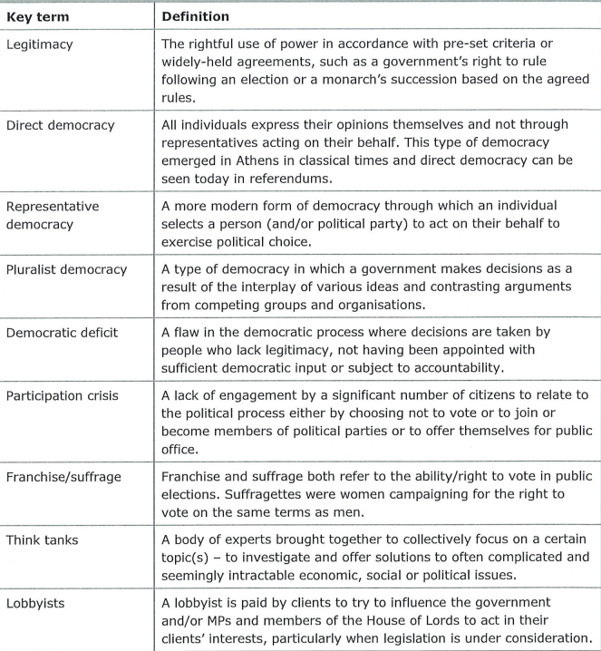

YOUR NEXT STEPS OPPORTUNITIES

Your next steps opportunities when you successfully achieve your chosen study program / course.

Next Steps Opportunities Guide – A Level Politics

Higher Education Pathways
Studying Politics at A level opens the door to a wide range of university courses, including:
- Politics / Political Science – in-depth study of government, ideologies, and political systems.
- International Relations – focus on diplomacy, conflict, and cooperation between states.
- Law – development of analytical and debating skills suited to legal training.
- Economics or PPE (Philosophy, Politics, and Economics) – interdisciplinary courses at leading universities.
- History / Sociology / Criminology – subjects with strong overlaps in themes of power, society, and justice.
- Journalism / Media Studies – pathways into political reporting and media analysis.

Career Opportunities
A Level Politics equips students with transferable skills (critical thinking, communication, research, debating) that are valued in many sectors. Common career routes include:
- Government and Civil Service – policy analysis, political advising, or public administration.
- Law – solicitor, barrister, or legal researcher.
- Journalism and Media – political reporting, broadcast journalism, or campaign communications.
- International Organisations / NGOs – human rights advocacy, international development, or environmental policy.
- Business and Finance – roles that require analytical and decision-making skills.
- Education – teaching or academic research in Politics or related fields.

Skills Development for the Future
Politics students should continue to strengthen:
- Analytical skills – evaluating complex arguments and sources.
- Communication skills – writing clear, structured essays and debating effectively.
- Research skills – using academic sources, statistics, and case studies.
- Digital literacy – managing information critically in an online world.

Suggested Next Steps for Students
- Attend university open days to explore Politics-related courses.
- Enter at least one essay competition or debating event during Year 12/13.
- Arrange work experience with a local MP, councillor, or political organisation.
- Read quality news sources (e.g. The Economist, BBC Politics, The Guardian, The Times) to stay informed.
- Build a super-curricular portfolio (lectures, competitions, enrichment activities) to showcase in UCAS applications.

NOTES

