Year 1 and 2 Student Handbook
A-LEVEL CURRICULUM AREA
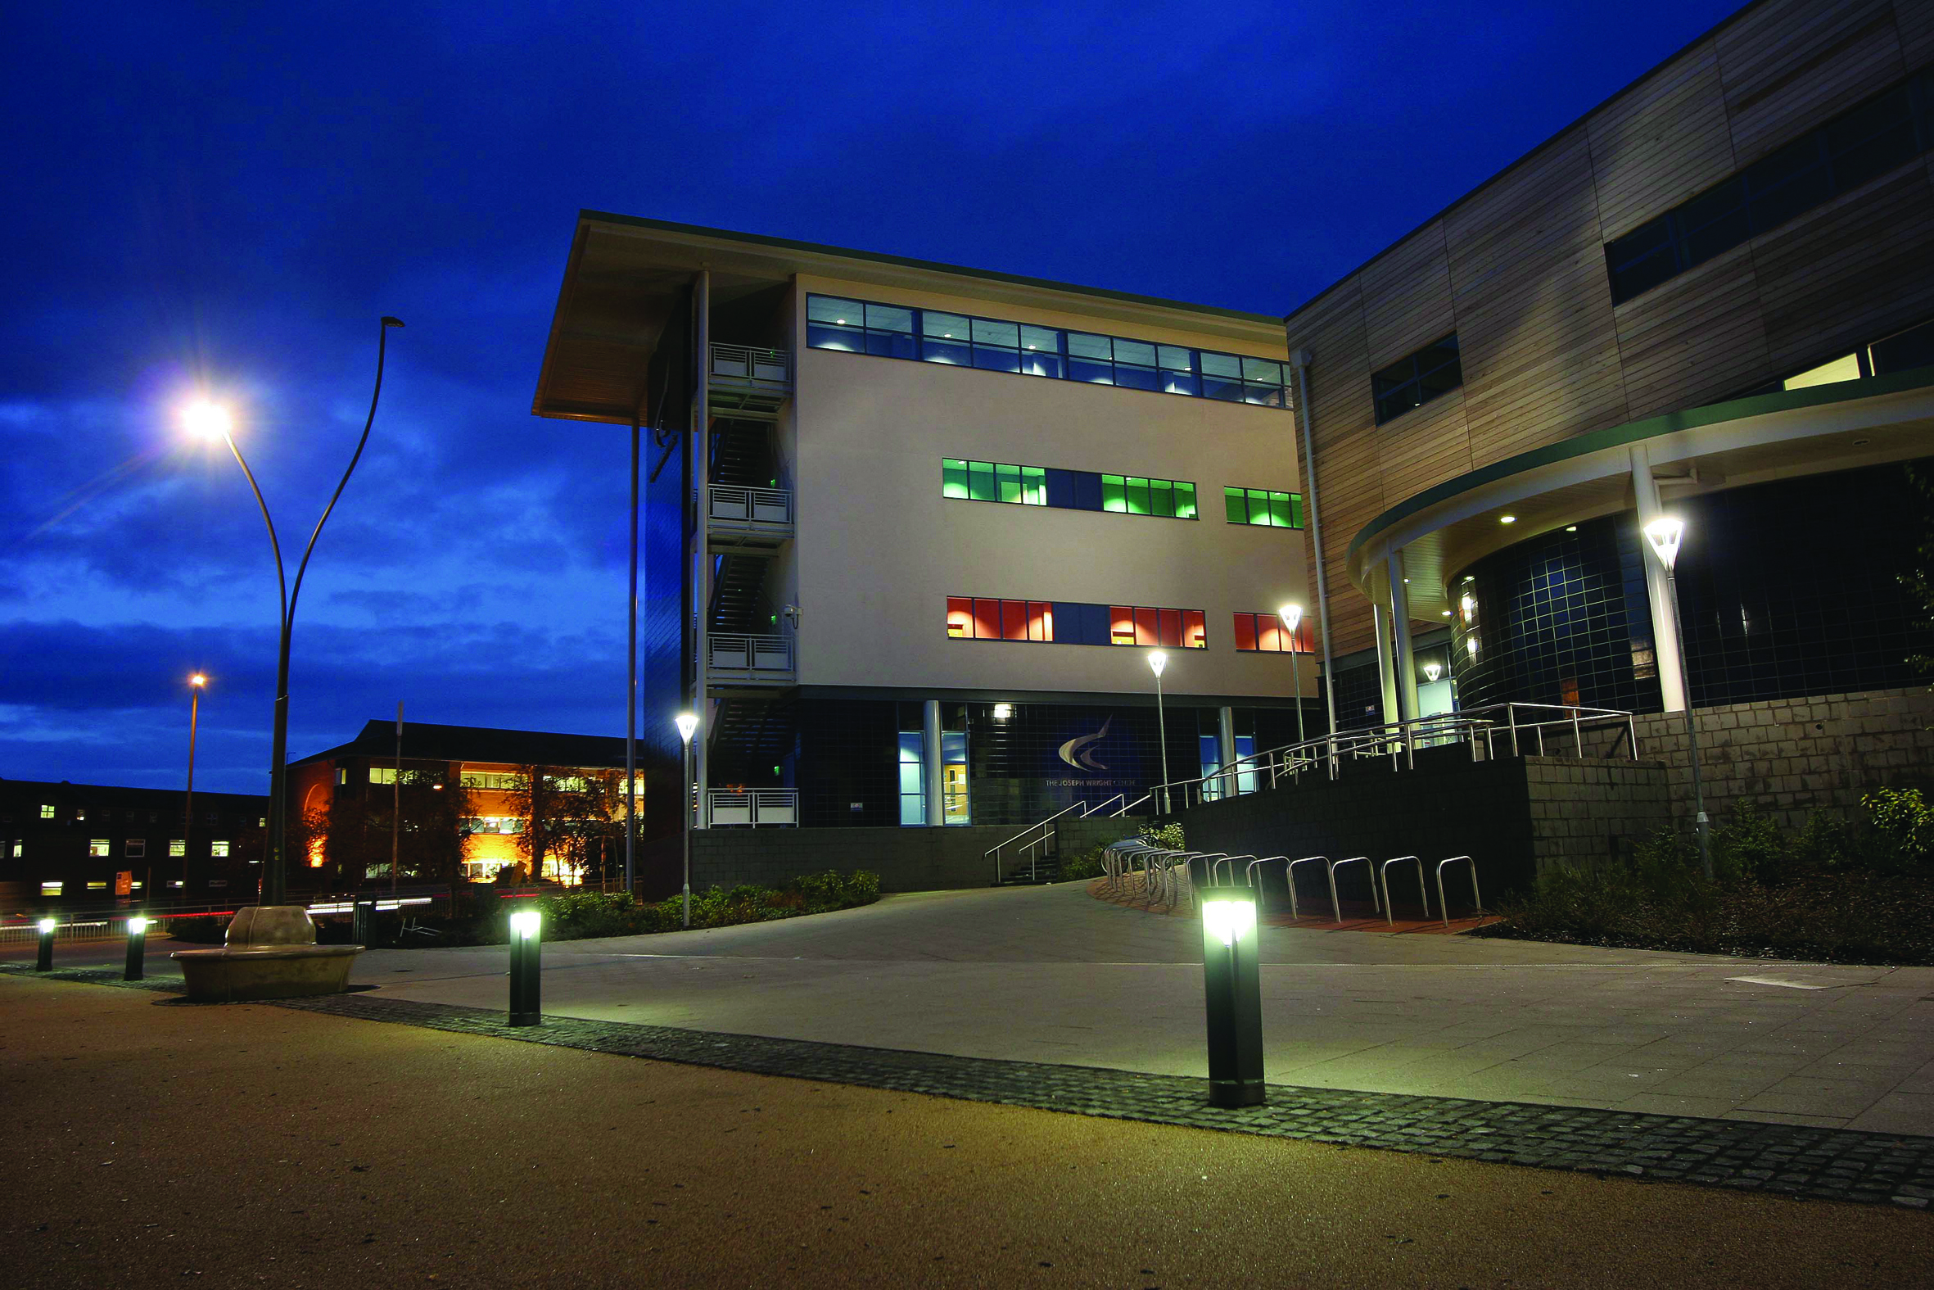

CONTENTS

WELCOME TO DCG 3
INTRODUCTION TO THE TEAM 4
EMERGENCY PROCEDURE 4
COLLEGE CALENDAR 6
KEY DATES 7
PROGRAMME OF STUDY 8
EXPECTATIONS 10
A LEVEL: SUCCESSFUL LEARNER HABITS 13
SUPPORT FOR STUDENTS 15
EXAM INFORMATION 16
STUDENT VOICE 17
RESOURCES FOR STUDENTS 18
SUPPORT TO DEVELOP YOUR STUDY SKILLS 19
SUPPORT TO DEVELOP YOUR DIGITAL SKILLS 20
INFORMATION FOR PARENTS 21
TERMINOLOGY GLOSSARY 22

WELCOME TO DCG

Warm welcome….

A very warm welcome to the A-level department at The Joseph Wright Centre, part of the Derby College group.

Our flourishing A-level centre offers a comprehensive range of subjects ensuring you can choose a selection of subjects that align best with your interests, talents and future progression routes.

Our enthusiastic group of expert teachers and experienced pastoral team are itching to welcome you as you embark on your next big adventure.

As you will quickly observe, students who study at the Joseph Wright Centre pride themselves on their passion for their subjects, their respectful behaviour and their professional approach to learning.
Students on the A-level programme embrace the step up from GCSE and work well with their teachers to meet higher expectations. They attend well, work hard and seek feedback from teachers on how to improve.

Our A-level results in recent years have demonstrated how our outstanding teaching and support teams collaborate with students to help them reach their full potential. A-level results day in 2026 was a particularly proud moment for the college, as we celebrated and gave students a memorable send-off before they transitioned to university courses or began their apprenticeships.

This handbook aims to provide you with some important information and alongside your individual subject handbooks will reveal the habits and routines necessary to achieve your best on an A-level programme.

I wish you all the best with your studies during your time at the Joseph Wright Centre.



Sally Archer
Head of A-levels and Academic Education.
Based in S24.

INTRODUCTION TO THE MANAGEMENT TEAM

Rajni Rampal
Curriculum Manager: English, the arts and Languages
A Levels in English Literature, English Language, Film Studies, Fine Art, French, Media Studies, Spanish and Textiles, BTEC Music Performance and the Extended Project Qualification, Level-3-Certificate-in-Speech-Grade-8.
Teacher: Psychology
Based in G19.


Ann Hopley-Dodd
Curriculum Manager: Social Sciences, A Level Sociology and A Level Psychology, Diploma in Criminology and BTEC Extended Certificate in Applied Psychology
Teacher: Criminology
Based in G19.


Ross Holmes
Curriculum Manager: Humanities
A Levels in Business, Economics, Geography, History, Politics, Religious Studies, Law and the BTEC Applied Law.
Teacher: History & Politics.
Based in G19.



Patrick Ring
Curriculum Manager: STEM
A Levels in Biology, Chemistry, Computer Science, Geology, Mathematics, Physics and the Certificate in MathematicalStudies(CoreMaths)
Teacher:(AAQ)AppliedScience
Based in G19

EMERGENCY PROCEDURE

Let’s start with the most important information – keeping you safe!

Fire alarms
If the fire alarm sounds continuously, it is essential that you:
- Leave the building immediately by the nearest safe exit
- Don’t stop to collect your belongings and do not use the lifts
- Report to your assembly point
- Do not re-enter the building until told to do so by a member of staff.

If you discover a fire, tell the first member of staff you see and sound the alarm. Leave the building by the
nearest safe exit and report to your assembly point.

If you will need help to get out of the building quickly make sure you tell staff during your induction so that a
Personal Emergency Evacuation Plan (PEEP) can be put in place for you.

First aid or feeling ill.
If you feel ill or have an accident in College, speak to the nearest member of staff. They will contact a first-aider or get you an ambulance if this is necessary. Staff can’t give you any medication, but they will be able to provide advice and emergency first aid, including arranging other help if appropriate. If you see anyone appearing to cause harm to themselves or others, please report this to a member of staff immediately.

Reporting accidents
If you think you have seen an accident or something that was nearly an accident, the College really needs to know about it! Make sure you tell a member of staff as soon as possible so the area can be made safe. In turn the member of staff will contact the Environmental Compliance Team to reduce the risk of the accident happening again.
Unidentified individuals
- Are they wearing a college ID badge?
- Can they account for their whereabouts?
- Have you seen them before on site?
- Are they confident in their actions?
- Do they have any memorable characteristics?

If you suspect anyone report them to a member of staff, giving your details, location, date and time. It may not
be relevant now but may be in the future!

Firearms and weapons attack
RUN
If there is safe route, run, if not, hide.
HIDE
- Be aware of your exits
- Try not to get trapped
- Lock yourself in a room if you can
- Move away from the door
- Be very quiet, turn off your phone
- Barricade yourself in
TELL
Dial 999 when you are safe. Give your location and as much information as possible.



COLLEGE CALENDAR

Autumn Term
• Teaching begins: Monday 7 September 2026
• Subject choice confirmation deadline: Friday 2 October 2026
• Half term: 26 to 30 October 2026
• Last teaching day: Friday 18 December 2026
Spring Term
• Teaching begins: Tuesday 5 January 2027
• Half term: 15 to 19 February 2027
• Last teaching day: Thursday 25 March 2027
Summer Term
• Teaching begins: Monday 12 April 2027
• College closure (Bank Holiday): Monday 3 May 2027
• Half term: 31 May to 4 June 2027
• Last teaching day: Friday 2 July 2027

KEY DATES

Key Dates

A-Level Year 1:
- Swap, Don’t Drop:
Deadline for swapping A-Level subjects: 2nd October 2026.
- Progression Fair: TBC
- Personal Statement Draft Deadline: 28th May 2026
- Extended Project Qualification Start: 8th January 2027.
- Progression Exam Week: w/c 24th May 2027.
- Progression Day: 2nd July 2027.
- Project Week w/c 28th June 2027.

Formal Assessment Dates:
- Formal Assessment 1: w/c 2-11-26
- Formal Assessment 2: w/c 4-1-27
- Formal Assessment 3: w/c 22-2-27
- Formal Assessment 4: w/c 12-4-27
- Progression Exam (FA5): w/c 24-5-27

A-Level Year 2:
- UCAS: Early Deadline: 15th October 2026
- UCAS: A-Level Target: 3rd November 2026
- UCAS: College Deadline: 28th November 2026.
- Progression Fair: TBC
- EPQ submission deadline: Around October Half Term.
- A level Exam Period begins: 10th May 2027
- Exam Period ends: 26th June 2027
- A-Level Results Day: 12th August 2027.

Formal Assessment Dates:
- Formal Assessment 1: w/c 5th October 2026
- Formal Assessment 2: w/c 23rd November 2026.
- MOCK EXAM WEEK (FA3): w/c 25th January 2027
- Formal Assessment 4: w/c 8th March 2027.
- Summer 2027 Exam Series From 10th May 2027 until 23rd June 2027 (to be confirmed)

PROGRAMME OF STUDY

A-level Programme of Study is one that is unique to you.

The following is a brief depiction of your A-level study programme. What you should see from the below is that an A-level programme of study is:

- Individual to you. You have significant choice in the subject combinations to choose from but also the enriching additions you can participate in. Speak to teachers, managers and support professionals to ensure you choose the right subject and enrichment combination choice for you.
- Aspirational. What you get out of an A-level programme is determined by what you choose to participate in. Choose to be aspirational and get involved! We live in a competitive world and employers and universities like to see students go above and beyond.

- Supportive. Whilst A-levels are challenging and adding enriching additions will add to the time you are committing to, you will recognise that there is a significant number of individuals here to support you. Ensure you are familiar with these support teams and that you use their support as and when needed.

Main Programme​
Choose 3 A level or equivalent subjects​
All students will be enrolled to a tutorial programme

Mix and match ​28 subjects​
5 GCSE grades including English at grade 5 and Maths at grade 4

4th A-level Subject.
Never necessary and only accepted students with an average GCSE grade 8+​
Core Maths
Opportunity to extend your Maths knowledge/ quals beyond GCSE.
The Extended Project Qualification (EPQ)
Wonderful project you can individualise to you.
Enrichment

Competitions

Work Experience
Trips and Visits
Personal Tutor

Pastoral Coaches

Welfare and Safeguarding
Inclusion

Careers Team
Work Placement Team
Apprenticeship Team
DanCop Study Skills
Subject Catch Up Coaches
DC Students Union
Student Services
Financial Support
UCAS Support

Guest Speakers

Additional Options:

Enriching additions:

Support From:

Libraries For Learning Team

Tutorial Programme

The tutorial programme will pro-actively encourage and nurture students to develop effective behaviours and attitudes, fostering understanding and preparing them as professionals at work and as social contributors in life.

A weekly session which will seek to raise awareness and develop your knowledge of key topics. Students will also be challenged to demonstrate key transferrable skills and exam ready techniques.

These compulsory sessions are also opportunities for you to get an update on the opportunities arising at college.

Within the tutorial programme, your personal tutor will also meet with you at least every 6 weeks to help offer individualised support and set and review targets.

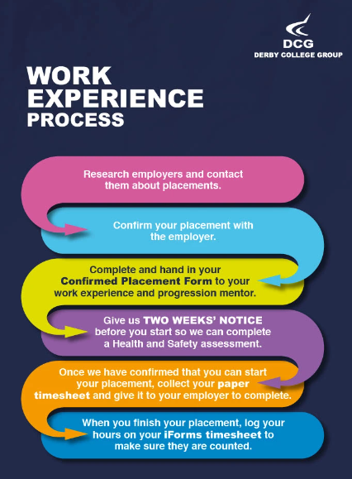
Work Placement

Whilst not a mandatory criterion to return to Year 2, work experience represents an important part of any application to university or apprenticeships.

Each student is challenged to organise the work experience placement themselves.

Students should consider the industry area they would like to transition to but also what skills and experiences would benefit them before entering their careers.

The A-Level Future’s Week whereby students are given time for Work Experience is w/c 7th July 2025.

The process students need to complete is on the right. More information can be found on the
Work Experience and Progression Hub (sharepoint.com)

EXPECTATIONS

ENRICHMENT

All students are challenged to engage in enrichment around their A-level studies. Students may take advantage of college run enrichment activities to help broaden their horizons, demonstrate developing attributes and skills or to have fun with likeminded peers.

Students may also evidence out of college activities through our Ad Astra scheme. This programme aims to broaden students' experiences and skills beyond the academic curriculum, preparing them for university or future careers.


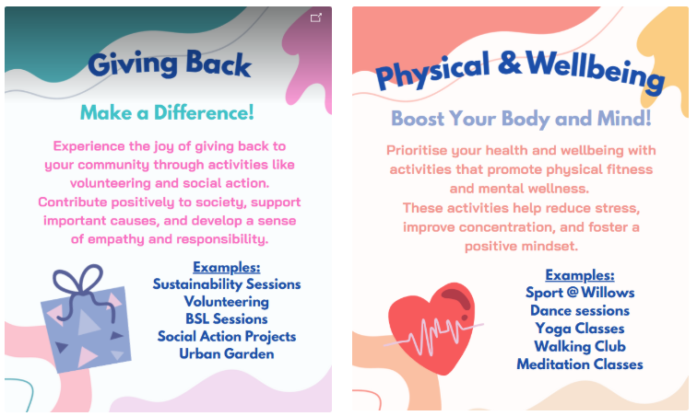

EXPECTATIONS

Watch: The 5Ps of Professional Behaviour (youtube.com)
The 5Ps and College code of conduct.
To be successful at Derby College you will be expected to be:
- Positive
- Polite
- Punctual
- Prepared, and
- Professional in your approach.

Please pay attention to the code of conduct, you will be asked to sign a copy to promise you will abide by the College guidelines: Code of Conduct (sharepoint.com)

Derby College has a zero tolerance approach to all forms of bullying, harassment and abuse both online and face-to-face. Statement on Sexual Harassment, Bullying and Online Abuse (sharepoint.com)
If you or anyone else is being bullied, harassed or abused – or if you become aware of discriminatory behaviour or actions taking place – you are encouraged to report this by contacting either your course tutor or https://studentderbycollegeac.sharepoint.com/sites/Welfare/SitePages/Chat-to-a-Welfare-Officer.aspx.

What all students can expect from Derby College Group:
- We will listen to you and take your concern seriously and deal with it in a sensitive manner.
- We will give you support and involve you in any decision that affects you.
- We will take disciplinary action against any student who has harmed you and/or breached the college Code of Conduct.

Absence reporting.

Students are expected to strive to achieve 100% attendance for all sessions however if you are unable to attend College students MUST notify the College as soon as possible by completing an online Student Absence Form. More information is here: STUDENT ABSENCE/LATENESS REPORTING - DCG (derby-college.ac.uk)

The Absence Report form is here: Report your absence here (derby-college.ac.uk). The form needs to be completed on each day of absence

The attendance policy can be found here: Attendance and Progression (sharepoint.com)

Independent Learning

A key element of any A-Level programme of study. How disciplined you are with your independent study will likely be the biggest influence on whether you achieve your potential or not.

The best performing students study for 5 hours per subject per week outside of classes.

Whilst teachers dictate some of this study, students are expected to develop routines of setting themselves
tasks to help them:
- Remember and recall the topics learnt in class. (E.g. revision cards)
- Practice the skills needed to perform well in exams. (E.g. Past paper question planning/completion)
Those students that do not develop a routine of studying outside of class are likely to underperform.

Assessment Methods

As an A-level student you have a number of different subjects to choose from and each subject will have specific requirements, these will include:
- Examination. Most traditional A-Level subjects are mostly or comprehensively assessed by examination Exam papers range from 1 hour to 3 hours and students have strict rules to adhere to.
- NEA. Non-exam assessment is offered in a few, often Creative or Humanities subjects, and accounts for a small proportion a students overall grade. This is a set task that students complete independently. Teachers can only provide minimal guidance and support.
- Assignments. For those subjects such as Applied Law, Applied Psychology, Applied Science, Music Performance and Sport and Exercise Science students are required to submit formal assignments that contribute to their overall grade. This can often be resubmitted if it does not meet required standards.
- Controlled Assessments. Certain subjects, e.g. Criminology have a controlled assessment, which is an extended task, under exam conditions over an extended period of time.

All subjects will include a range and variety of assessments designed to support students to improve, these will not directly contribute to a student’s overall grade but will underpin their development.

Formal Assessment, Feedback and Goal Setting
Students will regularly prepare for, and complete, Formal Assessments (roughly every 6 weeks). Please find the dates above or in Markbook (note some may be different for each subject).
Students are expected to prepare thoroughly for each Formal Assessment (FA) to ensure it is a true reflection of their ability and progress.

Following each FA, students will
- Receive clear feedback in terms of What Went Well and Even Better If given by their teachers
- Receive their feedback within two weeks of their formal assessment date
- Be provided with Dedicated Improvement and Reflection Time (D.I.R.T) in their subject classes to quickly demonstrate improvements based on the feedback
- Create an academic goal on ProPortal which reflects how improvement will be made in the next FA
- Be challenged and supported by personal tutors to achieve their goal in 1:1 tutorial time.

Students that underperform against their target grade may be provided with additional support and may be asked to attend additional sessions. For that reason, it is essential that students do their best to prepare for their formal assessments.

Academic Malpractice
DCG is keen to support students and avoid any cases of Academic malpractice. Awarding Organisations take matters of academic malpractice very seriously and require all schools and colleges to have specific policies and procedures in place to both educate staff and students about malpractice, thus deterring them from committing it whether intentional or not and report and investigate any suspected malpractice where it may occur.

Examples of malpractice include plagiarism; this is where work is copied directly or paraphrased from another source without referencing. Plagiarism also includes work created using artificial intelligence (AI) tools such as ChatGTP and submitted as a students’ own work without proper referencing of the AI source. It could also include copying another student’s work or allowing another student to copy your work.

Other examples include:
- Falsification or fabrication of results,
- Deliberate destruction of other student’s work
- Any other act that will give you an unfair advantage. This also relates to not following clear guidance in examinations or assessments where examination conditions exist.

Where academic malpractice is suspected, this will be reported to your Team Manager who will conduct an investigation and, where relevant, the Awarding Organisation may also be informed and investigate further. Where malpractice is discovered to have occurred, sanctions may be imposed including the potential to be disqualified from the qualification.

Appeals Procedures

Each Awarding Organisation will have slightly different processes for appealing decisions. Appeals can be made where:
- You believe that the awarding body policies and procedures have not been followed correctly in respect of external quality assurance/standards verification (policies and procedures can be found on the relevant awarding body website).
- You believe that the awarding body policies and procedures have not been followed correctly in respect of qualification decisions (policies and procedures can be found on the relevant awarding body website).
- You disagree with the outcome of your internal appeals procedure (for example, a decision in relation to reasonable adjustments or assessment outcomes).

However, should you, as a student wish to appeal, firstly:
- Contact your lecturer/trainer/assessor and discuss your concerns.

If you are still not satisfied with the outcome, the College would usually make an appeals application on your behalf. This would require your consent. It is possible to apply directly to the Awarding Organisation but only once the College’s internal processes have been followed. At this point you would be informed of the next stages and Awarding Organisation communication link. This is time bound and this will also be communicated to you once the internal appeals process has taken place.

Note: you must be aware that through this process the initial grade can go up, stay the same, or go down.

Progression Criteria: Passport to Progression.

A-levels are a two-year challenge; however, the foundation of success is built in year 1. To ensure students do not coast and to ensure they are focused on improving their knowledge and skills, we set minimum criteria to ensure students achieve their passport to progression.

These criteria are:
- Achieve a D grace or Merit or above in Year 1 Progression exams or Year 1 qualification. Universities/Apprenticeships may use these grades alongside other formal assessments when making offers, it is important to take them seriously.​
- 93% attendance including authorised absences. Overall attendance, including tutorial, is a key measure of your commitment to meet your potential.
- A ‘committed’ attitude to learning grade in Progress Log 3 and beyond. This considers effort levels inside and outside of class measured by ability to meet deadlines, preparation for assessments and how proactive you are at studying.​
- A reasonable plan of your intentions after A-levels. For example, have you identified 5 university choices or apprenticeship positions and submitted a revised draft personal statement by May half term.

What ifs:
- If a student achieves below a grade D / Merit in the year 1 exams, their average grade from formal assessments and/or homework activities will be considered.
- If a student doesn’t not meet 93% or above attendance for the year, attendance after February Half Term will be considered.

If a student doesn’t meet the progression criteria:
- A meeting may be called with either the Assistant Principal, Curriculum Manager or Coordinator for that subject. ​
- It may indicate that students are not on the best route to reach their intended destination and may therefore be supported to transition onto a vocational course elsewhere in the college or to gain an apprenticeship. ​​

A LEVEL: SUCCESSFUL LEARNER HABITS

The importance of attendance.

As part of your Student Agreement at Derby College, you are expected to:
- Achieve 100% attendance for all lessons, including your tutorial sessions.
- Arrive punctually at all classes for which you have enrolled.
- Take part in any additional activities as necessary, such as work experience, enrichment and sitting appropriate examinations.

Every absence represents lost learning and students can often feel under pressure to ‘catch up’ with that
missed learning. High or flawless attendance is the most efficient route to higher grades and will support
positive mental health.

Add value by studying effectively outside of class.

A key element of any A-level programme of study - how disciplined you are with your independent study will likely be the biggest influence on whether you achieve your potential or not.

The best performing students study for 5 hours per subject per week outside of classes.

Whilst teachers dictate some of this study, students are expected to develop routines of setting themselves tasks to help them:
- Remember and recall the topics learnt in class. (E.g. revision cards)
- Practise the skills needed to perform well in exams. (E.g. Past paper question planning/completion)
Those students that do not develop a routine of studying outside of class are likely to underperform.

We use the acronym STRIDE to identify to students behaviour that leads to success:

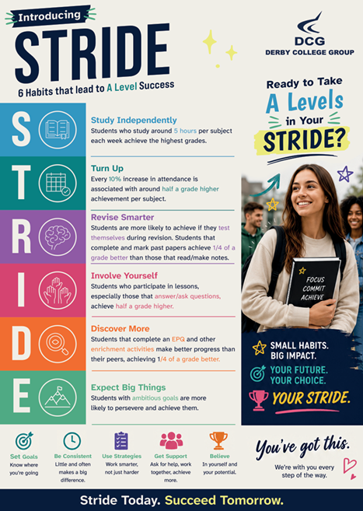

SUPPORT FOR STUDENTS
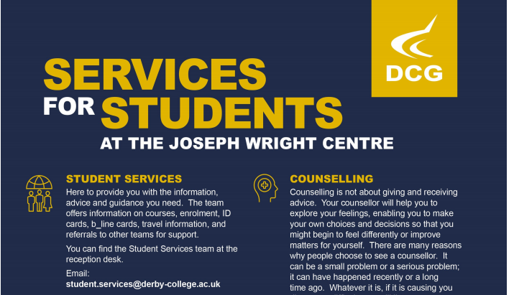


EXAM INFORMATION

Vocational, BTEC and Applied Subjects: Referrals Procedures and Resubmissions Procedures

If you study one of our BTEC, Applied or Vocational subjects there are strict guidance you need to follow.

You will have a clear plan of what to expect, what assignments will take place during the year and when you can expect these assignments to happen. You can expect your assignments to be marked and quality assured where appropriate and returned within 15 working days of submission.

Once you have submitted your assignments, it will be marked and potentially be quality assured by the Internal Quality Assurance team. This is particularly key where the learning outcomes have not been met and a resubmission opportunity has been given.

Where a referral has been given, by the teacher or assessor will provide you with an opportunity to resubmit. However, you must read the feedback carefully to ensure you are clear of what you need to do and where a graded qualification and assessment is in place what you can attempt. This will be time bound and you will be given a re-submission date by your trainer/assessor/lecturer, and you must meet this deadline.

Exam Access Arrangements

Access Arrangements are pre-examination adjustments for candidates based on evidence of need and normal way of working.

Access Arrangements allow candidates/learners with special educational needs, disabilities or temporary injuries to access the assessment without changing the demands of the assessment. For example, readers, scribes and Braille question papers. In this way Awarding Bodies will comply with the duty of the Equality Act 2010 to make ‘reasonable adjustments’. Please liaise with your personal tutor to provide evidence if you have received exam arrangements previously during your GCSE courses.

Exam Locations

In 2026/27 final examinations were based at the Roundhouse; however, for 2026/27 alternative locations are being investigated. If changes are necessary, we’ll also look to ensure Mock Exam weeks are based at the new location too. More information will be provided soon into your course.

Results Day

The next A-level results will be released on Thursday 12th August 2027.

We will be issuing physical statement of results from 07:45 until 11.00am in the atrium at the Joseph Wright
Centre. All students are asked to ensure they are available on the morning to celebrate with your teachers and where necessary receive specialist support from our careers team to access the UCAS clearing system.

Certificates.

Certificates are released to centres following the conclusion of the post results services. This tends to be towards the end of October/beginning of November. These will then be posted to students to the address we hold on our system so please ensure that the college holds an up-to-date address for you as any replacement of certificates is the responsibility of the student. If you have an exam related query, please do not hesitate to contact our exams team by email: examsgroup@derby-college.ac.uk

STUDENT VOICE

There is no bigger group of people than students in the classroom! Therefore, listening to students is essential.

Student Voice refers to listening to what YOU think and feel during your time in education at DCG. This is not just about the College listening, but also about acting upon, your feedback.

We want to know:
- Positives – what you enjoy and want to do again,
- Improvements – what and how we can change to improve,
- New Ideas – we are always looking for student-led initiatives.

We listen to students through...
- Cross College Surveys
- Focus Groups
- Student Voice Meetings
- And The Student Representative System.

What is a Student Representative?
Student Representatives or Student Reps are volunteers representing the opinions and suggestions of the students in their class. Student Reps gather the feedback from their class and pass that information to their Academy Representatives and leaders within the college. This is an outstanding experience to add to your CV, job application, or UCAS form.

What are Academy Reps?
This is a senior volunteer role and represents the views of students in the whole Academy, rather than just the class. Academy reps present feedback from Student Reps in their Academy to the senior leadership team (the people who lead the whole college).

Want to learn more about Student Voice?

- The Student Voice Coordinator will be visiting YOU in tutorial sessions this October.
- Contact Pippa Lucas (She/Her), Student Voice Coordinator, with any questions you may have via the email below.

Email - studentvoice@derby-college.ac.uk

LIBRARIES FOR LEARNING

Dive deeper into your subject with our diverse range of information resources.
Boost your knowledge, critical thinking, and digital skills through our dedicated skills hubs and online platforms.
Access expert assistance from our knowledgeable staff to support your learning journey.
The College library holds a vast range of e-books, online databases and physical books to help you in your studies. The simple to use search catalogue allows you to find up to date, relevant and trusted information which you can access or reserve at the click of a button.

Support from an expert team of staff is on hand 8.30-4.30pm each weekday. You can contact them by phone, email, “live chat” or in person at any of our four main sites. We also offer a comprehensive SharePoint page that hosts all our guides in a variety of formats to suit your learning needs. This extends the library to fit in with your working patterns and make sure you have access to information when you need it most.

Key Services
- Independent study spaces, printing and computers
- Course specific textbooks and material
- Expert staff to support with IT, digital access and research needs
- Databases and e-books
- Extensive online information, including access to a 24-7 search catalogue Library SharePoint
- Study skills guides
- Digital skills hub and Study skills hub – self paced online modules with digital badges
- Annual reading challenge
- Leisure reads and wellbeing books

Contact the team
Email: Learningresources@derby-college.ac.uk
Phone: 01332 334848

Specific resources and recommended reading lists to support your learning can be found on the course handbooks:
- Reading Lists (derby-college.ac.uk)
- learningresources@derby-college.ac.uk

SUPPORT FOR YOUR STUDY SKILLS AT DCG

The Study Skills Hub course includes a wide-ranging selection of information and resources to support the continuing development of your study skills, (the stuff you can easily do to improve your college life and continued learning). You can work through these short modules (see below for a detailed list) and obtain certificates in recognition of your participation.

There are 15 modules, and you will get a Bronze, Silver or Gold certificate when you have completed them. You will get a Bronze for completing the first five, a Silver for also completing the next five and a Gold for completing all the modules.

Links to the complete course and individual modules are listed below:

Study Skills Hub (complete course)
Bronze | Silver | Gold
Note Taking | Primary and Secondary Sources | Presentation Skills
Managing your Time | Learning from Feedback and Reflective Practice | Using Artificial Intelligence (AI) as a Study Aid
Starting Research | Copyright and Intellectual Property | Preparing for Assessments or Exams
Referencing and Plagiarism | Continuing Research | Better Thinking
Better Learning | Critical Thinking | Independent Learning



All modules are supported by the Libraries for Learning Team so please contact them at learningresources@derby-college.ac.uk if you would like any additional support or information – they are here to help!

SUPPORT FOR YOUR DIGITAL SKILLS AT DCG

Our online Digital Skills Hub courses include a wide-ranging selection of information and resources to support the continuing development of your Digital Skills from the time you start with us at DCG to the time you move on.

Digital Skills: Getting Started

There are 18 modules and you will get a Bronze, Silver or Gold certificate when you have completed them. You will get a Bronze for completing the first six modules, a Silver for also completing the next six and a Gold for completing all the modules.

For details and access to the course, go to the Getting Started course page

Digital Skills: Progressing

This course focusses in further on your digital skills knowledge and awareness. Again there are 18 modules with three levels of achievement. Completing the first 6 will get you a bronze certificate, the first 12 will get you silver and achieving all will get you the gold.

For details and access to the course, go to the Progressing course page

All modules are supported by the EdTech Team so please contact them edtech@derby-college.ac.uk if you have any issues trying to login, access or complete the courses.

INFORMATION FOR PARENTS

Parents website and FAQ

Visit the parents section of our website: https://www.derby-college.ac.uk/parents and read the parents FAQ for information on what to expect from the College, what happens when your son/daughter starts College and the support we offer. We hope you will find the answers to most of your questions online. However, if you need any more advice, you can contact us on: 0800 028 0289.

Parents Portal
We have a dedicated online Parents Portal for you to log onto. The Parents Portal enables you to view your child’s live attendance, progress reports and Targets. You will need their Student ID number (found on their ID badge) and date of birth to log on.

To access the Parents Portal:
- Log on to using this link: http://moodle.derby-college.ac.uk
- Click on the Parents Portal link on the front page, follow the logging on
instructions on the next page.

You will then be able to view your child’s:
- Live attendance and punctuality data.
- Progress logs which are updated every six weeks and
- where teachers may make comments or leave specific messages for you.
- SMART targets which are set by tutors and Students and are reviewed on a regular basis.

Parents e-Newsletter
The Parents e-newsletter is sent to you via email. It contains information on key dates, events and extra-curricular activities that your child may be involved in at College.

To ensure that you receive our newsletter and information on your child’s Student journey sign up to the e-newsletter at www.derby-college.ac.uk/keepintouch. You can find previous correspondence here: https://www.derby-college.ac.uk/parents/parent-communication

Parents’ Evening.
Parents’ Evenings are an opportunity for you to meet with your child’s subject teacher to discuss their progress on the course. Dates for our Parents Evening are available on the website here:
https://www.derby-college.ac.uk/parents/parents-evening-dates. Parents evenings for A level students take place remotely via teams or phone call

Reporting student absence.
If your child is unable to attend College we ask that they notify the College as soon as possible by completing an online Student Absence Form here: Report your absence here (derby-college.ac.uk). The form needs to be completed on each day of absence

UCAS – Parent Information Tool.
For many A-Level students University is the primary goal for progression.
The following link leads to access to UCAS’s parental tool for advice and guidance on the application journey, accommodation, student finance, monthly newsletters and much more. UCAS At the heart of connecting people to higher education (ucasdigital.com)

TERMINOLOGY GLOSSARY

The following list is a brief glossary of terms you may be presented with during induction or your first few weeks at college.

Absence | Students need to report every absence on every occasion. Absences to classes equates to lost learning and should be avoided in all cases. Students should report absences here: Report your absence here (derby-college.ac.uk).
Awarding body | Often known as an Exam Board. This is the body that certificates the qualifications you are studying. At A-Level they include: AQA or Edexcel or Eduqas or OCR or Pearson.
British values | We investigate British Values to help prepare you for life in modern Britain.  Training here: ETF Learners (https://www.etflearners.org.uk/)
Careers guidance | Further to information under the ‘Support for Students’, more details can be found here: Careers Guidance (sharepoint.com)
Code of conduct | Derby College has a specific Code of Conduct which you need follow at-all-times and are required to agree to when enrolling onto any Derby College programme of study. Code of Conduct (sharepoint.com)
Current Target Grade | This target, negotiable with you, will be an up-to-date reflection of what grades you strive to achieve to meet the requirements of your first choice next steps.  If you are not on target to achieve this target, you will discuss with your teachers and tutor what steps can be taken to do so.
Enrichment | All students are challenged to engage in enrichment around their A-level studies.  Students may take advantage of college run enrichment activities to help broaden their horizons, demonstrate developing attributes and skills or to have fun with likeminded peers.  Students may also evidence out of college activities however all students are challenged to participate at some point throughout the year.  More information can be found here: Enrichment @ Derby College (sharepoint.com)
Entry requirements | Pre-requisite grades that must be achieved to gain entry onto a course. For example, A-levels require a 5 in English Language and a 4 in Mathematics. Universities might require specific subjects to be studied, please check before confirming your choices.
Exam Access Arrangements | Access Arrangements are pre-examination adjustments for candidates based on evidence of need and normal way of working.  Access Arrangements allow candidates/learners with special educational needs, disabilities or temporary injuries to access the assessment without changing the demands of the assessment. For example, readers, scribes and Braille question papers. In this way Awarding Bodies will comply with the duty of the Equality Act 2010 to make ‘reasonable adjustments’.
Formal Assessment | A key assessment that is scheduled roughly every 6 weeks that gives teachers, students and parents the best indication of the progress a student is making.  Students should prepare thoroughly for these assessments.  These assessments will take place in exam like conditions and in the even the exams are cancelled may be used to form any Teacher Assessed Grade if requested.
Goals | Qualitative targets that demonstrate how students intend to improve. These goals can be academic, e.g. to improve a skill related to one of your subjects, or personal, e.g. to improve attendance or gain a work placement. Typically, these are set as a result of Formal Assessment feedback or a 1:1 with your tutor.
ILP | Individual Learning Plan contains key information that encompasses your programme at the college. This is held on ProPortal. This includes:  - Information about your course.  - Your attendance and punctuality.  - Your targets and goals  - Your plans after your course.  - Your markbook grades.
Independent Learning | A key element of any A-level programme of study.  How disciplined you are with your independent study will likely be the biggest influence on whether you achieve your potential or not.  The best performing students study for 5 hours per subject per week outside of classes.  Whilst teachers dictate some of this study, students are expected to develop routines of setting themselves tasks to help them:  - Remember and recall the topics learnt in class. (E.g. revision cards)  - Practice the skills needed to perform well in exams. (E.g. Past paper question planning/completion)  Those students that do not develop a routine of studying outside of class are likely to underperform.
Student Voice | Student voice – e.g. your views and opinions – is really important to the college and the A-level department.  We will seek to ascertain your views via your Student Ambassadors, during Walk Throughs (where staff visit lessons), via Student Surveys are lots more ad hoc informal methods.  We ask that you are always honest and where you have a critical comment to make, that you do so professionally.
Markbook | This is an area on ProPortal where students (and parents) can access their Formal Assessment grades.  Markbook will also indicate when your next Formal Assessment is planned for.
Mental Wellbeing Toolkit | Stepping up from School to College can be a challenge for everyone.  A-Levels themselves can be particularly challenging.  It is advised to proactively invest in your mental health. The following toolkit can help you be proactive or reactive.  Course: Mental Well-Being Toolkit (derby-college.ac.uk)
Moodle | Moodle is a VLE – Virtual Learning Environment. Whilst many A-level subjects use Teams to store their resources and interact with students. Some will continue to use Moodle.  A number of support teams will use Moodle pages to provide their support resources.  Moodle has been replaced by DCG POD (DCG Platform for Online Delivery.
Office 365 and OneDrive. | Office 365 is a suite of Microsoft applications, such as Word, Excel, Powerpoint etc. and they are available to all students free of charge. OneDrive is part of these applications and is the place where you should store your college files and electronic documents. A list of systems you will need access to at some point in your College life are here: Your Systems (sharepoint.com)
One-to-one | Personal tutors might have 1:1s which focus on your plans after college, your plans for independent study or your study techniques. These are scheduled at least every 6 weeks.  Teachers might have 1:1s which focus on how you can make better progress in your subject.
Personal Tutor | Your personal tutor is the professional that leads your tutorial sessions.  Your personal tutor will also complete a number of 1:1 meetings with you to:  - Ensure you are on the Right Course.  - Ensure you are developing the correct habits to achieve on A-levels  - Ensure you are considering your Next Steps.
POD | Platform for Online Delivery is a Virtual Learning Environment (VLE). Whilst many A-level subjects use Teams to store their resources and interact with students. Some will continue use POD.  A number of support teams will use POD pages to provide their support resources.  POD has replaced Moodle.
ProPortal | The system that includes your ILP. This includes:  - Information about your course.  - Your attendance and punctuality.  - Your targets and goals  - Your plans after your course.  - Your markbook grades.
Parent Portal | This system allows parents to view key aspects of a student’s ILP and performance including:  - Attendance.  - Formal Assessment Grades  - Progress Logs  - Targets
Prevent | An agenda that aims to stop people becoming terrorists or supporting terrorism or extremism. Prevent is included in the tutorial programme and all students are expected to understand the warning signs that someone might be an extremist.  Training here: ETF Learners
Progression Criteria | Criteria needed to guarantee progression to Year 2.  - Achieve a D grade or Merit or above in Year 1 Progression exams or Year 1 qualification.  - 93% attendance including authorised absences.  - A ‘committed’ attitude to learning grade in Progress Log 3 and beyond.  - A reasonable plan of your intentions after A-levels
Right course review | A 1:1 review with your personal tutor in the first 4 weeks that seeks to confirm that you are on the correct study programme and are pleased with your combination of subjects.
Student Ambassador | This role is a very exciting one, offering students the opportunity to volunteer during the enrolment period and information evenings, and meeting new students and their parents or carers to help them through the admissions and enrolment process. This opportunity will look fantastic on your CV or UCAS application ready for when you have completed your course with us.  More information can be found here: Getting Involved (sharepoint.com)
Student Representative | Students Representatives or Student Reps are volunteers for students in their tutorial group. They will collect and share the views of their tutor group to help influence decisions that are made in their curriculum.  An Academy Rep is a senior volunteer role, but rather than one in every class, there are two in each Academy, and they will attend meetings with Senior Leaders to help influence decision making.
Swap Don’t Drop | A window of opportunity where students can swap their subjects and amend their programme, typically in the first 4 weeks of term. Students are supported to research and get guidance about their desired changes.
Teams | Microsoft Teams. This platform is used in a variety of ways. Teachers will store their resources here, where classes are needed to be delivered remotely they will use Teams, there will be chat groups to share important information and you may be asked to submit assignments via the platform. Plus, much more.  All students are expected to be part of the following teams:  - Year 1 A-Levels or  - Year 2 A-Levels.  You should ensure notifications are turned on also.
Tutorial | A compulsory weekly session designed to support your progress, develop key skills, and prepare you for success in exams and beyond. Tutorials will help you build transferable skills, explore important topics, and stay up to date with opportunities available at college.
UCAS | ‘University and College Admissions Service’. Students use UCAS to apply for university places and universities will make their offers via the service. Tutorial sessions will provide more information about how to sign up and use the service.
Welfare Team | The welfare team are here to support you with any issue impacting on your wellbeing. You can find the team in G21 or via welfare@derby-college.ac.uk and find more information here: Welfare - Home (sharepoint.com)
Project week/ Work Experience | Whilst not a mandatory criterion to return to Year 2, work experience represents an important part of any application to university or apprenticeships.  You are challenged to organise the work experience placement yourself. Project week is an opportunity to get involved employer/ work readiness activities and work experience w/c 28th June 2027  More information here: Work Experience & Progression Hub (sharepoint.com)

NOTES

