Media Studies 2026/2027
Academic Studies


Start Date | 7 September 2026
End Date | July 2028
Level of course | A-Level (two-year study)
Awarding Body | AQA
Specification | 7572
CONTENTS

YOUR SUBJECT TEACHERS 3
INTRODUCTION & AIMS OF THE COURSE 4
COURSE STRUCTURE 5
KEY COURSE INFORMATION 6
YEAR PLAN OF STUDY 7
ENRICHMENT AND VISITS 8
SUCCESSFUL LEARNER HABITS 9
SUBJECT RESOURCES FOR STUDENTS 10
TERMINOLOGY GLOSSARY 11

YOUR SUBJECT TEACHER

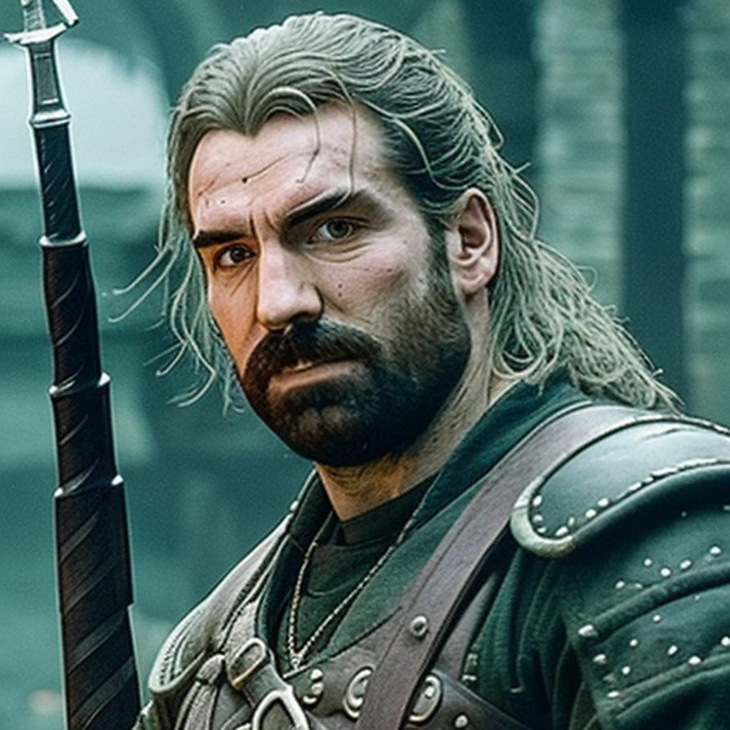

Matt Veazey – Teacher of Media Studies

Contact: matt.veazey@derby-college.ac.uk

Working days: Monday – Friday

Hello and welcome to A Level Media Studies!

My name is Matt Veazey, and I’m thrilled to be your teacher this year. I bring a deep passion for all things media studies and I’m excited to share that with you.

I hold a BA in English, a PGCE in English, and an MA in Media Literacy, which has given me a strong foundation in both critical theory and practical media analysis. Before joining this school, I spent five years teaching English as a Foreign Language (TEFL) in Thailand, an experience that broadened my perspective on global media and communication, and seven years teaching in a mainstream secondary school and 6th form.

In addition to teaching, I’m also an experienced AQA Examiner for Media Studies, which means I have a clear understanding of what examiners are looking for and how to help you succeed in both coursework and exams.

This course will challenge you to think critically about the media you consume every day—from film and television to advertising, social media, and beyond. We’ll explore how media shapes our world, influences our identities, and reflects the society we live in.


I look forward to getting to know each of you and supporting you on your journey through this fascinating subject. Let’s make it a creative, thought-provoking, and successful experience.


Matt Veazey
A Level Media Studies Co-ordinator

INTRODUCTION & AIMS OF THE COURSE

Media Studies aims to offer students the opportunity to study a wide range of media forms, think critically about academic theory, and creatively apply knowledge to produce media products.

Media Forms are the different kinds of media that audiences consume and possibly create. Students will study the conventions of these, and then focus on specific set texts (close study products). There are a wide range of media forms that we will study, which means that a student’s area of interest will likely be explored, however also there will be challenging new content to learn and think about. We study more traditional forms of media:

- Print Newspapers
- Print Magazines
- Print Adverts
- Film
- Television

However, we also cover more modern aspects of media, such as:

- Video Games
- Online, social and participatory media
- Online marketing campaigns
- Celebrity culture

Consequently, the course explores a broad range of knowledge regarding the media, as well as in depth understanding of media products. This part of the course develops students’ research skills, which is a key skill for further education and the workplace.

Crucially Media Studies is underpinned by the theoretical framework. This includes the four key theoretical concepts – Media Language, Media Representation, Media Industry and Media Audience. Within each concept students will develop and in depth understanding of a wide range of theories, and then apply these theories to close study products (CSPs). Subsequently, the course aims to develop critical thinking skills, allowing students to perceive the media from a range of perspectives.

Part of the course requires pupils to complete a non-exam assessment (NEA), this involves creating a media product from a selection of briefs. The options change every year, however, could be a music video, film trailer or a social media campaign for an influencer for example. While the NEA assesses application of knowledge of the course, students will develop their creative media skills.

COURSE STRUCTURE

Paper 1 – 35%

Media One, has sections on Media Language and Representations (Section A) and
Media Industries and Audiences (Section B).

Section A features questions on the following forms: advertising/marketing, music videos.

Section B features questions on any two of radio, newspapers and film.

The questions themselves will focus on the theoretical framework and contexts of the media, but you will be expected to answer by reference to the relevant CSPs.
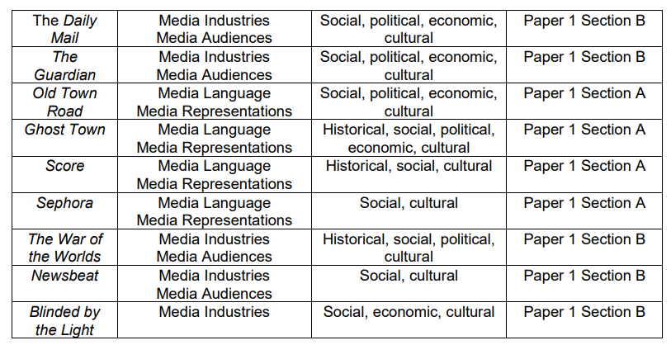

Paper 2 – 35%

The second exam, Media Two, features questions based on all the in-depth studies (Television, Magazines, Online, social and participatory media, Video games).

As with Media One, the questions themselves will focus on the theoretical framework and contexts of the media, but you will be expected to answer by reference to the relevant CSPs. There is also one unseen product on this paper.

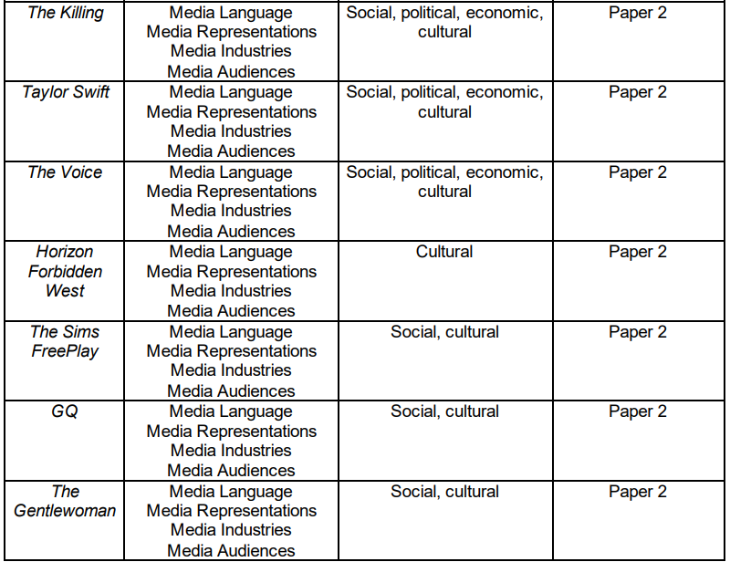

NEA – 30%

The knowledge and understanding built up in the study of the CSPs will help you to create your own cross-media production.

KEY COURSE INFORMATION

Headline

Length of Study | 5 hours per week, 38 weeks per year, 2 years.
Your classrooms | S6
Key skills you will be developing during the course to be successful | This course builds on the knowledge, understanding and skills established at GCSE, particularly literacy and Information Technology skills. Some learners may already have gained knowledge, understanding and skills through their study of Media Studies at GCSE.  This course provides a suitable progression to a range of higher education degree and vocational level courses or to employment. For those who do  not wish to progress further with Media Studies, this specification also provides a rich understanding of the media and develops vital critical thinking skills.
What will lessons look like? | Most lessons will focus on the learning the exam content and developing essay writing skills. This means that there will be a mix of traditional teaching and note taking, alongside research lessons, writing workshops and student led discussions.  Throughout the course students will develop their creative media skills, which helps to prepare for the NEA, and is also a crucial way of processing knowledge of the media.
Informal Assessment Methods | A combination of class quizzes, group presentations, practical work, extended writing, and homework tasks.
Essential Equipment/ Resources | A Lever-arch folder for sole use in Media Studies.  12 folder dividers (one per module).  A4 lined paper.  Plastic wallets.  Pen, pencil, ruler, and highlighters.
Health and Safety | All lessons will adhere to the college’s health and safety procedures.

YEAR PLAN OF STUDY

Year 1:
- Half term 1: introduction to theoretical framework – Introduction to the course: Theoretical framework introduced (2weeks)
&
- Advertising/marketing - Score hair cream print ad & Sephora Black Beauty is Beauty (online advert).

- Half term 2: Media language ad representation: Music Video - Old Town Road (official movie) – Lil Nas X, featuring Billy Ray Cyrus & The Specials – Ghost Town.

- Half term 3: Media industries and Audiences: Radio - The War of the Worlds (1938) & Newsbeat.

- Half term 4: Media industries and Audiences: Newspapers - The Guardian & The Daily Mail.
&
Media industries: Film – Blinded by the Light – Gurinda Chadha (2019).

- Half term 5: Television – No Offence and The Killing.

- Half term 6: NEA planning and pre-production.

Year 2:
- Half term 1: NEA completion.

- Half term 2: Online, Social and Participatory: Taylor Swift & The voice website.

- Half term 3: Video Games: Horizon Forbidden West & SIMS free play

- Half term 4: Essay writing skills.

- Half term 5: Exam revision.

- Half term 6: Exam revision.

ENRICHMENT AND VISITS

Visits:

- QUAD Cinema, Derby - QUAD is an international centre for engagement in contemporary art and film, focussing on major exhibitions, professional practice for artists, independent film and the creative use of emergent digital technologies.

- University of Derby, Markeaton Street Campus - A place of innovation and creativity, Markeaton Street is home to engineering, computing, and mathematics courses as well as art, design, media and performing arts.

Enrichment:

- When studying the various media forms, students will benefit from guest speakers working in the various media industries.

- Cross curricular engagement with creative media departments within the college.

SUCCESSFUL LEARNER HABITS

Knowledge Organisers: these will be completed at the end of each unit and provide an excellent revision resource for students. They can be continually revisited during the course, particularly before any practice exams. Ensuring the knowledge organisers are completed and revisited is a real key to success.
How to make notes:
Repetition, repetition, repetition. Cramming before an exam doesn’t work. What does work is regularly reviewing your material.
Pictures are easier to remember than words so if you’re short on time, draw an image.
If you like to colour code, don’t do it during initial notetaking.
Write short, succinct sentences.
Save time and use abbreviations and symbols.
Use your own words that mean something to you.
Use your teacher’s notes or your textbook as a starting point and a way to familiarise yourself with the topic. But do use your own note-taking method too.
Write questions to yourself if there’s something you don’t understand. Don’t gloss over it and hope you’ll understand later.
Don’t try to write everything down. You’ll just get information overload. It’s better to be engaged and have an efficient and effective system of recording the main points.
How to study independently:
Create a designated study space.
Mute your phone.
Create an effective study schedule.
Establish a reward system.
Make your work efficient.
Vary your study techniques.
Use Efficient Revision Techniques.
Time yourself.
Follow up by watch further films linked to the topic, director, genre etc. – be an expert.
Review each lesson’s notes and test yourself prior to the following lesson.
How to prepare for assessments:
As a starting point it is essential that students acquire specific knowledge of the CSPs. Going over the organisers and revising key information is essential. As the course progresses and knowledge is secure, practicing exam skills becomes a priority. Completing exams style questions in times conditions and requesting feedback is a very effective method to improve in this area.

SUBJECT RESOURCES FOR STUDENTS

Core Textbooks:

- Media Theory at A Level by Mark Dixon
- AQA MEDIA STUDIES FOR A LEVEL YR 1 & AS: STUDENT BOOK
- AQA MEDIA STUDIES FOR A LEVEL YEAR 2: STUDENT BOOK

Academic Reading:

- Gender Trouble by Judith Butler.
- There Ain't No Black in the Union Jack: The Cultural Politics of Race and Nation by Paul Gilroy.
- Participatory Culture in a Networked Era: A Conversation on Youth, Learning, Commerce, and Politics by Henry Jenkins.
- We The Media – Dan Gillmor

Online content:

- Media Studies Blog: http://mildenhallmedia.wordpress.com/
- www.mediaguardian.co.uk
- Mrs Fisher - YouTube
- Radio 4: The film programme- search on BBC iplayer or website
- Radio 4: The Media programme- search on BBC iplayer or website

TERMINOLOGY GLOSSARY

The following list is a brief glossary of terms that you will use regularly within this subject.

Active audience | An audience who thinks about the media that they consume and possibly creates media.
Anchorage | When different media elements work together to create a unified meaning
Connotation | What is suggested by a media language element
Context | When, where, how, and why the film is set. The time, place and circumstances.
Generic conventions | Methods, ingredients, things necessary for the style/category of film.
Diegetic | Sound that is part of the film world (car horns beeping, birds singing,  telephones ringing).
Non-diegetic sound | Sound added in post-production to create a certain atmosphere (sound  FX to increase fear, music to underscore emotion).
Genre | The style or category of the film.
Iconography | The images or symbols associated with a certain subject.
Indie/independent | Film that is independent of the constraints of mainstream Hollywood. These films are often characterised by low budgets, location settings (rather than studio), (often) inexperienced directors and fairly unknown casts.
Language | Media language is all the different ways that a producer can communicate using the media – text, colour, camera angles, sound, etc.
Mainstream | Popular, conventional, and/or part of a major film studio system.
Mise-en-scène | Literally, ‘what is in the frame’: setting, costume & props, colour, lighting, body language, positioning within the frame all come together to create meaning.
Narrative | The structure of a story, as well as the overall message of a product.
Representation | The way that people, places and events are constructed.
Stereotype | A set of ideas held about what a person or place is like that is applied to the whole group.

NOTES

