2026/2027
French A-Level
Course Handbook


Start Date | 7 September 2026
End Date | July 2028
Level of course | Level 3
Awarding Body | AQA
Specification | Paper 1: Listening, Reading and Writing (50%)  Paper 2: Writing (20%)  Paper 3: Speaking (30%)

CONTENTS

YOUR TEACHERS AND THE TEAM AROUND YOU 3
INTRODUCTION AND COURSE CONTENT 4
OVERVIEW OF UNITS/MODULES/TOPICS 5-6
KEY INFORMATION ABOUT YOUR COURSE 7
YEAR PLAN OF STUDY 8-12
ASSESSMENT AND FEEDBACK 13
KEY EXPECTATIONS 14
TUTORIALS 15
WORK EXPERIENCE 16
LIBRARIES FOR LEARNING 17
SUPPORT FOR YOUR STUDY SKILLS AT DCG 18
SUPPORT FOR YOUR DIGITAL SKILLS AT DCG 19
STUDENT VOICE 20
GLOSSARY OF TECHNICAL TERMS 21
YOUR NEXT STEPS OPPORTUNITIES 21

YOUR TEACHERS AND THE TEAM AROUND YOU

I look forward to working with you and I hope that you will enjoy your studies at the college. There are a wide range of facilities to help you to achieve your aims and ambitions.

The aim of this booklet is to provide you with information to prepare and guide you through your 2 year programme of study.



Sarah Vinecombe
sarah.vinecombe@derby-college.ac.uk
(Working days Mondays, Thursdays and Fridays)

INTRODUCTION AND COURSE CONTENT

Our intent in the A Level French course is that our learners attain a high level of spoken fluency in French so that they can utilise the language confidently as well as developing and widening their vocabulary and grammar skills so that they are able write confidently, clearly and accurately. Study on the A Level course will also allow them to enhance their study skills such as time management, punctuality, organising work and meeting deadlines. Students are prepared for progression to Higher Education and Apprenticeships.

Studying a language can also broaden your mind…

• Travel, so the saying goes, broadens the mind and never more so than when you can speak the language. That way you’ll be able to find out what the local people are thinking, how they live …. and how their culture really works.
• This course has been designed to give you a profound understanding of French. Not only will you know more about the mechanics of the language, such as the grammar and vocabulary, but also about the culture of how people live and use French on a day-to-day basis.

What are the benefits?

• Develop the knowledge and skills acquired at GCSE level and use French in a wide range of contexts.
• Gain a useful insight into another culture and reflect on various aspects of contemporary society.
• Enhance employment prospects, facilitate foreign travel and experience the enjoyment and motivation of improving your linguistic level.

What next?

Apart from being beneficial on a personal level, your A-level in French can help with many career
paths. For those who want to specialise in language, there are careers such as translation or teaching. You may need languages for all sorts of other career destinations - doctors, psychologists and physiotherapists need language skills to communicate effectively with patients whether they work in the UK or overseas; businessmen, bankers and entrepreneurs all need language skills to make deals and sell products on the global market. Politicians, historians, geographers and holiday reps all need language skills to get to know the people and area that they are passionate about. A foreign language A-Level will complement and enhance your other studies. Plus, Universities highly value the academic rigour of A Level languages and are considered by many to be ‘facilitator subjects’.

 On average, people who use languages in their jobs earn 8% more!

75% of the worlds population does not speak English at all. 

Why learn French? Europe is the worlds largest market; France is Europe’s second largest market.


OVERVIEW OF UNITS/MODULES/TOPICS

AS and A-Level Languages  Compulsory content | A-Level only
Aspects of French-speaking society: current trends  - The changing nature of family.  - The ‘cyber-society’.  - The place of voluntary work. | Aspects of French speaking society: current issues  - Positive features of a diverse society.  - Life for the marginalised.  - How criminals are treated.
Artistic culture in the French-speaking world  - A culture proud of its heritage.  - Contemporary francophone music.  - Cinema: the 7th art form. | Aspects of political life in the French-speaking world  - Teenagers, the right to vote and political commitment.  - Demonstrations, strikes – who holds the power?  - Politics and immigration.
The course will also consist of the study of a book and a film which are taken from a prescribed list. The book we will study is ‘Bonjour Tristesse’ by Françoise Sagan and the film is ‘La Haine’ by Matthieu Kassowitz. In additional students will undertake a personal research topic which will form part of their final speaking exam.

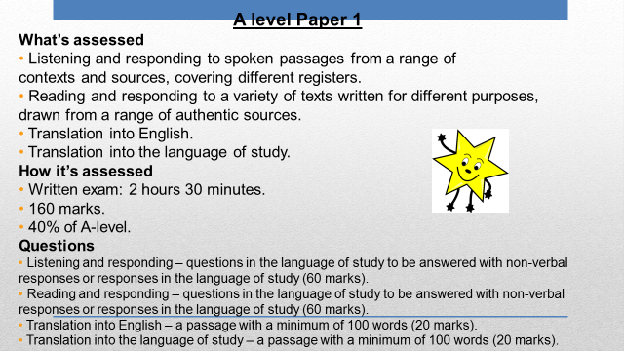

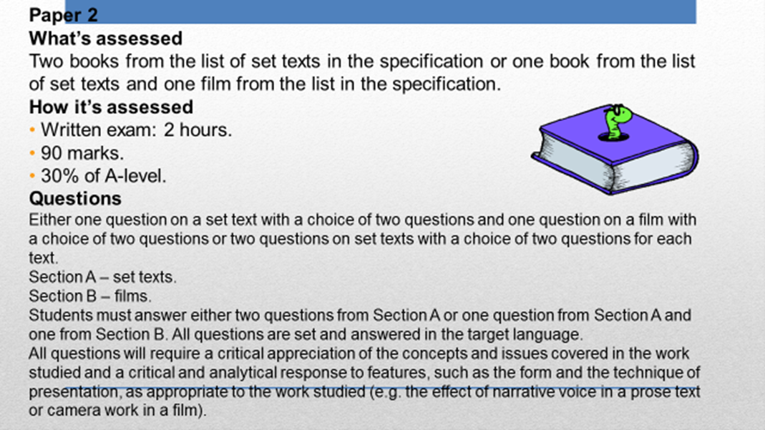

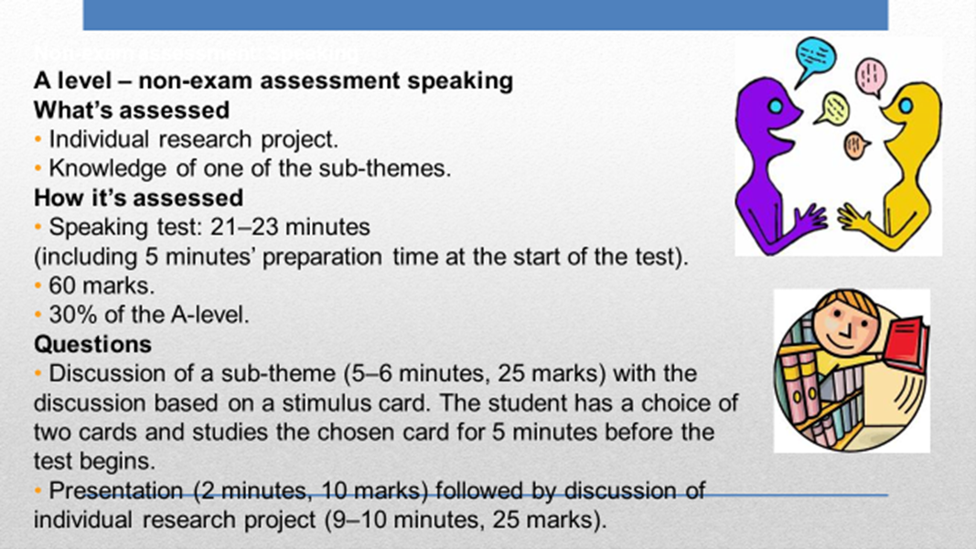

KEY INFORMATION ABOUT YOUR COURSE

Length of Study | 35 weeks year 1, 33 weeks year 2
Your classrooms | S23
Key skills you will be developing during the course to be successful | Aside from the development of language skills student will also develop their:  • Debate and discussion skills.  • Communication and analytical skills.  • Understanding of other people’s beliefs and values.  • Study skills such as time management, organising work and meeting deadlines.  • Digital skills through the use of Kerboodle and other interactive programmes.
What will lessons look like? | Each session will include a carousel of activities focussing on the key strands of reading, writing, grammar and speaking. There will be a wide variety of paired and group discussions, independent work using our interactive site Kerboodle as well as teacher led input. As well as our course book we will also use a variety of current texts and articles to enhance students’ political, social and cultural understanding.
Assessment Methods | Year 1: There will be 4 formative assessments in addition to the progression exams at the end of the Year to determine progression to Year 2.  Year 2: There will be 4 formative assessments in addition to the mock exams prior to formal assessments.  As well as the formative assessments there will be weekly homework and vocabulary tests.
Equipment/ Resources | You will be provided with unit booklets as well as general course booklets at the beginning of the year which you must bring to every lesson.  Please also get equipped with the following: :  • A ring binder Folder.  • Subject dividers: one for each topic area, grammar section, written tasks and essays, articles/authentic sources/independent work. Plastic wallets will also be useful to help you get organised.  The following books:  • A good French dictionary - (e.g. Collins Robert Concise French Dictionary)  • A copy of ‘Mot a Mot: New Advanced French Vocabulary  • A copy of the AQA A1 French textbook (You can purchase these from a variety of sources e.g. good bookstores or online or borrow them from the library)  • Stationery: Pens, pencils and highlighter pens

YEAR PLAN OF STUDY

During each lesson the key skills of reading, writing, speaking, translation and listening are all practised through a variety of activities with the intention of practising new knowledge and skills and to retrieve essential knowledge. This is done through a variety of tasks from the text book as well as additional grammar buster activities, listening extracts, stimulus card questions and reading activities such as current news articles linked to the theme. This enables us to continually carry out formative assessment to identify any gaps in the students knowledge which helps us to develop and adapt future planning.

WEEK DATE | ESSENTIAL KNOWLEDGE AND/OR SKILLS
1  08/09/25 | The Changing Nature of Family  La famille en voie de changement  La vie de couple: nouvelles tendances .  Describe and discuss trends in marriages and other forms of partnership.
2  15/09/25 | The Changing Nature of Family  La famille en voie de changement  Monoparentalite, homoparentalite,familles recomposes.  Consider and discuss the merits and problems of different family structures.
3  22/09/25 | The Changing Nature of Family  La famille en voie de changement  Grands-parents, parents et enfants: soucis et problemes : Consider the relationship between the generations and discuss problems that can arise.
4  29/09/25 | The Changing Nature of Family  La famille en voie de changement  Complete the end of unit Resumé activities.  Consider and summarise the key issues for the unit covered.
5  06/10/25 | The ‘Cyber Society ‘  La ‘cyber-societe’  Comment la technologie facilite la vie quotidienne  Describe and discuss how technology has transformed everyday life.
6  13/10/25 | The ‘Cyber Society ‘  La ‘cyber-societe’  Quels dangers la cybersociete pose-t-elle?  Examine current and potential usage of internet; its benefits and dangers; popularity and benefits/dangers of mobile phones, MP3 players etc.
7  20/10/25 | The ‘Cyber Society ‘  La ‘cyber-societe’  Qui sont les cybernautes?  Consider the different users of digital technology.
27/10/25 | HALF TERM
8  03/11/25 | The ‘Cyber Society ‘  La ‘cyber-societe’  Assessment 1  DIRT Feedback session  Review and reflection  Complete the end of unit Resumé activities.  Consider and summarise the key issues for the unit covered.
9  10/11/25 | The place of voluntary work  Le role du benevolat  Qui sont et que font les benevoles?  Examine the voluntary sector in France and the range of work volunteers do.
10  17/11/25 | The place of voluntary work  Le role du benevolat  Le benevolat: quelle valeur pour ceux qui sont aides?  Discuss the benefits of voluntary work for those that are helped and how beneficiaries request help.
11  24/11/25 | The place of voluntary work  Le role du benevolat  Le benevolat: quelles valeur pour ceux qui aident?  Look at the benefits of voluntary work for those that do it and for society as a whole
12  01/12/25 | The place of voluntary work  Le role du benevolat  Review, reflection and retrieval  Complete the end of unit Resumé activities.  Consider and summarise the key issues for the unit covered. Carry out reflection activities such as mind mapping, extended writing tasks linked to the 3 main themes covered.
13  08/12/25 | A culture proud of its heritage  Une culture fiere de son patrimoine  Le patrimoine sur le plan national, regional et local.  Understand the notion of heritage and heritage preservation on a regional and national scale.
14  15/12/25 | A culture proud of its heritage  Une culture fiere de son patrimoine  Le patrimoine et le tourisme  Consider the ways in which some of the country’s most famous heritage sites market themselves
22/12/25  29/12/25 | CHRISTMAS HOLIDAYS
15  05/01/26 | A culture proud of its heritage  Une culture fiere de son patrimoine
16  12/01/26 | A culture proud of its heritage  Une culture fiere de son patrimoine  Comment la patrimoine reflete la culture  Comprehend how heritage impacts upon and is guided by culture in society.
17  19/01/26 | A culture proud of its heritage  Une culture fiere de son patrimoine  Review, reflection and retrieval  Complete the end of unit Resumé activities.  Consider and summarise the key issues for the unit covered.
18  26/01/26 | Contemporary Francophone music  La musique francophone contemporaine  Comment sauvegarder la musique francophone contemporaine?  Consider and discuss the threats to contemporary francophone music and how it might be safeguarded
19  02/02/26 | Contemporary Francophone music  La musique francophone contemporaine  La musique francophone contemporaine  La diversite de la musique francophone contemporaine  Consider the popularity of contemporary francophone music and its diversity of genre and style.
20  09/02/26 | Contemporary Francophone music  La musique francophone contemporaine  Qui ecoute et apprecie la musique francophone contemporaine?  Consider who listens to contemporary francophone music, how often and by what means.
16/02/26 | HALF TERM
21  23/02/26 | Contemporary Francophone music  La musique francophone contemporaine  Complete Resumé activities.  Consider and summarise the key issues for the unit covered.
22  02/03/26 | Cinema: the 7th Art form  Le septième art  Pourquoi le septieme art?  Discuss the variety of aspects of French cinema.
23  09/03/26 | Cinema: the 7th Art form  Le septième art  Evolution du cinema: les grandes lignes.  Consider the major developments in the evolution of French cinema from its beginnings until the present day.
24  16/03/26 | Cinema: the 7th Art form  Le septième art  Le cinema: une passion nationale  Consider the continuing popularity of French cinema and film festivals.
25  23/03/26 | Cinema: the 7th Art form  Le septième art  Review, reflection and retrieval  Complete the end of unit Resumé activities.  Consider and summarise the key issues for the unit covered.
30/03/26  06/04/26 | EASTER HOLIDAYS
26  20/04/26 | Film / Book Study  La Haine / Bonjour Tristesse  ASSESSMENT 4  DIRT FEEDBACK  Introductory activities for film / book study.
27  28/04/26 | Film / Book Study  La Haine / Bonjour Tristesse  View films and explore social / cultural context of the book and film.
28  04/05/26 | Film / Book Study  La Haine / Bonjour Tristesse  Chapter summaries and scene summaries.
29  12/05/26 | Film / Book Study  La Haine / Bonjour Tristesse  Exploration of key themes.
30  18/05/26 | Film / Book Study  La Haine / Bonjour Tristesse  Character analysis.
25/05/26 | HALF TERM
31  01/06/26 | PROGRESSION EXAM WEEK
32  08/06/26 | Film / Book Study  La Haine / Bonjour Tristesse  Analysis of author’s style and director’s techniques.
33  15/06/26 | Film / Book Study  La Haine / Bonjour Tristesse  Essay writing techniques.
34  22/06/26 | Film / Book Study  La Haine / Bonjour Tristesse  Essay writing techniques.
35  29/06/26 | Film / Book Study  La Haine / Bonjour Tristesse  Essay writing techniques.

ASSESSMENT AND FEEDBACK

Assessment and Feedback

Formal assessments will take place on the following dates:

Formal Assessment 1:  W/C 3/11/2025 | Reading and Writing assessment on the Changing Nature of Family.
Formal Assessment 2:  W/C 5/1/2026 | Reading, Writing and Listening assessment on CyberSpace.
Formal Assessment 3:  W/C 23/2/2026 | Listening, Reading, Writing and Translation assessment on the Place of Voluntary Work and a Culture Proud of its Heritage.
Formal Assessment 4:  W/C 20/4/2026 | Listening, Reading, Writing and Translation assessment on Contemporary Francophone Music and Cinema.
Progression Exams:  W/C 1/6/2026 | Progression exam – all assessment objectives examined on all topics covered in year one.

Following the formal assessments there will be designated feedback sessions where you will be expected to complete feedback tasks and set your own targets linked to the assessment outcomes.

In addition to the formal assessments you will be set work on a weekly basis linked to the current topic and one of the key strands of learning (reading, writing, listening, translation or speaking). There will also be a weekly vocab test. You can expect your work to be marked and quality assured where appropriate and returned within 15 working days of submission.

Academic Malpractice

DCG is keen to support students and avoid any cases of Academic malpractice. Awarding Organisations take matters of academic malpractice very seriously and require all schools and colleges to have specific policies and procedures in place to both educate staff and students about malpractice, thus deterring them from committing it, whether intentional or not, and report and investigate any suspected malpractice where it may occur.

While we don’t want to see anyone jeopardise their grades or marks, we must ensure the validity of all qualifications and we must investigate any suspected breaches fully. It is your responsibility to ensure you understand the rules and boundaries:

- You must not copy from someone else or give opportunities to another student to copy from you.
- Any wording taken from a published source must be correctly referenced for example:
(Morrison, 2000, p29).
- Where computer-generated content has been used (AI tools such as ChatGPT) you must reference these correctly for example: ChatGPT 3.0 (https://openai.com/blog/chatgpt/), 25/01/2024.
- You may also be required to include a bibliography to support referencing.
- You must also avoid working collaboratively with other students beyond what is permitted as this may be deemed to be collusion.

KEY EXPECTATIONS

The 5Ps and College code of conduct.

To be successful at Derby College you will be expected to be:
- Positive
- Polite
- Punctual
- Prepared, and
- Professional in your approach.

Please pay attention to the code of conduct, you will be asked to sign a copy to promise you will abide by the College guidelines: Code of Conduct (sharepoint.com)

Derby College has a zero tolerance approach to all forms of bullying, harassment and abuse both online and face-to-face. Statement on Sexual Harassment, Bullying and Online Abuse (sharepoint.com)
If you or anyone else is being bullied, harassed or abused – or if you become aware of discriminatory behaviour or actions taking place – you are encouraged to report this by contacting either your course tutor or https://studentderbycollegeac.sharepoint.com/sites/Welfare/SitePages/Chat-to-a-Welfare-Officer.aspx or call our confidential BULLYING HELPLINE on 01332 387499.

What all students can expect from Derby College Group:

- We will listen to you and take your concern seriously and deal with it in a sensitive manner.
- We will give you support and involve you in any decision that affects you.
- We will take disciplinary action against any student who has harmed you and/or breached the college Code of Conduct.

TUTORIALS

Tutorial Programme

You will be assigned into a tutorial group during induction week and the weekly tutorials are a compulsory part of your A Level Course. The tutorial programme will pro-actively encourage and nurture students to develop effective behaviours and attitudes, fostering understanding and preparing them as professionals at work and as social contributors in life.

As well as seeking to raising awareness develop your knowledge of key topics, the weekly sessions will also be develop key transferrable skills and exam/assessment ready techniques.

These compulsory sessions are also opportunities for you to get an update on the opportunities arising at college.

Within the tutorial programme, your personal tutor will also meet with you at least every 6 weeks to help offer individualised support and set and review targets.

WORK EXPERIENCE

In addition to the course, students will also be expected to undergo a period of work experience. Information will be provided by your course teachers and tutors during the course of the year as to the different opportunities available.

More information can be found on the
Work Experience and Progression Hub (sharepoint.com)

LIBRARIES FOR LEARNING

Make your life easier!
To make a real success at Derby College visit the library. Bring your existing skills and the Libraries for Learning team will help you do the rest. Use the private study space to work on your assignments whilst making use of the extensive resources. There is IT help available to improve your skills to present your work with a professional finish and IT kit (laptops and PCs) for you to use on-site and then, print your work in the Library at no cost to you using your student print allowance.
Get the help you need!
Come into the Library or use the resources online and ask any one of our friendly team members for help. All the Libraries for Learning Team are skilled researchers willing to help you find the information you need and guide you to resources you might not have considered to help you finish those assignments. On the rare occasions that the library does not have exactly what you want, they will do their best to borrow it through another library. They can also give you advice on study skills and digital skills via the Skills Hubs too (see Study Skills and Digital Skills sections below).
Improve your grades!
Research has established that the students who achieved the highest grades on their chosen course of study were those who took full advantage of all that the library offers by borrowing books and accessing electronic resources most frequently. In contrast, the students with the lowest marks were those who made the fewest visits to the library. What are you waiting for?
Boost your Personal Development!
Embark on an exciting journey of discovery and growth by joining the Libraries for Learning Reading Challenge! This is more than just a chance to read – it's an opportunity to explore new worlds, ignite your imagination, and sharpen your mind. By diving into a variety of genres and authors, you'll enhance your critical thinking, expand your vocabulary, and gain a deeper understanding of different perspectives. Plus, completing the challenge can bolster your applications and CVs, showing your commitment to personal development and intellectual curiosity. So why not take on the challenge? It's your ticket to adventure, knowledge, and a brighter future!
Everything about the Libraries for Learning Service can be found on the Libraries for Learning Moodle Page including the Library Catalogue, and all the contact details.
Specific resources and recommended reading lists to support your learning can be found below:
Reading Lists (derby-college.ac.uk)

SUPPORT FOR YOUR STUDY SKILLS AT DCG

The Study Skills Hub course includes a wide-ranging selection of information and resources to support the continuing development of your study skills, (the stuff you can easily do to improve your college life and continued learning). You can work through these short modules (see below for a detailed list) in any order and obtain a virtual badge in recognition of your participation. On completion of any 6 modules, you will also be awarded a Bronze level certificate. If you go on to complete a further 6 (12 in total) you will be awarded a Silver level certificate and a Gold certificate on completion of all modules.

Links to the complete course and individual modules are listed below:

 | Study Skills Hub (complete course)
Better Learning | Note Taking | Managing your Time
Independent Learning | Better Thinking | Preparing for Assessments or Exams
Internet Search Strategies and using Google | Using Chatbots to Search the Internet | Starting Research
Referencing and Plagiarism | Using Artificial Intelligence (AI) as a Study Aid | Trusted Sources
Presentation Skills | Critical Thinking | Continuing Research
Primary and Secondary Sources | Copyright and Intellectual Property | Learning from Feedback and Reflective Practice

All modules are supported by the Libraries for Learning Team so please contact them at learningresources@derby-college.ac.uk if you would like any additional support or information – they are here to help!

SUPPORT FOR YOUR DIGITAL SKILLS AT DCG

Each of the three Digital Skills Hub courses includes a wide-ranging selection of information and resources to support the continuing development of your Digital Skills from the time you start with us at DCG to the time you move on. You can work through the modules and obtain a virtual badge in recognition of your participation. On completion of the first 6 modules, you will also be awarded a Bronze level certificate. If you go on to complete a further 6 (12 in total) you will be awarded a Silver level certificate and a Gold certificate on completion of all modules. The course and the modules for each one are listed below.

 |  | 
Digital Skills Hub: Getting Started | Digital Skills Hub: Progressing | Digital Skills Hub: Moving on
Acceptable Use Policy (AUP) | Plagiarism and Copyright | GDPR and Data Protection
Online Safety | Privacy and Cookies | Phishing and Scams
An Introduction to Mobile Devices | Essential Tech Skills | Setting up a Desktop PC
Introduction to MyDCG and your College Individual Learning Plan (MyILP) | Your Digital Footprint | LinkedIn and Professional Networks
College IT Troubleshooting | Maintaining a Device (Basic Troubleshooting) | Troubleshooting your Device
Logging In | Microsoft 365 Applications | Microsoft 365 Tips and Tricks
Microsoft OneDrive | Sharing on Microsoft OneDrive and Microsoft Teams | Collaborative Working
Emailing and Using Microsoft Outlook | Organising your Inbox | Creating a Personal Email (Gmail) Account
Microsoft Teams | Microsoft Teams for Remote Learning | Google Meet and Zoom
Microsoft Word | Progressing with Microsoft Word | Document Basics (Google Docs and Pages)
Using Library e-Resources | Creating a Digital Portfolio and Submitting Assignments | Creating and Presenting an Academic Poster
Using the Internet | Searching the Internet and Using Chatbots | Internet Search Techniques
Microsoft PowerPoint | Video Creation in Microsoft PowerPoint | Presentation Basics (Google Slides, Keynote and Prezzi)
Microsoft Excel | Progressing with Microsoft Excel | Spreadsheet Basics (Google Sheets and Numbers)
Microsoft OneNote | Accessibility Tools | Using External Applications and Websites
An Introduction to AI | Using Artificial Intelligence | Using AI to Prepare for Interviews
CVs, Application Forms and UCAS | Preparing for Interviews | Professional Image
Managing Your Money Online | Digital Tools for Everyday Living | Social Intelligence and Communication Skills

All modules are supported by the Libraries for Learning Team, so please contact them at learningresources@derby-college.ac.uk if you would like any additional support or information – they are here to help!

STUDENT VOICE

There is no bigger group of people than students in the classroom! Therefore, listening to students is essential.

Student Voice refers to listening to what YOU think and feel during your time in education at DCG. This is not just about the College listening, but also about acting upon, your feedback.

We want to know:
- Positives – what you enjoy and want to do again,
- Improvements – what and how we can change to improve,
- New Ideas – we are always looking for student-led initiatives.

We listen to students through...
- Cross College Surveys
- Focus Groups
- Student Voice Meetings
- And The Student Representative System.

What is a Student Representative?

Student Representatives or Student Reps are volunteers representing the opinions and suggestions of the students in their class. Student Reps gather the feedback from their class and pass that information to their Academy Representatives and leaders within the college. This is an outstanding experience to add to your CV, job application, or UCAS form.

What are Academy Reps?

This is a senior volunteer role and represents the views of students in the whole Academy, rather than just the class. Academy reps present feedback from Student Reps in their Academy to the senior leadership team (the people who lead the whole college).

Want to learn more about Student Voice?

- The Student Voice Coordinator will be visiting YOU in tutorial sessions this October.
- Contact Pippa Lucas (She/Her), Student Voice Coordinator, with any questions you may have via the email below.

Email - studentvoice@derby-college.ac.uk

GLOSSARY OF TECHNICAL TERMS

Please see the separate grammar booklet for a glossary of grammar terms that you will need to know for the A-Level course.

YOUR NEXT STEPS OPPORTUNITIES

A French degree courses will enable you to further improve proficiency and understanding and can be paired with the study of an additional language including Spanish, Italian, German and Russian. As part of your university course, you may be offered the exciting opportunity of a period of study or work abroad. However, there is no definitive list of subjects that could be studied alongside languages. Other industries that welcome language graduates are the media, business, economics, public relations, finance, banking, tourism, consulting or working internationally with a charity or as part of a business that trades internationally.

NOTES

