A Level Fine Art 2026/2027
Academic Studies

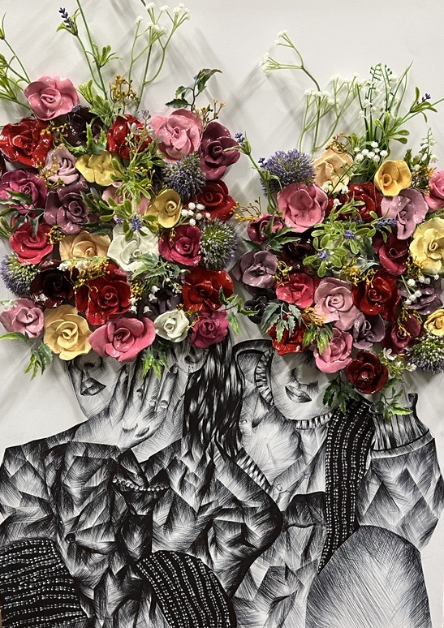
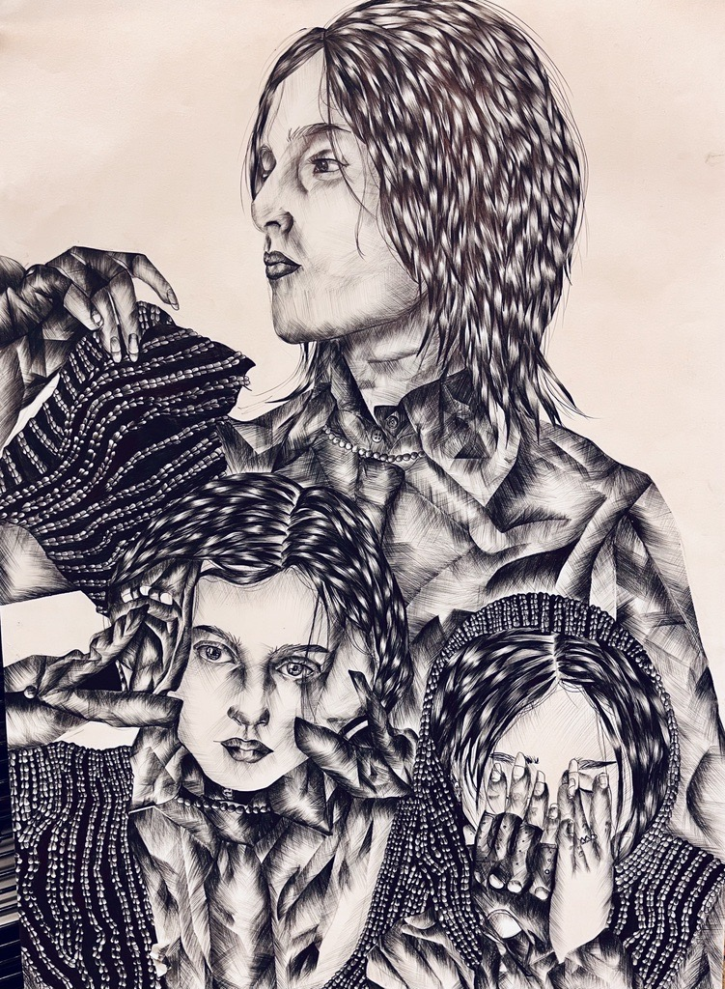
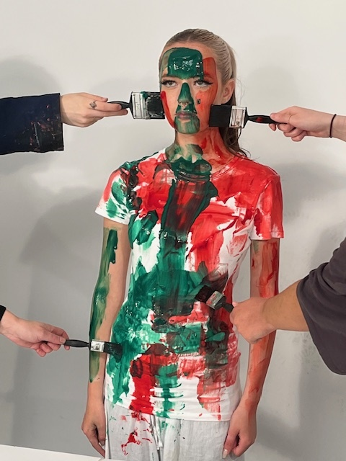

Start Date | 7 September 2026
End Date | 2 July 2028
Level of course | Level 3
Awarding Body | OCR
Specification | OCR A Level in Art and Design (H600-H606) Specification

CONTENTS

WELCOME TO DCG 3
YOUR TEACHERS AND THE TEAM AROUND YOU 4
INTRODUCTION AND COURSE CONTENT 5
OVERVIEW OF UNITS/MODULES/TOPICS 6
YEAR PLAN OF STUDY 7
KEY INFORMATION ABOUT YOUR COURSE 8
ASSESSMENT AND FEEDBACK 9
KEY EXPECTATIONS 11
TUTORIALS 12
WORK EXPERIENCE 13
LIBRARIES FOR LEARNING 14
SUPPORT FOR YOUR STUDY SKILLS AT DCG 15
SUPPORT FOR YOUR DIGITAL SKILLS AT DCG 16
STUDENT VOICE 17
GLOSSARY OF TECHNICAL TERMS 18
YOUR NEXT STEPS OPPORTUNITIES 19
COURSE SPECIFIC CONTENT 20

WELCOME TO DCG

YOUR TEACHERS AND THE TEAM AROUND YOU

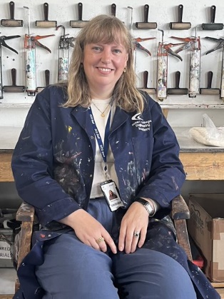

A Level Art and Design Course Coordinator Sarah Griffiths
Lecturer of A Level Fine Art
Room F34

Email contact: sarah.griffiths@derby-college.ac.uk

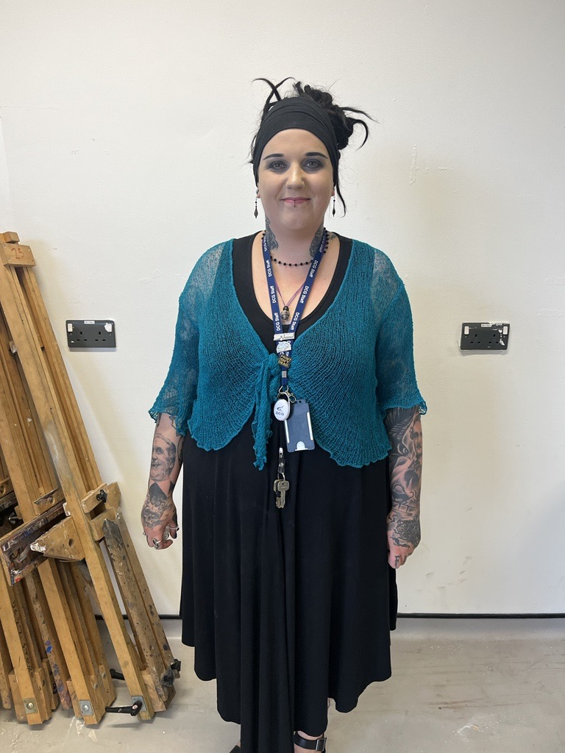

Art & Design Curriculum Support Emily Pallett
The Tech Office F34

Email contact: emily.pallett@derby-college.ac.uk

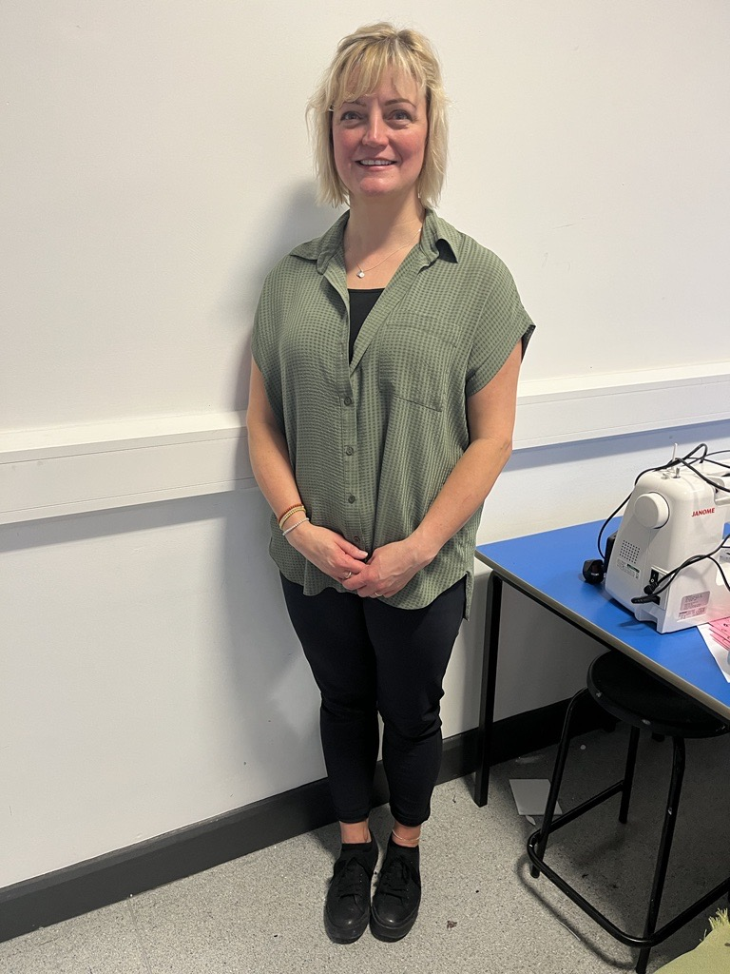
Art & Design Curriculum Support Ali Wilson
The Tech Office F34

Email contact: ali.wilson@derby-college.ac.uk


IQA A Level Fine Art
Catherine Guerrero
The Round House / Joseph Wright Centre

Email contact: catherine.guerrero@derby-college.ac.uk

Catherine checks and moderates A Level Fine Art assessment decisions and visits the course at least twice a year to standardise the work for Unit 1 personal Investigation and Unit 2 Externally Set Task ( This is the snake of portfolios which appears in the studio to establish the rank order for each unit)before the work is externally verified by a OCR External Moderator in June then grades are awarded in August on results day.

INTRODUCTION AND COURSE CONTENT

OCR Fine Art

The A Level Fine Art curriculum at Derby College encourages our students to:

- Become hardworking, creative independent learners who are highly motivated to achieve their full potential.
- Be independent, ambitious, confident and curious learners who are fully engaged with their learning and development.
- Be responsible citizens who make a positive contribution to their community and are respectful and show understanding towards others.

The OCR A Level Fine Art course is a two-year level three course which aims for students to develop their creative skills and contextual understanding of Fine Art.

Many students progress onto a Pre Degree-Art Foundation Course at Derby College then from this course into Higher Education to study Fine Art, then into employment in the creative industries.

Areas of Employment include Artist, Designer, Maker, Architecture, Stylist, Art Journalist, Art Curator, Art Restorer, Art Historian, Art Teacher.

Subjects which compliment A Level Fine Art include, Arts subjects: Music, Film and Media, English Literature, English Language, Modern Foreign Languages, Humanities: History, Geography, Politics, Business Studies, Social Sciences: Sociology and Psychology.

For students wishing to pursue a career in Architecture, Mathematics and a science subject would complement this subject.

OVERVIEW OF UNITS/MODULES/TOPICS

OCR Fine Art

Unit 1 Personal Investigation Non-Examined Assessment and 1,000 word illustrated Related Study (60% of overall A Level Grade)

This unit of learning starts in Year 1 March 2026, and it is completed January 2027. (Year 1 Students)

Unit 2 Externally Set task (40% of the overall A Level Grade)

This unit of learning starts in Year 2 and is completed in April of that academic year.
This task is an externally set exam paper by OCR. You are to select one question from a choice of 7.
You will have 7 working weeks in college to prepare your sketchbook and portfolio of artwork and are allowed to have all this evidence with you in the examination room. After the 15-hour examination is completed, you need to hand in all your prep work and sketchbook to the invigilator.

YEAR PLAN OF STUDY

A Level Fine Art Curriculum Overview
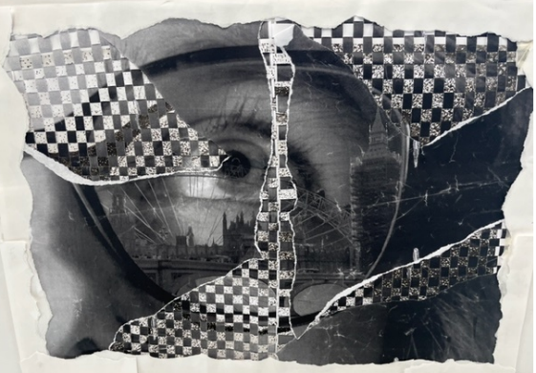

Unit 1 Year one
Initial Workshops and Project

9 September – 24 October 2025
The Everyday Project

The Everyday observational drawing workshops, an opportunity for you to record your observations and share your understanding of the formal elements through your research and practical creative skills. You will learn how to evaluate and review your work in your sketchbook and in discussions with your teachers and peers while applying your understanding of Art terms and specific Fine Art vocabulary. You will learn how to research and record findings from appropriate artists and makers in your sketchbook sharing understanding of their work and how and why it inspires your own creative development.

3 November 2025 – 24 February 2026

Everyday Project Development: Learning to develop your ideas for the Everyday exploring a variety of materials and processes in drawing, painting, mixed media, and print. Learning how to explore and experiment with ideas and materials to produce refined and resolved outcomes. You will continue to evaluate and review your work with your peers and teachers at every stage applying your understanding of art terms. You will be expected to take part in a presentation with your peers and tutors sharing your project development and the creative direction you have taken with your outcome.

March 2024 – 23 January 2026 Year 2
March 2025 – 24 January 2027 Year 1

Unit 1 Personal Investigation NEA (Non-Examined Assessment) Coursework, Practical Portfolio and Related Study

You will construct a title for your personal project. This theme needs to inspire you, and you must be able to demonstrate that you can produce a sustained project which is well developed and has contextual links to other artist's work. You need to produce a sustained and skilled outcome which responds personally and creatively to your brief.

You will complete a Personal Written Related Study which will contextualize and evaluate the findings of your artist research linked to your chosen theme. This needs to be at least 1,000 words long, word processed, illustrated include a Bibliography of sources to be submitted June 2024. This is also worth a maximum of 24 marks.

1 February 2026 – 13 April 2026 Year 2
1 February 2027 – 13 April 2027 Year 1

Unit 2 Externally Set Task (15-hour practical examination)

This is worth 40% of your overall grade marked out 20 for each Objective
Exam paper handed out to students on the 1^{st of} February 2025 and have till 22nd April 2024 to prepare for the exam, you can take your studies and sketchbook into the exam. All prep work and timed pieces are handed in once the examination is finished.

How will I be assessed

Assessment is against the four grading objectives below.

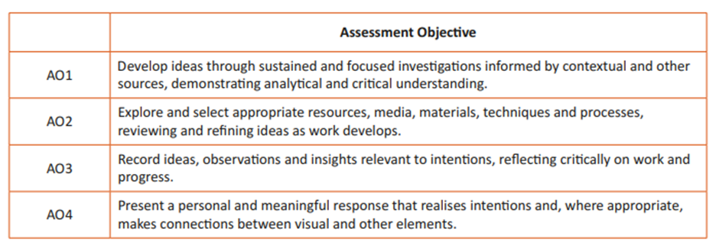

The Objectives are important, and you need to understand how you can achieve the highest marks for each of the Assessment Objectives.

For Unit 1 each objective has a maximum total mark of 24.
Your Related Study has a maximum total mark of 24.

For Unit 2 each objective is marked out of 20

If you understand the assessment objectives, you will make faster progress and achieve a higher-grade outcome.

Here are the assessment criteria grids for your information

The Assessment Process

Your work will be assessed by myself, and you will have FA points throughout the academic year where we review and give you formative assessment (see Key calendar dates below). After final unit submission your work will be a summative assessment by Sarah Griffiths and internally verified by Senior Art and Design Teaching and Learning Manager, Catherine Guerrero.

In June of the second year an OCR External Moderator will visit Derby College and external verify our assessment decisions in a student rank order exhibition to check our assessments meet national standards.

Final Grading is subject to OCR qualification boundaries which change yearly.

These are published annually on 15th August (A Level results).

What is Academic Malpractice?

DCG is keen to support students and avoid any cases of Academic malpractice. Each Awarding Organisation will take matters of academic misconduct very seriously and this can result in a failure, due to you being disqualified by the Awarding Organisation.

Examples of malpractice include plagiarism; this is where work is copied directly or paraphrased from another source without referencing. It could also include copying another student’s work or allowing another student to copy your work.

Other examples include:

- Falsification or fabrication of results,
- Deliberate destruction of other students’ work
- Any other act that will give you an unfair advantage. This also relates to not following clear guidance in examinations or assessments where examination conditions exist.

Where academic malpractice is suspected, this will be reported to your Team Manager who will investigate and, where relevant, the Awarding Organisation may also be informed and investigate further. Where malpractice is discovered to have occurred sanctions may be imposed including the potential to be disqualified from the qualification.

Key Expectations

What you can expect of us:
- Experience and Professionalism in delivering high quality Fine Art outcomes
b. Offering Creative opportunities both in and out of the classroom
c. Positive Learning environment where collaboration and creative risk taking is encouraged.
d Regular feedback in lessons for learners to be able to review their progress and set target on pro portal

What we expect of you:
a. 100% Attendance and excellent punctuality
b. Positive attitude to learning
c. Come prepared to lesson
d. Meet Project Deadlines

Year 1 Assessment Calendar

3/11/2025 | FA1 Upload Deadline
5/1/2026 | FA2 Upload Deadline
23/2/2026 | FA3 Upload Deadline
20/4/2026 | FA4 Upload Deadline
1/6/2026 | Year 1  Progression Exams
22/6/2026 | Unit 1 Related Study Final Hand in.

Year 2 Assessment Calendar

6/10/25 | FA1 NEA Portfolio upload
24/11/25 | FA2 NEA Portfolio upload
26/1/26 | FA3 Unit 1 Personal Investigation NEA  Hand in Summative assessment
1/2/26 | Start UNIT 2 (Exam Paper Select Question)
9/3/26 | FA4 Review of Exam Progress
14/4/26  15/4/26  16/4/26 | Unit 2 Externally Set Task  15hours Practical Examination exam.  Timed piece and all portfolio work handed in for the start of the exam

YEAR PLAN OF STUDY

Year 2 (2025 -26)

SEPTEMBER 2025
 |  |  |  |  |  |  | 1 |  |  |  |  |  |  | 2 |  |  |  |  |  |  | 3 |  |  |  |  |  |  | 4
1 | 2 | 3 | 4 | 5 | 6 | 7 | 8 | 9 | 10 | 11 | 12 | 13 | 14 | 15 | 16 | 17 | 18 | 19 | 20 | 21 | 22 | 23 | 24 | 25 | 26 | 27 | 28 | 29 | 30
ROOMING | INDUCTION |  |  |  |  | NEA: Unit 1 Personal Investigation  Producing a series of observational studies which record your ideas  (A01 Develop, A02 Explore, A03 Record, A04 Present  12th September 2025 Visit to Yorkshire Sculpture Park |  |  |  |  |  |  |  |  |  |  |  |  | NEA:Unit 1 Personal Investigation  Producing a series of 4 development studies informed by your personal research.  (A01 Develop, A02 Explore, A03 Record, A04 Present

OCTOBER 2025
4 |  |  |  |  | 5 |  |  |  |  |  |  | 6 |  |  |  |  |  |  |  | 7
1 | 2 | 3 | 4 | 5 | 6 | 7 | 8 | 9 | 10 | 11 | 12 | 13 | 14 | 15 | 16 | 17 | 18 | 19 | 20 |  | 21 | 22 | 23 | 24 | 25 | 26 | 27 | 28 | 29 | 30 | 31
FA1 Monday 6th Oct 2025 Upload all portfolio elements created so far for assessment |  |  |  |  | FA1 Assessment Point |  |  |  |  |  |  |  |  |  |  |  | 20/ 10/25  One to one teacher reviews (DIRT) to target set for next review set target on your ILP  In class applying how you are planning to make further work to make more evidence regarding  A01 Develop, A02 Explore A03 Record

NOVEMBER 2025
 |  | 8 |  |  |  |  |  |  | 9 |  |  |  |  |  |  |  | 10 |  |  |  |  |  |  | 11
1 | 2 | 3 | 4 | 5 | 6 | 7 | 8 | 9 | 10 | 11 | 12 | 13 |  | 14 | 15 | 16 | 17 | 18 | 11199 | 20 | 21 | 22 | 23 | 24 | 25 | 26 | 27 | 28 | 29 | 30
 | Unit 1 Personal Investigation  Producing a further development work samples at least 4 exploring a range of media and approaches to your concepts.  These are to be recorded in your sketchbook and evaluated so you can then decide which direction to develop for your outcome presentation.  FA2 Upload 24th November 2025 and group presentations of development work that week in class. |  |  |  |  |  |  |  |  |  |  |  |  |  |  |  |  |  |  |  |  |  |  | FA 2 ASSESSMENT

DECEMBER 2025
12 |  |  |  |  |  |  | 13 |  |  |  |  |  |  | 14
1 | 2 | 3 | 4 | 5 | 6 | 7 | 8 | 9 | 10 | 11 | 12 | 13 | 14 | 15 | 16 | 17 | 18 | 19 | 20 | 21 | 22 | 23 | 24 | 25 | 26 | 27 | 28 | 29 | 30 | 31
8th /12 /25 One to one teacher reviews (DIRT) to target set for next review set target on your ILP

Students in class embarking on finalising final plans and beginning to create their final piece. Homework documenting the process in the sketchbook.

Unit 1 Deadline 23/1/26 (A01 Develop, A02 Explore, A03 Record, A04 Present)

JANUARY 2026
 |  |  |  | 15 |  |  |  |  |  |  | 16 |  |  |  |  |  |  | 17 |  |  |  |  |  |  | 18
1 | 2 | 3 | 4 | 5 | 6 | 7 | 8 | 9 | 10 | 11 | 12 | 13 | 14 | 15 | 16 | 17 | 18 | 19 | 20 | 21 | 22 | 23 | 24 | 25 | 26 | 27 | 28 | 29 | 30 | 31
 |  |  |  |  | INSET | NEA:Unit 1 Personal Investigation  Producing an outcome which responses and communicates your ideas in an imaginative and thoughtful way.  Present and mount all supporting work and present related study in printed for assessment.  Coursework Deadline: Friday 23th January 2026  (A01 Develop, A02 Explore, A03 Record, A04 Present) |  |  |  |  |  |  |  |  |  |  |  |  |  |  |  | SUMMATIVE ASSESSMENT  NEA Unit 1 Personal Investigation Deadline 23/1/26 |  |  | FA3 Mock Exam week all students sitting exams |  |  |  |  | ASAS

FEBRUARY 2026
 |  | 19 |  |  |  |  |  |  | 20 |  |  |  |  |  |  |  |  |  |  |  |  |  | 21
1 | 2 |  | 3 | 4 | 5 | 6 | 7 | 8 | 9 | 10 | 11 | 12 | 13 | 14 | 15 | 16 | 17 | 18 | 19 | 20 | 21 | 22 | 23 | 24 | 25 | 26 | 27 | 28
EXAM PAPER RELEASED | Unit 2 Externally Set Task issued to students 1 February 2025  You select one question to respond to from a choice of seven and then must create research, prep studies, and planning development work which demonstrates your application of the following objectives. The timed piece is practical a 15-hour examination (hand in sketchbook and all prep work immediately after the exam with your timed piece.  (A01 Develop, A02 Explore, A03 Record, A04 Present)  Upload evidence created so far FA3 3st March 2025 |  |  |  |  |  |  | Trip to London or Paris to collect primary research |  |  |  |  |  |  | SG and CG to  verify marks awarded  The Snake. |  |  |  |  |  |  |  | Feedback and one to one dirt sessions to establish progress and actions for exam prep.

MARCH 2026
 |  | 22 |  |  |  |  |  |  | 23 |  |  |  |  |  |  |  | 24 |  |  |  |  |  |  | 25
1 | 2 |  | 3 | 4 | 5 | 6 | 7 | 8 | 9 | 10 | 11 | 12 | 13 | 14 | 15 | 16 |  | 17 | 18 | 19 | 20 | 21 | 22 | 23 | 24 | 25 | 26 | 27 | 28 | 29 | 30 | 31
 | Unit 2 Externally Set Task issued to students 1 February 2025  You select one question to respond to and then must create research, prep studies which demonstrate your application of the following objectives.  A01 Develop, A02 Explore, A03 Record, A04 Present)  Sharing final plan and equipment list requirements to techs before we break for Easter.  Students to continue to develop ideas and document process in their sketchbook. All sketchbooks and prep studies to be completed before the start of the examination and be in the exam room.  All work to be handed in straight after the examination. |  |  |  |  |  |  |  | FA4 9th March 2026

APRIL 2026
 |  |  |  |  |  |  |  |  |  |  |  | 26 |  |  |  |  |  |  | 27 |  |  |  |  |  |  | 28
1 | 2 | 3 | 4 | 5 | 6 | 7 | 8 | 9 | 10 | 11 | 12 | 13 | 14 | 15 | 16 | 17 | 18 | 19 | 20 | 21 | 22 | 23 | 24 | 25 | 26 | 27 | 28 | 29 | 30
 |  |  |  |  |  |  |  |  |  | Easter Exam prep workshop | Easter Exam prep workshop | Unit 2 15 hour exam  All work to be handed in after the exam 15/4//26

MAY 2026
 |  |  | 29 |  |  |  |  |  |  | 30 |  |  |  |  |  |  | 31
1 | 2 | 3 | 4 | 5 | 6 | 7 | 8 | 9 | 10 | 11 | 12 | 13 | 14 | 15 | 16 | 17 | 18 | 19 | 20 | 21 | 22 | 23 | 24 | 25 | 26 | 27 | 28 | 29 | 30 | 31
 |  |  |  | Unit 2 IQA CG to confirm rank order and verify grades awarded

JUNE 2026
32 |  |  |  |  |  |  | 33 |  |  |  |  |  |  | 34 |  |  |  |  |  |  | 35
1 | 2 | 3 | 4 | 5 | 6 | 7 | 8 | 9 | 10 | 11 | 12 | 13 | 14 | 15 | 16 | 17 | 18 | 19 | 20 | 21 | 22 | 23 | 24 | 25 | 26 | 27 | 28 | 29 | 30
 |  |  |  |  |  |  |  |  |  |  |  |  |  |  |  |  |  |  |  |  |  |  | SHOW WEEK. All Welcome

End of Year Show: 25th June 2026

Your course finished after your examination; the work you produce for the examination will be assessed by your teacher then Internally Verified by a Art and Design Manager. Your work will then be externally moderated by OCR on a visit to college to see your work exhibited in June 2026. Your grades are then awarded by the exam board the grade boundaries for A Level Fine Art are subject to change annually.

You will need to pick up artwork from college in November 2026 if you don’t pick it up it will be disposed.

Year 1 Year Plan of Study

Year 2 (2025 -26)

SEPTEMBER 2025
 |  |  |  |  |  |  | 1 |  |  |  |  |  |  | 2 |  |  |  |  |  |  | 3 |  |  |  |  |  |  | 4
1 | 2 | 3 | 4 | 5 | 6 | 7 | 8 | 9 | 10 | 11 | 12 | 13 | 14 | 15 | 16 | 17 | 18 | 19 | 20 | 21 | 22 | 23 | 24 | 25 | 26 | 27 | 28 | 29 | 30
ROOMING | INDUCTION |  |  |  | THE Everyday Project  The Everyday Formal Elements Workshops  (A01 Develop, A02 Explore, A03 Record, A04 Present)  Learning to Look, Observational Drawing of everyday objects  How to use a sketchbook to record research and creative ideas, how to apply the formal elements and specialist art terms in own writing.

OCTOBER 2025
4 |  |  |  |  | 5 |  |  |  |  |  |  | 6 |  |  |  |  |  |  |  | 7
1 | 2 | 3 | 4 | 5 | 6 | 7 | 8 | 9 | 10 | 11 | 12 | 13 | 14 | 15 | 16 | 17 | 18 | 19 | 20 |  | 21 | 22 | 23 | 24 | 25 | 26 | 27 | 28 | 29 | 30 | 31
The Everyday Project  The Everyday Formal Elements Workshops  (A01 Develop, A02 Explore, A03 Record, A04 Present  Creating drawings/ prints, drawing, collage to explore the formal elements.  How to undertake visual research in the form of Mood boards and visual research recorded in photographic and digital form, further observational drawing and academic writing in your sketchbook sharing creative influences. |  |  |  |  |  |  |  |  |  |  |  |  |  |  |  |  |  |  | Present work ready for assessment to peers and teacher in class.  Teacher to identify and support learners submissions. All work to be uploaded by 3/11/26

NOVEMBER 2025
 |  | 8 |  |  |  |  |  |  | 9 |  |  |  |  |  |  |  | 10 |  |  |  |  |  |  | 11
1 | 2 | 3 | 4 | 5 | 6 | 7 | 8 | 9 | 10 | 11 | 12 | 13 |  | 14 | 15 | 16 | 17 | 18 | 19 | 20 | 21 | 22 | 23 | 24 | 25 | 26 | 27 | 28 | 29 | 30
 |  | FA1 UPLOAD DEADLINE | The Everyday Project  Colour Theory/ Painting Workshop  (A01 Develop, A02 Explore, A03 Record, A04 Present)  The Colour Wheel  Colour Harmonies  Recording your findings in your sketchbook |  |  |  |  |  |  |  |  |  |  |  |  |  |  |  | The Everyday Project  Painting Acrylic, watercolour, Inks Workshop  (A01 Develop, A02 Explore, A03 Record, A04 Present)  Applying colour harmonies, Warm, Cool, ComplimentoryColour, surface Pattern, Texture |  |  |  |  |  | PROGRESS DAY ONE TO ONE FEEDBACK AND TARGETS SET

DECEMBER 2025
12 |  |  |  |  |  |  | 13 |  |  |  |  |  |  | 14
1 | 2 | 3 | 4 | 5 | 6 | 7 | 8 | 9 | 10 | 11 | 12 | 13 | 14 | 15 | 16 | 17 | 18 | 19 | 20 | 21 | 22 | 23 | 24 | 25 | 26 | 27 | 28 | 29 | 30 | 31
 | The Everyday Project  Oil Painting, Mixed Media  (A01 Develop, A02 Explore, A03 Record, A04 Present) |  |  |  |  |  |  |  |  |  |  |  |  | Present and upload work for FA2  Assessment  15/12/25 |  |  |  | London Trip  18/12/25  Tate Modern ,National Gallery

JANUARY 2026
 |  |  |  | 15 |  |  |  |  |  |  | 16 |  |  |  |  |  |  | 17 |  |  |  |  |  |  | 18
1 | 2 | 3 | 4 | 5 | 6 | 7 | 8 | 9 | 10 | 11 | 12 | 13 | 14 | 15 | 16 | 17 | 18 | 19 | 20 | 21 | 22 | 23 | 24 | 25 | 26 | 27 | 28 | 29 | 30 | 31
 |  |  |  |  |  | One to One Dirt Reviews  FA2 Reviews and Planning for creating a project outcome for the Everyday Project outcome |  |  |  |  |  |  |  |  |  |  |  | The Everyday Project Development: Selecting and developing a direction for an outcome  (A01 Develop, A02 Explore, A03 Record, A04 Present) |  |  |  |  |  |  |  |  |  |  |  | ASAS

FEBRUARY 2026
 |  | 19 |  |  |  |  |  |  | 20 |  |  |  |  |  |  |  |  |  |  |  |  |  | 21
1 | 2 |  | 3 | 4 | 5 | 6 | 7 | 8 | 9 | 10 | 11 | 12 | 13 | 14 | 15 | 16 | 17 | 18 | 19 | 20 | 21 | 22 | 23 | 24 | 25 | 26 | 27 | 28
 | Trip to London or Paris to collect primary research for NEA  The Everyday Creating an outcome to present to an audience. Present to teacher and Peers Upload FA3 23/2/25  (A01 Develop, A02 Explore, A03 Record, A04 Present) |  |  |  |  |  |  |  |  |  |  |  |  |  |  |  |  |  |  |  |  |  | FA3 Everyday Project Summative Assessment |  | Unit 1  Personal Investigation Project Proposal  NEA Visual Contextual, Research mood board, photography observational drawings x6 and independent visit to local gallery Derby or Nottingham

MARCH 2026
 |  | 22 |  |  |  |  |  |  | 23 |  |  |  |  |  |  |  | 24 |  |  |  |  |  |  | 25
1 | 2 |  | 3 | 4 | 5 | 6 | 7 | 8 | 9 | 10 | 11 | 12 | 13 | 14 | 15 | 16 |  | 17 | 18 | 19 | 20 | 21 | 22 | 23 | 24 | 25 | 26 | 27 | 28 | 29 | 30 | 31
 | FA3 One to one Progress reviews with SG (DIRT) |  |  |  |  |  | NEA Visual Contextual, Research mood board, photography observational drawings x6 and independent visit to local gallery Derby or Nottingham |  |  |  |  |  |  |  |  |  |  |  |  | PROGRESS DAY FEEDBACK AND TARGETS |  |  |  |  |  |  |  | Unit 1 Related Study 24 Marks  1,000 word essay,  How to construct a title for your  Related Study  With a Bibliography of appropriate sources.  Library visit

APRIL 2026
 |  |  |  |  |  |  |  |  |  |  |  | 26 |  |  |  |  |  |  | 27 |  |  |  |  |  |  | 28
1 | 2 | 3 | 4 | 5 | 6 | 7 | 8 | 9 | 10 | 11 | 12 | 13 | 14 | 15 | 16 | 17 | 18 | 19 | 20 | 21 | 22 | 23 | 24 | 25 | 26 | 27 | 28 | 29 | 30
 |  |  |  |  |  |  |  |  |  |  |  | Unit 1 Related Study 24 Marks  1,000 word essay,  How to create a related study for your  Related Study  With a Bibliography of appropriate sources. Hand in first draft 20/4/26 |  |  |  |  |  |  | Upload FA4 Deadline  Unit 1 Personal Investigation preparing a first draft of the related study. 20/4/26  (A01 Develop, A02 Explore, A03 Record, A04 Present

MAY 2026
 |  |  | 29 |  |  |  |  |  |  | 30 |  |  |  |  |  |  | 31
1 | 2 | 3 | 4 | 5 | 6 | 7 | 8 | 9 | 10 | 11 | 12 | 13 | 14 | 15 | 16 | 17 | 18 | 19 | 20 | 21 | 22 | 23 | 24 | 25 | 26 | 27 | 28 | 29 | 30 | 31
 |  |  | Unit 1 Personal Investigation preparing for your progression exam development timed piece.  (A01 Develop, A02 Explore, A03 Record, A04 Present) | One to One FA4 Dirt Reviews to plan and prepare for the progression examination.

JUNE 2026
32 |  |  |  |  |  |  | 33 |  |  |  |  |  |  | 34 |  |  |  |  |  |  | 35
1 | 2 | 3 | 4 | 5 | 6 | 7 | 8 | 9 | 10 | 11 | 12 | 13 | 14 | 15 | 16 | 17 | 18 | 19 | 20 | 21 | 22 | 23 | 24 | 25 | 26 | 27 | 28 | 29 | 30
Progression Exam weeek  One full day in Art working on a timed piece. |  |  |  |  |  |  |  |  |  | Visit to Loughborough Uni  Unit 1 Related Study reworking the draft and adding references to your bibliography  Documenting the Progression examination pieces in your sketchbook |  |  |  |  | Visit to Derby University |  |  |  |  |  | HAND IN FINAL RELATED STUDY | Summer Tasks set for September | SHOW WEEK

 |  | JULY 2026
 |  | 36
 | 1 |  | 2 | 3 | 4 | 5 | 6 | 7 | 8 | 9 | 10 | 11 | 12 | 13 | 14 | 15 | 16 | 17 | 18 | 19 | 20 | 21 | 22 | 23 | 24 | 25 | 26 | 27 | 28 | 29 | 30 | 31
 |  |  | Progression Day

Fine Art Year 1 and Year 2
The Week-by-Week Plan

Week Commencing | Teaching topic  Year 1  Year 2 | Other forms of assessment and independent tasks
02/09/25 | INDUCTION
08/09/25 | Fine Art  Induction to the subject, observational drawing.  Everyday Project  NEA Year 2 Review work produced over the summer. | Sketchbook, artist research tasks and mood board making tasks.  Review Related study and action improvements.  Produce four further studies.  Trip to Yorkshire Sculpture Park 8/9/25
15/09/25 | Fine Art Everyday Drawing Tone  Initial feedback on your work you have done over the summer.  NEA Production of four new samples which demonstrate develop and explore. | Produce a series of observational studies in your sketchbook two pages.  Reviewing and evaluating the process of making the work in your sketchbook step by step.
22/09/25 | Drawing in print, mono printing,  Exploring mark making with pen  NEA Production of four new samples which demonstrate develop and explore. | Documenting elements of drawing through print in your sketchbook with appropriate artist research.  Document the artist’s work which are inspiring your process in your sketchbook
29/09/25 | Fine Art Everyday Drawing with negative space/ lino.  Students to continue to develop and produce further NEA studies. | Document the concept of negative space in sketchbook and Line with Mono printing.  Students to clearly record all development pieces with reflective comments in their sketchbook.
6/10/25 | Etching/ Dry point / Collage  FA1 Students upload portfolio and related study to their one drive folder for feedback.  Students to continue to develop and produce further studies. | Document your print Experimentation in your sketchbook with related artists studies.  FA1 Students upload work and continue to develop four further development samples.  To document your work in your sketchbook with own reflections and evaluations of processes.
13/10/25 | Everyday Creative Process documentation and Presentation Week  Production of studies  One to one tutorial’s reviewing and feeding back on progress so far and Target setting across the objectives. | Students to Present their work across teams to each other and share creative ideas for further development.  Students to action the feedback making improvements to their coursework
19/10/25 | Everyday Creative Process documentation and Presentation Week FA1 Deadline 24/10/26  Production of studies  One to one tutorial’s reviewing and feeding back on progress so far and Target setting across the objectives. | Students to Present their work across teams to each other and share creative ideas for further development.  Students to action the feedback making improvements to their coursework
27/10/25 | HALF TERM
3/11/25 | Painting  Mark making with paint colour wheel.  One to one tutorial’s reviewing and feeding back on progress so far and Target setting across the objectives. | Students to document painting techniques in sketchbook with artist analysis linked to colour theory.  Planning the next three planning studies that they intend to undertake reflecting on composition and scales of working, through thumbnail planning sketches.
10/11/25 | Painting and colour workshop warm cool neutral harmonies  Preparation of portfolio for submission 24/11/25 continue to refine and complete appropriate development work three more samples | Documentation of colour harmonies in sketchbook with examples of artist’s work.  Evaluate and document your creative processes in your sketchbook practice refine your three studies documenting your progress.
17/11/25 | Painting workshop exploring  Colour warm cool neutral  Further three development samples exploring combinations of techniques and media which respond to your theme | Documentation of colour harmonies in sketchbook with examples of artist’s work.  Documentation of the creation of work in sketchbook citing artist and contextual references which inform ideas
24/11/25 | Painting Mixed media  Progress Day Year 1  25 / 11/ 26  FA2 Year 2 Upload 24/11/26  Design development for outcome planning scales of working and compositional complexity. | Record all experimental works with texture and the potential of different media watercolour through to oil and acrylic.  Plan the media and techniques you will move forward with to develop an outcome for your NEA project.
1/12/25 | Painting Development  Assessment  Design development for outcome planning scales of working and compositional complexity. | Record all findings and samples in your sketchbook discussing learning and application of the formal elements.  Photograph these processes and evaluate in your sketchbook referring to your concept and how your outcome will answer the brief, through documentation of work in your sketchbook.
8/12/25 | Class contextual research a personal approach to the everyday  Production of outcome | Continue to document the three artists who inspire your thinking for further project development.  Photograph every stage and annotate the process in your sketchbook.
16/12/25 | End of Term experimentation with media for Everyday personal project. Upload all work for assessment FA2.  Year 1 Visit to London Tate and National Galleries  Production of NEA Outcome | Document the experimentation with media in your sketchbook and discuss what you have learnt.  Present work onto teams in a power point for assessment.  Document the production of the outcome.
20/12/25  6/1/26 | STUDENT HOLIDAYS
06/01/26 | Everyday Personal project learning to problem solve ideas to make an outcome Deadline for Outcome 24 ^{th} February 2026  Production of NEA Outcome | Document drawings and research in sketchbook.  Refining outcome and recording process
12/01/26 | Production of development work  Production of NEA Outcome | Documentation of development pieces in sketchbook  Documentation of NEA outcome in sketchbook.
19/01/26 | Production of problem-solving prototype.  Production of NEA Outcome  NEA Deadline Hand in All work for Assessment 23/1/26 | Documenting this process in your sketchbook and photographing the process step by step.  Produce a final evaluation of your outcome document and present all your work for assessment.
26/01/26 | Start to make Everyday outcome.  Mock Examinations  Unit 2 External set assignment EXAM PAPER ISSUED Timed exam 15hours | Document in sketchbook the making process.  Read exam paper select question you wish to answer research, make visits to galleries, museums, libraries, start drawing.
03/02/25 | Production of outcome  Unit 2 Creative research and Drawing produce primary and secondary research which responds to your selected question. | Continue to produce outcome document the process.  Create mood board, contextual research pages at least three linked to initial ideas
9/02/25 | Production and Presentation of outcome. FA3 Upload outcome  Portfolio 23/2/24.  Recording at least 4 development drawings, samples in your sketchbook.  Unit 2 Creative research and Drawing produce primary and secondary research which responds to your selected question.  Year 1/Year 2 Trip to London or Paris | Document your outcome in your sketchbook.  Recording drawing and photography document these in sketchbook
16/02/26 | Half Term
23/02/26 | Deadline Hand in Project  Presentation The Everyday upload for FA3 Presentation of work to an audience.  26/2/26 Year 2 Progress Day  One to one tutorial to review progress and set appropriate targets.  Explore ideas through creating four prep studies prepare for portfolio upload FA4 9/03/26 | Project Proposal writing for the NEA, and the subject title for the 1,000-word related study.  Documenting the initial research and visual investigation demonstrating how you will respond to the exam paper starting point.
02/03/26 | Record Observational drawing, photography.  Unit 2 External Set Examination  UPLOAD ALL RESEARCH AND DRAWINGS/ SAMPLES completed so far for FA4 9/3/26  FOCUS explore a further range of three samples which respond to your chosen theme applying a variety of different combinations of materials. | Document at least three artists work in your sketchbook and produce creative responses to them.  Continue to document your prep work in your sketchbook discuss your choices and how they respond to your selected question.
10/03/25 | Unit 1 NEA Personal Investigation  RESEARCH AND DRAWING PHOTOGRAPHY  Unit 2 External Exam Paper  FOCUS explore a further range of four samples which demonstrate your chosen theme using a variety of different combinations of materials. | Document the recording observation process in your sketchbook making clear your intensions and areas which you want to develop.  Document the variety of samples into your sketchbook
17/03/25 | Unit 1 NEA Personal Investigation work in progress and related study.  19/3/ 26 Progress Day Year 1 review and target setting tutorial day.  PROJECT PROBLEM SOLVING sharing ideas and concepts which are developing ideas linked to answering your exam question. | Continue to document initial observational drawings and research in your sketchbook.  Acting on feedback to make further development samples which share your creative ideas.
23/03/26 | Unit 1 NEA Personal Investigation  RESEARCH DRAWING PHOTOGRAPHY  Last week to complete before easter holidays  UNIT 2 FOCUS explore a range of final compositional plan and a final prep study which can be brought into the exam to use for guidance for scale colour techniques media | Complete the initial plan and introduction.  For the Unit 1 1,000-word min illustrated related study.  Document this process in your sketchbook
30/03/26 | EASTER HOLIDAYS
6/04/26 | EASTER HOLIDAYS
13/04/24 | Written related study focusses this week for students to develop the main body of the study referencing relevant artists’ works  Unit 2 Timed - EXTERNAL EXAM  Practical Examination 15 hours in total | Draft out the main body of the assignment with concise Bibliography and labelled illustrated images.  Hand in 16/4/23
20/04/26 | Preparing for a practical progression exam produce three experimental studies to allow you to plan what you make in your progression exam  Mounting of key pieces for the final portfolio submission 20/4/25 clear draws and return equipment to Techs course finished. | Document the experimental pieces in your sketchbook
27/04/26 | Related study focus.  Complete your first draft of your written study by the 5/5/25 | Complete and refine the related study
04/05/26 | Hand in completed first drafts of the written studies | Prepare a plan for your timed 6-hour progression exam.
11/05/26 | Planning for the progression exam | Document your exam piece in your sketchbook
18/05/26 | Planning of next series of 4 samples to cover Explore and Develop | Document these samples in sketchbook. Review related studies with teacher to improve grade.
25/05/26 | HALF TERM
01/06/26 | Year 12 Progression Examination  Students off timetable sitting exams. | Continue to document the four samples which include explore and develop
8/06/26 | Production of four development pieces | Continue to document all samples into your sketchbook and complete refinements of your related study.
16/06/26 | Exhibition week DCG students to view student shows.  Upload refined draft Related study | Continue to document all development work in your sketchbook.
23/06/26 | One to one tutorial to review project plan over summer.  Hand in Final Draft of the Related Studies | Document linked appropriate artist research in your sketchbook
01/07/26 | One to one tutorial to review project plan over summer | Document linked appropriate artist research in your sketchbook.

KEY INFORMATION ABOUT YOUR COURSE

Course Coordinator to complete with team)

Key Information about your course (could be a table as follows)

OCR A Level Fine Art

Length of Study | 5 hours a week in class, minimum 5 hours a week independent study  2 Academic Years
Your classrooms | F34, G30
Key skills you will be developing during the course to be successful | Subject specific  Communication:  Reading information about artists and applying understanding of their work to your sketchbook research and own project development.  Writing academic research annotations in your sketchbook and personal evaluations of your creative processes.  Oracy in team presentations through weekly lay out and look sessions which build on student Oracy and presentation skills weekly to normalise discussion and sharing different opinions about artwork.  Digital skills: presenting creative information using a range of digital programmes and platforms.  Application of number: through practical tasks  Modern Britain: Practical Art and Design Coursework Projects which encourage discussion and concepts around Modern Britain. Making visits to Art Galleries to consider the role of artists and designers in Modern Britain  Sustainability: Apply sustainable working methods in your own creative practices. This will be shared in group discussions and research tasks where you can share how and why you are sustainable as a Fine Artist.
What will lessons look like? | Art Lessons will be conducted in a professional art studio, they will be creative practical lessons and include opportunities to develop academic research and writing skills, through class discussions, presentations and in written work. Digital skills will be developed through academic and creative practice.  How do they start?  You will be shown a creative concept or technique to consider for the first part of the lesson, this could be looking at Exemplar work or a teacher demonstration.  Learners than practice their skills of these creative concepts in the class.  Regular Features of my Art classes?  Group sharing’s of creative ideas and work completed in the class. To discuss and apply are understanding of the art elements and the creative art and design development process.  Termly Teacher FA one to ones where we review what learning has taken place, and what needs to be revisited in order to make further progress.  An opportunity to create learning targets which are set and reviewed with your art teacher and logged on pro portal My ILP.  Class Expectations  - 100% Attendance and be punctual to class  If you know you are going to be absent or late, please message me directly on teams or email sarah.griffiths@derby-college.ac.uk  - Be prepared with your pre-learning self-study tasks and equipment. Without these you will not make expected progress and you will feel left behind.  - If we have remote learning lessons be prompt and camera on for team’s lesson  - Upload all portfolio evidence weekly onto one drive for teacher feedback.  - Make sure your phone is turned off unless your teacher asks you to use it for a learning task.  - Be mindful of our working environment and each other, tidy away equipment at the end of sessions, return art resources to the support staff.  - Be resourceful: use recyclable pots, jars to put your paint into. Also bring in recyclable materials to use within your art: card, string, fabric etc.  Let us do our bit to be sustainable artists.  - Come into class with plenty of questions, creative thoughts, and artwork to share with your peers and teachers.
Informal Assessment Methods | One to one verbal feedback. Notes shared on Teams Chat
Essential Equipment/ Resources | As we will be working in a professional Art studio, we have a studio fee which is £30.00 and included is a starter pack of art materials which will get you started, and this includes, A3 sketchbook A3 folder, drawing and painting equipment. You will also have access to all the specialist materials, printing inks, paints, dyes, and equipment in the Art studios.  Year 2 Studios fee is £15 which covers all the print, paint, paper you will use in your second year of study. You will also need to purchase another A3 sketchbook for your examination which you may purchase from the tech office.  What’s in the A Level Fine Art / Starter Kit  Please ensure that you look after your equipment and use the folder to transport work to and from college. There are large A 1 draws that you will be assigned to keep your work in college.
  1 brush round watercolour
  Glue stick
  Individual Grade Pencils
  2B 4B 6B
  STABILO® point 88® Fine liner Black / Black Biro
  Rubber / Pencil sharpener
  Watercolour Tablet Set
  A3 Portrait soft Sketchbook
  A3+ Plastic Poly holdall
Health and Safety | We are all responsible, whilst on college premises, for our own safety and the safety of others. If you notice anything at all which you consider could jeopardise your own safety or the safety of your peers, you must report it immediately.  The studios and workshops you will be using will have specific health and safety rules; you will be advised of these during the course and expected to adhere to them. Failure to do so will result in disciplinary action being taken.  If you injure yourself whilst you are on college premises, make sure you report it to a member of staff, who will take any necessary action on your behalf.  If you or someone else requires First Aid, contact a member of the college staff immediately.  In Art and Design your First Aid Team are :  - Pete Gardner  - Tracey Ramsdale  - Cath Wood  - Sarah Griffiths  - Philip Taylor  - Eve Billingham

ASSESSMENT AND FEEDBACK

How will I be assessed

Assessment is against the four grading objectives below.

The Objectives are important, and you need to understand how you can achieve the highest marks for each of the Assessment Objectives.

For Unit 1 each objective has a maximum total mark of 24.
Your Related Study has a maximum total mark of 24.

For Unit 2 each objective is marked out of 20

If you understand the assessment objectives, you will make faster progress and achieve a higher-grade outcome.

Here are the assessment criteria grids for your information

The Assessment Process

Your work will be assessed by myself, and you will have FA points throughout the academic year where we review and give you formative assessment (see Key calendar dates below). After final unit submission your work will be a summative assessment by Sarah Griffiths and internally verified by Senior Art and Design Teaching and Learning Manager, Catherine Guerrero.

In June of the second year an OCR External Moderator will visit Derby College and external verify our assessment decisions in a student rank order exhibition to check our assessments meet national standards.

Final Grading is subject to OCR qualification boundaries which change yearly.

These are published annually on 15th August (A Level results).

What is Academic Malpractice?

DCG is keen to support students and avoid any cases of Academic malpractice. Each Awarding Organisation will take matters of academic misconduct very seriously and this can result in a failure, due to you being disqualified by the Awarding Organisation.

Examples of malpractice include plagiarism; this is where work is copied directly or paraphrased from another source without referencing. It could also include copying another student’s work or allowing another student to copy your work.

Other examples include:

- Falsification or fabrication of results,
- Deliberate destruction of other student’s work
- Any other act that will give you an unfair advantage. This also relates to not following clear guidance in examinations or assessments where examination conditions exist.

Where academic malpractice is suspected, this will be reported to your Team Manager who will investigate and, where relevant, the Awarding Organisation may also be informed and investigated further. Where malpractice is discovered to have occurred sanctions may be imposed including the potential to be disqualified from the qualification.

Key Expectations

What you can expect of us:
- Experience and Professionalism in delivering high quality Fine Art outcomes
b. Offering Creative opportunities outside of the classroom
c. Positive Learning environment which encourages collaboration and creative risk taking
d Regular feedback in lessons and one to one tutorials to support your progress through setting FA targets and reviewing progress.

What we expect of you:
a. 100% Attendance and excellent punctuality
b. Positive attitude to learning
c. Come prepared for the lesson, check daily any new posts on teams for lesson requirements and equipment.
d. Enthusiasm for the subject and to make positive contributions to the classes, through engaging with a wide range of creative learning experiences.

Year 1 Assessment Calendar

3/11/2025 | FA1 Upload Deadline
5/1/2026 | FA2 Upload Deadline
23/2/2026 | FA3 Upload Deadline
20/4/2026 | FA4 Upload Deadline
1/6/2026 | Year 1  Progression Exams
23/6/2024 | Unit 1 Related Study Final Hand in.

Year 2 Assessment Calendar

6/10/25 | FA1 NEA Portfolio upload
24/11/25 | FA2 NEA Portfolio upload
23/1/26 | FA3 Unit 1 Personal Investigation NEA  Hand in Summative assessment
1/2/26 | Start UNIT 2 (Exam Paper Select Question)
9/3/26 | FA4 Review of Exam Progress
13/4/26 | Unit 2 Externally Set Task  15hours Practical Examination exam.  Timed piece and all portfolio work handed in for the start of the exam

Course Coordinator to complete.

Assessment and Feedback
- Assessment Calendar overview (to include key progress checks for courses which have end examination
- Provisional Exam dates (where relevant)
- Assignment Submission Procedures and/or Exam Entry Procedures and where the exams may take place (particularly relevant for JWC students who will be taking exams at RH – advance info at this stage is useful in meeting specific needs)
- When can you expect to have your work returned?
- Expectations on marking and feedback (to include what students are expected to “do” with feedback, TOES/DIRT where relevant)
- Setting of developmental, actionable target goals on ProMonitor in response to assessment and how these are reviewed and closed.
- Assessment Grading Definitions

Referrals Procedures and Resubmissions Procedures

You will have a clear plan of what to expect, what assessments will take place during the year and when you can expect these assessments to happen. You can expect your work to be marked and quality assured where appropriate and returned within 15 working days of submission.

Once you have submitted your work, it will be marked and potentially be quality assured by the Internal Quality Assurance team. This is particularly key where the learning outcomes have not been met and a resubmission opportunity has been given.

Where a referral has been given, by the teacher or assessor will provide you with an opportunity to resubmit. However, you must read the feedback carefully to ensure you are clear of what you need to do and where a graded qualification and assessment is in place what you can attempt. This will be time bound and you will be given a re-submission date by your trainer/assessor/lecturer, and you must meet this deadline.

Academic Malpractice

DCG is keen to support students and avoid any cases of Academic malpractice. Awarding Organisations take matters of academic malpractice very seriously and require all schools and colleges to have specific policies and procedures in place to both educate staff and students about malpractice, thus deterring them from committing it, whether intentional or not, and report and investigate any suspected malpractice where it may occur.

While we don’t want to see anyone jeopardise their grades or marks, we must ensure the validity of all qualifications and we must investigate any suspected breaches fully. It is your responsibility to ensure you understand the rules and boundaries:

- You must not copy from someone else or give opportunities to another student to copy from you.
- Any wording taken from a published source must be correctly referenced for example:
(Morrison, 2000, p29).
- Where computer-generated content has been used (AI tools such as ChatGPT) you must reference these correctly for example: ChatGPT 3.0 (https://openai.com/blog/chatgpt/), 25/01/2024.
- You may also be required to include a bibliography to support referencing.
- You must also avoid working collaboratively with other students beyond what is permitted as this may be deemed to be collusion.

Other examples include:

- Falsification or fabrication of results,
- Deliberate destruction of other student’s work
- Any other act that will give you an unfair advantage. This also relates to not following clear guidance in examinations or assessments where examination conditions exist.

You will be required to complete an Authentication Form on submission of any and all assignments/NEA projects. This will confirm that the work is your own, and that it is referenced appropriately, including the use of AI. Where academic malpractice is suspected, this will be reported to your Team Manager who will conduct an investigation and, where relevant, the Awarding Organisation may also be informed and investigate further. Where malpractice is discovered to have occurred, sanctions may be imposed which could include:

- Zero marks for the work or exam.
- Disqualification from the qualification.
- Disqualification from taking any qualification with that Awarding Organisation often over a set period of time.
- Warnings which can last several years.

For further details and to fully familiarise yourself with JCQ guidance please see the Joint Councils for Qualifications (JCQ) website:
Information for candidates documents - JCQ Joint Council for Qualifications

Further information can be found on the DCG website:
Examination Information - DCG (derby-college.ac.uk)

Appeals Procedures

Each Awarding Organisation will have slightly different processes for appealing decisions. Appeals can be made where:
- You believe that the awarding body policies and procedures have not been followed correctly in respect of external quality assurance/standards verification (policies and procedures can be found on the relevant awarding body website).
- You believe that the awarding body policies and procedures have not been followed correctly in respect of qualification decisions (policies and procedures can be found on the relevant awarding body website).
- You disagree with the outcome of your internal appeals procedure (for example, a decision in relation to reasonable adjustments or assessment outcomes).

However, should you, as a student wish to appeal, firstly:

- Contact your lecturer/trainer/assessor and discuss your concerns.

If you are still not satisfied with the outcome, the College would usually make an appeals application on your behalf. This would require your consent. It is possible to apply directly to the Awarding Organisation but only once the College’s internal processes have been followed. At this point you would be informed of the next stages and Awarding Organisation communication link. This is time bound and this will also be communicated to you once the internal appeals process has taken place.

Note: you must be aware that through this process the initial grade can go up, stay the same, or go down.

KEY EXPECTATIONS

The 5Ps and College code of conduct.

To be successful at Derby College you will be expected to be:
- Positive
- Polite
- Punctual
- Prepared, and
- Professional in your approach.

Please pay attention to the code of conduct, you will be asked to sign a copy to promise you will abide by the College guidelines: Code of Conduct (sharepoint.com)

Derby College has a zero tolerance approach to all forms of bullying, harassment and abuse both online and face-to-face. Statement on Sexual Harassment, Bullying and Online Abuse (sharepoint.com)
If you or anyone else is being bullied, harassed or abused – or if you become aware of discriminatory behaviour or actions taking place – you are encouraged to report this by contacting either your course tutor or https://studentderbycollegeac.sharepoint.com/sites/Welfare/SitePages/Chat-to-a-Welfare-Officer.aspx or call our confidential BULLYING HELPLINE on 01332 387499.

What all students can expect from Derby College Group:

- We will listen to you and take your concern seriously and deal with it in a sensitive manner.
- We will give you support and involve you in any decision that affects you.
- We will take disciplinary action against any student who has harmed you and/or breached the college Code of Conduct.

Key Expectations (course specific) (Could look like this)

What you can expect of us:
- Excellent Creative Teaching and Learning classroom experience which supports you as a Fine Artist; to develop your knowledge, understanding, and skills to be able to take creative risks in class to make progress with your units of learning.
b. To have the opportunity to work in Professional Art and Design studios with access to specialist equipment, processes, and technical support
c. To provide supportive and engaging teaching and learning, which develops a deeper understanding of Fine art and the creative project process through creating a supportive classroom where students can share creative ideas and opinions in classroom discussions and critiques.
d. Creating opportunities for Fine Art students to visit Museums, galleries and Higher Education courses to bring Fine Art learning to life through engaging with art in person.

What we expect of you:

a. A readiness to learn and follow instructions in class no phones out or on unless your teacher asks you to use it.
b. To only bring water into the studio to drink during class no food in the studios please eat in the atrium.
c. To ask the teacher if you need any support or have questions that need answering, do this before you leave every class so you can be prepared for the next lesson.
d. To bring positivity and kindness to class so everyone can enjoy making progress in Fine Art

TUTORIALS

Tutorials [could include a hyperlink to student experience and pastoral hub here)]
- What are these?
- Expectations in group tutorials on this course?
- Expectations in a one to one on this course?

Could look like this:

Tutorial Programme

The tutorial programme will pro-actively encourage and nurture students to develop effective behaviours and attitudes, fostering understanding and preparing them as professionals at work and as social contributors in life.

A weekly session which will seek to raise awareness and develop your knowledge of key topics. Students will also be challenged to demonstrate key transferrable skills and exam/assessment ready techniques.

These compulsory sessions are also opportunities for you to get an update on the opportunities arising at college.

Within the tutorial programme, your personal tutor will also meet with you at least every 6 weeks to help offer individualised support and set and review targets.

WORK EXPERIENCE

Work Experience/Placement
- Expectations and why it is important.
- When and where?
- Support for gaining a placement.
- Preparation for work placement/experience, recording hours, reflections and learning.

More information can be found on the
Work Experience and Progression Hub (sharepoint.com)

LIBRARIES FOR LEARNING

SUBJECT RESOURCES FOR STUDENTS

Get the help you need! Come into the Library or use the resources online and ask any one of the friendly team members for help. All the Libraries for Learning Team are skilled researchers willing to help you find the information you need and guide you to resources you might not have considered to help you finish those assignments. On the rare occasions that the library does not have exactly what you want, they will do their best to borrow it through another library. They can also give you advice on study skills and digital skills via the Skills Hubs too (see Study Skills and Digital Skills on the Libraries for Learning Pod Page).

Specific resources and recommended reading lists to support your learning can be found below

- Fine Art A level
- Drawing
- Fine Art - Reading List
- History of art books
- History of Art eBooks
- Painting
- Still life
- Landscape
- Natural world

Specific resources and recommended reading lists to support your learning can be found below:

Search for more resources using the library catalogue: Library Catalogue



Dive deeper into your subject with our diverse range of information resources.
Boost your knowledge, critical thinking, and digital skills through our dedicated skills hubs and online platforms.
Access expert assistance from our knowledgeable staff to support your learning journey.

The College library holds a vast range of e-books, online databases and physical books to help you in your studies. The simple to use search catalogue allows you to find up to date, relevant and trusted information which you can access or reserve at the click of a button.

Support from an expert team of staff is on hand 8.30-4.30pm each weekday. You can contact them by phone, email, “live chat” or in person at any of our four main sites. We also offer a comprehensive SharePoint page that hosts all our guides in a variety of formats to suit your learning needs. This extends the library to fit in with your working patterns and make sure you have access to information when you need it most.

Key Services
- Independent study spaces, printing and computers
- Course specific textbooks and material
- Expert staff to support with IT, digital access and research needs
- Databases and e-books
- Extensive online information, including access to a 24-7 search catalogue Library SharePoint
- Study skills guides
- Digital skills hub and Study skills hub – self paced online modules with digital badges
- Annual reading challenge
- Leisure reads and wellbeing books

Contact the team
Email: Learningresources@derby-college.ac.uk
Phone: 01332 334848

Specific resources and recommended reading lists to support your learning can be found below:
- [Subject-reading List (with hyperlinks if e-resource)], please look here, Reading Lists (derby-college.ac.uk) to select the reading list for your course, or contact learningresources@derby-college.ac.uk to send you the link.

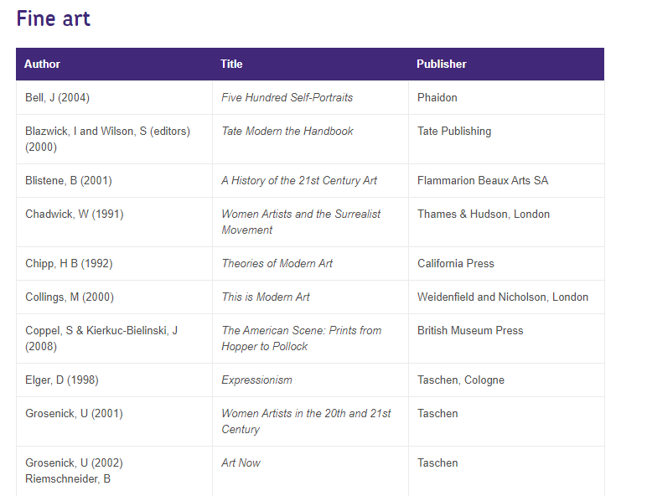
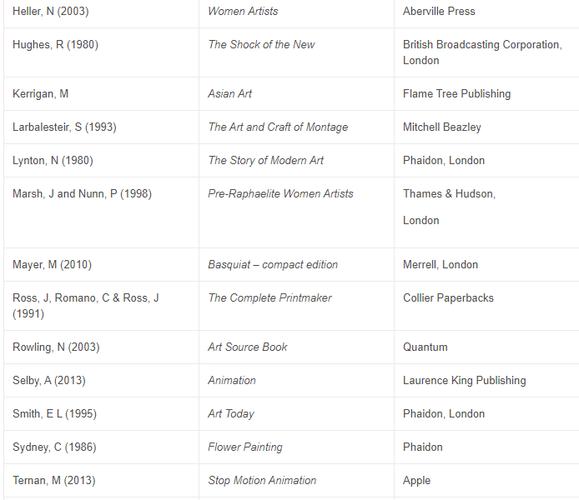

USEFUL WEBSITES FOR RESEARCH – Fine Art

www.tate.org.uk - site for all Tate galleries with good picture library and educational section
www.moma.org – Museum of Modern Art in New York, art gallery with good on-line collection
www.britishmuseum.org – on-line tours of various cultures
www.guggenheim.org – good on-line collections
www.metmuseum.org – Metropolitan Museum, New York, good collection database
www.craftscouncil.org.uk – national development agency for contemporary crafts
www.vam.ac.uk – the Victoria and Albert Museum, good online resources for research especially for fashion, applied art.
www.getty.edu – good on-line research
www.bbc.co.uk – useful site to source all sorts of information for research from social, economic and political issues to film clips, tv programmes and news articles
www.designmuseum.org – good resources to aid research on designers
www.fashionmuseum.co.uk – museum based in Bath
www.saatchi-gallery.co.uk – the world’s interactive art gallery
www.artcyclopedia.com – a database of artists and art movements
www.textilearts.net – good textile art directory
www.caa.org.uk – contemporary textiles and crafts, good links to artists
www.ptmlondon.org – fashion and textiles museum, London
www.londonfashionweek.co.uk – catwalk reports and research tool for most fashion designers
www.top-fashion-designers.info – good directory of world fashion designers
www.firstview.com – excellent database for designers and collections (you have to pay to see current collections but can access all past collections)
www.trendsop.com – looks at what’s happening in fashion: catwalk shows, colours, moods, fabrics, streetstyle

GOOGLE, Instagram, Pinterest– find contemporary on-line, artists, designers, work, biographies, and inspiration!

SUPPORT FOR YOUR STUDY SKILLS AT DCG

The Study Skills Hub course includes a wide-ranging selection of information and resources to support the continuing development of your study skills, (the stuff you can easily do to improve your college life and continued learning). You can work through these short modules (see below for a detailed list) and obtain certificates in recognition of your participation.

There are 15 modules, and you will get a Bronze, Silver or Gold certificate when you have completed them. You will get a Bronze for completing the first five, a Silver for also completing the next five and a Gold for completing all the modules.

Links to the complete course and individual modules are listed below:

Study Skills Hub (complete course)
Bronze | Silver | Gold
Note Taking | Primary and Secondary Sources | Presentation Skills
Managing your Time | Learning from Feedback and Reflective Practice | Using Artificial Intelligence (AI) as a Study Aid
Starting Research | Copyright and Intellectual Property | Preparing for Assessments or Exams
Referencing and Plagiarism | Continuing Research | Better Thinking
Better Learning | Critical Thinking | Independent Learning



All modules are supported by the Libraries for Learning Team so please contact them at learningresources@derby-college.ac.uk if you would like any additional support or information – they are here to help!

SUPPORT FOR YOUR DIGITAL SKILLS AT DCG

Our online Digital Skills Hub courses include a wide-ranging selection of information and resources to support the continuing development of your Digital Skills from the time you start with us at DCG to the time you move on.

Digital Skills: Getting Started

There are 18 modules and you will get a Bronze, Silver or Gold certificate when you have completed them. You will get a Bronze for completing the first six modules, a Silver for also completing the next six and a Gold for completing all the modules.

For details and access to the course, go to the Getting Started course page

Digital Skills: Progressing

This course focusses in further on your digital skills knowledge and awareness. Again there are 18 modules with three levels of achievement. Completing the first 6 will get you a bronze certificate, the first 12 will get you silver and achieving all will get you the gold.

For details and access to the course, go to the Progressing course page

All modules are supported by the EdTech Team so please contact them at edtech@derby-college.ac.uk if you have any issues trying to login, access or complete the courses.

STUDENT VOICE

There is no bigger group of people than students in the classroom! Therefore, listening to students is essential.

Student Voice refers to listening to what YOU think and feel during your time in education at DCG. This is not just about the College listening, but also about acting upon, your feedback.

We want to know:
- Positives – what you enjoy and want to do again,
- Improvements – what and how we can change to improve,
- New Ideas – we are always looking for student-led initiatives.

We listen to students through...
- Cross College Surveys
- Focus Groups
- Student Voice Meetings
- And The Student Representative System.

What is a Student Representative?

Student Representatives or Student Reps are volunteers representing the opinions and suggestions of the students in their class. Student Reps gather the feedback from their class and pass that information to their Academy Representatives and leaders within the college. This is an outstanding experience to add to your CV, job application, or UCAS form.

What are Academy Reps?

This is a senior volunteer role and represents the views of students in the whole Academy, rather than just the class. Academy reps present feedback from Student Reps in their Academy to the senior leadership team (the people who lead the whole college).

Want to learn more about Student Voice?

- The Student Voice Coordinator will be visiting YOU in tutorial sessions this October.
- Contact Pippa Lucas (She/Her), Student Voice Coordinator, with any questions you may have via the email below.

Email - studentvoice@derby-college.ac.uk

GLOSSARY OF TECHNICAL TERMS

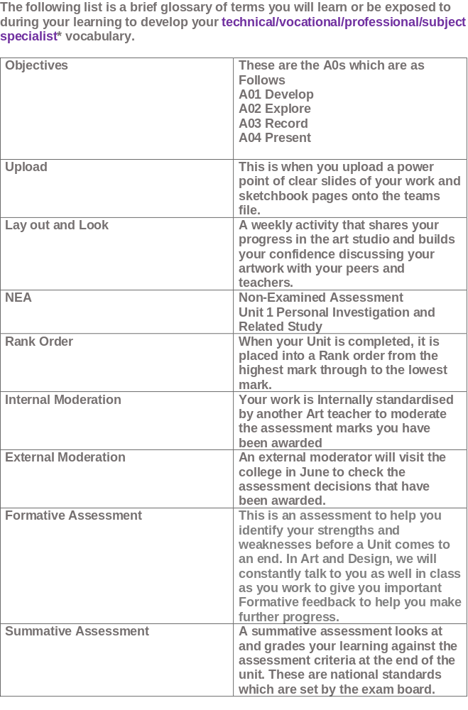

Art and Design Terms

Term | Definition
Fine Art | Visual Art whose products are to be appreciated for their imaginative, aesthetic or intellectual content.
Summative  Assessment | A summative assessment looks at and grades your learning against the assessment criteria at the end of the unit. These are national standards which are set by the exam board.
Assessment Objective | This is an aspect of learning that you must demonstrate understanding of these to meet objectives for the qualification.
Technical Skill | This is your skill of knowing your tools and materials and how to use them
Contextual Research | Something that is RELEVANT and ‘to do with’ what you need to study. If you were studying painting, researching a painter would be a very relevant idea.
Related Study | This a piece of writing that you need to complete for Unit 1 Personal Investigation, which is minimum 1,000 words and illustrated (related content to your practical portfolio).
Translating | A translation is turning one language into another but keeping the same or similar meaning. So you might ‘translate’ an actual object into a 2 dimensional image, and it still look like the object
Observational | Observational is what you see and notice about something when you analyse it.
Subjective | This is based on your own feelings and must not be confused with facts. Subjective opinions are given when you discuss your own feelings about an artist’s work.
Objective | Objective observations are based on facts. Example the Sistine Chapel is in the Vatican Rome.
2D | This means there is only an x and y axis. It means the thing is factually FLAT, like a photo or a drawing. It may have the ‘illusion’ of looking like it has form, but technically this is known as 2D
3D | This means it does actually have form, it has 3 axes, (many axis) x, y, and z. You can pick it up hold it. This means it has DEPTH, (z axis)
Sfumato | The technique of allowing tones and colour to shade gradually into one another producing hazy tones, a good example is the Mona Lisa, by Leonardo Di Vinci.
Chiaroscuro | The treatment of light and shade in drawing and painting. Example
Assess/Evaluate | When you assess something, you look at its qualities. Often you will be looking for specific things. When we mark your portfolio, we will be looking at how well you are meeting the assessment objectives.  When you Evaluate, you really are looking at the VALUE of something to you, or for a purpose. Everyone does it, for example when they buy clothes.  You will have to learn to be CRITICAL and develop JUDGEMENT skills
FORMAL ELEMENTS  (See below) | These are the basic things from which art is made. Below there a few of the main terms for you to become familiar with
LINE | A continuous mark, often made with a Pencil
SHAPE | The outline to something. BUT shape refers ONLY to 2D, as in a square drawn on paper
TONE | This is how light or dark something is. Tone can make shape look 3D by adding a light and a dark side to create CONTRAST.
FORM | Form is when something is 3D OR has the ‘illusion’ of 3 dimensions. You can physically touch it.
PLANE | Planes are the flat sides that face different directions. A cube has 6, each side is a ‘Plane’
STRUCTURE | A structure is an arrangement of parts that makes something., usually in 3D. The Eifel Tower is a structure. Structure can also be used in 2D to how the parts of a painting are placed together
SURFACE | A surface is the outer layer to something. Your skin is your surface, your skeleton could be your structure and your muscles show FORM
TEXTURE | This is how you describe a surface; it might be soft, rough, smooth for example
PATTERN | Pattern is usually when shapes repeat themselves as they do in Wallpaper
COLOUR | Colour is the way in which your eye responds with electrical signals to your brain when it is hit by a wavelength of light radiation. Each wavelength stimulates a different electrical signal that you see as a different colour.
SPACE | In art and design SPACE is something between objects, usually empty which is known as NEGATIVE SPACE
Perspective | In art Perspective is a method or way of showing the illusion that things get smaller as they move away from us. It is used in painting and drawing to show Structure, Form and Space.
Portrait | A portrait is an art version of how someone looks. This could be a painting or a sculpture. In sculpture it is often termed a ‘Bust’
Collage | Collage is when you make an image from other images or surfaces, so you might make a picture from torn pieces of magazine paper or you might deliberately cut round some images then put them together. You might use photographs

Below are excellent links which have extensive glossaries of art terms and techniques, they are very useful to read and apply understanding of to your own annotations and to your related study to enable you to meet the highest standard for this aspect of your studies:

Art Terms | Tate

MoMA | Glossary of Art Terms

Glossary | Paintings | National Gallery, London

