Film Studies 2026/2027
Academic Studies

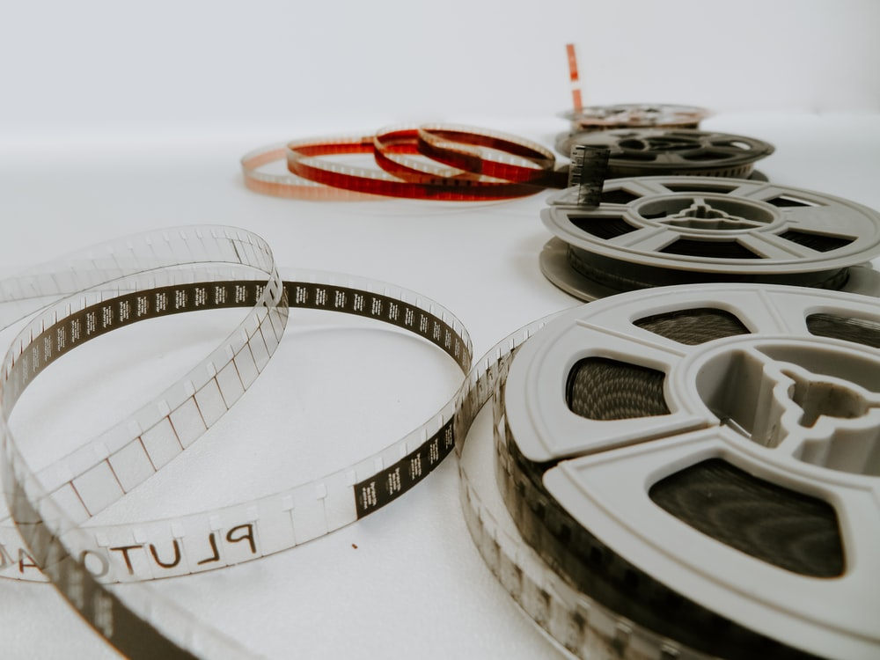

Start Date | 7th September 2026
End Date | 2nd July 2027
Level of course | A-Level (two-year study)
Awarding Body | EDUQAS
Specification | Specification
CONTENTS

YOUR SUBJECT TEACHERS 3
INTRODUCTION & AIMS OF THE COURSE 4
COURSE STRUCTURE 5
KEY COURSE INFORMATION 6
YEAR PLAN OF STUDY 7
ENRICHMENT AND VISITS 8
SUCCESSFUL LEARNER HABITS 9
SUBJECT RESOURCES FOR STUDENTS 10
TERMINOLOGY GLOSSARY 11

YOUR SUBJECT TEACHER

James Morgan – Teacher of Film Studies

Contact: James.morgan@derby-college.ac.uk

Working days: Mondays, Thursdays and Fridays only


INTRODUCTION & AIMS OF THE COURSE

Film is one of the main cultural innovations of the 20th century and a major art form of the last hundred years. Those who study it characteristically bring with them a high degree of enthusiasm and excitement for what is a powerful and culturally significant medium, inspiring a range of responses from the emotional to the reflective. Film Studies consequently makes an important contribution to the curriculum, offering the opportunity to investigate how film works both as a medium of representation and as an aesthetic medium.

The course is designed to introduce A level learners to a wide variety of films to broaden their knowledge and understanding of film and the range of responses films can generate. This specification therefore offers opportunities to study mainstream American films from the past and the present as well as a range of recent and contemporary British films, American independent films, and global films, both non-English language and English language. The historical range of film represented in those films is extended by the study of silent film and significant film movements so that learners can gain a sense of the development of film from its early years to its still emerging digital future. Studies in documentary, experimental and short films add to the breadth of the learning experience.

Production work is a crucial part of this specification and is integral to learners' study of film. Studying a diverse range of films from several different contexts is designed to give learners the opportunity to apply their knowledge and understanding of how films are constructed to their own filmmaking and screenwriting. This is intended to enable learners to create high quality film and screenplay work as well as provide an informed filmmaker's perspective on their own study of film.

The A level in Film Studies aims to enable learners to demonstrate knowledge and understanding of:

• a diverse range of film, including documentary, film from the silent era, experimental film and short film
• the significance of film and film practice in national, global and historical contexts
• film and its key contexts (including social, cultural, political, historical and technological contexts)
• how films generate meanings and responses
• film as an aesthetic medium
• the different ways in which spectators respond to film.

It also aims to enable learners to:

• apply critical approaches to film and
• apply knowledge and understanding of film through either filmmaking or screenwriting.

The course is additionally designed to reflect the diversity of film culture through both filmmakers and the films they make. The wide choice of films offered includes films by women directors and films which represent ethnic and cultural experiences. Over sixty films are offered from which eleven feature-length films will be chosen. In addition, a compilation of short films will be studied.

This courses consequently provides a framework for the systematic study of a broad range of film as well as providing opportunities for creative work, an integral part of film study. Most of all, it offers the opportunity to explore a range of important ideas and emotions, reflect on art and technology and connect theory and creative practice in ways which are designed to provide an

absorbing and motivating educational experience.

COURSE STRUCTURE

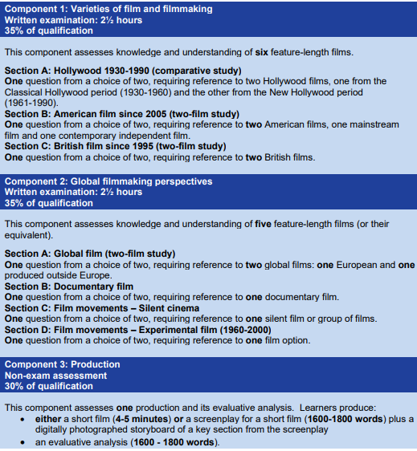

KEY COURSE INFORMATION

Headline

Length of Study | 5 hours per week, 38 weeks per year, 2 years.
Your classrooms | TBC
Key skills you will be developing during the course to be successful | This course builds on the knowledge, understanding and skills established at GCSE, particularly literacy and Information Technology skills. Some learners may already have gained knowledge, understanding and skills through their study of film at GCSE or AS.  This course provides a suitable progression to a range of higher education degree and vocational level courses or to employment. For those who do  not wish to progress further with Film Studies, this specification also provides a  coherent, engaging and culturally valuable course of study.
What will lessons look like? | Most lessons will be conducted in a non-ICT, classroom environment. Each lesson begins with a recall quiz based on the previous lesson’s content.  There will be frequent use of film clips to demonstrate filmmaking techniques alongside small, group-based practical work to actualise these techniques.  Extended writing and essay skills are an important success criterion in Film Studies. As a result, lots of writing practise is needed. This may take the form of cloze exercises, summary paragraphs, shared writing and formally assessed essays.  Students are seated in groups and encouraged to participate through verbally responding to pre-planned questions, group talk and direct questioning.
Informal Assessment Methods | A combination of class quizzes, group presentations, short film practical work, extended writing, and homework tasks.
Essential Equipment/ Resources | A Lever-arch folder for sole use in Film Studies.  12 folder dividers (one per module).  A4 lined paper.  Plastic wallets.  Pen, pencil, ruler, and highlighters.
Health and Safety | All lessons will adhere to the college’s health and safety procedures.

YEAR PLAN OF STUDY

Year 1:
- Half term 1: introduction to key elements – cinematography, editing, sound, mise-en-scene, and performance.

- Half term 2: Component 2 section A – Global Film (two-film study) – Parasite and The Worst Person in the World. Core study areas: meaning and responses, key elements, and context.

- Half term 3: Component 2 Section B – Documentary Film (single film study) - Amy. Core study areas: meaning and responses, key elements and context PLUS critical debates and filmmakers’ theories.

- Half term 4: Component 2 Section C – Silent Cinema - One Week (1920), and The Scarecrow (1920), and The 'High Sign' (1921), and Cops (1922), (Keaton, US). Core study areas: meaning and responses, key elements, and context PLUS critical debates.

- Half term 5: Component 2 Section D – Experimental Film (single film study) - Mulholland Drive. Core study areas: meaning and responses, key elements and context PUS auteur and narrative.

- Half term 6: NEA planning - This component assesses one production and its evaluative analysis. Learners produce: a screenplay for a short film (1600-1800 words) plus a digitally photographed storyboard of a key section from the screenplay and an evaluative analysis (1600 - 1800 words)
Year 2:
- Half term 1: NEA completion - This component assesses one production and its evaluative analysis. Learners produce: a screenplay for a short film (1600-1800 words) plus a digitally photographed storyboard of a key section from the screenplay and an evaluative analysis (1600 - 1800 words)

- Half term 2: Component 1 Section C - British film since 1995 (two-film study) - We Need to Talk about Kevin and Under the Skin. Core study areas: meaning and responses, key elements and context PUS narrative and ideology.

- Half term 3: Component 1 Section B - American film since 2005 (two-film study) - Joker and Captain Fantastic. Core study areas: meaning and responses, key elements and context PUS ideology and spectatorship.

- Half term 4: Component 1 Section A - Hollywood 1930 - 1990 (comparative study) - Some Like It Hot and Alien. Core study areas: meaning and responses, key elements and context PUS auteur.

- Half term 5: Exam revision.

- Half term 6: Exam revision.

ENRICHMENT AND VISITS

Visits:

QUAD Cinema, Derby - QUAD is an international centre for engagement in contemporary art and film, focussing on major exhibitions, professional practice for artists, independent film and the creative use of emergent digital technologies.

University of Derby, Markeaton Street Campus - A place of innovation and creativity, Markeaton Street is home to engineering, computing, and mathematics courses as well as art, design, media and performing arts.

Enrichment:

BFI Film Academy – all Film Studies pupils are supported in their application for the BFI Film Academy, held at QUAD cinema, Derby.

BFI Academy short course will be taking place again from October-February 2026/2027. The BFI Film Academy offers opportunities for young people, anywhere in the UK to get to know more about film and how you could make a career in the film industry.

As a student of a BFI Film Academy course, you will gain invaluable experience working alongside industry professionals who are respected practitioners in their field. You will be offered hands-on filmmaking experience which will help you to develop practical knowledge and skills.

You will work towards a Silver Arts Award as part of your BFI Film Academy accreditation.

Once you are a BFI Film Academy Alumni you will have access to exclusive opportunities, advice, and professional development.

There are no qualification requirements just a simple application form and we can offer support if you have educational or disability needs.

Course fee: £25

SUCCESSFUL LEARNER HABITS

Knowledge Organisers: these will be provided for the key elements – cinematography, editing, sound, performance, and mise-en-scene – and should be revised thoroughly until all the terms can be recalled from memory. Additionally, information sheets will be provided for all the examined films, containing key contextual information, key scene details and further reading. The use of knowledge organisers and information sheets should be incorporated into regular study and used during lessons wherever possible.
How to make notes:
Repetition, repetition, repetition. Cramming before an exam doesn’t work. What does work is regularly reviewing your material.
Pictures are easier to remember than words so if you’re short on time, draw an image.
If you like to colour code, don’t do it during initial note-taking.
Write short, succinct sentences.
Save time and use abbreviations and symbols.
Use your own words that mean something to you.
Use your teacher’s notes or your textbook as a starting point and a way to familiarise yourself with the topic. But do use your own note-taking method too.
Write questions to yourself if there’s something you don’t understand. Don’t gloss over it and hope you’ll understand later.
Don’t try to write everything down. You’ll just get information overload. It’s better to be engaged and have an efficient and effective system of recording the main points.
How to study independently:
Create a designated study space.
Mute your phone.
Create an effective study schedule.
Establish a reward system.
Make your work efficient.
Vary your study techniques.
Use Efficient Revision Techniques.
Time yourself.
Follow up by watch further films linked to the topic, director, genre etc. – be an expert.
Review each lesson’s notes and test yourself prior to the following lesson.
How to prepare for assessments:
The most important way to prepare for a Film Studies assessment is to re-watch key scenes of the examined films. Knowledge of the films is the most critical aspect of preparation. You should be able to recall, at minimum, cinematography, sound, editing, mise-en-scene, and performance techniques from the opening and closing scenes of every film studied. On top of this, ensure you’re prepared to discuss any additional study areas and link these to supplementary scenes.
How to practice exam skills:
WAGOLL booklets are provided for each unit. These provide valuable insight into successful exam responses. Use these alongside side past papers to practise essays and hand your work in for feedback.

SUBJECT RESOURCES FOR STUDENTS

Suggested reading for Film Studies students

Books

Villarejo: Film Studies: The Basics
Turner: The Film Cultures Reader
Hayward: Cinema Studies: The Key Concepts
Bordwell and Thompson: Film Art: An Introduction (10th edition)
Corrigan and Barry: The Film Experience: An Introduction (3rd edition)
Hjort and Mackenzie: Cinema and Nation
Dennison and Lim: Remapping World Cinema: Identity Culture and Politics in Film
Chapman: Cinemas of the World: Film and Society from 1895 to the Present
McDonald and Wasko: The Contemporary Hollywood Film Industry

Films

5 Hollywood Classics

Citizen Kane (Orson Welles, 1942)
Double Indemnity (Billy Wilder, 1944)
Rebel Without a Cause (Nicholas Ray, 1955)
Vertigo (Alfred Hitchcock, 1958)
The Shining (Stanley Kubrick, 1980)

5 European Classics

Bicycle Thieves (Italy, Vittorio De Sica, 1948)
A bout de souffle (France, Jean-Luc Godard, 1960)
Cleo de 5 à 7 (France, Agnes Varda, 1962)
Don’t Look Now (UK/Italy, Nicholas Roeg, 1973)
Fear Eats the Soul (West Germany, Rainer Werner Fassbinder, 1974)

5 East Asian Classics

The Goddess (China, Cai Chusheng, 1934)
Tokyo Story (Japan, Yasujiro Ozu, 1953)
A Touch of Zen (Taiwan/Hong Kong, King Hu, 1975)
A City of Sadness (Taiwan, Hou Hisao-hsien, 1989)
Poetry (South Korea, Lee Chang-dong, 2010)

5 World Cinema Classics

Man with a Movie Camera (USSR, Sergei Eisenstein, 1929)
The Battle of Algiers (Algeria/Italy, Gillo Pontecorvo, 1966)
Where is the friend's home? (Iran, Abbas Kiarostami, 1987)
City of God (Brazil, Fernando Meirelles and Katia Lund, 2002)
Mustang (France/Turkey, Deniz Gamze Ergüven, 2015)

TERMINOLOGY GLOSSARY

The following list is a brief glossary of terms that you will use regularly within this subject.

Aesthetics | The specific ‘look’ of the film. The film’s style.
Auteur | From the French ‘author’. A director who has control over the style of  the film.
Cinematography | Aspects of camera angles, distance, and movement. Also a consideration of colour, lighting and texture of the footage
Context | When, where, how, and why the film is set. The time, place and circumstances.
Generic conventions | Methods, ingredients, things necessary for the style/category of film.
Diegetic | Sound that is part of the film world (car horns beeping, birds singing,  telephones ringing).
Non-diegetic sound | Sound added in post-production to create a certain atmosphere (sound  FX to increase fear, music to underscore emotion).
Genre | The style or category of the film.
Iconography | The images or symbols associated with a certain subject.
Indie/independent | Film that is independent of the constraints of mainstream Hollywood. These films are often characterised by low budgets, location settings (rather than studio), (often) inexperienced directors and fairly unknown casts.
Key lighting (high and low) | Lighting design to create different light/dark ratios. High-key lighting is bright and produces little shadow, whereas low-key lighting is used to specifically create shadow and contrast.
Mainstream | Popular, conventional, and/or part of a major film studio system.
Mise-en-scène | Literally, ‘what is in the frame’: setting, costume & props, colour, lighting, body language, positioning within the frame all come together to create meaning.
Motif | A dominant theme or recurring idea.
Plot | Different to story, plot is the narrative order that the story is told in.
Representation | The way that people, places and events are constructed.
Screenplay | Written by the screen writer, this document tells the story and will contain no camera direction
Story | The ideas & events of the narrative whole
Shooting script | Written by the director & cinematographer (not the screen writer), this script focuses on planning the camera shots & other practical elements that will bring the screenplay to life.
Spectator | An individual member of the audience. Although we may view a film in the cinema together, the experience will be individual according to a range of factors

NOTES
