English Literature A Level
Course Handbook 2026-27

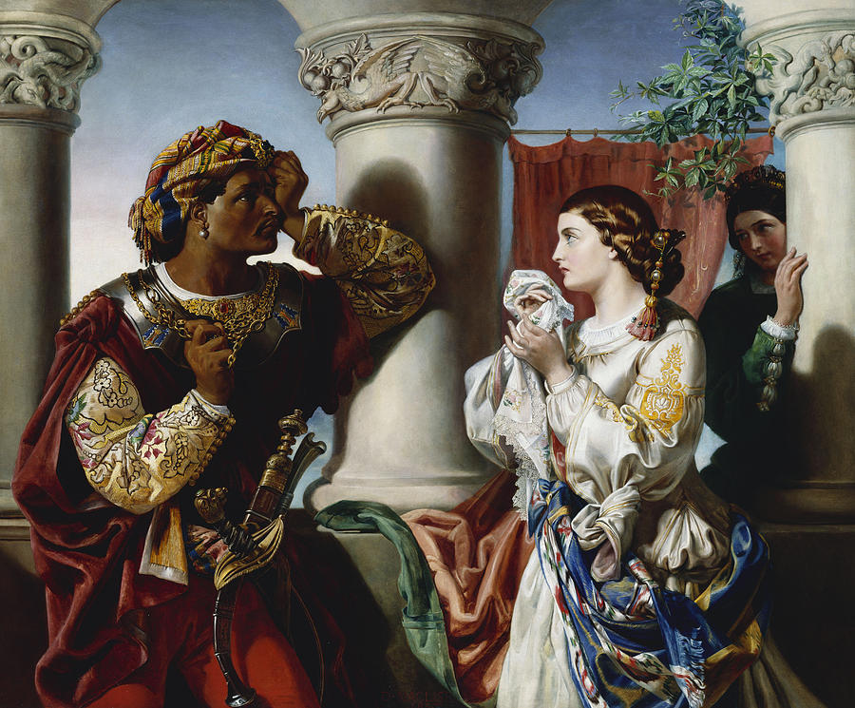

Edexcel (9ET0)
Specification: Pearson Edexcel Level 3 Advanced GCE in English Literature

CONTENTS

YOUR SUBJECT TEACHERS 3
INTRODUCTION & AIMS OF THE COURSE 5
COURSE STRUCTURE 6
KEY COURSE INFORMATION 11
ASSESSMENT AND FEEDBACK 12
KEY EXPECTATIONS 14
LIBRARIES FOR LEARNING 15
SUPPORT FOR YOUR STUDY SKILLS AT DCG 16
SUPPORT FOR YOUR DIGITAL SKILLS AT DCG 17
STUDENT VOICE 18
GLOSSARY OF TECHNICAL TERMS 19
ENRICHMENT AND VISITS 20
GOOD STUDY HABITS AND HOMEWORK 21
SUBJECT RESOURCES FOR STUDENTS 22
ASSESSMENT OBJECTIVES 23

YOUR SUBJECT TEACHERS

A very warm welcome from the A Level English Literature Team at Joseph Wright. This handbook is designed to give you an overview of the course and what is expected of you as a learner. It will also help you to plan your workload and knowledge of when topics alter and the texts that will be studying throughout the year.


Jonny Lee: Course coordinator/teacher

I studied English Literature and History at Lancaster University. I have a PGCE in Secondary Education from The University of Nottingham.

For most of my career, I have worked as an English Teacher in secondary schools. I joined the A Level English department at Joseph Wright in 2023 and love being part of the team! It is a real privilege to teach such a dynamic, varied subject and to work with so many thoughtful, insightful students.

Favourite books: My favourite novelists are Dona Tartt, John Steinbeck, E Annie Proulx, Susanna Clarke, George Orwell, John Steinbeck and Joseph Conrad. My favourite poet is Edward Thomas and my favourite playwright is Arthur Miller.

Top tips: Know your texts inside-out and practise essay writing from the very start of the course.


Leah Careless: Teacher

I studied English Literature and History at the University of Derby. I have a PGCE in post-14 education from the University of Derby.
I have previously been a personal tutor for the SOCSCI area at the Joseph Wright Centre and supported students with their next steps. I joined the A level and GCSE plus English department in September 2025.
Favourite books: My favourite novelists are Emily Bronte, Holly Jackson, Stephen King, George Orwell, J.K Rowling, and Alice Sebold. My favourite poets are William Blake and T. S Eliot. My favourite playwrights are Arthur Miller for The Crucible, and William Shakespeare for The Taming of the Shrew.
Top tip: I would strongly recommend bringing your highlighters to your English lessons!
We are based in the Joseph Wright building. You will find us in F26 during non-teaching hours. English Literature lessons are typically in S28.

Please feel free to contact us on Microsoft Teams.

INTRODUCTION & AIMS OF THE COURSE

English Literature is an ideal course for anyone with a thirst for knowledge and a passion for learning. It is an academically challenging but very highly-regarded discipline for both employers and universities. A Level English Literature is delivered by a highly qualified subject specialist team with an extensive range of subject qualifications in literature.

Having an A Level in English Literature is particularly attractive for students hoping to go to Russell Group institutions and on to graduate careers across the professional spectrum. This course will require you to analyse, interpret, compare and understand a wide range of literary texts from two specific literary genres throughout time (tragedy and crime writing).

It fits particularly well with students who wish to pursue criminology, humanities, law and classics as we cover ideas from all of these areas in our curriculum. We offer a number of supra-curricular enrichment opportunities such as theatre visits, university trips and hosting guest speakers. If you have a curiosity and a flair for analysis, and are prepared to work hard, you are our ideal learner!

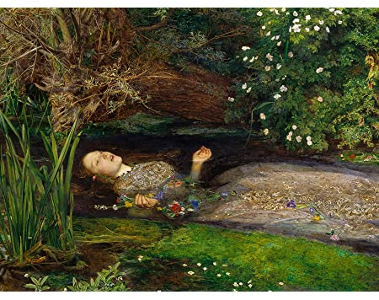

COURSE STRUCTURE

We study the Edexcel English Literature A Level. Over the two-year course, you will work towards three exam papers. You will also complete one essay for the NEA (non-exam assessment) component of the course.

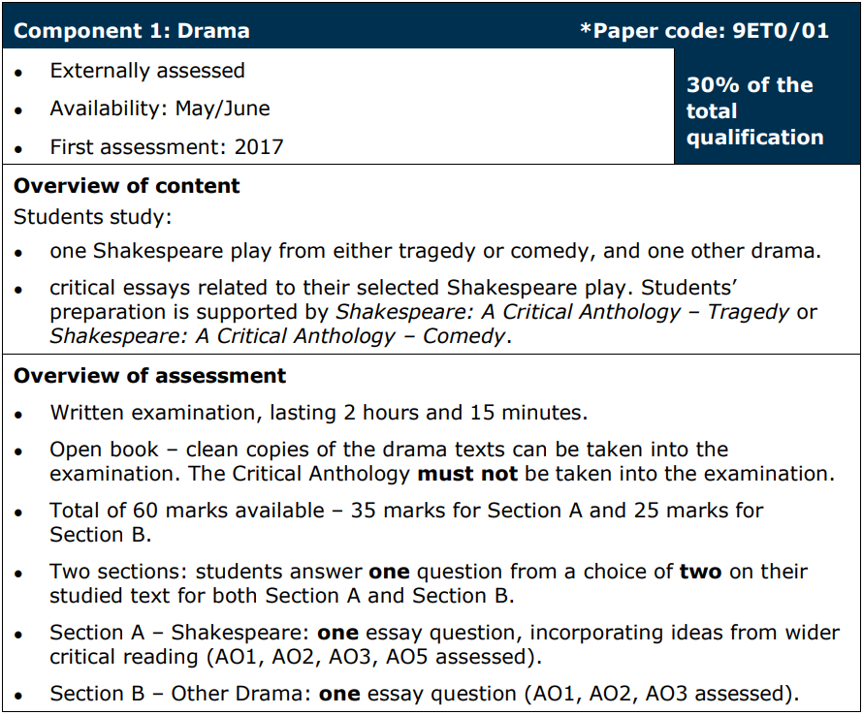

For this paper, you will be studying ‘Othello’ by William Shakespeare and ‘A Streetcar Named Desire’ by Tennessee Williams.

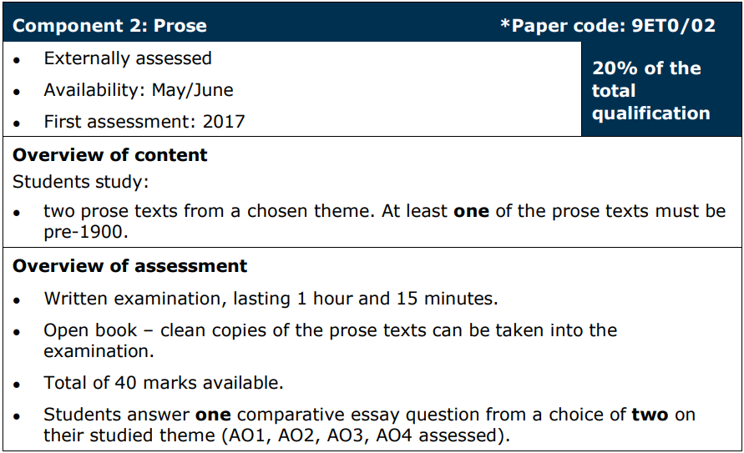

For this paper you will be studying ‘A Handmaid’s Tale’ by Margaret Atwood and ‘Frankenstein’ by Mary Shelley’.
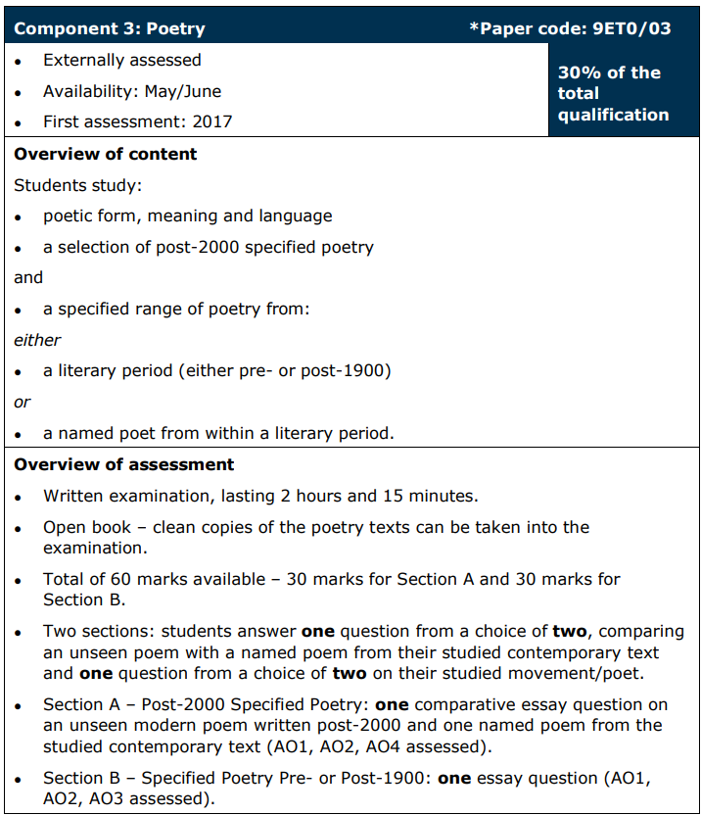

For this paper, all students must study the same anthology of modern poetry. You will also study a selection of Romantic poetry. More details are available in the specification.

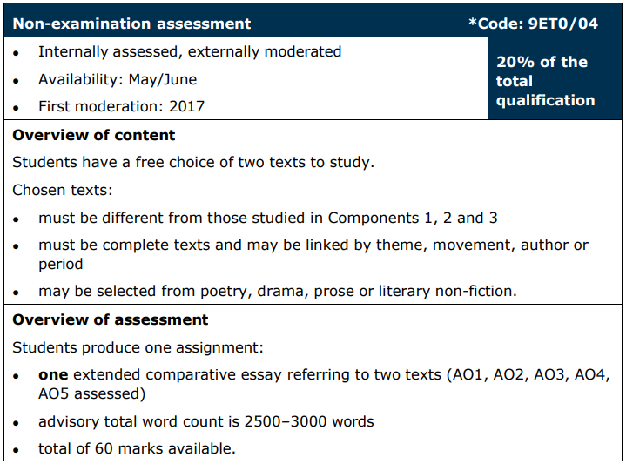

You are all going to study a selection of poems from Carol Ann Duffy’s collection ‘The World’s Wife’. In this collection, Duffy reimagines famous women from a feminist perspective. You are going to choose a novel in which women are presented more traditionally and compare the depiction of women between the poetry collection and your novel.
A broad outline of the first year…
Year 1 | Teacher 1 (2 lessons per week) | Teacher 2 (1 lesson per week)
Half-term 1 | A Streetcar Named Desire | 21st century poetry and unseen poetry
Half-term 2 | A Streetcar Named Desire + start The Handmaid’s Tale | 21st century poetry and unseen poetry
Half-term 3 | The Handmaid’s Tale | Coursework
Half-term 4 | Othello | Coursework
Half-term 5 | Othello and progression exam revision | Progression exam revision  Poetry and Streetcar
Progression exam
Paper on drama (replicates paper 1 in your final exam)
Half-term 6 | 21st century poetry and unseen poetry | 21st century poetry and unseen poetry

A broad outline of the second year
Year 2 | Teacher 1 (2 lessons per week) | Teacher 2 (1 lesson per week)
Half-term 1 | Frankenstein | Coursework/Romantic poetry
Half-term 2 | Frankenstein/Revise prose | Romantic poetry
Half-term 3 | Revise prose/drama | Revise poetry
Half-term 4 | Revise drama | Revise poetry
Half-term 5 | Bespoke revision | Bespoke revision
Final exams – exam dates are available for 2027

If you would like a more detailed breakdown then please speak to Leah or Jonny. Please also note that all of the past exam questions will be available to you.

KEY COURSE INFORMATION

Level of course | Level 3
Awarding Body | Edexcel
Specification | Pearson Edexcel Level 3 Advanced GCE in English Literature
Length of Study | 5 hours per week in Year 1  5 hours per week in Year 2
Your classrooms | S28
Key skills you will be developing during the course to be successful | Analysis, evaluation, comparison, world issues, inclusivity, morals and ethics, contextualisation and many more.
What will lessons look like? | A range of discussion  Annotations of text  Regular group and paired work  Modelled answers and improvement
Informal Assessment Methods | Regular written and verbal feedback  Use of technology for feedback
Essential Equipment/ Resources | Subject folder  Set texts (students need to buy their own copies)  Optional textbooks  Pens and paper
Health and Safety | Responsible classroom conduct



ASSESSMENT AND FEEDBACK

Dates of assessments:

Year 1Year 1 Assessment Schedule

Week Commencing | Year 1 assessments
21/09/2026 | Initial assessment – A Streetcar Named Desire
19/10/2026 | Practice assessment 1 – A Streetcar Named Desire
02/11/2026 | Formal Assessment 1 – A Streetcar Named Desire
14/12/2026 | Practice assessment 2 – Unseen poetry
04/01/2027 | Formal Assessment 2 – Unseen poetry
08/02/2027 | Practice assessment 3 – The Handmaid’s Tale
22/02/2027 | Formal Assessment 3 – The Handmaid’s Tale
22/03/2027 | Practice assessment 4 (oracy based) – Othello
12/04/2027 | Formal Assessment 4 (oracy based) – Othello
07/06/2027 | Progression exams – Drama paper (paper 1)

Week commencing | Year 2 assessments
28/09/2026 | Practice assessment 1 - Romantic poetry
05/10/2026 | Formal assessment 1 - Romantic poetry
09/11/2026 | Interim assessment 2 - Frankenstein
23/11/2026 | Formal assessment 2 - Frankenstein
25/01/2027 | YR2 Mock week - Paper 2 (novels) and Romantic poetry
22/02/2027 | Interim assessment 4 - Modern poetry
08/03/2027 | Formal assessment 4- Modern poetry

Dates for year two FINAL exams (your actual A Level papers)

Paper 1: Drama Thursday 13 May 2027 Morning 2 hours 15 minutes
Paper 2: Prose Thursday 20 May 2027 Morning 1 hour 15 minutes
Paper 3: Poetry Friday 28 May 2027 Morning 2 hours 15 minutes

Assessment and Feedback
- Your work will be returned within 15 working days. You will then complete a DIRT (dedicated improvement and reflection time) task in which you take the time to work through your feedback and improve the quality of your assessment.
- After every assessment, you will set developmental, actionable target goals on ProMonitor. It is vital that you come back to these targets throughout the year.
- As you probably know, A Level work is ultimately graded using grades A* to E.

Academic Malpractice

DCG is keen to support students and avoid any cases of Academic malpractice. Awarding Organisations take matters of academic malpractice very seriously and require all schools and colleges to have specific policies and procedures in place to both educate staff and students about malpractice, thus deterring them from committing it, whether intentional or not, and report and investigate any suspected malpractice where it may occur.

While we don’t want to see anyone jeopardise their grades or marks, we must ensure the validity of all qualifications and we must investigate any suspected breaches fully. It is your responsibility to ensure you understand the rules and boundaries:

- You must not copy from someone else or give opportunities to another student to copy from you.
- Any wording taken from a published source must be correctly referenced for example:
(Morrison, 2000, p29).
- Where computer-generated content has been used (AI tools such as ChatGPT) you must reference these correctly for example: ChatGPT 3.0 (https://openai.com/blog/chatgpt/), 25/01/2024.
- You may also be required to include a bibliography to support referencing.
- You must also avoid working collaboratively with other students beyond what is permitted as this may be deemed to be collusion.

Other examples include:

- Falsification or fabrication of results,
- Deliberate destruction of other student’s work
- Any other act that will give you an unfair advantage. This also relates to not following clear guidance in examinations or assessments where examination conditions exist.

You will be required to complete an Authentication Form on submission of any and all assignments/NEA projects. This will confirm that the work is your own, and that it is referenced appropriately, including the use of AI. Where academic malpractice is suspected, this will be reported to your Team Manager who will conduct an investigation and, where relevant, the Awarding Organisation may also be informed and investigate further. Where malpractice is discovered to have occurred, sanctions may be imposed which could include:

- Zero marks for the work or exam.
- Disqualification from the qualification.
- Disqualification from taking any qualification with that Awarding Organisation often over a set period of time.
- Warnings which can last several years.

For further details and to fully familiarise yourself with JCQ guidance please see the Joint Councils for Qualifications (JCQ) website:
Information for candidates documents - JCQ Joint Council for Qualifications

Further information can be found on the DCG website:
Examination Information - DCG (derby-college.ac.uk)

Appeals Procedures

Each Awarding Organisation will have slightly different processes for appealing decisions. Appeals can be made where:
- You believe that the awarding body policies and procedures have not been followed correctly in respect of external quality assurance/standards verification (policies and procedures can be found on the relevant awarding body website).
- You believe that the awarding body policies and procedures have not been followed correctly in respect of qualification decisions (policies and procedures can be found on the relevant awarding body website).
- You disagree with the outcome of your internal appeals procedure (for example, a decision in relation to reasonable adjustments or assessment outcomes).

However, should you, as a student wish to appeal, firstly:

- Contact your lecturer/trainer/assessor and discuss your concerns.

If you are still not satisfied with the outcome, the College would usually make an appeals application on your behalf. This would require your consent. It is possible to apply directly to the Awarding Organisation but only once the College’s internal processes have been followed. At this point you would be informed of the next stages and Awarding Organisation communication link. This is time bound and this will also be communicated to you once the internal appeals process has taken place.

Note: you must be aware that through this process the initial grade can go up, stay the same, or go down.

KEY EXPECTATIONS

The 5Ps and College code of conduct.

To be successful at Derby College you will be expected to be:
- Positive
- Polite
- Punctual
- Prepared, and
- Professional in your approach.

Please pay attention to the code of conduct, you will be asked to sign a copy to promise you will abide by the College guidelines: Code of Conduct (sharepoint.com)

Derby College has a zero tolerance approach to all forms of bullying, harassment and abuse both online and face-to-face. Statement on Sexual Harassment, Bullying and Online Abuse (sharepoint.com)
If you or anyone else is being bullied, harassed or abused – or if you become aware of discriminatory behaviour or actions taking place – you are encouraged to report this by contacting either your course tutor or https://studentderbycollegeac.sharepoint.com/sites/Welfare/SitePages/Chat-to-a-Welfare-Officer.aspx or call our confidential BULLYING HELPLINE on 01332 387499.

What all students can expect from Derby College Group:

- We will listen to you and take your concern seriously and deal with it in a sensitive manner.
- We will give you support and involve you in any decision that affects you.
- We will take disciplinary action against any student who has harmed you and/or breached the college Code of Conduct.

RESOURCES FOR STUDENTS

Libraries for Learning.

Research has established that the students who achieved the highest grades on their chosen course of study were those students who took full advantage of all that the library has to offer by borrowing books and accessing the electronic resources most frequently. In contrast, the students with the lowest marks were those who made the fewest visits to the library. What are you waiting for?

The libraries for learning team can help with finding and borrowing books and journals, accessing eBooks and online resources, borrowing laptops, logging on to Derby College Group (DCG) Wi-Fi and systems, printing, scanning, and copying, using Microsoft Office 365 applications such as Teams, and Outlook, and finding fiction and reading books.

Embark on an exciting journey of discovery and growth by joining the Libraries for Learning Reading Challenge! This is more than just a chance to read – it's an opportunity to explore new worlds, ignite your imagination, and sharpen your mind. By diving into a variety of genres and authors, you'll enhance your critical thinking, expand your vocabulary, and gain a deeper understanding of different perspectives. Plus, completing the challenge can bolster your applications and CVs, showing your commitment to personal development and intellectual curiosity. So why not take on the challenge? It's your ticket to adventure, knowledge, and a brighter future!

Come into the library to see the Libraries for Learning Team or contact us by:
- calling 01332 334848 (direct line to the library team)
- calling 0800 028 0289 (switchboard) and ask for the library team
- emailing learningresources@derby-college.ac.uk
- chatting to a Librarian’ using Live Chat on the library Catalogue

Everything about the Libraries for Learning Service can be found on the Libraries for Learning Moodle Page including the Library Catalogue, and all the contact details.

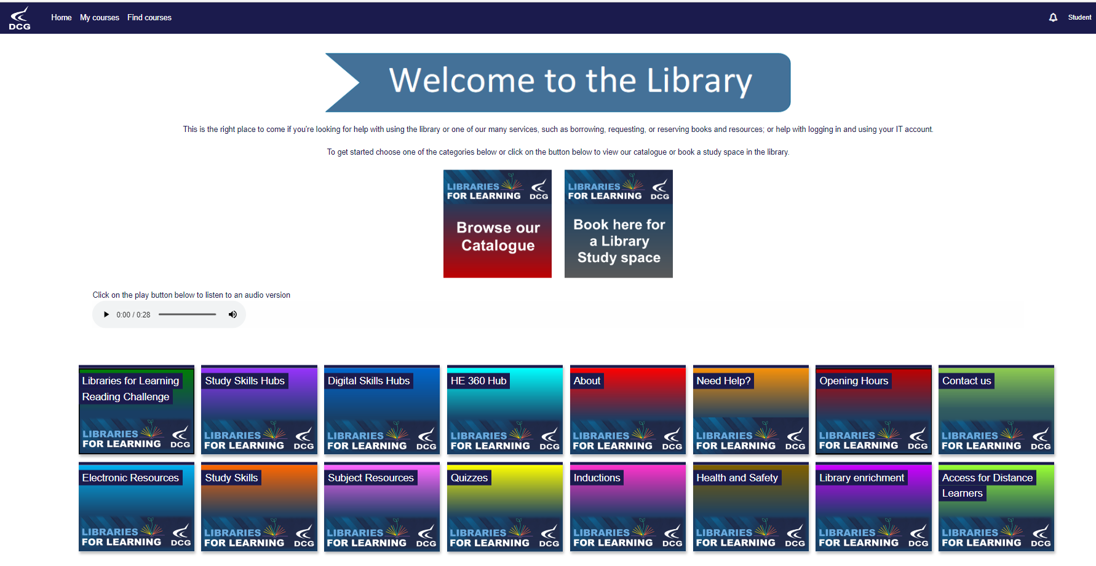

PLEASE COMPLETE AS MUCH EXTRA READING AS YOU CAN! ASK JONNY OR LEAH FOR ADVICE.

SUPPORT FOR YOUR STUDY SKILLS AT DCG

The Study Skills Hub course includes a wide-ranging selection of information and resources to support the continuing development of your study skills, (the stuff you can easily do to improve your college life and continued learning). You can work through these short modules (see below for a detailed list) in any order and obtain a virtual badge in recognition of your participation.

On completion of any 6 modules, you will also be awarded a Bronze level certificate. If you go on to complete a further 6 (12 in total) you will be awarded a Silver level certificate and a Gold certificate on completion of all modules.

Links to the complete course and individual modules are listed below:

 | Study Skills Hub (complete course)
Better Learning | Note Taking | Managing your Time
Independent Learning | Better Thinking | Preparing for Assessments or Exams
Internet Search Strategies and using Google | Using Chatbots to Search the Internet | Starting Research
Referencing and Plagiarism | Using Artificial Intelligence (AI) as a Study Aid | Trusted Sources
Presentation Skills | Critical Thinking | Continuing Research
Primary and Secondary Sources | Copyright and Intellectual Property | Learning from Feedback and Reflective Practice

All modules are supported by the Libraries for Learning Team so please contact them at learningresources@derby-college.ac.uk if you would like any additional support or information – they are here to help!

SUPPORT FOR YOUR DIGITAL SKILLS AT DCG

Each of the three Digital Skills Hub courses includes a wide-ranging selection of information and resources to support the continuing development of your Digital Skills from the time you start with us at DCG to the time you move on. You can work through the modules and obtain a virtual badge in recognition of your participation. On completion of the first 6 modules, you will also be awarded a Bronze level certificate. If you go on to complete a further 6 (12 in total) you will be awarded a Silver level certificate and a Gold certificate on completion of all modules. The course and the modules for each one are listed below.

 |  | 
Digital Skills Hub: Getting Started | Digital Skills Hub: Progressing | Digital Skills Hub: Moving on
Acceptable Use Policy (AUP) | Plagiarism and Copyright | GDPR and Data Protection
Online Safety | Privacy and Cookies | Phishing and Scams
An Introduction to Mobile Devices | Essential Tech Skills | Setting up a Desktop PC
Introduction to MyDCG and your College Individual Learning Plan (MyILP) | Your Digital Footprint | LinkedIn and Professional Networks
College IT Troubleshooting | Maintaining a Device (Basic Troubleshooting) | Troubleshooting your Device
Logging In | Microsoft 365 Applications | Microsoft 365 Tips and Tricks
Microsoft OneDrive | Sharing on Microsoft OneDrive and Microsoft Teams | Collaborative Working
Emailing and Using Microsoft Outlook | Organising your Inbox | Creating a Personal Email (Gmail) Account
Microsoft Teams | Microsoft Teams for Remote Learning | Google Meet and Zoom
Microsoft Word | Progressing with Microsoft Word | Document Basics (Google Docs and Pages)
Using Library e-Resources | Creating a Digital Portfolio and Submitting Assignments | Creating and Presenting an Academic Poster
Using the Internet | Searching the Internet and Using Chatbots | Internet Search Techniques
Microsoft PowerPoint | Video Creation in Microsoft PowerPoint | Presentation Basics (Google Slides, Keynote and Prezzi)
Microsoft Excel | Progressing with Microsoft Excel | Spreadsheet Basics (Google Sheets and Numbers)
Microsoft OneNote | Accessibility Tools | Using External Applications and Websites
An Introduction to AI | Using Artificial Intelligence | Using AI to Prepare for Interviews
CVs, Application Forms and UCAS | Preparing for Interviews | Professional Image
Managing Your Money Online | Digital Tools for Everyday Living | Social Intelligence and Communication Skills

All modules are supported by the Libraries for Learning Team, so please contact them at learningresources@derby-college.ac.uk if you would like any additional support or information – they are here to help!

STUDENT VOICE

There is no bigger group of people than students in the classroom! Therefore, listening to students is essential.

Student Voice refers to listening to what YOU think and feel during your time in education at DCG. This is not just about the College listening, but also about acting upon, your feedback.

We want to know:
- Positives – what you enjoy and want to do again,
- Improvements – what and how we can change to improve,
- New Ideas – we are always looking for student-led initiatives.

We listen to students through...
- Cross College Surveys
- Focus Groups
- Student Voice Meetings
- And The Student Representative System.

What is a Student Representative?

Student Representatives or Student Reps are volunteers representing the opinions and suggestions of the students in their class. Student Reps gather the feedback from their class and pass that information to their Academy Representatives and leaders within the college. This is an outstanding experience to add to your CV, job application, or UCAS form.

What are Academy Reps?

This is a senior volunteer role and represents the views of students in the whole Academy, rather than just the class. Academy reps present feedback from Student Reps in their Academy to the senior leadership team (the people who lead the whole college).

Want to learn more about Student Voice?

- The Student Voice Coordinator will be visiting YOU in tutorial sessions this October.
- Contact Pippa Lucas (She/Her), Student Voice Coordinator, with any questions you may have via the email below.

Email - studentvoice@derby-college.ac.uk

GLOSSARY OF TECHNICAL TERMS

The following list is a brief glossary of terms you will learn or be exposed to during your learning.

Term | Definition
DIRT | Dedicated improvement and reflection time. This is time to reflect on assessments and demonstrate improvements in the quality of your work.
FA | Formal Assessments You will have one assessment every half term. These will be graded. They help you and your teacher to understand your progress.
Genre | This is a noun that you will be hearing a lot! The simplest definition is that genre is a category or type (of literature). For example, ‘Othello’ is one of the best Shakesperean tragedies. It is vital that you understand the conventions of the genres that we work with – the things that we often see in these texts.
Literature | Any collection of written work – usually used (including by us) more narrowly for texts specifically considered to be an art form, especially novels, plays, and poems.
NEA | Non-exam assessment. This used to be known as coursework. You will complete one extended piece of work in class and at home. They are worth 20% of your final grade. Your teachers will give you lots of support!
Practice assessment | You will complete a practice assessment in the week or two before your formal assessment to give you the best possible chance.

ENRICHMENT AND VISITS

Past visits have included: Derby Gaol Museum, The Globe Theatre, Paris Trip, Theatre Productions and in-house and outbound university lectures. We are forging links with Derby University and Derby Book festival and hope to run events for both first years and second years in the Autumn term.



GOOD STUDY HABITS AND HOMEWORK

You should aim to complete 3-5 hours per subject, per week. You Will be given a separate booklet to record what you have done and how it has helped you.



SUBJECT RESOURCES FOR STUDENTS

A variety of resources are available in your class Teams site

We also recommend these additional textbooks, some of which are available in the library. It is not mandatory to purchase these textbooks, and they will only be used to enhance the programme rather than as set work. You might want to try the second hand book site abebooks.co.uk:


Textbooks/Revision Guides

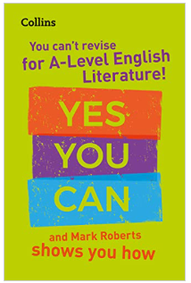
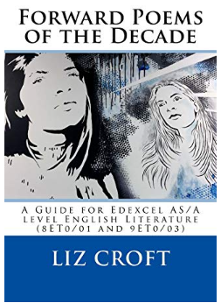
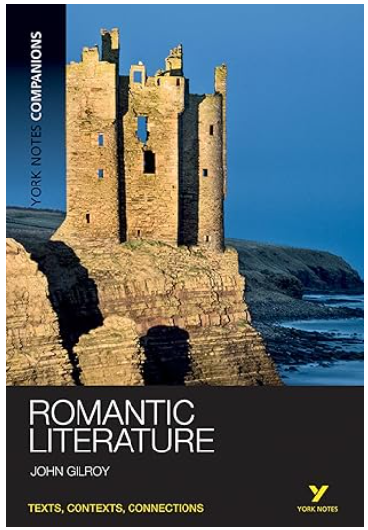

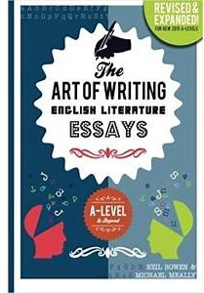
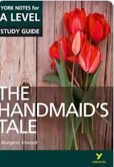



ASSESSMENT OBJECTIVES

• AO1: Articulate informed, personal and creative responses to literary texts, using associated
concepts and terminology, and coherent, accurate written expression.
• AO2: Analyse ways in which meanings are shaped in literary texts.
• AO3: Demonstrate understanding of the significance and influence of the contexts in which
literary texts are written and received.
• AO4: Explore connections across literary texts.
• AO5: Explore literary texts informed by different interpretations.

