English Language 2026/2027
Academic Studies



Start Date | September 2026
End Date | July 2027 (End of Year 1)  June 2028 (End of Year 2)
Level of course | Level 3
Awarding Body | AQA
Specification | AQA | AS and A-level | English Language | Specification at a glance

CONTENTS

YOUR SUBJECT TEACHERS 3
INTRODUCTION & AIMS OF THE COURSE 4
COURSE STRUCTURE 5
KEY COURSE INFORMATION 6
YEAR PLAN OF STUDY 7
ENRICHMENT AND VISITS 8
SUCCESSFUL LEARNER HABITS 9
SUBJECT RESOURCES FOR STUDENTS 10
TERMINOLOGY GLOSSARY 11

YOUR SUBJECT TEACHERS

Welcome to English Language!

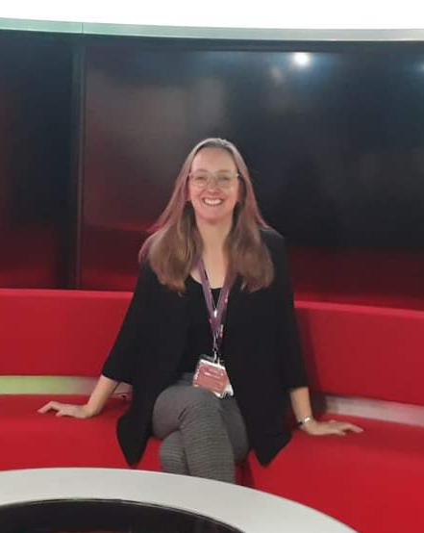
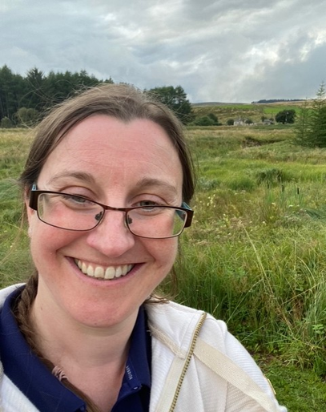

Rachel Hunt
English Language Teacher
rachel.hunt@derby-college.ac.uk
Jude Grundy
English Language Subject Co-ordinator
jude.grundy@derby-college.ac.uk

INTRODUCTION & AIMS OF THE COURSE

During your two years studying English Language we aim to analyse, debate, and evaluate theory relating to the language we speak daily. During the first year you will cover: The Methods of Analysis, Language and Gender, Accent and Dialect, Occupational Language, Language and Social Groups and a piece of original writing coursework. In your second year you will explore Language Change, Global English and Child Language Development as well as conducting your own language investigation piece of coursework.

English Language works well with many other subjects including:
- Sociology
- Psychology
- English Literature
- History
- Law
- Media Studies
- Film Studies

Other students who study English have gone on to study/ have careers in:
- Speech and Language Therapy
- Linguistics
- Teaching
- Journalism
- Creative Writing
- Business and Marketing
- Working within education for students with additional needs

And many more…

COURSE STRUCTURE

Assessment overview.

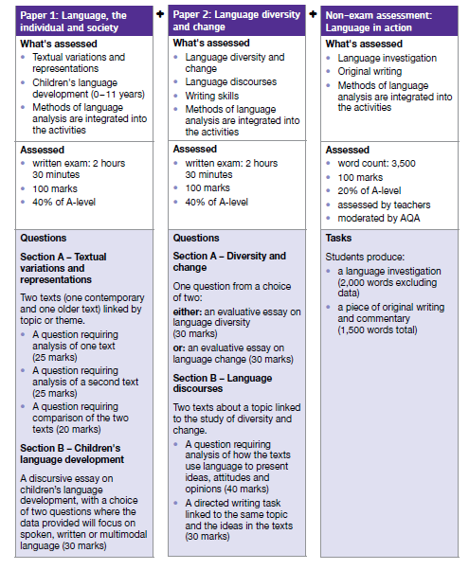

KEY COURSE INFORMATION

Length of Study | 5 hours per week, over two years.
Your classrooms | S27
Key skills you will be developing during the course to be successful | The ability to think analytically, apply theory and write in many different styles. We will also regularly look at how language is evolving around us and apply theory to this.
What will lessons look like? | You will engage in group work, class discussion, interactive activities, independent research and a variety of written tasks.
Informal Assessment Methods | Exam style essay questions will feature frequently throughout the year. We will also do lots of quizzes to ensure you remember the terminology and theory.
Essential Equipment/ Resources | Paper, pens, highlighters.

YEAR PLAN OF STUDY

Autumn Term First Year:

- Methods of analysis
- Spoken Language
- Accent and Dialect

Spring Term First Year:

- Original Writing coursework
- Language and Gender
- Language and Social Groups

Summer Term First Year:

- Begin Language investigation
- Language and Occupation

Autumn Term Second Year:

- Language investigation
- Child Language Development
- Language Change

Spring Term Second Year;

- Child Language Development continued
- Global English

Summer Term Second Year;

- Revision and exam preparation

A weekly independent study plan will be provided on Teams once the course has begun.

ENRICHMENT AND VISITS

During the course you will have the opportunity to:

- Visit a university for a day of English Language taster activities.
- Participate in an English Language conference

Successful Learner Habits
Regular revision: this will be necessary throughout the year due to the number of theories and array of terminology that we cover in English language. We will support you to identify the revision techniques that work best for you.
Good attendance: We have lots of content to cover so attendance is essential to ensure that you don’t miss a key idea/concept.
Exam practice: As the year progresses you will need to engage with a variety of exam-style questions and practice
Engage with assessment feedback: You will receive feedback after each Formal Assessment which will enable you to develop your skills.

Subject resources

All resources can be found on the English Language library link:

English Language (A Level) - Level 3

TERMINOLOGY GLOSSARY

We cover a huge amount of terminology across both years which will be provided in the booklets you receive in class. You will also receive a theory bank at the end of each year. But some key things we may refer to are:
NEA | Non- Examined Assessment. This is coursework that you will complete throughout the course which makes up 20% of your final grade.
Text Analysis | Text analysis involves identifying and exploring how a text uses language to create meanings and representations. It must include close language analysis using the specialist terminology that you will learn and links to the texts’ contexts to explain the language choices.
Comparison | Comparison questions involve comparing the representations in two texts and linking to the texts’ context to explain the similarities and differences in the representations and the language used to create them.
Opinion Article | Opinion articles use a chatty, engaging style to express a viewpoint on a language issue for a non-specialist audience.
Discursive Essay | A discursive essay is a formal essay which explores different sides of a language issue using examples, terminology, theories and studies that you have learned on the course.
AO | We regularly refer to the AO’s, these are the Assessment Objectives that the exam board requires you to meet. AO1 is using terminology and creating a line of argument, AO2 is application of specialist knowledge, AO3 is making links to context, AO4 is comparison and AO5 is your use of written language.

