English Language 2025/2026
Academic Studies



Start Date | September 2025
End Date | July 2026 (End of Year 1)  June 2027(End of Year 2)
Level of course | Level 3
Awarding Body | AQA
Specification | AQA | AS and A-level | English Language | Specification at a glance

CONTENTS

YOUR SUBJECT TEACHERS 3
INTRODUCTION & AIMS OF THE COURSE 4
COURSE STRUCTURE 5
KEY COURSE INFORMATION 6
YEAR PLAN OF STUDY 7
ENRICHMENT AND VISITS 8
SUCCESSFUL LEARNER HABITS 9
SUBJECT RESOURCES FOR STUDENTS 10
TERMINOLOGY GLOSSARY 11

YOUR SUBJECT TEACHERS

Welcome to English Language!
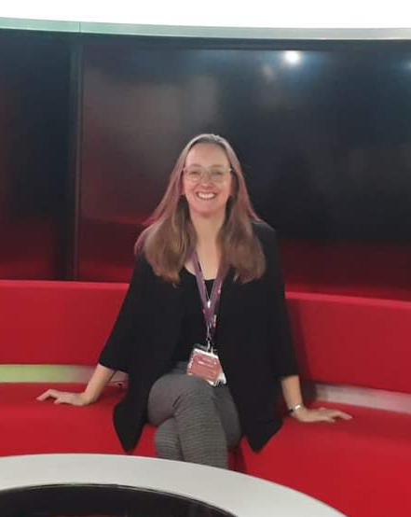

I’m Jude and I did a degree in English Studies at Nottingham University, followed by a PGCE. I’ve been teaching English since 2001. I’ve also worked as an examiner for both OCR and AQA exam boards marking English Language A level papers. If you’ve got any questions about English Language A-level, please get in touch with me via Teams or at judegrundy@derby-college.ac.uk

INTRODUCTION & AIMS OF THE COURSE

Headline

During your two years studying English Language we aim to analyse, debate, and evaluate theory relating to the language we speak daily. Throughout the first year you will cover: The Methods of Analysis, Language and Gender, Accent and Dialect, Occupational Language, Language and Social Groups and an original writing coursework. In your second year you will explore Language Change, Global English and Child Language Acquisition as well as conducting your own language investigation piece of coursework.

English Language works well with many other subjects including;
- Sociology
- Psychology
- English Literature
- History
- Law

Other students who study English have gone on to study/ have careers in;
- Speech and Language Therapy
- Linguistics
- Teaching
- Journalism
- Creative Writing
- Business and Marketing
- Working within SEND

And many more…

COURSE STRUCTURE

Assessment overview.

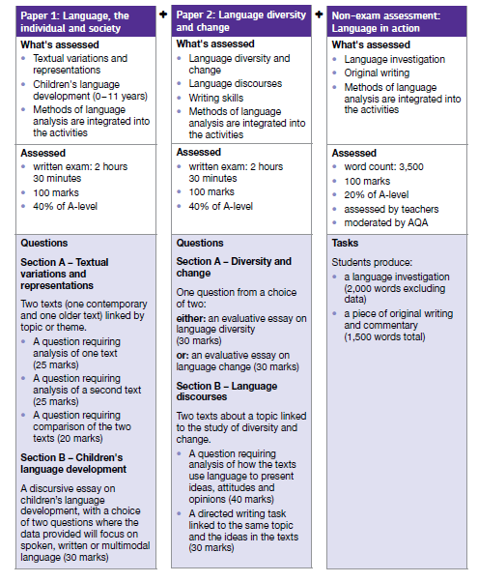

KEY COURSE INFORMATION

Headline

Length of Study | 5 hours per week, over two years.
Your classrooms | S27
Key skills you will be developing during the course to be successful | The ability to think analytically, apply theory and write in many different styles. We will also regularly look at how language is evolving around us and apply theory to this.
What will lessons look like? | You will engage in group work, class discussion, interactive activities, independent research and a variety of written tasks.
Informal Assessment Methods | Exam style essay questions will feature frequently throughout the year. We will also do lots of quizzes to ensure you remember the terminology and theory.
Essential Equipment/ Resources | Paper, pens, highlighters.

YEAR PLAN OF STUDY

Content by term;

Autumn Term first year:

Methods of analysis which includes:

- Grammar
- Lexis and Semantics
- Discourse
- Graphology

Spring Term first year:

Sociolinguistic topics and coursework

- Original Writing coursework
- Language and Gender
- Accent and Dialect
- Language and occupation

Summer term first year:

Sociolinguistic topics and coursework

- Begin Language investigation
- Language and Gender continued
- Language and Social Groups

Autumn Term second year:

- Language investigation
- Child Language Acquisition
- Language Change

Spring Term second year;

- Child Language Acquisition continued
- Language Investigation continued
- Global English

Summer term second year;

- Revisit of exam structure
- Revision of first year topics

A weekly independent study plan will be provided on Teams once the course has begun.

ENRICHMENT AND VISITS

Visits:

- Nursery school – in second year you will visit a local nursery to enable you to collect original data and witness child language acquisition happening in the real world.

- University masterclasses – we aim to visit university for masterclasses in topics we cover throughout the year.

Enrichment:
- Newspaper club

Successful Learner Habits
Regular revision: this will be necessary throughout the year due to the number of theories and array of terminology that we cover in English language, you will be able to do this in whichever way you please such as flashcards, mind maps, Quizlets etc.
Good attendance: We have lots of content to cover so attendance is essential to ensure that you don’t miss a key idea/concept.
Exam practice: As the year progresses you will need to engage with a variety of exam-style questions and practice
Engage with WAGOLLS: Exemplars are provided regularly

Subject resources

All resources can be found on the English Language library link:

English Language (A Level) - Level 3

TERMINOLOGY GLOSSARY

We cover a huge amount of terminology across both years; therefore, this will be provided in class in the form of the methods booklet. You will also receive a theory bank at the end of each year. But some key things we may refer to are:
NEA | Non- examined assessment. This is coursework that you will complete throughout the course which results in 20% of your grade.
Analysis | One of the essay styles you will become familiar with is an analysis, sometimes referred to as a methods analysis which involves you identifying how a text creates representations through specific terminology.
Comparison | This is an exam question which involves you comparing two texts for context and the way in which they use language according to the time period they were produced in.
Opinion article | This is a requirement on paper 2 where you will need to produce an article on a specified topic of language ensuring that you write for a non-specialist audience and use creative language techniques.
Discursive | This is an essay style which requires you to discuss two sides on an argument on a language issue, using theory and terminology to support your points.
AO | We regularly refer to the AO’s, these are assessment objectives that are used to mark your work as set out by the exam board. AO1 is terminology, AO2 is theory, AO3 is context, AO4 is comparisons and AO5 is creativity.

