2025/2026
STEM: A Level Computer Science

Course Handbook for A Level Computer Science

2025/2026

Start Date | 08/09/2025
End Date | 2027
Level of course | Level 3
Awarding Body | AQA
Specification | AS and A-level Computer Science Specification Specifications for first teaching in 2015

CONTENTS

YOUR SUBJECT TEACHER: COMPUTER SCIENCE 3
INTRODUCTION & AIMS OF THE COURSE 3
COURSE STRUCTURE 4
KEY COURSE INFORMATION 6
YEAR PLAN OF STUDY 7
ENRICHMENT AND VISITS 8
SUCCESSFUL LEARNER HABITS 8
SUBJECT RESOURCES FOR STUDENTS 9
TERMINOLOGY GLOSSARY 10

YOUR SUBJECT TEACHER: COMPUTER SCIENCE



Course Teacher and co-ordinator: Gurcharan Girn

Email: gurcharan.girn@derby-college.ac.uk

INTRODUCTION & AIMS OF THE COURSE

Introduction:

It is impossible to imagine a world without computers or mobile devices The A-Level Computer Science course will teach you how to use and program computers to make the world work as it does.

You will learn how to program a computer to behave as you want it to, anything from controlling a robot to making life-saving calculations or building your own version of Amazon. You will learn how computers communicate together to form networks like the Internet.

You will also learn an important life skill: how to formulate and solve problems. This is a great foundation for being able to solve challenges that lie in the future – not only for computer scientists but also for people in a wide variety of professions.

What subjects combine together and why?
Computer Science is used everywhere and in every profession. It works with Maths, Physics, Chemistry, Biology, Psychology, Sociology, Criminology, Law, Art, History, Geography, English, Philosophy, Business, Economics etc.

Most common career pathways post Computer Science degree:

- Cyber security specialist
- Software engineer
- Programmer
- System analyst
- IT/Computer Science support specialist
- Robotics engineer
- Computer Science Teacher/Lecturer
- Web developer/designer
- Computer networking specialist/administrator
- Computer scientist/researcher
- Computer specialist in manufacturing
- Database administrator

COURSE STRUCTURE

Subject content

10. | 4.1 Fundamentals of programming
11. | 4.2 Fundamentals of data structures
12. | 4.3 Fundamentals of algorithms
13. | 4.4 Theory of computation
14. | 4.5 Fundamentals of data representation
15. | 4.6 Fundamentals of computer systems
16. | 4.7 Fundamentals of computer organisation and architecture
17. | 4.8 Consequences of uses of computing
18. | 4.9 Fundamentals of communication and networking
19. | 4.10 Fundamentals of databases
20. | 4.11 Big Data
21. | 4.12 Fundamentals of functional programming
22. | 4.13 Systematic approach to problem solving
23. | 4.14 Non-exam assessment - the computing practical project

Assessments

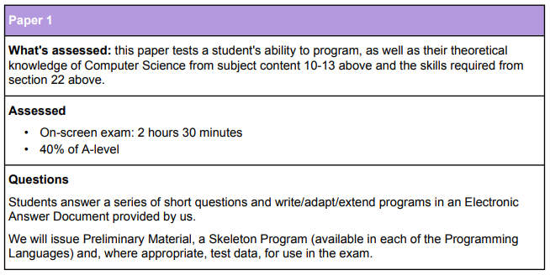

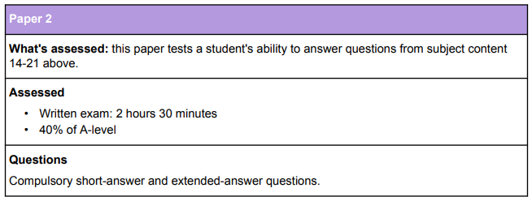

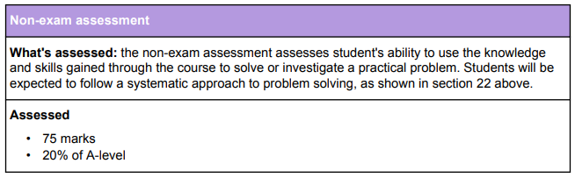

KEY COURSE INFORMATION

Length of Study | 5 hours, 37 weeks at college, 2 years.
Your classrooms | G3
Key skills you will be developing during the course to be successful | Subject specific.  Computer terminology, proofreading, report writing, writing clearly and concisely, problem solving, self-assessment, algorithms, programming, logic and writing code correctly to produce the desired results.
What will lessons look like? | A mixture of computer science theory and practical work in programming. You will also work in pairs to analyse and produce programs. You will work independently to produce an individual NEA report which includes analysis, design, coding, testing and evaluation.
Informal Assessment Methods | A mixture of questioning, monitoring practical work and engagement with exam questions and programming skills.
Essential Equipment/ Resources | A working computer with Microsoft Windows. All other software is free to download so ask your teacher (if not sure)  Make sure you bring your previous lesson’s notes in your class.  Bring a notepad, pen, pencil, calculator and highlighters in your class

YEAR PLAN OF STUDY

Paper 1 Year 1  Python programming basics including arithmetic, Boolean and relational operations  String handling  Random numbers  Selection and iteration  Lists and arrays  Functions and subroutines  File handling  Object oriented programming  Building GUI  Exception handling  Recursion  Problem solving  Abstraction and automation  Algorithms | Paper 2 Year 1  Number systems and number bases  Information coding systems  Images, sound and other data  Hardware and software  Programming languages and translators  Fundamentals of databases, relational Databases and SQL  External hardware devices
Paper 1 Year 2  Object Oriented Programming and UML  Recursion  Algorithms – Searching, Sorting, Graph Traversal, Tree Traversal, Dijkstra  Data structures – Queues, Stacks, Hash Tables, Dictionaries, Trees, Vectors, Graphs  Reverse Polish Notation  Set Theory  Regular Expressions (Regex)  Backus-Naur Form  Finite state machines  Turing Machines  Abstraction and Automation (revisited)  Systematic approach to problem solving  Skelton program and exam revision | Paper 2 Year 2  Communication and networking  Internal hardware components of a computer systems  Stored program concept  Processor and its components  Assembly language programming  Logic gates and Boolean algebra  Consequences of uses of computing  Functional programming and Haskell
NEA Year 1  Individual project selection  Analysis  Produce a draft technical solution  Add comments to individual NEA | NEA Year 2  Produce a technical solution  Test and debug individual technical solution  Designs  Evaluation  Complete NEA report and hand in

ENRICHMENT AND VISITS

Visit to Loughborough University – TBC

Visit to University of Staffordshire - TBC

Visit to Derby University – programming workshop – TBC

Industry webinars/activities online or face to face – TBC

Other educational trips - TBC

SUCCESSFUL LEARNER HABITS

A-levels in general are a marathon. They require organisation and revision/ lesson preparation on a weekly basis. Computer Science can be very tricky and so it is essential that the following is done by students to ensure success:

Plan when you're going to study: make a timetable for when you will put aside time
- Carry out independent programming practice each week

- Revise little and often: ensure that you are going over past content on a weekly basis… avoid revising only when you have an assessment

- Go over last lesson’s content prior to your next lesson – refresh your memory before you begin the lesson

- Be attentive and active in lessons – engage in new ideas, programming concepts and questioning. To do this, you should actively engage in every lesson, listen to other points of view and offer your own. Discuss these ideas with your peers and approach with an open mind.

- Share programming solutions with others and enhance problem solving skills.

- Use the Teams resources. One of these will be past papers. Test yourself using these and self-mark or hand in this extra exam practice. The more exam practice that you do, the more feedback that you will receive and the more prepared you will be for your exam.

SUBJECT RESOURCES FOR STUDENTS

Specific resources and recommended reading lists to support your learning can be found below:

Resources:

A Level Computer Science: https://www.hoddereducation.co.uk/subjects/ict/products/16-18/aqa-a-level-computer-science - Textbook is available both in the library and online

A-Level Computing/AQA - Wikibooks,: https://en.m.wikibooks.org/wiki/A-level_Computing/AQA

Use OneNote resources available for Paper 1, Paper 2 and NEA – you will get access in your first lesson

Moodle – Use Moodle course for Paper 1 consisting of example programs and practice tasks.

Isaac Computer Science: https://isaaccomputerscience.org/topics/searching?examBoard=aqa&stage=a_level

A-Level Computer Science AQA Unit 1, by Kevin Bond, published by Educational Computing Services

A-Level Computer Science AQA Unit 2, by Kevin Bond, published by Educational Computing Services

A-Level Computing, by Peter Kemp, available on WikiBooks: Wikibooks – AQA A-level Computing

Raspberry Pi Assembly Language (2nd edition) by Bruce Smith, published by Creative Space, ISBN 978-1-4921-3528-9

AS Computer Science AQA Units 1 and 2, by Kevin Bond, published by Educational Computing Services

AQA Computer Science A-Level, by Bob Reeve published by Hodder

Search for more resources using the library catalogue: Library Catalogue



Please use the link below to access the Reading Lists for A Level Computer Science:

Computer Science (A Level)

TERMINOLOGY GLOSSARY

The following list is a brief glossary of terms that you will use regularly within this subject.

Students must also demonstrate understanding of and be able to use philosophical terminology correctly. In addition to the philosophical terminology set out in each section, students must understand and be able to use the following philosophical terminology:
- Hardware/software
- Program and translators
- Sequence, selection and iteration
- Operators: arithmetic, Boolean, logical
- Loops
- Data structures like lists, queue etc
- Subroutines, functions
- Algorithms
- Data structure
- Relational databases
- Functional programming
- Big data
- Legal and ethical issues with computers
- Text files and binary files
- Fixed point and floating-point numbers
- Floating point normalisation
- SQL
- Analysis
- Design
- Test plan
- Evaluation
- Technical solution
- Coding
- Object oriented programming
- Structured programming
- Functional programming
- Recursion

NOTES

NOTES

