Chemistry 2026/2027
Academic Studies



Start Date | 7 September 2026
End Date | July 2028
Level of course | Level 3
Awarding Body | OCR
Specification | OCR A Level Chemistry A H432 Specification

CONTENTS

YOUR SUBJECT TEACHERS 3
AIMS OF THE COURSE 3
COURSE STRUCTURE AND EXAMS 4
KEY COURSE INFORMATION 4
YEAR PLAN OF STUDY 5
ASSESSMENTS 6
PRACTICAL WORK 7
PRACTICAL ENDORSEMENT 8
FORMAL ASSESSMENTS 8
ORGANISING YOUR WORK 8
HOW TO STUDY 9
INDEPENDENT STUDY 9
ENRICHMENT AND VISITS 10
BEING EQUIPPED 10
SUBJECT RESOURCES FOR STUDENTS 11
CHEMISTRY PUBLICATIONS 12
ACCESSING LIBRARY RESOURCES 12
POSSIBLE CAREERS 13
GLOSSARY OF TERMS 14
SPECIFICATION 15

YOUR SUBJECT TEACHERS

Gautam Saluja
(Teacher & Course Coordinator)

gautam.saluja@derby-college.ac.uk

AIMS OF THE COURSE

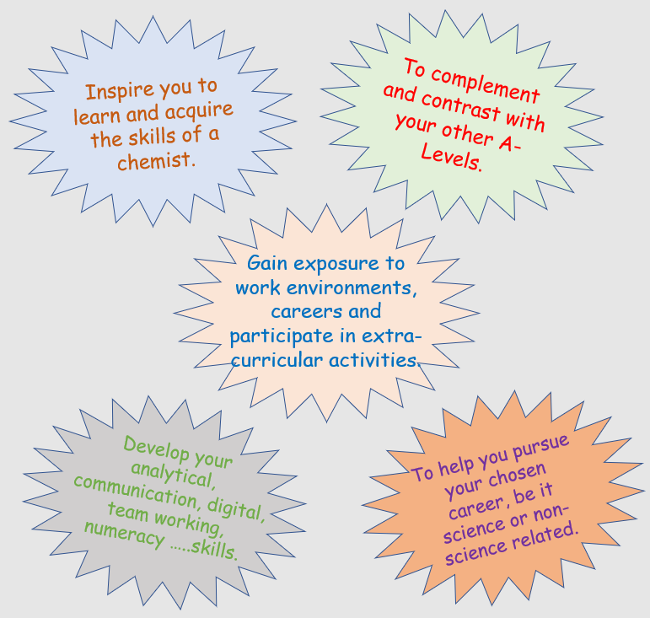

COURSE STRUCTURE AND EXAMS

Year 1 modules: Module 1 - Development of practical skills in chemistry
Module 2 – Foundations in chemistry
Module 3 – Periodic table and energy
Module 4 – Core organic chemistry

Year 2 modules: Module 1 - Development of practical skills in chemistry (continued)
Module 5 – Physical chemistry and transition elements
Module 6 – Organic chemistry and analysis

Three exams at the end of the second year and a practical endorsement:

Exam 1 - Physical Chemistry (2 hrs and 15 mins)
Exam 2 - Organic Chemistry (2 hrs and 15 mins)
Exam 3 – Whole course (1 hrs and 30 mins)

KEY COURSE INFORMATION

Length of Study | Two years (5 hours per week class time)
Your classrooms | T4
Key skills you will be developing during the course to be successful | Numeracy, communication, digital, practical, analytical, study skills and sustainability
What will lessons look like? | A blend of taught ideas and practical work. You will be asked to work independently and collaboratively.
Informal Assessment Methods | Development of understanding during lessons checked through class activities.  Written assessments every half-term.
Essential Resources | Stationary, scientific calculator, folders and textbook (available from the college library):  Year 1 Chemistry  OCR Chemistry A 2nd Edition AS/A Level - Sam Holyman, David Scott (Pearson)  Year 2 Chemistry  OCR Chemistry A Second Edition A Level Student Book 2  Sam Holyman, David Scott, Victoria Stutt (Pearson)
Health and Safety | Students are expected follow the code of practice in science laboratories. Details are given later in the handbook.

YEAR PLAN OF STUDY

The course consists of the following four modules in year 1. A general plan of delivery is given below. Formal Assessments, FAs, and feedback will take place every half term and feed into Progress Logs.

Module 1 - Development of practical skills in chemistry (over the whole course)

- Completion of class practical work for written exams and the Practical Endorsement.

Module 2 – Foundations in Chemistry (September – December of Year 1)

- Bridging from GCSE Chemistry (atoms, compounds, molecules and equations).
- Molar calculations.
- Acid-base and redox reactions.
- Bonding and structure.

Module 3 – Periodic table and energy (December – May of Year 1)

- Periodic Trends.
- Alkali earth metals and the halogens.
- Testing for ions.
- Enthalpy.
- Rates of reaction.
- Equilibrium.

Module 4 – Core organic chemistry (December – May of Year 1)

- Basic concepts and hydrocarbons.
- Alcohols and haloalkanes.
- Organic synthesis
- Analytical techniques.

The modules in year 2 build on knowledge and skills covered in the first year:

Module 5 – Physical chemistry and transition elements (December – May of Year 2)

- Reaction rates
- Equilibrium
- pH and buffers
- Enthalpy, entropy and free energy
- Redox and electrode potentials
- Transition elements

Module 6 – Organic chemistry and analysis (May of Year 1 – December of Year 2)

- Aromatic and carbonyl compounds
- Carboxylic acids and esters
- Nitrogen compounds & Polymers
- Organic synthesis
- Chromatography and NMR spectroscopy

PLAN OF STUDY

ASSESSMENTS

YEAR PLAN OF STUDY
The table below shows the exams at the end of the course which will determine your A-Level grade.

Assessment | Modules assessed | Time | Mode | Marks | Structure of assessment | Weighting towards  A-Level
Periodic table, elements and physical chemistry | 1, 2, 3 & 5 | 2 hours and  15 minutes | Written exam paper | 100 | Section A – multiple choice questions worth 15 marks.  Section B – short answer question styles and extended response questions worth 85 marks. | 37%
Synthesis and analytical techniques | 1, 2, 4 & 6 | 2 hours and  15 minutes | Written exam paper | 100 |  | 37%
Unified Chemistry | 1 - 6 | 1 hour and  30 minutes | Written exam paper | 70 | Short answer question styles and extended response questions worth 70 marks. | 26%
Practical endorsement in chemistry | 1 - 6 | - | Non exam  Assessment | - | A minimum of 12 practical activities over the two years must completed. | A ‘pass’ grade will be issued and recorded separately if standard is met.

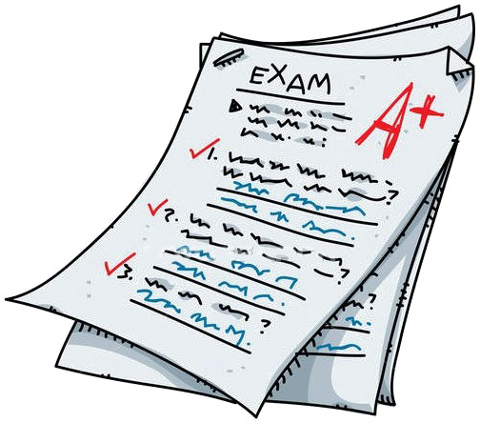

PRACTICAL WORK

Science is a practical subject. You cannot expect to develop your own understanding of the subject unless you actively participate and complete practical tasks. There is a large amount of practical work in chemistry which prepares you for the practical endorsement and examinations. You can only do practical work in class and so you will need to ensure your attendance as high as possible.

Science laboratories can be hazardous places and safe working is important. Protective clothing and safety equipment will be provided for use during practical work. All students are expected follow the code of practice in science laboratory as given by the Health and Safety at Work Act 1974 and The Control of Substances Hazardous to Health (COSHH) Regulations 1989. The code of practice is given below.

- Entry to Laboratories
Students will be required to wait outside a laboratory until a member of staff is present.
- Protective Clothing
When working with chemicals, microbiological materials and radioactive substances, all students must wear a lab coat which is fastened up. These are available in each laboratory.
- Eye Protection
Safety glasses are provided in all laboratories and must be worn during practical work.
- Hair
Long hair must be tied back and fastened securely during all practical work.
- Coats and bags
Bags and coats should be stored neatly under benches and out of the way. The floor must be always kept clear.
- General Laboratory Procedures
- Instructions from staff must be followed. If in doubt, ask.
- Apparatus and equipment should be returned to the appropriate place after use.
- All used glassware should be placed in the washing bowls provided. Do not put used glassware back in the cupboards.
- Faulty or damaged equipment should be reported so that repair or replacement can be arranged.
- Broken glass must not be placed in the normal waste bins. There is a special broken glass in each laboratory. Report breakages to the lecturer.
- Make sure that you follow any special instructions on the disposal of solids or hazardous waste which should not go down the drains.
- Solids or rubbish must not be placed in the sinks.
- Benches should be cleared and wiped at the end of each practical session.
- Hands should be washed your after practical work.
- Eating and drinking in a science laboratory is forbidden. Food and drink bottles should be place away in the bags before entering the laboratory.
- Injuries
Any injury should be reported to a member of staff immediately.
- Emergency Procedures
In the event of an emergency or a fire drill, follow the instructions given by staff or on college notices.
- Graffitti
Do not write or graffiti any laboratory surface or desk. Any damage will be expected to made good.

PRACTICAL ENDORSEMENT

You are required to formally write up twelve practical experiments over the two years if you are to be awarded the practical endorsement. This will only be a selection of the experiments you will complete over the two years. Six of the twelve practical experiments will be assessed during the first year of the course.

You will be required to keep the practical endorsement booklet fully up to date and submit it after writing up each experiment. The booklet should demonstrate a development of your own practical skills and will prepare you for written exams. Each experiment will be graded as either PASS or FAIL and each experiment must be passed to be awarded the practical endorsement. The booklet should be taken care of during the course and can be asked for at university interviews. The outcome of the practical endorsement will be reported separately to your final grade on the qualification certificate.

FORMAL ASSESSMENTS

Due to A-Level examinations taking place at the end of the two-year course, progress will be monitored every half term through a Formal Assessment (FA). Each half-termly FA will be an exam of an equivalent standard to the final A-Level examinations, and you will be assessed against your own target grade. You will not be able to improve on your FA grades once they have been sat. Your performance will be reported in the termly progress logs and be used for predicting A-Level grades when you are applying to university.

ORGANISING YOUR WORK

Success at A-Level requires you be organised. It is up to you how you organise yourself, but whatever you do should be effective in helping you achieve the grade you want to achieve. Here is a key suggestion on organisation:

- Get a hard-backed lever arch folder to keep at home. Store handouts & notes in the correct order as you go along (weekly, fortnightly….) and use dividers to separate topics/subjects.
- Get an A4 folder for daily use. Use dividers to separate subjects.



HOW TO STUDY

Success in Chemistry will depend upon how you approach the subject. You cannot expect to achieve high grader if your own approach takes you in the opposite direction. You are expected to:

- Attend all classes. An attendance of at least 93% is expected, but you should be aiming to attend every lesson. If you miss more lessons, you will be unable to catch up because the subject requires you to consistently recall previous knowledge.
- Be punctual. Being late interrupts the lesson, disturbs the learning of other students and means that you have missed important parts of the lessons.
- Work productively and maturely in class. You are expected to focus on the tasks set in class and actively participate in activities. You should be part of a safe and positive learning environment, which is important for every class member.
- Complete the work set for completion outside class. You will be asked to regularly complete work outside of class. It is important that you demonstrate that you can meet deadlines and attempt tasks to the best of your own ability.
- Be responsible for your own learning. You need to keep your notes in order, regularly revise concepts taught, supplement your own understanding, practise questions and write up laboratory work. You should be spending 5 hours per week in private study. You need to develop your own study skills, respond to feedback and work consistently at the subject to make it a success.

INDEPENDENT STUDY

You need to engage in independent study if you are going to succeed on the A-Level course. It can take time to learn what works for you. Here are some suggestions:

- Organise and go over your notes.
- Make summaries of topics, i.e. mind maps, revision notes or flash cards.
- Highlight key words on your notes and test yourself.
- Complete tasks set to be completed outside class.
- Read the topic in a textbook.
- Try worked examples and questions in the textbook.
- Discuss the topic/difficult concepts with peers.
- Read the topic on the Internet.
- Watch media clips on the topic.
- Try past paper questions.
- Read a chemistry journal such as Chemistry Review.

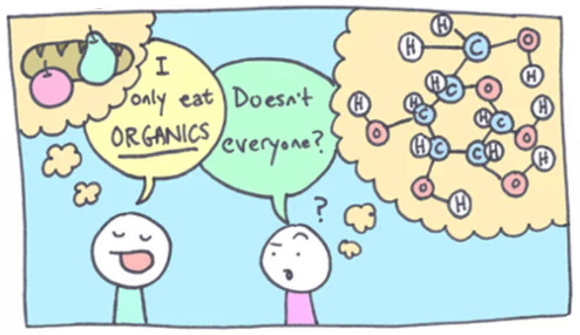

ENRICHMENT AND VISITS

The table below shows recent enrichment activities which have been available to A-Level Chemistry.

Year 1 | Year 2
Cambridge Chemistry Challenge  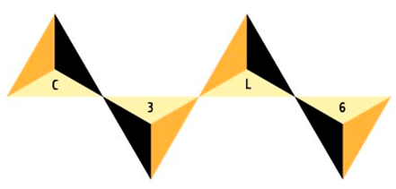 | Spectroscopy Workshop  
Chemistry Outreach at University of Huddersfield   | RSC Chemistry Olympiad  

BEING EQUIPPED

H
You always need certain equipment for studying a subject. In Chemistry, you should have the following items with you:

- Black biro
Your calculator is REALLY IMPORTANT. More people have failed exams through calculator problems than anything else.

Make sure you have your own calculator.
- Coloured biros
- Pencil HB
- Eraser
- Sharpener
- Ruler
- Calculator
- File paper

SUBJECT RESOURCES FOR STUDENTS

The following resources are suitable for developing your own understanding of the subject beyond the classroom:

Textbooks

Year 1 Chemistry: OCR Chemistry A 2nd Edition AS/A Level
Sam Holyman, David Scott (Pearson)

Year 2 Chemistry: OCR Chemistry A Second Edition A Level Student Book 2
Sam Holyman, David Scott, Victoria Stutt (Pearson)

The above textbooks, as well as alternative textbooks are available to loan from the library.

Websites

Chemguide http://www.chemguide.co.uk
S-cool http://www.s-cool.co.uk/alevel/chemistry.html
Docbrown http://www.docbrown.info/
RSC http://www.rsc.org/learn-chemistry

Media

Seneca http://www.senecalearning.com
MaChemGuy https://www.youtube.com/user/MaChemGuy
Khan Academy Khan Academy Chemistry
Snaprevise Snaprevise chemistry

General Interest/Inspiration

Periodic Table of Videos

periodicvideos.com

Royal Institute

rigb.org

CHEMISTRY PUBLICATIONS

Chemistry Review

The contents of a typical magazine will appear as given below. The magazine includes questions, quizzes and exam tips which can help you develop your understanding of the subject.

To access online go to the college intranet and click on Share point on the top left of the page à DCG Library à Electronic resources à Hodder Education à Search for Chemistry and then select Chemistry Review.

The username is DCG and password is PAR. Leave the centre number section blank.

You can access the online magazine by clicking on SharePoint.

ACCESSING LIBRARY RESOURCES

There is a course reading list is available through our SharePoint page and additional resources can be searched for on the online catalogue Look 4.



POSSIBLE CAREERS

By studying chemistry, you will develop your numeracy, teamwork, communication, practical and ICT skills. Here is a selection of careers which are accessible as a result of completing the full A-Level course:

Forensic Chemistry
Chemical engineering
Medicine
Health & Safety Adviser
Accountancy
Law
Dentistry
Pharmacy
Marketing and Sales Manager

As the year progresses, you will need to research which career you would like to pursue with your qualification in chemistry. There will be a progression fair where a large number of universities will visit The Joseph Wright Centre during the second term of the course.



GLOSSARY OF TERMS

The glossary of terms below will be used at the beginning of the A-Level course.

Term | Definition
Atomic Number | The number of protons in the nucleus of an atom.
Electron | A negatively charged subatomic particle which orbits the nucleus at various energy levels.
Ion | A charged atom or molecule.
Isotopes | Atoms of the same element with the same number of protons and electrons but different numbers of neutrons.
Mass Number | The total number of protons and neutrons in the nucleus of an atom.
Neutron | A neutral subatomic particle found in the nucleus of an atom. The relative mass of a neutron is 1.
Proton | A positively charged subatomic particle found in the nucleus of an atom. The relative mass of a proton is 1.
Relative Atomic Mass | The weighted mean mass of an atom compared with 1/12th mass of  an atom of carbon-12.
Relative Isotopic Mass | The mass of an atom of an isotope compared with 1/12th mass of an atom of carbon-12.
Relative Formula Mass | The mass of the formula unit of a compound with a giant structure.
Relative Molecular Mass (M_{r}) | The mass of a simple molecule.
Ionic Compound | A compound which is made up of oppositely charged ions that are held  together by electrostatic forces.
Amount of substance | The quantity that has moles as its units, a way of counting atoms.
Anhydrous | a crystalline compound containing no water.
Avogadro Constant (N_{A}): | The number of particles per mole of substance (6.02 x 10²³ mol⁻¹).
Empirical Formula | The simplest whole number ratio of atoms of each element present in a  compound.
Molar Mass | Mass per mole of a substance (units: g mol⁻¹).
Mole (mol) | The amount of any substance containing as many particles as there are carbon atoms in exactly 12 g of carbon-12 isotope.

SPECIFICATION

Click on link below to access specification:

OCR A Level Chemistry A H432 Specification

Or type OCR A Level Chemistry A H432 Specification into google and search.

.

