AAQ Applied Science Certificate

Course Handbook



Start Date | 8th September 2025
End Date | June 2026
Level of course | 3
Year of course | Year 1
Awarding Body | OCR
Specification | https://www.ocr.org.uk/Images/697579-specification-cambridge-advanced-national-in-applied-science.pdf

CONTENTS

WELCOME TO DCG 3
YOUR TEACHERS AND THE TEAM AROUND YOU 4
INTRODUCTION AND COURSE CONTENT 4
OVERVIEW OF UNITS/MODULES/TOPICS 6
YEAR PLAN OF STUDY 7
KEY INFORMATION ABOUT YOUR COURSE 8
ASSESSMENT AND FEEDBACK 9
KEY EXPECTATIONS 11
TUTORIALS 12
WORK EXPERIENCE 13
LIBRARIES FOR LEARNING 14
SUPPORT FOR YOUR STUDY SKILLS AT DCG 17
SUPPORT FOR YOUR DIGITAL SKILLS AT DCG 18
STUDENT VOICE 19
GLOSSARY OF TECHNICAL TERMS 20
YOUR NEXT STEPS OPPORTUNITIES 21

WELCOME TO DCG

A very warm welcome to our The Joseph Wright Centre, part of the Derby College group.

I am delighted that you have chosen to study the on the AAQ Applied Science with us. We aim to provide you with an excellent education that develops your knowledge, skills, behaviours and ambition to become successful in your future learning, employment and to be confident in life.

Throughout your course you will be supported by an excellent team of staff who will help and guide you through your programme. I am sure you will make this easy for them by maintaining good attendance, punctuality, conduct and commitment to the course.

As you will quickly observe, students who study at the Joseph Wright Centre pride themselves on their passion for their subjects, their respectful behaviour and their professional approach to learning. They attend well, work hard and seek feedback from teachers on how to improve.

This handbook aims to provide you with some important information and the habits and routines necessary to achieve your best on your programme.

I wish you all the best with your studies during your time at the Joseph Wright Centre.



Sally Archer: Head of A-levels and Academic Education
Based in S24.

Welcome from your Curriculum manager Patrick Ring who is also a Geology A Level teacher:

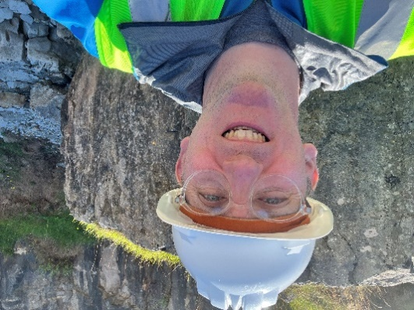

I’m based in G19 by the Student Services and will be popping into classes from time to time. I’ll be driving your minibus on trips such as the primary school work experience teaching science to the under 10s! If you can explain science to them then you have learned the message of teaching to your audience. You will also be delivering in this course to industry professionals and university academics. This course will prepare you for your future science life completely. Enjoy and good luck.

YOUR TEACHERS AND THE TEAM AROUND YOU

Curriculum Manager and Lecturer | Patrick Ring | patrick.ring@derby-college.ac.uk
Lecturer | Uzma Lal | uzma.lal@derby-college.ac.uk
Lecturer | Zani Cockerham | zani.cockerham@derby-college.ac.uk
Lecturer | Nneka Davis | nneka.davis@derby-college.ac.uk

INTRODUCTION AND COURSE CONTENT

Welcome to Derby College Group - Science Department.

This booklet aims to tell you about the OCR AAQ Applied Science Certificate Qualification and what you will be doing over the year. We hope you will find your time with us enjoyable and interesting, as well as enable you to achieve a valuable qualification which will prepare you to further your studies in science and work within the Science industry.

AAQs embody a fundamentally learner-centred approach to the curriculum, with a flexible,
unit-based structure and knowledge applied in project-based assessments. They focus on the
holistic development of the practical, interpersonal and thinking skills required to be able to
succeed in employment and higher education.

The course is demanding as you would expect of a direct competitor to A Levels. You will have to complete a unit called a controlled assessment during lesson time that will form 50% of this qualification.

Objectives
The objectives of this qualification are to equip you with:
• the core knowledge and core skills relevant to science
• up-to-date occupational knowledge and skills that have continued currency amongst employers and others
• the necessary English, mathematics and digital skills
• threshold competence that meets employer expectations and is as close to full occupational competence as possible
• opportunities to manage and improve your own performance.

On successful completion of the course, you will be awarded a qualification equivalent to 0.5 of an A level which can be topped up to a full A Level equivalent next year in the Extended Certificate.

Grading for units and qualifications

Achievement in the qualification requires a demonstration of depth of study in each unit, assured acquisition of a range of practical skills required for employment or progression to HE, and successful development of transferable skills. Learners achieving a qualification will have achieved across mandatory units, including external and synoptic assessment. Units are assessed using a grading scale of Distinction (D), Merit (M), Pass (P), Near Pass (N) and Unclassified (U). Both units in the certificate are mandatory.

UCAS Tariff points

Certificate
D* 28
D 24
M 16
P 8

Extended Certificate

D* 56 equivalent to A* at A Level
D 48 equivalent to A at A Level
M 32 equivalent to C at A Level
P 16 equivalent to E at A Level

STRUCTURE OF THE QUALIFICATION

A side from the mandatory units, the optional units are usually decided upon based on the specialisms of the teachers delivering them, but the course will contain a balance of biology, chemistry and physics related units.

Unit F180: Fundamentals of science

This unit is assessed by an exam.
In this unit you will learn about the key topics that are important in biology, chemistry and
physics. You will study two key practicals for each of those components to be assessed as
part of section D of the exam. Topics include:

Section A (Biology)
Topic Area 1 Cell structure and microscopy
Topic Area 2 Bioenergetics
Topic Area 3 Structure and function of biological molecules
Topic Area 4 Biodiversity and ecosystems

Section B (Chemistry)
Topic Area 1 Atomic structure and the Periodic Table
Topic Area 2 Quantitative chemistry
Topic Area 3 Structure and bonding
Topic Area 4 Rates of reactions and enthalpy changes

Section C (Physics)
Topic Area 1 Electricity
Topic Area 2 Motion
Topic Area 3 Medical physics

Section D
Practicals

Unit F182: Investigating Science

This unit is assessed by an assignment.

In this unit you will learn about the role of a research scientist in industry by learning how to conduct your own scientific investigation. You will develop the skills to research, plan and risk assess your investigation before safely undertaking the practical tasks. Topics include:

Topic Area 1 Planning a scientific investigation
Topic Area 2 Performing a scientific investigation
Topic Area 3 Analysing and communicating results
Topic Area 4 Evaluating a scientific investigation

KEY INFORMATION ABOUT YOUR COURSE

Length of Study | 1 Year
Key skills you will be developing during the course to be successful | Project management (managing time and priorities), researching using a range of literature, working with others (with peers and at work placements), creativity and innovation (solving problems and identifying challenges), communication (presentations, professional discussions and digital), reflective evaluation (identifying strategies to improve).
What will lessons look like? | Lessons will be varied depending on the topic you're learning and the time of year, but you can expect a mixture of practical and theoretical content. You will also have lessons delivered by external speakers from local representatives from the sector.
Assessment Methods | Summative assessments include exams for the mandatory unit.  For the internally assessed unit all work will be completed within lesson time.
Equipment/ Resources | You are required to bring with you:  - Ring binder/Folder & dividers  - Lined Paper  - Pen, Pencil, Ruler, Highlighter, Scientific Calculator
Health and Safety | You will be expected to wear appropriate safety equipment when required. You will also be expected to read all relevant safety information and listen to and follow safety instructions given by staff, both in college and on work placement.

ASSESSMENT AND FEEDBACK

The course follows the A Level FA system

- Following formative assessments your teachers will assess your work and will feedback within ten working days of the assessments.
- During the feedback session you will reflect your performance in the exam and set goals for future tasks. To work towards these goals, you will complete directed tasks targeted to address areas which need development.
- Grade Calculation

Referrals Procedures and Resubmissions Procedures
You will have a clear plan of what to expect, what assessments will take place during the year and when you can expect these assessments to happen. You can expect your work to be marked and quality assured where appropriate and returned within a maximum of 15 working days of submission.

Once you have submitted your work, it will be marked and potentially be quality assured by the Internal Quality Assurance team. This is particularly key where the learning outcomes have not been met and a resubmission opportunity has been given.

Where a referral has been given, by the teacher or assessor will provide you with an opportunity to resubmit. However, you must read the feedback carefully to ensure you are clear of what you need to do and where a graded qualification and assessment is in place what you can attempt. This will be time bound and you will be given a re-submission date by your trainer/assessor/lecturer, and you must meet this deadline.

Academic Malpractice
DCG is keen to support students and avoid any cases of Academic malpractice. Awarding Organisations take matters of academic malpractice very seriously and require all schools and colleges to have specific policies and procedures in place to both educate staff and students about malpractice, thus deterring them from committing it whether intentional or not and report and investigate any suspected malpractice where it may occur.

Examples of malpractice include plagiarism; this is where work is copied directly or paraphrased from another source without referencing. Plagiarism also includes work created using artificial intelligence (AI) tools such as ChatGTP and submitted as a students’ own work without proper referencing of the AI source. It could also include copying another student’s work or allowing another student to copy your work.

Other examples include:

- Falsification or fabrication of results,
- Deliberate destruction of other student’s work
- Any other act that will give you an unfair advantage. This also relates to not following clear guidance in examinations or assessments where examination conditions exist.

Where academic malpractice is suspected, this will be reported to your Team Manager who will investigate and, where relevant, the Awarding Organisation may also be informed and investigate further. Where malpractice is discovered to have occurred, sanctions may be imposed including the potential to be disqualified from the qualification.

Appeals Procedures
Each Awarding Organisation will have slightly different processes for appealing decisions. Appeals can be made where:
- You believe that the awarding body policies and procedures have not been followed correctly in respect of external quality assurance/standards verification (policies and procedures can be found on the relevant awarding body website).
- You believe that the awarding body policies and procedures have not been followed correctly in respect of qualification decisions (policies and procedures can be found on the relevant awarding body website).
- You disagree with the outcome of your internal appeals procedure (for example, a decision in relation to reasonable adjustments or assessment outcomes).

However, should you, as a student wish to appeal, firstly:
Contact your lecturer/trainer/assessor and discuss your concerns.

If you are still not satisfied with the outcome, the College would usually make an appeals application on your behalf. This would require your consent. It is possible to apply directly to the Awarding Organisation but only once the College’s internal processes have been followed. At this point you would be informed of the next stages and Awarding Organisation communication link. This is time bound and this will also be communicated to you once the internal appeals process has taken place.

Note: you must be aware that through this process the initial grade can go up, stay the same, or go down.

KEY EXPECTATIONS

The 5Ps and College code of conduct.

To be successful at Derby College you will be expected to be:
- Positive
- Polite
- Punctual
- Prepared, and
- Professional in your approach.

Please pay attention to the code of conduct, you will be asked to sign a copy to promise you will abide by the College guidelines: Code of Conduct (sharepoint.com)

Derby College has a zero-tolerance approach to all forms of bullying, harassment and abuse both online and face-to-face. Statement on Sexual Harassment, Bullying and Online Abuse (sharepoint.com)
If you or anyone else is being bullied, harassed or abused – or if you become aware of discriminatory behaviour or actions taking place – you are encouraged to report this by contacting either your course tutor or https://studentderbycollegeac.sharepoint.com/sites/Welfare/SitePages/Chat-to-a-Welfare-Officer.aspx or call our confidential BULLYING HELPLINE on 01332 387499.

What all students can expect from Derby College Group:

- We will listen to you and take your concern seriously and deal with it in a sensitive manner.
- We will give you support and involve you in any decision that affects you.
- We will take disciplinary action against any student who has harmed you and/or breached the college Code of Conduct.

Key Expectations (course specific)

What you can expect of us:
a. Lessons planned in line with the specification.
b. All work will be marked and fed within an appropriate length of time.
c. Ensure that all students are treated fairly and respectfully.
d. We will ensure you are provided with a suitable work placement.

What we expect of you:
a. To have good attendance and punctuality.
b. To engage in lessons and complete homework.
c. To bring appropriate equipment to lessons.
d. To have good commitment to completing work placement.

TUTORIALS

The course follows the A Level tutorial system

LIBRARIES FOR LEARNING

Make your life easier! To make a real success at Derby College visit the library. Bring your existing skills and the Libraries for Learning team will help you do the rest. Use the private study space to work on your assignments whilst making use of the extensive resources. There is IT help available to improve your skills to present your work with a professional finish and IT kit (laptops and PCs) for you to use on-site and then, print your work in the library at no cost to you using your student print allowance.

Get the help you need! Come into the Library or use the resources online and ask any one of the friendly team members for help. All the Libraries for Learning Team are skilled researchers willing to help you find the information you need and guide you to resources you might not have considered to help you finish those assignments. On the rare occasions that the library does not have exactly what you want, they will do their best to borrow it through another library. They can also give you advice on study skills and digital skills via the Skills Hubs too (see Study Skills and Digital Skills sections below).

Improve your grades! Research has established that the students who achieved the highest grades on their chosen course of study were those who took full advantage of all that the library offers by borrowing books and accessing electronic resources most frequently. In contrast, the students with the lowest marks were those who made the fewest visits to the library. What are you waiting for?

Everything about the Libraries for Learning Service can be found on the Libraries for Learning POD page including the Library Catalogue, and all the contact details.

Specific resources and recommended reading lists to support your learning can be found below:

Course textbook-This can be loaned from the college library.



Digital resources from the library
Working in the Health and Science Sector - DCG Library List
Access to Higher Education Diploma - Health Professions: Index (derby-college.ac.uk)
Applied Science: Index (derby-college.ac.uk)
BTEC Nationals Applied Science Student Book 1 - Chapter 1: Principles and Applications of Science
BTEC level 3 Nationals applied science: (Student book 2) (vlebooks.com) - Chapter 5: Principles and Applications of Science II
Access to Higher Education Diploma - Science: Index (derby-college.ac.uk)
Health & Social Care: Index (derby-college.ac.uk)
Health and Safety at Work - DCG Library List
AS data and data handling for Biology
Ethics - DCG Library List
Scientific Methodology - DCG Library List
Lab Safety, Techniques, procedures, apparatus, equipment, materials
Biology eBooks - DCG Library List
Chemistry Books - DCG Library List
Physics Books - DCG Library List

Resources lists from the library
Biology: Index (derby-college.ac.uk)
Cell Biology and Biochemistry Books - DCG Library List
Cell Biology and Biochemistry eBooks - DCG Library List
Genetics and Evolution eBooks - DCG Library List
Genetics and Evolution Books - DCG Library List
Health Promotion eBooks - DCG Library List
Health Promotion Books - DCG Library List
Human Anatomy and Physiology eBooks - DCG Library List
Health Promotion Books - DCG Library List
Human Anatomy and Physiology Books - DCG Library List
Infectious Disease Books - DCG Library List
Infectious Disease eBooks - DCG Library List
Medicine and Pharmaceutical Science eBooks - DCG Library List
Medicine and Pharmaceutical Science Books - DCG Library List
Nutrition eBooks - DCG Library List
Nutrition Books - DCG Library List
Chemistry: Index (derby-college.ac.uk)
Chemistry (A Level) Core Specification - DCG Library List
Chemistry (A Level) Core Specification eBooks - DCG Library List
Chemistry (A Level) Wider Reading - DCG Library List
Chemistry (A Level) Wider Reading eBooks - DCG Library List
Physics: Index (derby-college.ac.uk)
Physics (A Level) Core Specification - DCG Library List
Physics (A Level) Core Specification eBooks - DCG Library List
Physics (A Level) Wider Reading - DCG Library List
Physics (A Level) Wider Reading eBooks - DCG Library List

Course: Study Skills Hub (derby-college.ac.uk)
Study Skills: Index (derby-college.ac.uk)
Digital Skills Hub: Before you start DCG
Digital Skills Hub: Progressing at DCG
Digital Skills Hub: Leaving the DCG

Course: Libraries for Learning Reading Challenge 2021/22 (derby-college.ac.uk)

SUPPORT FOR YOUR STUDY SKILLS AT DCG

The Study Skills Hub course includes a wide-ranging selection of information and resources to support the continuing development of your study skills, (the stuff you can easily do to improve your college life and continued learning). You can work through these short modules (see below for a detailed list) in any order and obtain a virtual badge in recognition of your participation. On completion of any 6 modules, you will also be awarded a Bronze level certificate. If you go on to complete a further 6 (12 in total) you will be awarded a Silver level certificate and a Gold certificate on completion of all modules.

Links to the complete course and individual modules are listed below:

 | Study Skills Hub (complete course)
Better Learning | Note Taking | Managing your Time
Independent Learning | Better Thinking | Preparing for Assessments or Exams
Internet Search Strategies and using Google | Using Chatbots to Search the Internet | Starting Research
Referencing and Plagiarism | Using Artificial Intelligence (AI) as a Study Aid | Trusted Sources
Presentation Skills | Critical Thinking | Continuing Research
Primary and Secondary Sources | Copyright and Intellectual Property | Learning from Feedback and Reflective Practice

All modules are supported by the Libraries for Learning Team so please contact them at learningresources@derby-college.ac.uk if you would like any additional support or information – they are here to help!

SUPPORT FOR YOUR DIGITAL SKILLS AT DCG

Each of the Digital Skills Hub courses includes a wide-ranging selection of information and resources to support the continuing development of your Digital Skills from the time you start with us at DCG to the time you move on. You can work through the modules and obtain a virtual badge in recognition of your participation. On completion of the first 6 modules, you will also be awarded a Bronze level certificate. If you go on to complete a further 6 (12 in total) you will be awarded a Silver level certificate and a Gold certificate on completion of all modules. The course and the modules for each one are listed below.

 | 
Digital Skills Hub: Getting Started | Digital Skills Hub: Progressing
Acceptable use policy (AUP) | Plagiarism and Copyright
Online Safety | Privacy and Cookies
Logging In | Microsoft 365 Applications
An Introduction to Mobile Devices | Organising Your Inbox
Introduction to MyDCG and Your College Individual Learning Plan (MyILP) | Your Digital Footprint
College IT Troubleshooting | Progressing with Microsoft Word
Microsoft OneDrive | Video Creation in Microsoft PowerPoint
Emailing and Using Microsoft Outlook | Searching the Internet
Microsoft Teams | Using Artificial Intelligence
Microsoft Word | GDPR and Data Protection
Using Library eResources | Microsoft Teams for Remote Learning
Using the Internet | Phishing
Microsoft PowerPoint | Creating and Presenting an Academic Poster
Microsoft Excel | Digital Wellbeing
Microsoft OneNote | Progressing with Microsoft Excel
An Introduction to AI | EdTech Apps
CVs, Application Forms and UCAS | Microsoft Tools
Browser and accessibility tools | LinkedIn

All modules are supported by the Libraries for Learning Team, so please contact them at learningresources@derby-college.ac.uk if you would like any additional support or information – they are here to help!

STUDENT VOICE

There is no bigger group of people than students in the classroom! Therefore, listening to students is essential.

Student Voice refers to listening to what YOU think and feel during your time in education at DCG. This is not just about the College listening, but also about acting upon, your feedback.

We want to know:
- Positives – what you enjoy and want to do again,
- Improvements – what and how we can change to improve,
- New Ideas – we are always looking for student-led initiatives.

We listen to students through...
- Cross College Surveys
- Focus Groups
- Student Voice Meetings
- And The Student Representative System.

What is a Student Representative?

Student Representatives or Student Reps are volunteers representing the opinions and suggestions of the students in their class. Student Reps gather the feedback from their class and pass that information to their Academy Representatives and leaders within the college. This is an outstanding experience to add to your CV, job application, or UCAS form.

What are Academy Reps?

This is a senior volunteer role and represents the views of students in the whole Academy, rather than just the class. Academy reps present feedback from Student Reps in their Academy to the senior leadership team (the people who lead the whole college).

Want to learn more about Student Voice?

The Student Voice Coordinator will be visiting YOU in tutorial sessions this October.
Contact Pippa Lucas (She/Her), Student Voice Coordinator, with any questions you may have via the email below.

Email - studentvoice@derby-college.ac.uk

GLOSSARY OF TECHNICAL TERMS
The following list of command verbs you will learn or be exposed to during your assessments.
The course textbook includes a list of key scientific terms
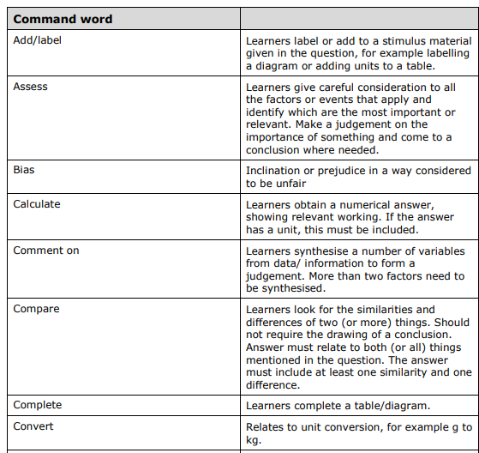
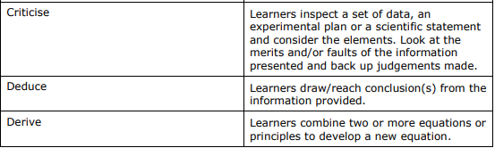
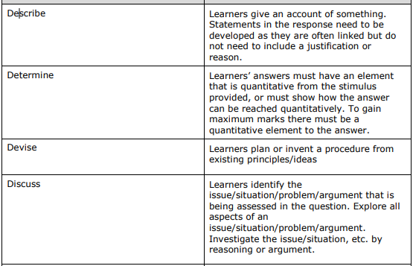

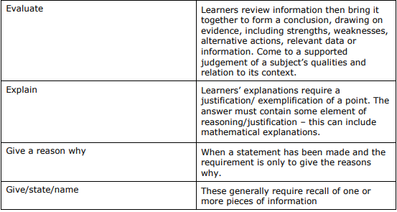
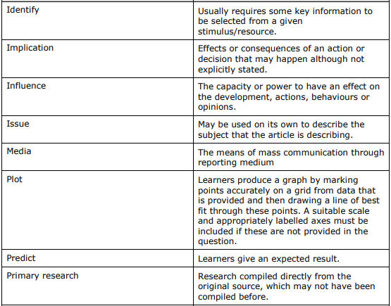

YOUR NEXT STEPS OPPORTUNITIES
Your next steps opportunities when you successfully achieve your chosen study program / course.

This is an ideal progression pathway to a variety of science degrees such as Biomedical Science, Radiography, Pharmacy, Pathology, Nursing and Paramedic Sciences.

Careers
The science sector of the economy offers huge potential for interested students, with a wealth of large employers needing this skillset.

The UK is currently regarded as a world leader in environmental science (Socotec) renewable energy (Good Energy, Ecotricity); space (Surrey Satellites, UK Space Agency, Starchaser – remember Rosetta?); low carbon (Energy, Green Buildings, Fabrics, Architecture, Transport, Wind, Solar, Biomass); pharmaceutical (Glaxo SmithKline, Astra Zeneca, Lilly); utilities (EON, Scottish and Southern Power); engineering (Rolls Royce) automotive (Ford, Jaguar Land Rover, Aston Martin, Vauxhall); agri-food (ICI, Fisons); bioscience (Welcome Foundation); health care (NHS, Bupa); oil and gas (BP, Shell); and household chemical (Proctor and Gamble, Unilever).

NOTES

